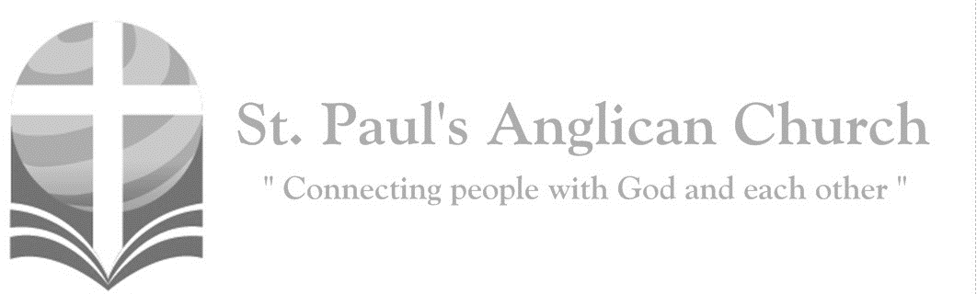
Sunday, April 5, 2020: Palm Sunday
Christ became obedient unto death, even death on a cross. Therefore, God has highly exalted him and bestowed on him the name which is above every name.
(Philippians 2:8-9)

Opening Song: Hosanna
Praise is rising
Eyes are turning to You
We turn to You
Hope is stirring
Hearts are yearning for You
We long for You

(Pre-Chorus) 'Cause when we see You
We find strength to face the day
In Your presence
All our fears are washed away
Washed away

(Chorus) Hosanna, hosanna
You are the God who saves us
Worthy of all our praises
Hosanna, hosanna
Come have Your way among us
We welcome You here Lord Jesus

Hear the sound
Of hearts returning to You
We turn to You
In Your Kingdom
Broken lives are made new
You make us new (To Pre-Chorus)

Palm Sunday
Rev. Myron: Blessed is he who comes in the name of the Lord.
All: Hosanna in the highest.
Rev. Myron: Dear friends in Christ, during Lent we have been preparing for the celebration of our Lord’s paschal mystery. On this day our Lord Jesus Christ entered the holy city of Jerusalem in triumph. The people welcomed him with palms and shouts of praise, but the path before him led to self-giving, suffering, and death. Today we greet him as our King, although we know his crown is thorns and his throne a cross. We follow him this week from the glory of the palms to the glory of the resurrection by way of the dark road of suffering and death. United with him in his suffering on the cross, may we share his resurrection and new life.
Let us pray: Assist us mercifully with your help, Lord God of our salvation, that we may enter with joy into the celebration of those mighty acts whereby you give us life and immortality; through Jesus Christ our Lord.
All: Amen.

Morning Prayer
Rev. Myron: Christ became obedient unto death: O come, let us worship. (Venite –Psalm 95:1-7) Come, let us sing to the Lord; let us shout for joy to the rock of our salvation. Let us come before his presence with thanksgiving and raise a loud shout to him with psalms. For the Lord is a great God, and a great king above all gods. In his hand are the caverns of the earth, and the heights of the hills are his also. The sea is his for he made it, and his hands have moulded the dry land. Come, let us bow down, and bend the knee, and kneel before the Lord our maker. For he is our God, and we are the people of his pasture and the sheep of his hand. Oh, that today you would hearken to his voice!

The Psalm
Canticle: Psalm 118:1-2, 19-29
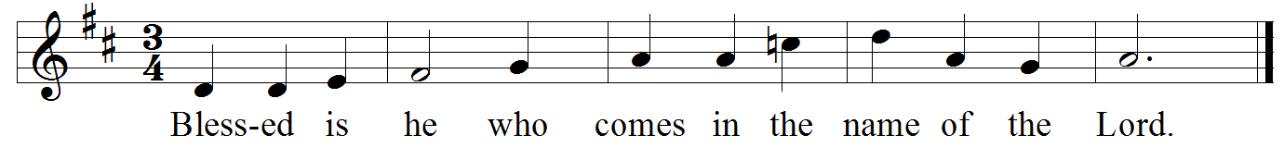
Refrain:

Give thanks to the Lord, for he is good; his mercy endures for ever. Let Israel now proclaim, "His mercy endures for ever." Refrain
Open for me the gates of righteousness; I will enter them; I will offer thanks to the Lord. "This is the gate of the Lord; / he who is righteous may enter." Refrain
I will give thanks to you, for you answered me and have become my salvation. The same stone which the builders rejected has become the chief cornerstone. Refrain
This is the Lord’s doing, and it is marvellous in our eyes. On this day the Lord has acted; we will rejoice and be glad in it. Refrain
Hosanna, Lord, hosanna! / Lord, send us now success. Blessed is he who comes in the name of the Lord; / we bless you from the house of the Lord. Refrain
God is the Lord; / he has shined upon us; form a procession with branches up to the horns of the altar. Refrain
"You are my God, and I will thank you; you are my God, and I will exalt you." Give thanks to the Lord, for he is good; / his mercy endures for ever. Refrain

The Gospel Reading
Rev. Myron: The Lord be with you.
People: And also with you.
Rev. Myron: The Holy Gospel of our Lord Jesus Christ according to St. Matthew.
People: Glory to you, Lord Jesus Christ.
Gospel Reading: Matthew 21:1-11
When they had come near Jerusalem and had reached Bethphage, at the Mount of Olives, Jesus sent two disciples, saying to them, "Go into the village ahead of you, and immediately you will find a donkey tied, and a colt with her; untie them and bring them to me. If anyone says anything to you, just say this, 'The Lord needs them.' And he will send them immediately." This took place to fulfill what had been spoken through the prophet, saying, "Tell the daughter of Zion, Look, your king is coming to you, humble, and mounted on a donkey, and on a colt, the foal of a donkey." The disciples went and did as Jesus had directed them; they brought the donkey and the colt, and put their cloaks on them, and he sat on them. A very large crowd spread their cloaks on the road, and others cut branches from the trees and spread them on the road. The crowds that went ahead of him and that followed were shouting, "Hosanna to the Son of David! Blessed is the one who comes in the name of the Lord! Hosanna in the highest heaven!" When he entered Jerusalem, the whole city was in turmoil, asking, "Who is this?" The crowds were saying, "This is the prophet Jesus from Nazareth in Galilee."
Rev. Myron: The Gospel of Christ.
People: Praise to you, Lord Jesus Christ.

Message from Rev. Myron

Affirmation of Faith – Hear, O Israel
All: Hear, O Israel, the Lord our God, the Lord is one. Love the Lord your God with all your heart, with all your soul, with all your mind, and with all your strength. This is the first and the great commandment. The second is like it: Love your neighbour as yourself. There is no commandment greater than these.

Prayers of the People
Reader: With confidence and trust let us pray to the Lord, saying, “Lord, have mercy.” For the one holy catholic and apostolic Church throughout the world, we pray to you, Lord.
All: Lord, have mercy.
Reader: Remembering today those in our St. Paul’s Cycle of Prayer: Peter and Renée Jackson, Jason and Jennifer Spoor, Darlene Hergert, and Kimberley Howard as well as all of those in the Anglican Cycle of Prayer. For the mission of the Church, that in faithful witness it may preach the gospel to the ends of the earth, we pray to you, Lord.
All: Lord, have mercy.
Reader: For those preparing for baptism and for their teachers and sponsors, we pray to you, Lord.
All: Lord, have mercy.
Reader: For peace in the world, that a spirit of respect and reconciliation may grow among nations and peoples, we pray to you, Lord.
All: Lord, have mercy.
Reader: For the poor, the persecuted, the sick, and all who suffer; for refugees, prisoners, and all in danger; that they may be relieved and protected, we pray to you, Lord.
All: Lord, have mercy.
Reader: For all whom we have injured or offended, we pray to you, Lord.
All: Lord, have mercy.
Reader: For grace to amend our lives and to further the reign of God, we pray to you, Lord.
All: Lord, have mercy.

The Collect
Rev. Myron: Almighty and everliving God, in tender love for all our human race you sent your Son our Saviour Jesus Christ to take our flesh and suffer death upon a cruel cross. May we follow the example of his great humility, and share in the glory of his resurrection; through Jesus Christ our Lord, who is alive and reigns with you and the Holy Spirit, one God, now and for ever.
All: Amen.

The Lord’s Prayer
Rev. Myron: And now, as our Saviour Christ has taught us, we are bold to say,
All: Our Father, who art in heaven, hallowed be thy name, thy kingdom come, thy will be done, on earth as it is in heaven. Give us this day our daily bread. And forgive us our trespasses, as we forgive those who trespass against us. And lead us not into temptation, but deliver us from evil. For thine is the kingdom, the power, and the glory, for ever and ever. Amen.

Rev. Myron: The Lord be with you.
All: And also with you.
Rev. Myron: Let us give thanks to the Lord our God.
All: It is right to give our thanks and praise.
Rev. Myron: It is right to praise you, almighty God, for the acts of love by which you have redeemed us through your Son Jesus Christ our Lord. The Hebrews acclaimed Jesus as Messiah and King, with palm branches in their hands, crying, Hosanna in the highest. May we also go forth to meet Christ and follow him in the way that leads to eternal life; who lives and reigns in glory with you and the Holy Spirit, now and for ever.
All: Amen.

Closing Song: Hosanna

I see the King of glory
Coming on the clouds with fire
The whole earth shakes
The whole earth shakes
I see His love and mercy
Washing over all our sin
The people sing, the people sing
(Chorus) Hosanna, hosanna
Hosanna in the highest
Hosanna, hosanna
Hosanna in the highest

I see a generation
Rising up to take their place
With selfless faith, with selfless faith
I see a near revival
Stirring as we pray and seek
We're on our knees
We're on our knees (To Chorus)

Heal my heart and make it clean
Open up my eyes to the things unseen
Show me how to love
Like You have loved me
Break my heart for what breaks Yours
Everything I am
For Your Kingdom's cause
As I walk from earth into eternity
(To Chorus)

The Dismissal
Rev. Myron: Let us bless the Lord.
All: Thanks be to God.
Rev. Myron: May the God of peace enable us to do his will in every kind of goodness, working in us what pleases him, through Jesus Christ, to whom be the glory for ever and ever.
All: Amen.
Holy Saturday Zoom Video Service – April 11 at 7:30PM
ANTHROPOS EPIPHANOS EMERGING FROM THE CAVE: A Holy Saturday Vigil where we wait for Christ's resurrection... and also for our own. The Tomb of Jesus, the Allegory of Plato, the Poetry of Nick Cave and the Theology of Alan Lewis will be our guides and companions for this Interface Worship on-line liturgy.

Online sign-in: 7:00-7:15PM. Tea-steeping: 7:15-7:30. Service: 7:30-9:00.

Pre-event registration will be required to prevent being Zoom-bombed (when event codes are released to the public, hackers can overwhelm the event with false registrations). To Register: Contact Jim Robertson at interfaceworship@gmail.com, or watch the St. Paul's Facebook page for an upcoming announcement to register.

Volunteers Needed: Scripture Readers, Devotional Readers, a Zoom Host (shared responsibility with one other), Event Registration Administrator(s). Out of an abundance of caution with the growing pandemic, also seeking stand-bys for these roles. Please Contact Jim Robertson @ interfaceworship@gmail.com or 780.721.0045 if you are willing to help.

Zoom Account: If anyone in the congregation has a paid-for Zoom account that could host this, that would be wonderful. Contact Jim ASAP if you can help.

Good Friday Live Stream – April 10 at 10:00AM
St. Paul’s will Live Stream a service on Good Friday at 10:00AM. All services can be streamed from our YouTube page (search “St. Paul's Anglican – Edmonton” to find us on YouTube). A bulletin for Good Friday will be emailed out and posted on the website no later than Thursday, April 9.

Holy Week (Monday-Thursday) Live Streams
Rev. Myron will be leading a Live-Streamed service of Evening Prayer Monday-Thursday, April 6-9. All services can be streamed from our YouTube page (search “St. Paul's Anglican – Edmonton” to find us on YouTube). The Monday, Tuesday, and Thursday Live Streams will be at 7:00PM and the Wednesday Live Stream will be at 6:30PM. Bulletins for these Live Streams will be available on the website under the sermon tab as well as being emailed out to the parish email list.

St. Paul’s Cycle of Prayer:
Peter and Renée Jackson;
Jason and Jennifer Spoor;
Darlene Hergert;
Kimberley Howard

Anglican Cycle of Prayer:
Diocese of British Columbia; the Rt. Rev. Logan McMenamie, Bishop. All lay people in parishes throughout the Diocese of Edmonton and all their various ministries. Buyé Diocese, Kigufi Parish: Frederic Miburo, Rector. Cold Lake First Nations.
St. Paul’s Anglican Church
10127 145 Street, Edmonton T5N 2X6
Phone: (780) 455-0771; Email: office@stpauls-anglican.ca
Website: www.stpauls-anglican.ca
Office Hours:
Monday-Thursday: 9:00AM-12:00PM
Closed: Fri/Sat/Sun and Stat Holidays
St. Paul’s Vestry:
Peter Jackson, Rector’s Warden
Margot Byer, People’s Warden
David Heritage, Treasurer
Barb Dixon, Vestry Member
John Green, Vestry Member
Deanna Kalles, Vestry Member
David Parker, Vestry Member
Carol Rudat, Vestry Member

facebook.com/stpachurchedmonton
@StEdmonton
For Care/Concern Team
or other prayer requests, email:
office@stpauls-anglican.ca
For urgent prayer requests call
the church office: (780) 455-0771
For pastoral emergencies call:
(587) 334-2130

St. Paul’s Staff:
Rector: The Rev. Myron B. Penner
Office Administrator: RJ Chambers
Youth Leader: Victoria Eeles

