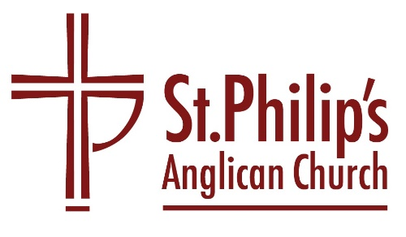
Holy Week Service of Compline
Officiate: The Rev’d Stuart Hallam

An Order for Night Prayers

Preparation
Officiant The Lord almighty grant us a quiet night and a perfect end.
All Amen.

Officiant Our help is in the name of the Lord
All who made heaven and earth.

A period of silence for reflection on the past day may follow.
The following or other suitable words of penitence may be used

All Most merciful God,
we confess to you,
before the whole company of heaven and one another,
that we have sinned in thought, word and deed
and in what we have failed to do.
Forgive us our sins,
heal us by your Spirit
and raise us to new life in Christ. Amen.

Officiant O God, make speed to save us.
All O Lord, make haste to help us.

All Glory to the Father and to the Son
and to the Holy Spirit;
as it was in the beginning is now
and shall be for ever. Amen.

The following or another suitable hymn may be sung

Before the ending of the day,
Creator of the world, we pray
That you, with steadfast love, would keep
Your watch around us while we sleep.
From evil dreams defend our sight,
From fears and terrors of the night;
Tread underfoot our deadly foe
That we no sinful thought may know.
O Father, that we ask be done
Through Jesus Christ, your only Son;
And Holy Spirit, by whose breath
Our souls are raised to life from death.

The Word of God
Psalmody

Psalm 134
1 Come, bless the Lord, all you servants of the Lord,*
you that by night stand in the house of the Lord.
2 Lift up your hands towards the sanctuary*
and bless the Lord.
3 The Lord who made heaven and earth*
give you blessing out of Zion.

At the end of the psalmody, the following is said or sung

All Glory to the Father and to the Son and to the Holy Spirit; as it was in the beginning is now and shall be for ever. Amen.

Scripture Reading
One of the following short lessons or another suitable passage is read

You, O Lord, are in the midst of us and we are called by your name; leave us not, O Lord our God. Jeremiah 14.9
(or)
Be sober, be vigilant, because your adversary the devil is prowling round like a roaring lion, seeking for someone to devour. Resist him, strong in the faith. 1 Peter 5.8, 9
(or)
The servants of the Lamb shall see the face of God, whose name will be on their foreheads. There will be no more night: they will not need the light of a lamp or the light of the sun, for God will be their light, and they will reign for ever and ever. Revelation 22.4, 5

The following responsory may be said

Officiant Into your hands, O Lord, I commend my spirit.
All Into your hands, O Lord, I commend my spirit.
Officiant For you have redeemed me, Lord God of truth.
All I commend my spirit.
Officiant Glory to the Father and to the Son and to the Holy Spirit.
All Into your hands, O Lord, I commend my spirit.

Gospel Canticle

The Nunc dimittis (The Song of Simeon) is sung

Sung Save us, O Lord, while waking,
and guard us while sleeping,
that awake we may watch with Christ
and asleep may rest in peace.

1 Now, Lord, you let your servant go in peace:*
your word has been fulfilled.
2 My own eyes have seen the salvation*
which you have prepared in the sight of every people;
3 A light to reveal you to the nations*
and the glory of your people Israel. Luke 2.29-32

All Glory to the Father and to the Son
and to the Holy Spirit;
as it was in the beginning is now
and shall be for ever. Amen.

Sung Save us, O Lord, while waking,
and guard us while sleeping,
that awake we may watch with Christ
and asleep may rest in peace.

Prayers
Silence may be kept.

Officiant Visit this place, O Lord, we pray, and drive far from it the snares of the enemy; may your holy angels dwell with us and guard us in peace, and may your blessing be always upon us; through Jesus Christ our Lord.
All Amen.

The Lord’s Prayer
All Our Father in heaven,
hallowed be your name,
your kingdom come,
your will be done,
on earth as in heaven.
Give us today our daily bread.
Forgive us our sins
as we forgive those who sin against us.
Lead us not into temptation
but deliver us from evil.
For the kingdom, the power,
and the glory are yours
now and for ever.
Amen.

The Conclusion

Officiant In peace we will lie down and sleep;
All for you alone, Lord, make us dwell in safety.
Officiant Abide with us, Lord Jesus,
All for the night is at hand and the day is now past.
Officiant As the night watch looks for the morning,
All so do we look for you, O Christ.

Officiant The Lord bless us and watch over us;
the Lord make his face shine upon us and be gracious to us;
the Lord look kindly on us and give us peace.
All Amen.

