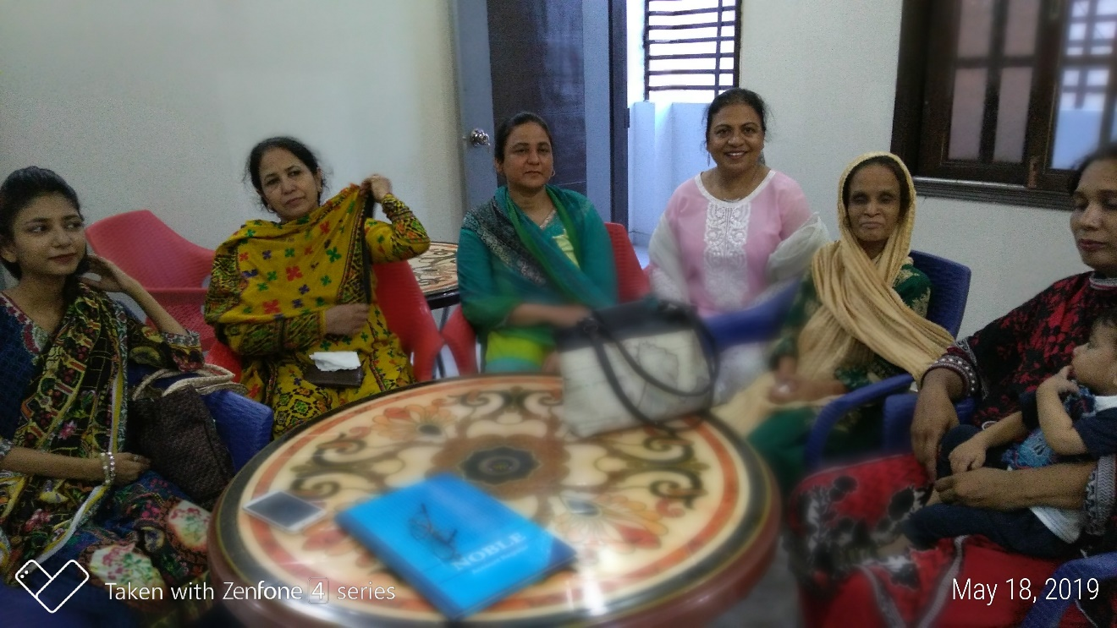

News Letter No.4
  - May 2019
  - Praise the Lord!

  - we have survived with the First heat wave in April temperature +40c.

  - For us finding a ministry center was a challenging as we tried different ways rented apt. rented church fellowship halls, etc.), but it didn’t work out.
  - finally, by the grace of God we got our own apt to run the ministry without any disturbance. though that apartment is in the Muslim’s surrounding but close enough to the marginalized and poor location.

Saturday women fellowship
We just take it as it comes for us. We find that Marginalized Ladies need our help learning the word of God in Urdu and Punjabi languages. Last Saturday about five ladies showed up and we hosted them and enjoyed teaching them worship songs and time of introducing each other and wonderful fellowship time. Coming Saturday some more ladies are joining us. We are excited that we could use our Ministry place for multiple purposes and for all age group. We are excited to meet individual; each has a very sad and hopeless stories. We encourage them that they could find hope in Jesus Christ only. Jamila has a good opportunity to share messages accordingly and pray for them in their heart languages.
Our Son Erwin Qazi came to visit us with his family from Thailand. We have enjoyed a lot.
For all those who are standing with us in Prayer and financial support. We deeply appreciate your commitment.
May Lord bless you and reward you. Please keep praying for our safety and security in our travelling in the streets.
Blessings,
Yours in Christ,
Nadeem and Jamila Qazi

