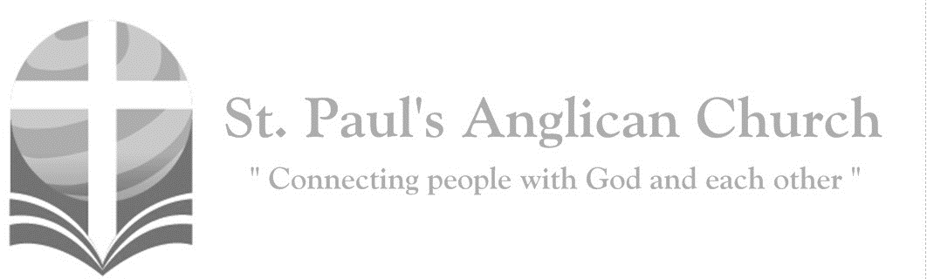
Thursday, April 8, 2020, 7:00PM – Maundy Thursday
Live Streamed Evening Prayer
A new commandment I give to you, that you love
one another as I have loved you. (John 13:34)

Light your candle if you are using one and take a moment of silence to pay attention to the presence of God.

Evening Prayer
Rev. Myron: O Lord, I call to you; come to me quickly;
All: Hear my voice when I cry to you.
Rev. Myron: Let my prayer be set forth in your sight as incense,
All: The lifting up of my hands as the evening sacrifice. Glory to the Father, and to the Son, and to the Holy Spirit: as it was in the beginning, is now, and will be for ever. Amen.

Maundy Thursday
Rev. Myron: This is the day that Christ the Lamb of God gave himself into the hands of those who would slay him. This is the day that Christ gathered with his disciples in the upper room. This is the day that Christ took a towel and washed the disciples’ feet, giving us an example that we should do to others as he has done to us. This is the day that Christ our God gave us this holy feast, that we who eat this bread and drink this cup may here proclaim his Holy Sacrifice and be partakers of his resurrection, and at the last day may reign with him in heaven.

The Invitatory
Rev. Myron: (O Gracious Light by Phos Hilaron) O gracious Light, pure brightness of the everliving Father in heaven, O Jesus Christ, holy and blessed! Now as we come to the setting of the sun, and our eyes behold the vesper light, we sing your praises, O God: Father, Son, and Holy Spirit. You are worthy at all times to be praised by happy voices, O Son of God, O Giver of life, and to be glorified through all the worlds.

The Psalm
Psalm 116:1-2, 12-19
I love the LORD, because he has heard my voice and my supplications. Because he inclined his ear to me, therefore I will call on him as long as I live. What shall I return to the LORD for all his bounty to me? I will lift up the cup of salvation and call on the name of the LORD, I will pay my vows to the LORD in the presence of all his people. Precious in the sight of the LORD is the death of his faithful ones. O LORD, I am your servant; I am your servant, the child of your serving girl. You have loosed my bonds. I will offer to you a thanksgiving sacrifice and call on the name of the LORD. I will pay my vows to the LORD in the presence of all his people, in the courts of the house of the LORD, in your midst, O Jerusalem. Praise the LORD!

The Gospel Reading
Rev. Myron: The Lord be with you.
People: And also with you.
Rev. Myron: The Holy Gospel of our Lord Jesus Christ according to St. John.
People: Glory to you, Lord Jesus Christ.
Gospel Reading: John 13:1-17, 31b-35
Now before the festival of the Passover, Jesus knew that his hour had come to depart from this world and go to the Father. Having loved his own who were in the world, he loved them to the end. The devil had already put it into the heart of Judas son of Simon Iscariot to betray him. And during supper Jesus, knowing that the Father had given all things into his hands, and that he had come from God and was going to God, got up from the table, took off his outer robe, and tied a towel around himself. Then he poured water into a basin and began to wash the disciples' feet and to wipe them with the towel that was tied around him. He came to Simon Peter, who said to him, "Lord, are you going to wash my feet?" Jesus answered, "You do not know now what I am doing, but later you will understand." Peter said to him, "You will never wash my feet." Jesus answered, "Unless I wash you, you have no share with me." Simon Peter said to him, "Lord, not my feet only but also my hands and my head!" Jesus said to him, "One who has bathed does not need to wash, except for the feet, but is entirely clean. And you are clean, though not all of you." For he knew who was to betray him; for this reason he said, "Not all of you are clean." After he had washed their feet, had put on his robe, and had returned to the table, he said to them, "Do you know what I have done to you? You call me Teacher and Lord--and you are right, for that is what I am. So if I, your Lord and Teacher, have washed your feet, you also ought to wash one another's feet. For I have set you an example, that you also should do as I have done to you. Very truly, I tell you, servants are not greater than their master, nor are messengers greater than the one who sent them. If you know these things, you are blessed if you do them.
When he had gone out, Jesus said, "Now the Son of Man has been glorified, and God has been glorified in him. If God has been glorified in him, God will also glorify him in himself and will glorify him at once. Little children, I am with you only a little longer. You will look for me; and as I said to the Jews so now I say to you, 'Where I am going, you cannot come.' I give you a new commandment, that you love one another. Just as I have loved you, you also should love one another. By this everyone will know that you are my disciples, if you have love for one another."
Rev. Myron: The Gospel of Christ.
People: Praise to you, Lord Jesus Christ.

Affirmation of Faith – Hear, O Israel
All: Hear, O Israel, the Lord our God, the Lord is one. Love the Lord your God with all your heart, with all your soul, with all your mind, and with all your strength. This is the first and the great commandment. The second is like it: Love your neighbour as yourself. There is no commandment greater than these.

Prayers of the People
Rev. Myron: In peace let us pray to the Lord, saying, “We pray to you, Lord.”
That this evening may be holy, good, and peaceful,
All: We pray to you, Lord.
Rev. Myron: That the work we have done this day and the people we have met may bring us closer to you,
All: We pray to you, Lord.
Rev. Myron: That we may be forgiven our sins and offences,
All: We pray to you, Lord.
Rev. Myron: That we may hear and respond to your call to peace and justice,
All: We pray to you, Lord.
Rev. Myron: That you will sustain the faith and hope of the weary, the lonely, and the oppressed,
All: We pray to you, Lord.
Rev. Myron: That you will strengthen us in your service, and fill our hearts with longing for your kingdom,
All: We pray to you, Lord.

The Collect
Rev. Myron: O God, you Son Jesus Christ has left to us this meal of bread and wine in which we share his body and his blood. May we who celebrate this sign of his great love show in our lives the fruits of his redemption; through Jesus Christ our Lord, who lives and reigns with you and the Holy Spirit, one God, now and for ever.
All: Amen.

The Lord’s Prayer
Rev. Myron: And now, as our Saviour Christ has taught us, we are bold to say,
All: Our Father, who art in heaven, hallowed be thy name, thy kingdom come, thy will be done, on earth as it is in heaven. Give us this day our daily bread. And forgive us our trespasses, as we forgive those who trespass against us. And lead us not into temptation, but deliver us from evil. For thine is the kingdom, the power, and the glory, for ever and ever. Amen.

As the candle continues to burn, please spend some time watching with Jesus and remembering his prayer in the garden.

