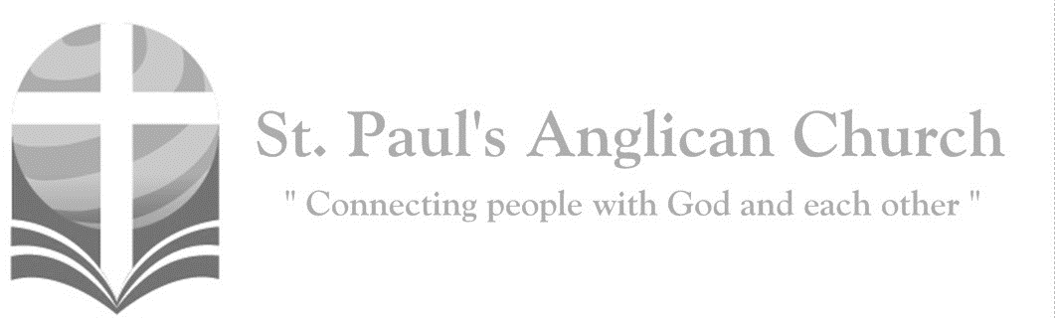
Friday, April 10, 2020: Good Friday

Christ became obedient unto death, even death on a cross. Therefore, God has highly exalted him and bestowed on him
the name which is above every name. (Philippians 2:8-9)

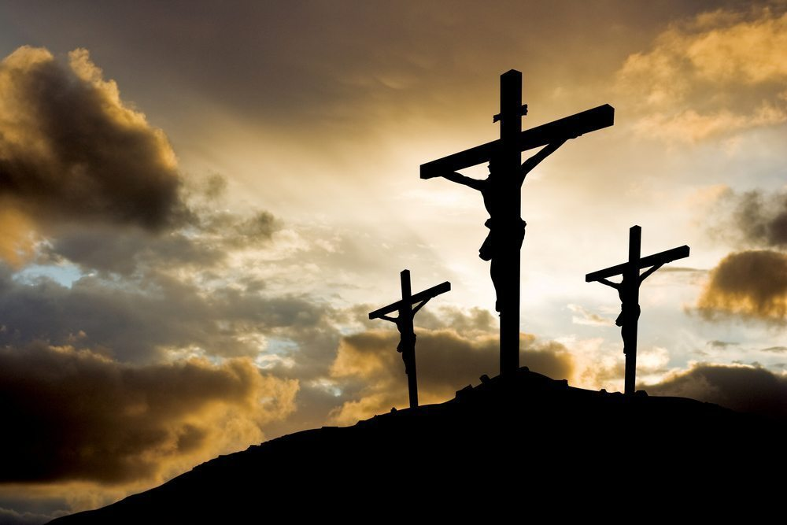

Opening Song: Lead Me to the Cross

Saviour I come, quiet my soul
Remember redemption's hill
Where Your blood was spilled
For my ransom

(Pre-Chorus) Everything I once held dear
I count it all as loss

(Chorus) Lead me to the cross
Where Your love poured out
Bring me to my knees
Lord I lay me down
Rid me of myself
I belong to You
Oh lead me, lead me to the cross

You were as I
Tempted and tried, human
The word became flesh
Bore my sin in death
Now You're risen
(To Pre-Chorus)

The Ministry of the Word
Rev. Myron: All we like sheep have gone astray; we have turned every one to his own way,
All: And the Lord has laid on him the iniquity of us all.
Rev. Myron: Christ the Lord became obedient unto death,
All: Even death on a cross.
Rev. Myron: Almighty God,
All: our heavenly Father, we have sinned in thought and word and deed; we have not loved you with our whole heart; we have not loved our neighbours as ourselves. We pray you of your mercy, forgive us all that is past, and grant that we may serve you in newness of life to the glory of your name. Amen.

Rev. Myron: The Lord be with you.
People: And also with you.
Rev. Myron: Let us pray.
Almighty God, look graciously, we pray, on this your family, for whom our Lord Jesus Christ was willing to be betrayed and given into the hands of sinners, and to suffer death upon the cross; who now lives and reigns with you and the Holy Spirit, one God, for ever and ever.

The Reading of Scripture
First Reading: Isaiah 52:13-53:12
See, my servant shall prosper; he shall be exalted and lifted up, and shall be very high. Just as there were many who were astonished at him--so marred was his appearance, beyond human semblance, and his form beyond that of mortals-so he shall startle many nations; kings shall shut their mouths because of him; for that which had not been told them they shall see, and that which they had not heard they shall contemplate. Who has believed what we have heard? And to whom has the arm of the LORD been revealed? For he grew up before him like a young plant, and like a root out of dry ground; he had no form or majesty that we should look at him, nothing in his appearance that we should desire him. He was despised and rejected by others; a man of suffering and acquainted with infirmity; and as one from whom others hide their faces he was despised, and we held him of no account. Surely he has borne our infirmities and carried our diseases; yet we accounted him stricken, struck down by God, and afflicted. But he was wounded for our transgressions, crushed for our iniquities; upon him was the punishment that made us whole, and by his bruises we are healed. All we like sheep have gone astray; we have all turned to our own way, and the LORD has laid on him the iniquity of us all. He was oppressed, and he was afflicted, yet he did not open his mouth; like a lamb that is led to the slaughter, and like a sheep that before its shearers is silent, so he did not open his mouth. By a perversion of justice he was taken away. Who could have imagined his future? For he was cut off from the land of the living, stricken for the transgression of my people. They made his grave with the wicked and his tomb with the rich, although he had done no violence, and there was no deceit in his mouth. Yet it was the will of the LORD to crush him with pain. When you make his life an offering for sin, he shall see his offspring, and shall prolong his days; through him the will of the LORD shall prosper. Out of his anguish he shall see light; he shall find satisfaction through his knowledge. The righteous one, my servant, shall make many righteous, and he shall bear their iniquities. Therefore I will allot him a portion with the great, and he shall divide the spoil with the strong; because he poured out himself to death, and was numbered with the transgressors; yet he bore the sin of many, and made intercession for the transgressors.
Reader: The Word of the Lord.
People: Thanks be to God.

Canticle: Psalm 22
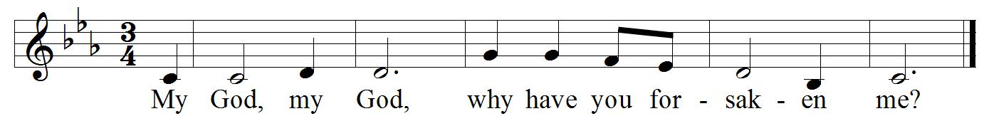
Refrain:

My God, my God, why have you forsaken me? And are so far from my cry and from the words of my distress? O my God, I cry in the daytime, but you do not answer; by night as well, but I find no rest. Refrain
Yet you are the Holy One, enthroned upon the praises of Israel. Our forefathers put their trust in you; they trusted, and you delivered them. Refrain
They cried out to you and were delivered; they trusted in you and were not put to shame. But as for me, I am a worm and no man, scorned by all and despised by the people. Refrain
All who see me laugh me to scorn; they curl their lips and wag their heads, saying, "He trusted in the Lord; let him deliver him; let him rescue him, if he delights in him." Ref.
Yet you are he who took me out of the womb, and kept me safe upon my mother’s breast. I have been entrusted to you ever since I was born; you were my God when I was still in my mother’s womb. Refrain
Be not far from me, for trouble is near, and there is none to help. Many young bulls encircle me; strong bulls of Bashan surround me. They open wide their jaws at me, like a ravening and a roaring lion. Refrain
I am poured out like water; all my bones are out of joint; my heart within my breast is melting wax. My mouth is dried out like a pot-sherd; my tongue sticks to the roof of my mouth; and you have laid me in the dust of the grave. Refrain

Second Reading: Hebrews 10:16-25
"This is the covenant that I will make with them after those days, says the Lord: I will put my laws in their hearts, and I will write them on their minds," he also adds, "I will remember their sins and their lawless deeds no more." Where there is forgiveness of these, there is no longer any offering for sin. Therefore, my friends, since we have confidence to enter the sanctuary by the blood of Jesus, by the new and living way that he opened for us through the curtain (that is, through his flesh), and since we have a great priest over the house of God, let us approach with a true heart in full assurance of faith, with our hearts sprinkled clean from an evil conscience and our bodies washed with pure water. Let us hold fast to the confession of our hope without wavering, for he who has promised is faithful. And let us consider how to provoke one another to love and good deeds, not neglecting to meet together, as is the habit of some, but encouraging one another, and all the more as you see the Day approaching.
Reader: The Word of the Lord.
People: Thanks be to God.

The Gospel Reading
Rev. Myron: The Passion of our Lord Jesus Christ according to St. John.
Gospel Reading: John 18:1 – 19:42
After Jesus had spoken these words, he went out with his disciples across the Kidron valley to a place where there was a garden, which he and his disciples entered. Now Judas, who betrayed him, also knew the place, because Jesus often met there with his disciples. So Judas brought a detachment of soldiers together with police from the chief priests and the Pharisees, and they came there with lanterns and torches and weapons. Then Jesus, knowing all that was to happen to him, came forward and asked them, "Whom are you looking for?" They answered, "Jesus of Nazareth." Jesus replied, "I am he." Judas, who betrayed him, was standing with them. When Jesus said to them, "I am he," they stepped back and fell to the ground. Again he asked them, "Whom are you looking for?" And they said, "Jesus of Nazareth." Jesus answered, "I told you that I am he. So if you are looking for me, let these men go." This was to fulfill the word that he had spoken, "I did not lose a single one of those whom you gave me." Then Simon Peter, who had a sword, drew it, struck the high priest's slave, and cut off his right ear. The slave's name was Malchus. Jesus said to Peter, "Put your sword back into its sheath. Am I not to drink the cup that the Father has given me?" So the soldiers, their officer, and the Jewish police arrested Jesus and bound him.

First they took him to Annas, who was the father-in-law of Caiaphas, the high priest that year. Caiaphas was the one who had advised the Jews that it was better to have one person die for the people. Simon Peter and another disciple followed Jesus. Since that disciple was known to the high priest, he went with Jesus into the courtyard of the high priest, but Peter was standing outside at the gate. So the other disciple, who was known to the high priest, went out, spoke to the woman who guarded the gate, and brought Peter in. The woman said to Peter, "You are not also one of this man's disciples, are you?" He said, "I am not." Now the slaves and the police had made a charcoal fire because it was cold, and they were standing around it and warming themselves. Peter also was standing with them and warming himself. Then the high priest questioned Jesus about his disciples and about his teaching. Jesus answered, "I have spoken openly to the world; I have always taught in synagogues and in the temple, where all the Jews come together. I have said nothing in secret. Why do you ask me? Ask those who heard what I said to them; they know what I said." When he had said this, one of the police standing nearby struck Jesus on the face, saying, "Is that how you answer the high priest?" Jesus answered, "If I have spoken wrongly, testify to the wrong. But if I have spoken rightly, why do you strike me?" Then Annas sent him bound to Caiaphas the high priest. Now Simon Peter was standing and warming himself. They asked him, "You are not also one of his disciples, are you?" He denied it and said, "I am not." One of the slaves of the high priest, a relative of the man whose ear Peter had cut off, asked, "Did I not see you in the garden with him?" Again Peter denied it, and at that moment the cock crowed.

Then they took Jesus from Caiaphas to Pilate's headquarters. It was early in the morning. They themselves did not enter the headquarters, so as to avoid ritual defilement and to be able to eat the Passover. So Pilate went out to them and said, "What accusation do you bring against this man?" They answered, "If this man were not a criminal, we would not have handed him over to you." Pilate said to them, "Take him yourselves and judge him according to your law." The Jews replied, "We are not permitted to put anyone to death." (This was to fulfill what Jesus had said when he indicated the kind of death he was to die.) Then Pilate entered the headquarters again, summoned Jesus, and asked him, "Are you the King of the Jews?" Jesus answered, "Do you ask this on your own, or did others tell you about me?" Pilate replied, "I am not a Jew, am I? Your own nation and the chief priests have handed you over to me. What have you done?" Jesus answered, "My kingdom is not from this world. If my kingdom were from this world, my followers would be fighting to keep me from being handed over to the Jews. But as it is, my kingdom is not from here." Pilate asked him, "So you are a king?" Jesus answered, "You say that I am a king. For this I was born, and for this I came into the world, to testify to the truth. Everyone who belongs to the truth listens to my voice." Pilate asked him, "What is truth?" After he had said this, he went out to the Jews again and told them, "I find no case against him. But you have a custom that I release someone for you at the Passover. Do you want me to release for you the King of the Jews?" They shouted in reply, "Not this man, but Barabbas!" Now Barabbas was a bandit. Then Pilate took Jesus and had him flogged. And the soldiers wove a crown of thorns and put it on his head, and they dressed him in a purple robe. They kept coming up to him, saying, "Hail, King of the Jews!" and striking him on the face. Pilate went out again and said to them, "Look, I am bringing him out to you to let you know that I find no case against him." So Jesus came out, wearing the crown of thorns and the purple robe. Pilate said to them, "Here is the man!" When the chief priests and the police saw him, they shouted, "Crucify him! Crucify him!" Pilate said to them, "Take him yourselves and crucify him; I find no case against him." The Jews answered him, "We have a law, and according to that law he ought to die because he has claimed to be the Son of God." Now when Pilate heard this, he was more afraid than ever. He entered his headquarters again and asked Jesus, "Where are you from?" But Jesus gave him no answer. Pilate therefore said to him, "Do you refuse to speak to me? Do you not know that I have power to release you, and power to crucify you?" Jesus answered him, "You would have no power over me unless it had been given you from above; therefore the one who handed me over to you is guilty of a greater sin." From then on Pilate tried to release him, but the Jews cried out, "If you release this man, you are no friend of the emperor. Everyone who claims to be a king sets himself against the emperor." When Pilate heard these words, he brought Jesus outside and sat on the judge's bench at a place called The Stone Pavement, or in Hebrew Gabbatha. Now it was the day of Preparation for the Passover; and it was about noon. He said to the Jews, "Here is your King!" They cried out, "Away with him! Away with him! Crucify him!" Pilate asked them, "Shall I crucify your King?" The chief priests answered, "We have no king but the emperor." Then he handed him over to them to be crucified.

So they took Jesus; and carrying the cross by himself, he went out to what is called The Place of the Skull, which in Hebrew is called Golgotha. There they crucified him, and with him two others, one on either side, with Jesus between them. Pilate also had an inscription written and put on the cross. It read, "Jesus of Nazareth, the King of the Jews." Many of the Jews read this inscription, because the place where Jesus was crucified was near the city; and it was written in Hebrew, in Latin, and in Greek. Then the chief priests of the Jews said to Pilate, "Do not write, 'The King of the Jews,' but, 'This man said, I am King of the Jews.'" Pilate answered, "What I have written I have written." When the soldiers had crucified Jesus, they took his clothes and divided them into four parts, one for each soldier. They also took his tunic; now the tunic was seamless, woven in one piece from the top. So they said to one another, "Let us not tear it, but cast lots for it to see who will get it." This was to fulfill what the scripture says, "They divided my clothes among themselves, and for my clothing they cast lots." And that is what the soldiers did. Meanwhile, standing near the cross of Jesus were his mother, and his mother's sister, Mary the wife of Clopas, and Mary Magdalene. When Jesus saw his mother and the disciple whom he loved standing beside her, he said to his mother, "Woman, here is your son." Then he said to the disciple, "Here is your mother." And from that hour the disciple took her into his own home. After this, when Jesus knew that all was now finished, he said (in order to fulfill the scripture), "I am thirsty." A jar full of sour wine was standing there. So they put a sponge full of the wine on a branch of hyssop and held it to his mouth. When Jesus had received the wine, he said, "It is finished." Then he bowed his head and gave up his spirit. Since it was the day of Preparation, the Jews did not want the bodies left on the cross during the sabbath, especially because that sabbath was a day of great solemnity. So they asked Pilate to have the legs of the crucified men broken and the bodies removed. Then the soldiers came and broke the legs of the first and of the other who had been crucified with him. But when they came to Jesus and saw that he was already dead, they did not break his legs. Instead, one of the soldiers pierced his side with a spear, and at once blood and water came out. (He who saw this has testified so that you also may believe. His testimony is true, and he knows that he tells the truth.) These things occurred so that the scripture might be fulfilled, "None of his bones shall be broken." And again another passage of scripture says, "They will look on the one whom they have pierced." After these things, Joseph of Arimathea, who was a disciple of Jesus, though a secret one because of his fear of the Jews, asked Pilate to let him take away the body of Jesus. Pilate gave him permission; so he came and removed his body. Nicodemus, who had at first come to Jesus by night, also came, bringing a mixture of myrrh and aloes, weighing about a hundred pounds. They took the body of Jesus and wrapped it with the spices in linen cloths, according to the burial custom of the Jews. Now there was a garden in the place where he was crucified, and in the garden there was a new tomb in which no one had ever been laid. And so, because it was the Jewish day of Preparation, and the tomb was nearby, they laid Jesus there.

Message from Rev. Myron

Song: What Wondrous Love Is This

What wondrous love is this
O my soul, O my soul
What wondrous love is this, O my soul
What wondrous love is this
That caused the Lord of bliss
To bear the dreadful curse
For my soul, for my soul
To bear the dreadful curse for my soul

To God and to the Lamb
I will sing, I will sing
To God and to the Lamb I will sing
To God and to the Lamb
Who is the Great I Am
While millions join the theme
I will sing, I will sing
(continued on next page)

While millions join the theme
I will sing
And when from death I'm free
I'll sing on, I'll sing on
And when from death I'm free
I'll sing on
And when from death I'm free
I'll sing and joyful be
And through eternity
I'll sing on, I'll sing on
And through eternity I'll sing on

The Solemn Intercession
Rev. Myron: Dear people of God, our heavenly Father sent his Son into the world, not to condemn the world, but that the world through him might be saved, that all who believe in him might be delivered from the power of sin and death and become heirs with him of eternal life. Let us pray for the one holy catholic and apostolic Church of Christ throughout the world: for its unity in witness and service, for all bishops and other ministers and the people whom they serve, for Jane our bishop, and all the people of this diocese, for all Christians in this community, for those about to be baptized, that the Lord will confirm his Church in faith, increase it in love, and preserve it in peace.
Silence

Rev. Myron: Almighty and everlasting God, by your Spirit the whole body of your faithful people is governed and sanctified. Receive our supplications and prayers which we offer before you for all members of your holy Church, that in our vocation and ministry we may truly and devoutly serve you; through our Lord and Saviour Jesus Christ.
All: Amen.

Rev. Myron: Let us pray for all nations and peoples of the earth, and for those in authority among them: for Elizabeth our Queen and all the Royal Family, for Justin the Prime Minister and for the government of this country, for Jason the premier of this province and the members of the legislature, for Don the mayor of this municipality and those who serve with him on the Edmonton city council, for all who serve the common good, that by God’s help they may seek justice and truth, and live in peace and concord.
Silence
Rev. Myron: Almighty God, kindle, we pray, in every heart the true love of peace, and guide with your wisdom those who take counsel for the nations of the earth, that justice and peace may increase, until the earth is filled with the knowledge of your love; through Jesus Christ our Lord.
All: Amen.

Rev. Myron: Let us pray for all who suffer and are afflicted in body or in mind: for the hungry and homeless, the destitute and the oppressed, and all who suffer persecution or prejudice, for the sick, the wounded, and the handicapped, for those in loneliness, fear, and anguish, for those who face temptation, doubt, and despair, for the sorrowful and bereaved, for prisoners and captives and those in mortal danger, that God in his mercy will comfort and relieve them, and grant them the knowledge of his love, and stir up in us the will and patience to minister to their needs.
Silence

Rev. Myron: Gracious God, the comfort of all who sorrow, the strength of all who suffer, hear the cry of those in misery and need. In their afflictions show them your mercy, and give us, we pray, the strength to serve them, for the sake of him who suffered for us, your Son Jesus Christ our Lord.
All: Amen.

Rev. Myron: Let us pray for all who have not received the gospel of Christ: for all who have not heard the words of salvation, for all who have lost their faith, for all whose sin has made them indifferent to Christ, for all who actively oppose Christ by word or deed, for all who are enemies of the cross of Christ, and persecutors of his disciples, for all who in the name of Christ have persecuted others, that God will open their hearts to the truth, and lead them to faith and obedience.
Silence

Rev. Myron: Merciful God, creator of the peoples of the earth and lover of souls, have compassion on all who do not know you as you are revealed in your Son Jesus Christ. Let your gospel be preached with grace and power to those who have not heard it, turn the hearts of those who resist it, and bring home to your fold those who have gone astray; that there may be one flock under one shepherd, Jesus Christ our Lord.
All: Amen.

Rev. Myron: Let us commit ourselves to God, and pray for the grace of a holy life, that with all who have departed this life and have died in the peace of Christ, and those whose faith is known to God alone, we may be accounted worthy to enter into the fullness of the joy of our Lord, and receive the crown of life in the day of resurrection.
Silence

Rev. Myron: O God of unchangeable power and eternal light, look favourably on your whole Church, that wonderful and sacred mystery. By the effectual working of your providence, carry out in tranquillity the plan of salvation. Let the whole world see and know that things which were cast down are being raised up, and things which had grown old are being made new, and that all things are being brought to their perfection by him through whom all things were made, your Son Jesus Christ our Lord; who lives and reigns with you, in the unity of the Holy Spirit, one God, for ever and ever.
All: Amen.

Meditation on the Cross of Jesus
Rev. Myron: This is the wood of the cross, on which hung the Saviour of the world.
All: Come let us worship.

All (sung): O sacred Head now wounded with grief and shame weighed down
Now scornfully surrounded with thorns Thine only crown
O sacred Head what glory, what bliss till now was Thine
Yet though despised and gory, I joy to call Thee mine

Jodi: What Thou my Lord hast suffered was all for sinners' gain
Mine, mine was the transgression but Thine the deadly pain
Lo, here I fall my Saviour, 'Tis I deserve Thy place
Look on me with Thy favour, vouchsafe to me Thy grace
Is it nothing to you, all you who pass by? Look and see if there is any sorrow like my sorrow which was brought upon me, which the Lord inflicted on the day of his fierce anger.
All: Holy God, holy and mighty, holy and immortal one, have mercy upon us.

RJ: Men mock and taunt and jeer Thee, Thou noble countenance
Though mighty worlds shall fear Thee and flee before Thy glance
How art Thou pale with anguish, with sore abuse and scorn
How doth Thy visage languish that once was bright as morn
O my people, O my Church, what have I done to you, or in what have I offended you? Testify against me. I led you forth from the land of Egypt, and delivered you by the waters of baptism, but you have prepared a cross for your Saviour.
All: Holy God, holy and mighty, holy and immortal one, have mercy upon us.

Jodi: Now from Thy cheeks has vanished their color once so fair
From Thy red lips is banished the splendor that was there
Grim death with cruel rigour hath robbed Thee of Thy life
Thus Thou hast lost Thy vigour, Thy strength in this sad strife
I led you through the desert forty years, and fed you with manna. I brought you through tribulation and penitence, and gave you my body, the bread of heaven, but you have prepared a cross for your Saviour.
All: Holy God, holy and mighty, holy and immortal one, have mercy upon us.

RJ: My burden in Thy Passion, Lord Thou hast borne for me
For it was my transgression which brought this woe on Thee
I cast me down before Thee, wrath were my rightful lot
Have mercy I implore Thee, Redeemer spurn me not
What more could I have done for you that I have not done? I planted you, my chosen and fairest vineyard, I made you the branches of my vine; but when I was thirsty, you gave me vinegar to drink, and pierced with a spear the side of your Saviour.
All: Holy God, holy and mighty, holy and immortal one, have mercy upon us.
Jodi: What language shall I borrow to thank Thee dearest friend
For this Thy dying sorrow, Thy pity without end
O make me Thine forever and should I fainting be
Lord let me never, never outlive my love to Thee
I went before you in a pillar of cloud, and you have led me to the judgement hall of Pilate. I scourged your enemies and brought you to a land of freedom, but you have scourged, mocked, and beaten me. I gave you the water of salvation from the rock, but you have given me gall and left me to thirst.
All: Holy God, holy and mighty, holy and immortal one, have mercy upon us.

RJ: My Shepherd now receive me, my guardian own me Thine
Great blessings Thou didst give me, O source of gifts divine
Thy lips have often fed me with words of truth and love
Thy Spirit oft hath led me to heavenly joys above
I gave you a royal sceptre, and bestowed the keys to the kingdom, but you have given me a crown of thorns. I raised you on high with great power, but you have hanged me on the cross.
All: Holy God, holy and mighty, holy and immortal one, have mercy upon us.

Jodi: Here I will stand beside Thee, from Thee I will not part
O Saviour do not chide me when breaks Thy loving heart
When soul and body languish in death's cold cruel grasp
Then in Thy deepest anguish Thee in mine arms I'll clasp
My peace I gave, which the world cannot give, and washed your feet as a sign of my love, but you draw the sword to strike in my name, and seek high places in my kingdom. I offered you my body and blood, but you scatter and deny and abandon me.
All: Holy God, holy and mighty, holy and immortal one, have mercy upon us.

RJ: The joy can never be spoken, above all joys beside
When in Thy body broken I thus with safety hide
O Lord of life desiring Thy glory now to see
Beside Thy cross expiring, I'd breathe my soul to Thee
I sent the Spirit of truth to guide you, and you close your hearts to the Counsellor. I pray that all may be as one in the Father and me, but you continue to quarrel and divide. I call you to go and bring forth fruit, but you cast lots for my clothing.
All: Holy God, holy and mighty, holy and immortal one, have mercy upon us.

Jodi: My Saviour be Thou near me when death is at my door
Then let Thy presence cheer me, forsake me nevermore
When soul and body languish Oh leave me not alone
But take away mine anguish by virtue of Thine own
I grafted you into the tree of my chosen Israel, and you turned on them with persecution and mass murder. I made you joint heirs with them of my covenants, but you made them scapegoats for your own guilt.
All: Holy God, holy and mighty, holy and immortal one, have mercy upon us.

RJ: Be Thou my consolation, my shield when I must die
Remind me of Thy passion when my last hour draws nigh
Mine eyes shall then behold Thee, upon Thy cross shall dwell
My heart by faith enfolds Thee, who dieth thus dies well
I came to you as the least of your brothers and sisters; I was hungry and you gave me no food, I was thirsty and you gave me no drink, I was a stranger and you did not welcome me, naked and you did not clothe me, sick and in prison and you did not visit me.
All: Holy God, holy and mighty, holy and immortal one, have mercy upon us.

All (sung): O sacred Head now wounded with grief and shame weighed down
Now scornfully surrounded with thorns Thine only crown
O sacred Head what glory, what bliss till now was Thine
Yet though despised and gory, I joy to call Thee mine

The Lord’s Prayer
Rev. Myron: And now, as our Saviour Christ has taught us, we are bold to say,
All: Our Father, who art in heaven, hallowed be thy name, thy kingdom come, thy will be done, on earth as it is in heaven. Give us this day our daily bread. And forgive us our trespasses, as we forgive those who trespass against us. And lead us not into temptation, but deliver us from evil. For thine is the kingdom, the power, and the glory, for ever and ever. Amen.

Closing Song: Jesus, Keep Me Near the Cross

Jesus keep me near the cross
There a precious fountain
Free to all a healing stream
Flows from Calv'ry's mountain

(Chorus) In the cross, in the cross
Be my glory ever
Till my raptured soul shall find
Rest beyond the river

Near the cross a trembling soul
Love and mercy found me
There the Bright and Morning Star
Sheds its beams around me (To Chorus)

Near the cross O Lamb of God
Bring its scenes before me
Help me walk from day to day
With its shadows o'er me (To Chorus)

Near the cross I'll watch and wait
Hoping trusting ever
Till I reach the golden strand
Just beyond the river (To Chorus)

The Closing Prayer
Rev. Myron: Send down your abundant blessing, Lord, upon your people who have devoutly recalled the death of your Son in the sure and certain hope of the resurrection. Grant them pardon; bring them comfort. May their faith grow stronger and their eternal salvation be assured. We ask this through Christ our Lord.
All: Amen.
Holy Saturday Zoom Video Service – April 11 at 7:30PM
ANTHROPOS EPIPHANOS EMERGING FROM THE CAVE: A Holy Saturday Vigil where we wait for Christ's resurrection... and also for our own.
Online sign-in: 7:00-7:15PM. Tea-steeping: 7:15-7:30. Service: 7:30-9:00.
Pre-registration is required. To Register: Contact Jim Robertson at interfaceworship@gmail.com.

Easter Sunday – Live Stream at 10:00AM, April 12
Please join us virtually on Easter Sunday! Our Easter Sunday service will be Live Streamed on YouTube starting at 10:00AM. To find our Live Stream, visit our YouTube channel (search “St. Paul's Anglican – Edmonton” to find us on YouTube). If you are unable to stream the service at 10:00AM, the service will be available to watch anytime following the service itself. We hope you can join us in this way!!

St. Paul’s Anglican Church
10127 145 Street, Edmonton T5N 2X6
Phone: (780) 455-0771; Email: office@stpauls-anglican.ca
Website: www.stpauls-anglican.ca
Office Hours:
Monday-Thursday: 9:00AM-12:00PM
Closed: Fri/Sat/Sun and Stat Holidays
St. Paul’s Vestry:
Peter Jackson, Rector’s Warden
Margot Byer, People’s Warden
David Heritage, Treasurer
Barb Dixon, Vestry Member
John Green, Vestry Member
Deanna Kalles, Vestry Member
David Parker, Vestry Member
Carol Rudat, Vestry Member

facebook.com/stpachurchedmonton
@StEdmonton
For Care/Concern Team
or other prayer requests, email:
office@stpauls-anglican.ca
For urgent prayer requests call
the church office: (780) 455-0771
For pastoral emergencies call:
(587) 334-2130

St. Paul’s Staff:
Rector: The Rev. Myron B. Penner
Office Administrator: RJ Chambers
Youth Leader: Victoria Eeles

