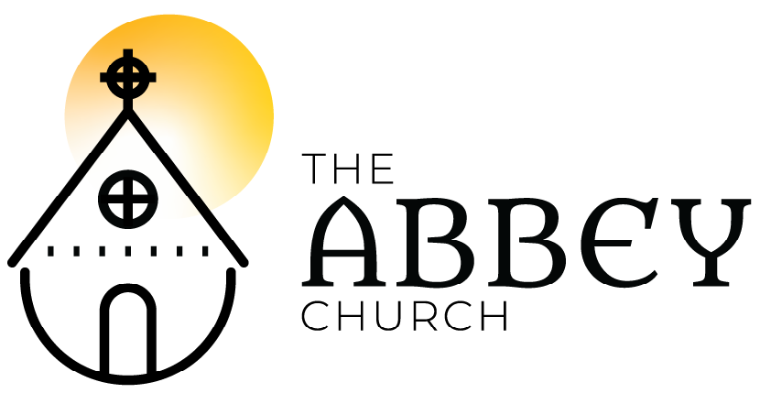
Easter Sunday – April 12, 2020

Please submit your prayer requests in the chat or email to admin@emmauscommunity.ca to be included in prayers of people.

Welcome
Land Acknowledgment - Murray Pruden
Regional Indigenous Minister
Pacific Mountain Region United Church of Canada)

Song: Who Will Roll Away The Stone?
Early in the morning- the sun already risen
Three women came bearing spices,
the Lord's body to anoint.
Standing outside the tomb,
they asked each other saying
"Who will roll away the stone?“ (x4)

Looking up they realized
the stone had been removed
And to their amazement,
a young man sat before them
"Do not be afraid," he said,
“for Jesus the Nazarene
He who has been crucified,
here you will not find
He has risen from the dead. (x4)
You’ll find Him on the road
You’ll find Him at your table (X4)
Tom Wuest / Brass Trumpet Publishing 2008 / CCLI

Reading: Mark 16:1-6a - Meagan

Opening Words - Meagan
The darkness has passed. The promise of God from before all time is fulfilled. The love of God has redeemed us. Sing and shout all of you! Rejoice with the heavens! Dance with the stars! Leap with all creation! Praise and bless the Lord our God, for Christ Jesus, who died our death, and in rising has restored all of creation!

Christ is risen!
Christ is risen indeed, Alleluia!
This is the day the Lord has made.
Let us rejoice and be glad in it! Amen, Alleluia!
Ringing Our Bells!!!!

Song: Jesus Christ is Risen Today
Jesus Christ is risen today, Alleluia!
our triumphant holy day, Alleluia!
Who did once upon the cross, Alleluia!
Suffer to redeem our loss, Alleluia!

Hymns of praise then let us sing, Alleluia!
unto Christ our heavenly king, Alleluia!
Who endured the cross and grave, Alleluia!
Sinners to redeem and save, Alleluia!

But the pains which he endured, Alleluia!
Our salvation have procured, Alleluia!
Now above the sky he’s king, Alleluia!
Where the angels ever sing, Alleluia!
Sing we to our God above, Alleluia!
Praise eternal as his love, Alleluia!
Praise him, all you heavenly host, Alleluia!
Father, Son, and Holy Ghost, Alleluia!
Public Domain / 14th century Latin / Charles Wesley / Monk

Kids time: Unboxing our Alleluias!

Poem: Gardener by Loren Wilkinson
and Prayer of approach - Melanie Ihmels

Reading: Jeremiah 31:1-6 - Kirsten McMenamie

Song: Gospel Acclamation
Alleluia! Alleluia! Alleluia! (x4)
Reading: Matthew 28:1-10
– The Rev. Matt Humphrey, EC
Alleluia! Alleluia! Alleluia! (x2)
Mass of Restoration / Josh Blakesley / OCP / OneLicense

Sermon: The Rev. Meagan Crosby-Shearer, EC
Silence

The Creed
I believe in God the Maker almighty,
Creator of heaven and earth; I believe in Jesus Christ, God’s only Son, our Lord. He was conceived by the power of the Holy Spirit and born of the Virgin Mary.

He suffered under Pontius Pilate, was crucified, died and was buried. He descended to the dead on the third day he rose again. He ascended into heav’n and is seated at the right hand of the Maker. He will come again to judge the living and the dead.

I believe in the Holy Spirit, the holy catholic Church, the communion of saints, the forgiveness of sins, +the resurrection of the body, and the life everlasting. Amen.
Ryan Flanigan, alt., © 2017, Common Hymnal, CCLI

Prayers of the People - Roxy Humphrey, EC

Song: Thine be the Glory
Thine be the glory, risen conquering Son;
Endless is the victory over death you won.

Angels robed in splendour rolled the stone away,
Kept the folded graveclothes where your body lay.
Thine be the glory, risen conquering Son;
Endless is the victory over death you won.

See! Jesus meets us, risen from the tomb;
Lovingly he greets us, scatters fear and gloom.
Thine be the glory, risen conquering Son;
Endless is the victory over death you won.

No more we doubt you, glorious Prince of life:
What is life without you? Aid us in our strife;
Make us more than conquerers through your deathless love; bring us safe through Jordan to your home above.

Thine be the glory, risen conquering Son;
Endless is the victory over death you won.
Edmond Louis Budry/ Richard Birch Hoyle /
World Student Christian Federation / OneLicense

The Holy Eucharist:
The Lord be with you! And also with you
Lift up your hearts! We lift them to the Lord
Let us give thanks to the Lord our God.
It is right to give God thanks and praise…

Proper preface from the Book of Common
(occasionally: Glory to You forever and ever!)

The Sanctus:
Holy, holy, holy Lord
God of power and might!
Heaven and Earth are full of your glory. Hosanna in the highest. +Blessed is the one who comes in the name of the Lord. Hosanna in the highest.
---
The Memorial Acclamation:
Christ has died! Christ is risen!
Christ will come again!
Eucharistic Prayer adapted - St. Lydia’s Table, Brooklyn,

The Lord’s Prayer:
As beloved children of a loving parent, we pray as Jesus taught us: Our Father who art in heaven, hallowed be Thy name, Thy kingdom come, Thy will be done, on earth as in it is heaven. Give us this day our daily bread. And forgive us our trespasses as we forgive those who trespass against us. And lead us not into temptation but deliver us from evil. For thine is the kingdom, the power, and the glory. Forever and ever. Amen.
The gifts of God for the people of God.
Thanks be to God. Silence
Song: Because He Lives
God sent the son, they called him Jesus,
He came to love, heal and forgive.
He lived and died to buy my pardon, an empty grave is there to prove my saviour lives.

Because he lives I can face tomorrow
Because he lives All fear is gone
Because I know he holds the future and life
Is worth living, Just because he lives.

How sweet to hold a new born baby
And feel the pride and joy they give
But greater still the calm assurance
This child can face uncertain day because he lives

Because he lives I can face tomorrow
Because he lives All fear is gone
Because I know he holds the future and life
Is worth living, Just because he lives.

And then one day I’ll cross the river
I’ll fight life’s final war with pain
And then, as death gives way to vict’ry
I’ll see the lights of glory and I’ll know he reigns.

Because he lives I can face tomorrow
Because he lives All fear is gone
Because I know he holds the future and life
Is worth living, Just because he lives.
William Gaither / Capital Music Group / CCLI

Prayer After Communion

Song: O Happy Day
Oh, happy day (Oh, happy day)
Oh, happy day (Oh, happy day)
When Jesus washed (When Jesus washed)
Oh, when He washed (When Jesus washed)
When Jesus washed (When Jesus washed)
He washed my sins away (Oh, happy day)
Oh, happy day (Oh, happy day)
(repeat)

He taught me how (He taught me how)
To watch and pray - Watch and pray
And live rejoicing every day!

Oh, happy day….
Dodridge (18th c) / Edwin Hawkins Singers (COGIC)/ CCLI

Blessing:

Postlude: Practicing Resurrection Dance – Rise up!!! The Spirit’s time has come!!!!

Thanks to all who came together this Holy Week and Easter Day to collaborate in distributed community, even in isolation!
Note: No morning prayer Monday! Back at 7:45am Tuesday.
AbbeyChurch Streaming license CCLI and OneLicense

