English Conversation Classes

Eagle Ridge Bible Fellowship
1160 Lansdown, Coquitlam
2020
Wednesday Class  January 15 to April 29  12:30 to 2:00 pm. | Friday Class  January 17 to May 1  12:30 to 2:00 pm.

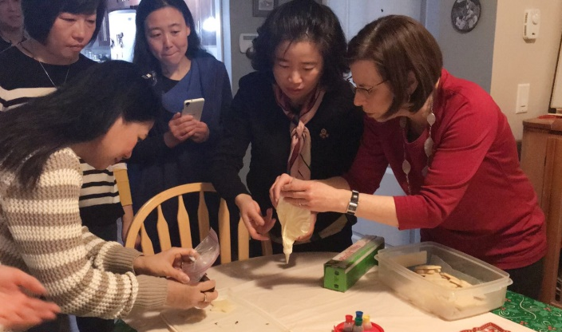
Lesson Material:
Conversation practice
Canadian culture and holidays
Local events and issues of interest

Bible stories and wisdom
Pronunciation, grammar, idioms
ESL textbook, Bible, handouts
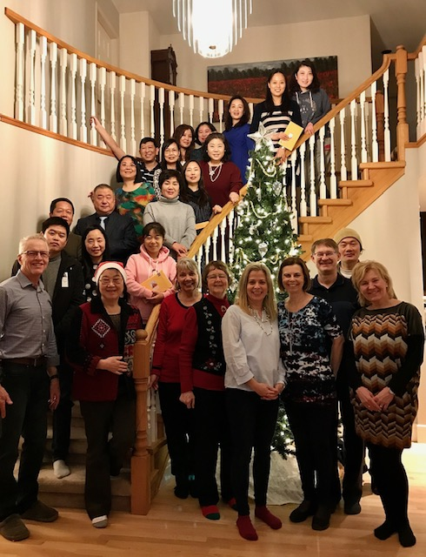
Cost: $55.00 plus textbook
Drop-in rate is $5.00 per class

Registration Deadline: January 8
Class size limited to 15, so register now!

Contact:
Lois Hammond – 604-941-3543 or loishammond@shaw.ca
Register online @ www.erbf.com

