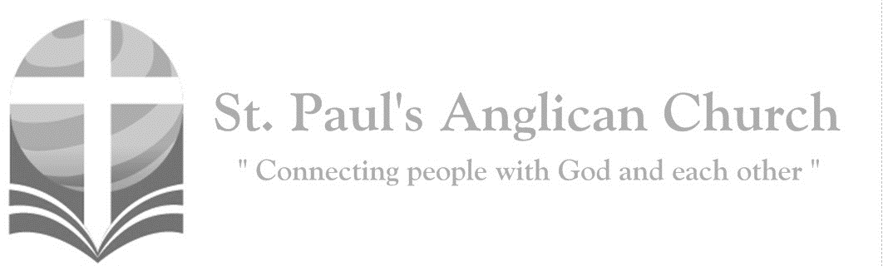
Sunday, April 19, 2020: 2nd Sunday of Easter

Have you believed, Thomas, because you have seen me? Blessed are those who have not seen and yet believe. (John 20:29)

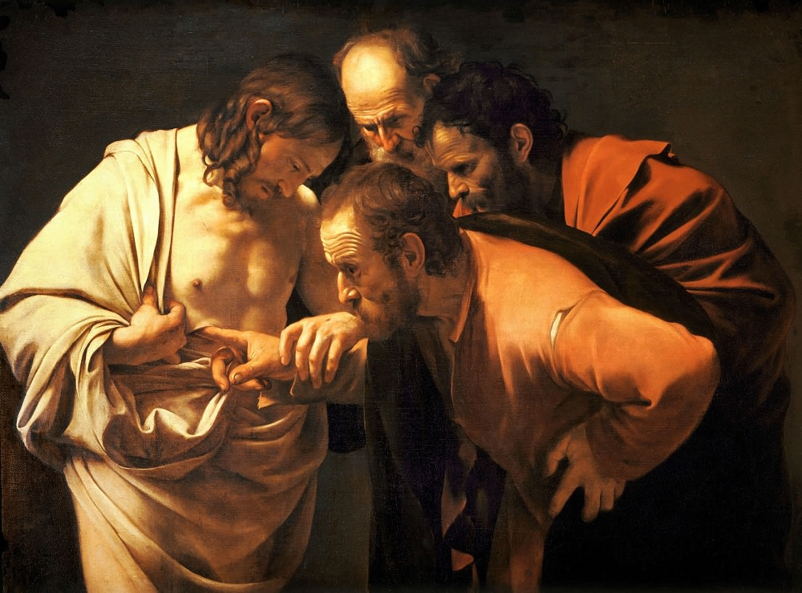

Opening Song: Here I am to Worship
Light of the world
You stepped down into darkness
Opened my eyes let me see
Beauty that made
This heart adore You
Hope of a life spent with You

(Chorus) So here I am to worship
Here I am to bow down
Here I am to say that You're my God
And You're altogether lovely
Altogether worthy
Altogether wonderful to me
King of all days
Oh so highly exalted
Glorious in heaven above
Humbly You came
To the earth You created
All for love's sake became poor
(To Chorus)

And I'll never know how much it cost
To see my sin upon that cross
And I'll never know how much it cost
To see my sin upon that cross
(To Chorus)

Morning Prayer
Rev. Myron: Lord, open our lips,
All: And our mouth shall proclaim your praise.
Rev. Myron: O God, make speed to save us.
All: O Lord, make haste to help us. Glory to the Father, and to the Son, and to the Holy Spirit: as it was in the beginning, is now, and will be for ever. Amen. Alleluia!

Rev. Myron: Alleluia! The Lord is risen indeed: O come, let us worship. (Christ our Passover) Alleluia! Christ our Passover has been sacrificed for us; therefore, let us keep the feast, not with the old leaven, the leaven of malice and evil, but with the unleavened bread of sincerity and truth. Alleluia! Christ being raised from the dead will never die again; death no longer has dominion over him. The death that he died, he died to sin, once for all; but the life he lives, he lives to God. So also consider yourselves dead to sin, and alive to God in Jesus Christ our Lord. Alleluia! Christ has been raised from the dead, the first fruits of those who have fallen asleep. For since by a man came death, by a man has come also the resurrection of the dead. For as in Adam all die, so also in Christ shall all be made alive. Alleluia!

The Reading of Scripture
First Reading: Acts 2:14a, 22-32
But Peter, standing with the eleven, raised his voice and addressed them, "You that are Israelites, listen to what I have to say: Jesus of Nazareth, a man attested to you by God with deeds of power, wonders, and signs that God did through him among you, as you yourselves know- this man, handed over to you according to the definite plan and foreknowledge of God, you crucified and killed by the hands of those outside the law. But God raised him up, having freed him from death, because it was impossible for him to be held in its power. For David says concerning him, 'I saw the Lord always before me, for he is at my right hand so that I will not be shaken; therefore my heart was glad, and my tongue rejoiced; moreover my flesh will live in hope. For you will not abandon my soul to Hades, or let your Holy One experience corruption. You have made known to me the ways of life; you will make me full of gladness with your presence.' "Fellow Israelites, I may say to you confidently of our ancestor David that he both died and was buried, and his tomb is with us to this day. Since he was a prophet, he knew that God had sworn with an oath to him that he would put one of his descendants on his throne. Foreseeing this, David spoke of the resurrection of the Messiah, saying, 'He was not abandoned to Hades, nor did his flesh experience corruption.' This Jesus God raised up, and of that all of us are witnesses.
Reader: The Word of the Lord.
People: Thanks be to God.

Canticle: Psalm 16
Refrain:

Protect me, O God, for I take refuge in you; I have said to the Lord, "You are my Lord, my good above all other." All my delight is upon the godly that are in the land, upon those who are noble among the people. Refrain

But those who run after other gods shall have their troubles multiplied. Their libations of blood I will not offer, nor take the names of their gods upon my lips. Refrain
O Lord, you are my portion and my cup; it is you who uphold my lot. My boundaries enclose a pleasant land; indeed, I have a goodly heritage. Ref. (continued on next page)
I will bless the Lord who gives me counsel; my heart teaches me, night after night. I have set the Lord always before me; because he is at my right hand I shall not fall. Refrain

My heart, therefore, is glad, and my spirit rejoices; my body also shall rest in hope. For you will not abandon me to the grave, nor let your holy one see the Pit. Refrain

You will show me the path of life; in your presence there is fullness of joy, and in your right hand are pleasures for evermore. Refrain

Second Reading: 1 Peter 1:3-9
Blessed be the God and Father of our Lord Jesus Christ! By his great mercy he has given us a new birth into a living hope through the resurrection of Jesus Christ from the dead, and into an inheritance that is imperishable, undefiled, and unfading, kept in heaven for you, who are being protected by the power of God through faith for a salvation ready to be revealed in the last time. In this you rejoice, even if now for a little while you have had to suffer various trials, so that the genuineness of your faith--being more precious than gold that, though perishable, is tested by fire--may be found to result in praise and glory and honor when Jesus Christ is revealed. Although you have not seen him, you love him; and even though you do not see him now, you believe in him and rejoice with an indescribable and glorious joy, for you are receiving the outcome of your faith, the salvation of your souls.
Reader: The Word of the Lord.
People: Thanks be to God.

The Gospel Reading
Rev. Myron: The Lord be with you.
People: And also with you.
Rev. Myron: The Holy Gospel of our Lord Jesus Christ according to St. John.
People: Glory to you, Lord Jesus Christ.
Gospel Reading: John 20:19-31
When it was evening on that day, the first day of the week, and the doors of the house where the disciples had met were locked for fear of the Jews, Jesus came and stood among them and said, "Peace be with you." After he said this, he showed them his hands and his side. Then the disciples rejoiced when they saw the Lord. Jesus said to them again, "Peace be with you. As the Father has sent me, so I send you." When he had said this, he breathed on them and said to them, "Receive the Holy Spirit. If you forgive the sins of any, they are forgiven them; if you retain the sins of any, they are retained." But Thomas (who was called the Twin), one of the twelve, was not with them when Jesus came. So the other disciples told him, "We have seen the Lord." But he said to them, "Unless I see the mark of the nails in his hands, and put my finger in the mark of the nails and my hand in his side, I will not believe." A week later his disciples were again in the house, and Thomas was with them. Although the doors were shut, Jesus came and stood among them and said, "Peace be with you." Then he said to Thomas, "Put your finger here and see my hands. Reach out your hand and put it in my side. Do not doubt but believe." Thomas answered him, "My Lord and my God!" Jesus said to him, "Have you believed because you have seen me? Blessed are those who have not seen and yet have come to believe." Now Jesus did many other signs in the presence of his disciples, which are not written in this book. But these are written so that you may come to believe that Jesus is the Messiah, the Son of God, and that through believing you may have life in his name.
Rev. Myron: The Gospel of Christ.
People: Praise to you, Lord Jesus Christ.

Message from Rev. Myron

Affirmation of Faith – The Apostle’s Creed
All: I believe in God, the Father almighty, Creator of heaven and earth. I believe in
Jesus Christ, his only Son, our Lord. He was conceived by the power of the Holy
Spirit and born of the Virgin Mary. He suffered under Pontius Pilate, was
crucified, died and was buried. He descended to the dead. On the third day, he
rose again. He ascended into heaven and is seated at the right hand of the
Father. He will come again to judge the living and the dead. I believe in the
Holy Spirit, the holy catholic Church, the communion of saints, the forgiveness
of sins, the resurrection of the body, and the life everlasting. Amen.

Prayers of the People
Reader: In joy and hope let us pray to the source of all life, saying, “Hear us, Lord of glory!” That our risen Saviour may fill us with the joy of his holy and life-giving resurrection, let us pray to the Lord.
All: Hear us, Lord of glory!
Reader: Remembering today those in our St. Paul’s Cycle of Prayer: James Parker, Olga Elizarova and their daughter Sophia; Nathan and Deanna Kalles; Lorraine Bednar; and Paul Dowie as well as all of those in the Anglican Cycle of Prayer. That isolated and persecuted churches may find fresh strength in the Easter gospel, let us pray to the Lord.
All: Hear us, Lord of glory!
Reader: That he may grant us humility to be subject to one another in Christian love, let us pray to the Lord.
All: Hear us, Lord of glory!
Reader: That he may provide for those who lack food, work, or shelter, let us pray to the Lord.
All: Hear us, Lord of glory!
Reader: That by his power wars and famine may cease through all the earth, let us pray to the Lord.
All: Hear us, Lord of glory!
Reader: That he may reveal the light of his presence to the sick, the weak, and the dying, that they may be comforted and strengthened, let us pray to the Lord.
All: Hear us, Lord of glory!
Reader: That he may send the fire of the Holy Spirit upon his people, that we may bear faithful witness to his resurrection, let us pray to the Lord.
All: Hear us, Lord of glory!

The Collect
Rev. Myron: Almighty and eternal God, the strength of those who believe and the hope of those who doubt, may we, who have not seen, have faith and receive the fullness of Christ’s blessing, who is alive and reigns with you and the Holy Spirit, one God, now and for ever.
All: Amen.

The Lord’s Prayer
Celebrant: And now, as our Saviour Christ has taught us, we are bold to say,
All: Our Father, who art in heaven, hallowed be thy name, thy kingdom come, thy will be done, on earth as it is in heaven. Give us this day our daily bread. And forgive us our trespasses, as we forgive those who trespass against us. And lead us not into temptation, but deliver us from evil. For thine is the kingdom, the power, and the glory, for ever and ever. Amen.

Closing Song: In Christ Alone

In Christ alone my hope is found
He is my light, my strength, my song
This Cornerstone, this solid Ground
Firm through the fiercest drought
And storm
What heights of love
What depths of peace
When fears are stilled
When strivings cease
My Comforter, my All in All
Here in the love of Christ I stand

In Christ alone who took on flesh
Fullness of God in helpless babe
This gift of love and righteousness
Scorned by the ones He came to save
Till on that cross as Jesus died
The wrath of God was satisfied
For every sin on Him was laid
Here in the death of Christ I live

There in the ground His body lay
Light of the world by darkness slain
Then bursting forth in glorious Day
Up from the grave He rose again
And as He stands in victory
Sin's curse has lost its grip on me
For I am His and He is mine
Bought with the precious blood of Christ

No guilt in life, no fear in death
This is the power of Christ in me
From life's first cry to final breath
Jesus commands my destiny
No power of hell, no scheme of man
Can ever pluck me from His hand
Till He returns or calls me home
Here in the power of Christ I'll stand

The Dismissal
Rev. Myron: Let us bless the Lord.
All: Thanks be to God.
Rev. Myron: May the God of peace enable us to do his will in every kind of goodness, working in us what pleases him, through Jesus Christ, to whom be the glory for ever and ever.

Anglican Cycle of Prayer:
Diocese of Calgary; the Most Rev. Gregory Kerr-Wilson, Archbishop (Metropolitan of the Ecclesiastical Province of Rupert’s Land); the Rt. Rev. Sidney Black, Indigenous Bishop for Treaty 7 Territory. Retired clergy of Edmonton diocese: Will Drake; Terry Dunn (s. Joanne); Arthur Dyck (s. Joy); Peter Dyck (s. Mary); Ted Eden (s. Pamela); René Faille (s. Ruby); Bishop Ken Genge (s. Ruth); Neil Gordon (s. Susan Bercov); Donald Gray; Sheila Hagan-Bloxham; Martin Hattersley (s. Florence); Peter Heritage (s. Lois); Ronald Hörst and Maude Parsons-Hörst. Buyé Diocese, Ruyenzi (St. Emmanuel) Parish: Papias Masengesho. Ermineskin Cree Nation.
All: Amen.

St. Paul’s Cycle of Prayer:
James Parker and Olga Elizarova and Sophia;
Nathan and Deanna Kalles;
Lorraine Bednar;
Paul Dowie
St. Paul’s Anglican Church
10127 145 Street, Edmonton T5N 2X6
Phone: (780) 455-0771; Email: office@stpauls-anglican.ca
Website: www.stpauls-anglican.ca
Office Hours:
Monday-Thursday: 9:00AM-12:00PM
Closed: Fri/Sat/Sun and Stat Holidays
St. Paul’s Vestry:
Peter Jackson, Rector’s Warden
Margot Byer, People’s Warden
David Heritage, Treasurer
Barb Dixon, Vestry Member
John Green, Vestry Member
Deanna Kalles, Vestry Member
David Parker, Vestry Member
Carol Rudat, Vestry Member

facebook.com/stpachurchedmonton
@StEdmonton
For Care/Concern Team
or other prayer requests, email:
office@stpauls-anglican.ca
For urgent prayer requests call
the church office: (780) 455-0771
For pastoral emergencies call:
(587) 334-2130

St. Paul’s Staff:
Rector: The Rev. Myron B. Penner
Office Administrator: RJ Chambers
Youth Leader: Victoria Eeles

