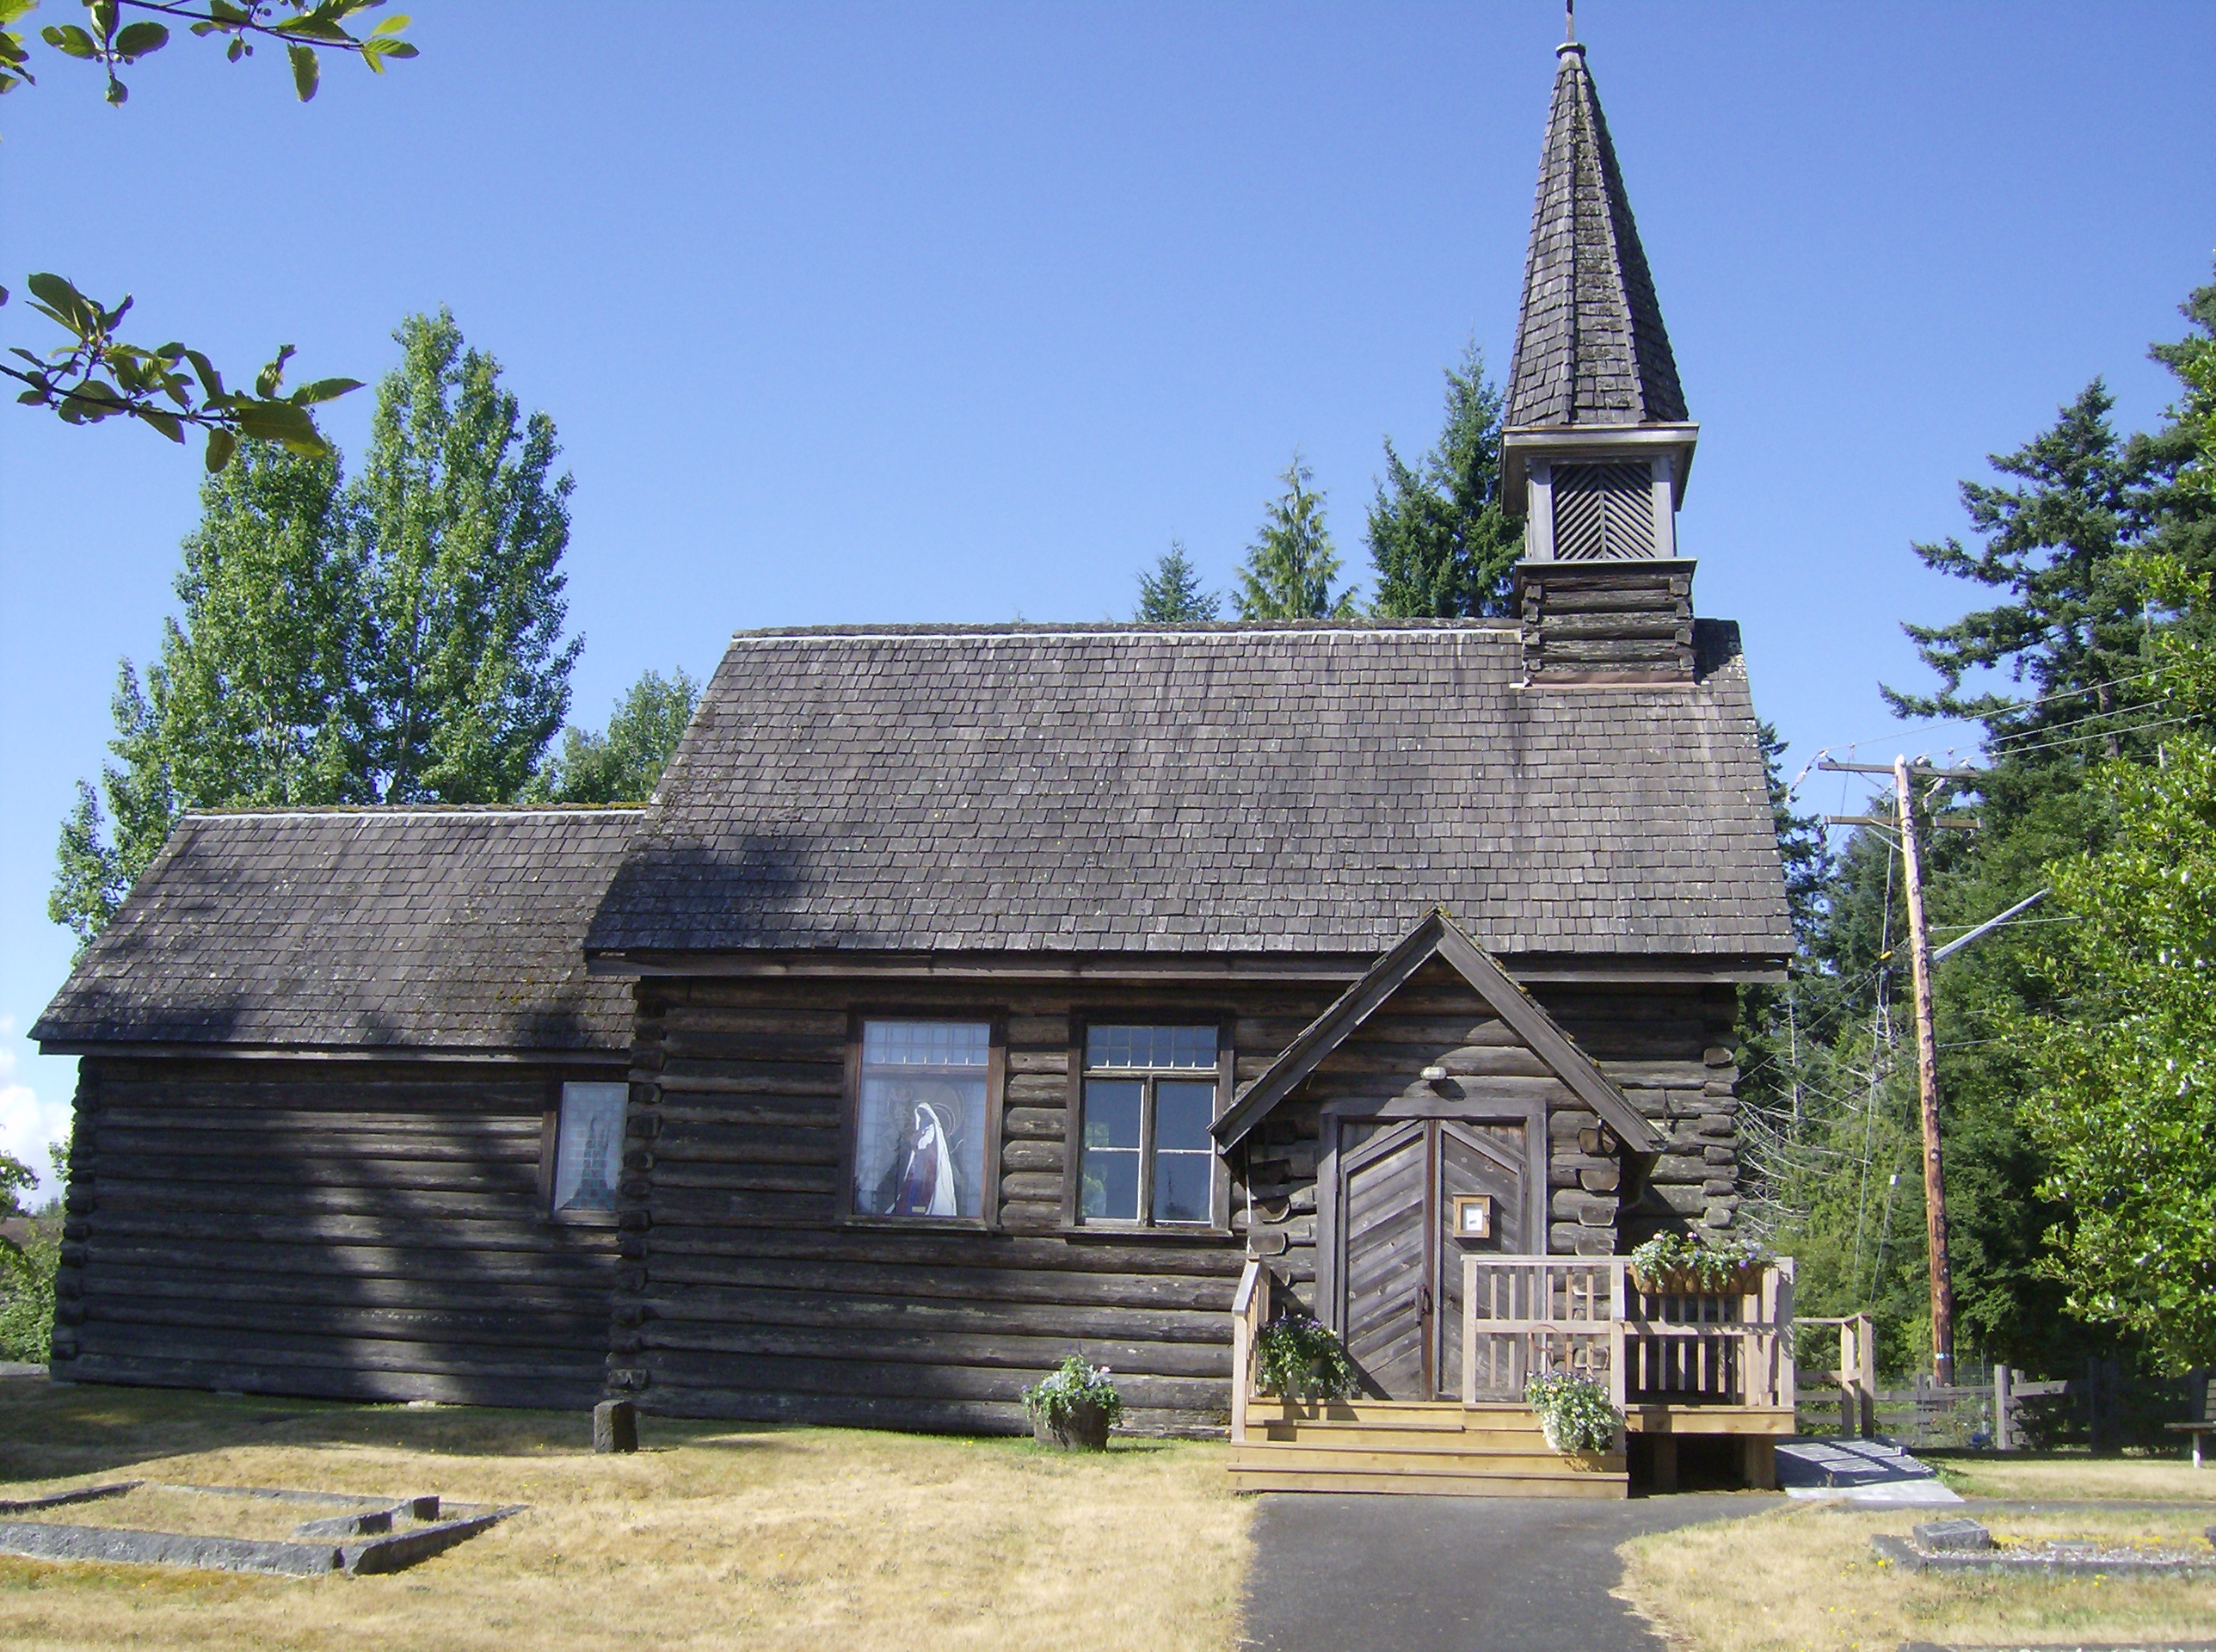

Visit
Historic St. Anne's Church
Oldest Vancouver Island Church
north of Nanaimo
still offering Sunday services
Open House
A Guide will be on hand to answer questions

TUESDAYS June 19th-August 28th

10 a.m. to 2 p.m.
Wheelchair accessible

407 Wembley Rd at Church Rd, Parksville
Behind Wembley Mall

