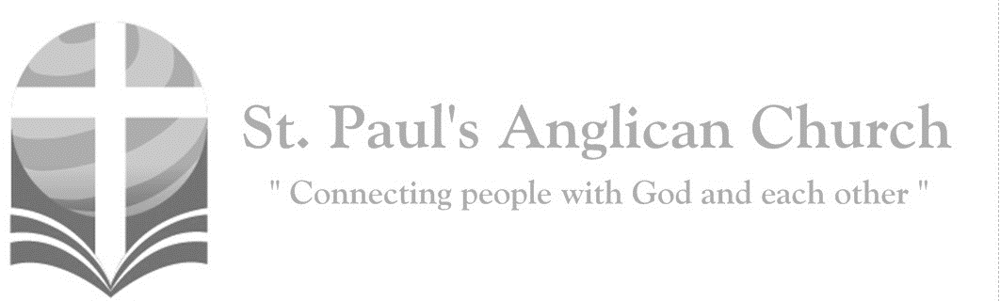
Sunday, May 3, 2020: 4th Sunday of Easter

I am the good shepherd, says the Lord:
I know my own and my own know me. (John 10:14)

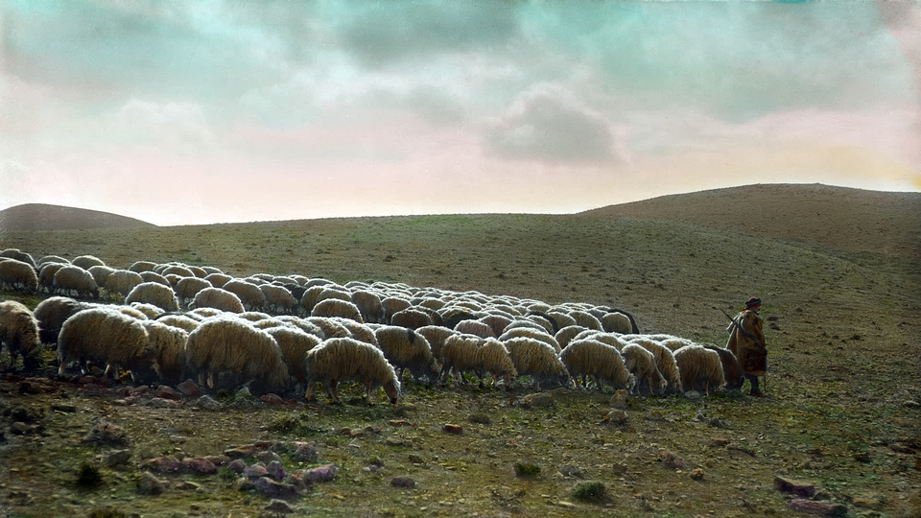

Opening Song: Praise the Father, Praise the Son
O sovereign God, O matchless King
The saints adore, the angels sing
And fall before the throne of grace
To You belongs the highest praise

These sufferings, this passing tide
Under Your wings I will abide
And every enemy shall flee
You are my hope and victory

(Chorus) Praise the Father
Praise the Son
Praise the Spirit, Three in One
Clothed in power and in grace
The name above all other names

To the valley for my soul
Thy great descent has made me whole
Your word my heart
Has welcomed home
Now peace like water ever flows
(To Chorus)

Morning Prayer
Leader: Lord, open our lips,
All: And our mouth shall proclaim your praise.
Leader: O God, make speed to save us.
All: O Lord, make haste to help us. Glory to the Father, and to the Son, and to the Holy Spirit: as it was in the beginning, is now, and will be for ever. Amen. Alleluia!

Leader: Alleluia! The Lord is risen indeed: O come, let us worship.
All: Alleluia! Christ our Passover has been sacrificed for us; therefore, let us keep the feast, not with the old leaven, the leaven of malice and evil, but with the unleavened bread of sincerity and truth. Alleluia! Christ being raised from the dead will never die again; death no longer has dominion over him. The death that he died, he died to sin, once for all; but the life he lives, he lives to God. So also consider yourselves dead to sin, and alive to God in Jesus Christ our Lord. Alleluia! Christ has been raised from the dead, the first fruits of those who have fallen asleep. For since by a man came death, by a man has come also the resurrection of the dead. For as in Adam all die, so also in Christ shall all be made alive. Alleluia!

The Reading of Scripture
First Reading: Acts 2:42-47
They devoted themselves to the apostles' teaching and fellowship, to the breaking of bread and the prayers. Awe came upon everyone, because many wonders and signs were being done by the apostles. All who believed were together and had all things in common; they would sell their possessions and goods and distribute the proceeds to all, as any had need. Day by day, as they spent much time together in the temple, they broke bread at home and ate their food with glad and generous hearts, praising God and having the goodwill of all the people. And day by day the Lord added to their number those who were being saved.
Reader: The Word of the Lord.
People: Thanks be to God.

Canticle: Psalm 23

The Lord's my Shepherd, I'll not want
He makes me down to lie
In pastures green He leadeth me
The quiet waters by

My soul He doth restore again
And me to walk doth make
Within the paths of righteousness
E'en for His own name's sake

Yea, though I walk in death's dark vale
Yet will I fear no ill
For Thou art with me and Thy rod
And staff me comfort still

My table Thou hast furnished
In presence of my foes
My head Thou dost with oil anoint
And my cup overflows (continued on next page)

Goodness and mercy all my life
Shall surely follow me
And in God's house for evermore
My dwelling place shall be

Second Reading: 1 Peter 2:19-25
For it is a credit to you if, being aware of God, you endure pain while suffering unjustly. If you endure when you are beaten for doing wrong, what credit is that? But if you endure when you do right and suffer for it, you have God's approval. For to this you have been called, because Christ also suffered for you, leaving you an example, so that you should follow in his steps. "He committed no sin, and no deceit was found in his mouth." When he was abused, he did not return abuse; when he suffered, he did not threaten; but he entrusted himself to the one who judges justly. He himself bore our sins in his body on the cross, so that, free from sins, we might live for righteousness; by his wounds you have been healed. For you were going astray like sheep, but now you have returned to the shepherd and guardian of your souls.
Reader: The Word of the Lord.
People: Thanks be to God.

The Gospel Reading
Leader: The Lord be with you.
People: And also with you.
Leader: The Holy Gospel of our Lord Jesus Christ according to St. John.
People: Glory to you, Lord Jesus Christ.
Gospel Reading: John 10:1-10
Very truly, I tell you, anyone who does not enter the sheepfold by the gate but climbs in by another way is a thief and a bandit. The one who enters by the gate is the shepherd of the sheep. The gatekeeper opens the gate for him, and the sheep hear his voice. He calls his own sheep by name and leads them out. When he has brought out all his own, he goes ahead of them, and the sheep follow him because they know his voice. They will not follow a stranger, but they will run from him because they do not know the voice of strangers." Jesus used this figure of speech with them, but they did not understand what he was saying to them. So again Jesus said to them, "Very truly, I tell you, I am the gate for the sheep. All who came before me are thieves and bandits; but the sheep did not listen to them. I am the gate. Whoever enters by me will be saved, and will come in and go out and find pasture. The thief comes only to steal and kill and destroy. I came that they may have life, and have it abundantly."
Leader: The Gospel of Christ.
People: Praise to you, Lord Jesus Christ.

Message from Rev. Myron Penner

Affirmation of Faith – Hear, O Israel
All: Hear, O Israel, the Lord our God, the Lord is one. Love the Lord your God with all your heart, with all your soul, with all your mind, and with all your strength. This is the first and the great commandment. The second is like it: Love your neighbour as yourself. There is no commandment greater than these.

Prayers of the People
Reader: As we stand in God’s presence, let us pray to the Lord, saying,
“Lord, have mercy.” remembering those in our St. Paul’s Cycle of Prayer: Ryan and Michelle Young and their children Carson, Jordan, and Weston;
Gordon and Pat Stretch; Rob Smith; Margaret Ushko as well as all of those in the Anglican Cycle of Prayer, and for the whole People of God, that each one may be a true and faithful servant of Christ, let us pray to the Lord.
All: Lord, have mercy.

Reader: For those drawing near to the light of faith, that the Lord will bring them to true knowledge of himself, let us pray to the Lord.
All: Lord, have mercy.

Reader: For our families and friends, that the Lord will give them joy and satisfaction in all that they do, let us pray to the Lord.
All: Lord, have mercy.

Reader: For those who are lonely, sick, hungry, persecuted, or ignored, that the Lord will comfort and sustain them, let us pray to the Lord.
All: Lord, have mercy.
Reader: For our country, that the Lord will help us to contribute to its true growth and well-being, let us pray to the Lord.
All: Lord, have mercy.

Reader: For the whole human family, that we may live together in justice and peace, let us pray to the Lord.
All: Lord, have mercy.

The Collect
Leader: O God of peace, who brought again from the dead our Lord Jesus Christ, that great shepherd of the sheep, by the blood of the eternal covenant, make us perfect in every good work to do your will, and work in us that which is well-pleasing in your sight; through Jesus Christ our Lord.
All: Amen.

The Lord’s Prayer
Leader: And now, as our Saviour Christ has taught us, we are bold to say,
All: Our Father, who art in heaven, hallowed be thy name, thy kingdom come, thy will be done, on earth as it is in heaven. Give us this day our daily bread. And forgive us our trespasses, as we forgive those who trespass against us. And lead us not into temptation, but deliver us from evil. For thine is the kingdom, the power, and the glory, for ever and ever. Amen.

Closing Song: Hear the Call of the Kingdom

Hear the call of the kingdom
Lift your eyes to the King
Let His song rise within you
As a fragrant offering
Of how God rich in mercy
Came in Christ to redeem
All who trust in His unfailing grace

Hear the call of the kingdom
To be children of light
With the mercy of heaven
The humility of Christ
Walking justly before Him
Loving all that is right
That the life of Christ
May shine through us
(continued on next page)

(Chorus) King of heaven
We will answer the call
We will follow
Bringing hope to the world
Filled with passion
Filled with power to proclaim
Salvation in Jesus’ name
Hear the call of the kingdom
To reach out to the lost
With the Father's compassion
In the wonder of the cross
Bringing peace and forgiveness
And a hope yet to come
Let the nations put their trust in Him
(To Chorus)

The Dismissal
Leader: Let us bless the Lord.
All: Thanks be to God.
Leader: May the God of peace enable us to do his will in every kind of goodness, working in us what pleases him, through Jesus Christ, to whom be the glory for ever and ever.
All: Amen.

St. Paul's Open Hours - Please Call Ahead
Starting in May, if you plan to come into St. Paul's for prayer or to drop off food or other items, please call ahead before you come. Myron will try to be onsite during the open prayer hours but sometimes has pastoral emergencies that take him offsite and RJ will be working from home until gathering restrictions are lifted.

Not Receiving Email Announcements from St. Paul’s?
If you have not been receiving email updates from St. Paul’s (which we have been sending every week since gatherings restrictions went into effect), it means you are not on our email list or we have an incorrect email address for you. If you are not receiving our emails and would like to, please email office@stpauls-angican.ca and ask to be added to the announcement contact list. We want to be sure we are remain connected – especially at this difficult time.

St. Paul’s Cycle of Prayer:
Ryan and Michelle Young and Carson, Jordan, and Weston;
Gordon and Pat Stretch;
Rob Smith;
Margaret Ushko

Anglican Cycle of Prayer:
Diocese of Eastern Newfoundland & Labrador; the Rt. Rev. Dr. Geoffrey Peddle, Bishop. The retired clergy of the Diocese of Edmonton: Michael Rolph (s. Cora); John Rushton (s. Elizabeth); Doreen Scott; Nancy Selwood; Susan Storey; Allan Studd (s. Betty); Michael Sung (s. Agnes); Pauline Tiffen; Jacques deG Vaillancourt (s. Bobbi); Dan Van Alstine (s. Carolyn Skinner); Robin Walker (s. Joanne); Linda Whittle (s. Jim); Anne Wightman (s. Peter); Mary Charlotte Wilcox; Robert Wild; Michael Williamson (s. Janet). Buyé Hospital Chaplaincy: Daniel Bizimana, Chaplain. Frog Lake First Nation.

St. Paul’s Anglican Church
10127 145 Street, Edmonton T5N 2X6
Phone: (780) 455-0771; Email: office@stpauls-anglican.ca
Website: www.stpauls-anglican.ca
Office Hours:
Monday-Thursday: 9:00AM-12:00PM
Closed: Fri/Sat/Sun and Stat Holidays
St. Paul’s Vestry:
Peter Jackson, Rector’s Warden
Margot Byer, People’s Warden
David Heritage, Treasurer
Barb Dixon, Vestry Member
John Green, Vestry Member
Deanna Kalles, Vestry Member
David Parker, Vestry Member
Carol Rudat, Vestry Member

facebook.com/stpachurchedmonton
@StEdmonton
For Care/Concern Team
or other prayer requests, email:
office@stpauls-anglican.ca
For urgent prayer requests call
the church office: (780) 455-0771
For pastoral emergencies call:
(587) 334-2130

St. Paul’s Staff:
Rector: The Rev. Myron B. Penner
Office Administrator: RJ Chambers
Youth Leader: Victoria Eeles

