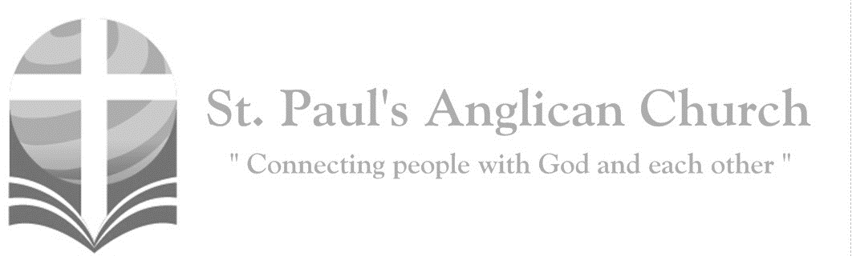
Sunday, May 17, 2020: 6th Sunday of Easter

If you love me, you will keep my word, and my Father
will love you, and we will come to you. (John 14:23)

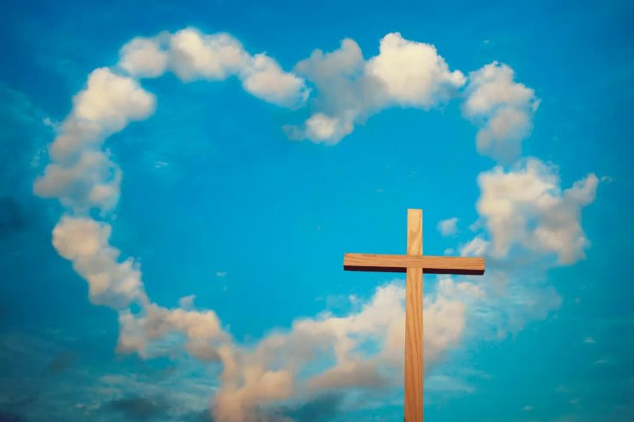

Opening Song: Children of the Light
We are the children of light
We are the children of day
So let us worship Him
In whom we have our being
Until the coming of the Lord

We are the children of God
Made in the image of Christ
And on the day He comes
We shall be made like Him
For we shall see Him as He is

(Chorus) Come, let us worship now
Let us kneel
Let us humbly bow down
He is our God, we are His people
We are the flock in His care
So come let us bow
(Last time) So come let us bow

We are the soldiers of Christ
Dressed for the battle on high
So let us call on Him
For He will fight the battle
And we will march with Him on that day

We are the faithful of God
We will endure 'til the end
So let us run the race
That He has set before us
To win the crown of righteousness
(To Chorus)

Morning Prayer
Leader: Lord, open our lips,
All: And our mouth shall proclaim your praise.
Leader: O God, make speed to save us.
All: O Lord, make haste to help us. Glory to the Father, and to the Son, and to the Holy Spirit: as it was in the beginning, is now, and will be for ever. Amen. Alleluia!

Leader: Alleluia! The Lord is risen indeed: O come, let us worship.
All: You are God: we praise you; you are the Lord: we acclaim you; you are the eternal Father: all creation worships you. To you all angels, all the powers of heaven, Cherubim and Seraphim, sing in endless praise: Holy, holy, holy Lord, God of power and might, heaven and earth are full of your glory. The glorious company of apostles praise you. The noble fellowship of prophets praise you. The white-robed army of martyrs praise you. Throughout the world the holy Church acclaims you: Father, of majesty unbounded, your true and only Son, worthy of all worship, and the Holy Spirit, advocate and guide. You, Christ, are the King of Glory, the eternal Son of the Father. When you became man to set us free you did not shun the Virgin’s womb. You overcame the sting of death and opened the kingdom of heaven to all believers. You are seated at God’s right hand in glory. We believe that you will come, and be our judge. Come then, Lord, and help your people, bought with the price of your own blood, and bring us with your saints to glory everlasting.

The Reading of Scripture
First Reading: Acts 17:22-31
Then Paul stood in front of the Areopagus and said, "Athenians, I see how extremely religious you are in every way. For as I went through the city and looked carefully at the objects of your worship, I found among them an altar with the inscription, 'To an unknown god.' What therefore you worship as unknown, this I proclaim to you. The God who made the world and everything in it, he who is Lord of heaven and earth, does not live in shrines made by human hands, nor is he served by human hands, as though he needed anything, since he himself gives to all mortals life and breath and all things. From one ancestor he made all nations to inhabit the whole earth, and he allotted the times of their existence and the boundaries of the places where they would live, so that they would search for God and perhaps grope for him and find him--though indeed he is not far from each one of us. For 'In him we live and move and have our being'; as even some of your own poets have said, 'For we too are his offspring.' Since we are God's offspring, we ought not to think that the deity is like gold, or silver, or stone, an image formed by the art and imagination of mortals. While God has overlooked the times of human ignorance, now he commands all people everywhere to repent, because he has fixed a day on which he will have the world judged in righteousness by a man whom he has appointed, and of this he has given assurance to all by raising him from the dead."
Reader: The Word of the Lord.
People: Thanks be to God.
Canticle: Psalm 66:8-20

Don’t let the rebellious
against Him arise;
But praise God, O people,
let praise fill the skies.
For He has preserved us,
and kept our feet sure;
For You, God, did test us,
like silver most pure.

You put us in prison, bound us in the net; Laid burdens upon us, oppressing us yet.
You let men ride o’er us; great fire we went through; Through fire and through water,
but You brought us through.

I’ll come to Your temple with burnt offering; My vows I’ll fulfill; sacrifices I’ll bring.
For vows that my lips made when trouble did brew, I’ll sacrifice rams, bulls,
and goats unto You.

Come, listen, all you who fear God earnestly, And let me proclaim
what He has done for me.
I cried out to Him with my mouth and my voice, My tongue spoke His praise
and my spirit rejoiced.

Now if I had cherished my sin in my heart, The Lord would not listen, nor answer impart.
But God surely listened and He heard my voice. His love’s ever with me—
I’ll praise and rejoice!

Second Reading: 1 Peter 3:13-22
Now who will harm you if you are eager to do what is good? But even if you do suffer for doing what is right, you are blessed. Do not fear what they fear, and do not be intimidated, but in your hearts sanctify Christ as Lord. Always be ready to make your defense to anyone who demands from you an accounting for the hope that is in you; yet do it with gentleness and reverence. Keep your conscience clear, so that, when you are maligned, those who abuse you for your good conduct in Christ may be put to shame. For it is better to suffer for doing good, if suffering should be God's will, than to suffer for doing evil. For Christ also suffered for sins once for all, the righteous for the unrighteous, in order to bring you to God. He was put to death in the flesh, but made alive in the spirit, in which also he went and made a proclamation to the spirits in prison, who in former times did not obey, when God waited patiently in the days of Noah, during the building of the ark, in which a few, that is, eight persons, were saved through water. And baptism, which this prefigured, now saves you--not as a removal of dirt from the body, but as an appeal to God for a good conscience, through the resurrection of Jesus Christ, who has gone into heaven and is at the right hand of God, with angels, authorities, and powers made subject to him.
Reader: The Word of the Lord.
People: Thanks be to God.

The Gospel Reading
Leader: The Lord be with you.
People: And also with you.
Leader: The Holy Gospel of our Lord Jesus Christ according to St. John.
People: Glory to you, Lord Jesus Christ.
Gospel Reading: John 14:15-21
"If you love me, you will keep my commandments. And I will ask the Father, and he will give you another Advocate, to be with you forever. This is the Spirit of truth, whom the world cannot receive, because it neither sees him nor knows him. You know him, because he abides with you, and he will be in you. "I will not leave you orphaned; I am coming to you. In a little while the world will no longer see me, but you will see me; because I live, you also will live. On that day you will know that I am in my Father, and you in me, and I in you. They who have my commandments and keep them are those who love me; and those who love me will be loved by my Father, and I will love them and reveal myself to them."
Leader: The Gospel of Christ.
People: Praise to you, Lord Jesus Christ.

Message from Alison Hurlburt

Affirmation of Faith – Hear, O Israel
All: Hear, O Israel, the Lord our God, the Lord is one. Love the Lord your God with all your heart, with all your soul, with all your mind, and with all your strength. This is the first and the great commandment. The second is like it: Love your neighbour as yourself. There is no commandment greater than these.

Prayers of the People
Reader: In joy and hope let us pray to the source of all life, saying, “Hear us, Lord of glory!” That our risen Saviour may fill us with the joy of his holy and life-giving resurrection, let us pray to the Lord.
All: Hear us, Lord of glory!
Reader: Remembering today those in our St. Paul’s Cycle of Prayer: Andrew and Nancy Whistance-Smith and their children Greg, Tim and Emily; Nathan and Deanna Kalles; George Jakeway; and Lucie Messum as well as all of those in the Anglican Cycle of Prayer. That isolated and persecuted churches may find fresh strength in the Easter gospel, let us pray to the Lord.
All: Hear us, Lord of glory!
Reader: That he may grant us humility to be subject to one another in Christian love, let us pray to the Lord.
All: Hear us, Lord of glory!
Reader: That he may provide for those who lack food, work, or shelter, let us pray to the Lord.
All: Hear us, Lord of glory!
Reader: That by his power wars and famine may cease through all the earth, let us pray to the Lord.
All: Hear us, Lord of glory!
Reader: That he may reveal the light of his presence to the sick, the weak, and the dying, that they may be comforted and strengthened, let us pray to the Lord.
All: Hear us, Lord of glory!
Reader: That he may send the fire of the Holy Spirit upon his people, that we may bear faithful witness to his resurrection, let us pray to the Lord.
All: Hear us, Lord of glory!

The Collect
Leader: Merciful God, you have prepared for those who love you riches beyond imagination. Pour into our hearts such love toward you, that we, loving you above all things, may obtain your promises, which exceed all that we can desire; through Jesus Christ our Lord, who is alive and reigns with you and the Holy Spirit, one God, now and for ever.
All: Amen.

The Lord’s Prayer
Leader: And now, as our Saviour Christ has taught us, we are bold to say,
All: Our Father, who art in heaven, hallowed be thy name, thy kingdom come, thy will be done, on earth as it is in heaven. Give us this day our daily bread. And forgive us our trespasses, as we forgive those who trespass against us. And lead us not into temptation, but deliver us from evil. For thine is the kingdom, the power, and the glory, for ever and ever. Amen.

Closing Song: This is My Father’s World

This is my Father's world
And to my listening ears
All nature sings and 'round me rings
The music of the spheres
This is my Father's world
I rest me in the thought
Of rocks and trees, of skies and seas
His hand the wonders wrought

This is my Father's world
The birds their carols raise
The morning light, the lily white
Declare their Maker's praise
This is my Father's world
He shines in all that's fair
In the rustling grass I hear Him pass
He speaks to me everywhere

This is my Father's world
O let me ne'er forget
And though the wrong
Seems oft so strong
God is the Ruler yet
(Repeat previous three lines)
This is my Father's world
Why should my heart be sad
The Lord is King, let the heavens ring
God reigns, let the earth be glad
(Repeat previous two lines)

The Dismissal
Leader: Let us bless the Lord.
All: Thanks be to God.
Leader: May the God of peace enable us to do his will in every kind of goodness, working in us what pleases him, through Jesus Christ, to whom be the glory for ever and ever. All: Amen.

St. Paul's Open Hours – Updates for May 17-23
The church will be closed (both the office and the Sanctuary for prayer) on Monday, May 18 due to Victoria Day. The church will also be closed on Thursday, May 21. As a reminder, if you plan to come into St. Paul's for prayer or to drop off food or other items, please call ahead before you come.

Anglican Cycle of Prayer:
Diocese of Fredericton; the Rt. Rev. David Edwards, Bishop. The clergy on a leave of absence in the Diocese of Edmonton and the Interim Ministry Team. Buyé Diocese Bible School: Daniel Bizimana, Director; Alfred Uwimanihaye, Teacher. Louis Bull Tribe.
St. Paul’s Cycle of Prayer:
Andrew and Nancy Whistance-Smith and Greg, Tim and Emily;
Nathan and Deanna Kalles;
George Jakeway;
Lucie Messum
St. Paul’s Anglican Church
10127 145 Street, Edmonton T5N 2X6
Phone: (780) 455-0771; Email: office@stpauls-anglican.ca
Website: www.stpauls-anglican.ca
Office Hours:
Monday-Thursday: 9:00AM-12:00PM
Closed: Fri/Sat/Sun and Stat Holidays
St. Paul’s Vestry:
Peter Jackson, Rector’s Warden
Margot Byer, People’s Warden
David Heritage, Treasurer
Barb Dixon, Vestry Member
John Green, Vestry Member
Deanna Kalles, Vestry Member
David Parker, Vestry Member
Carol Rudat, Vestry Member

facebook.com/stpachurchedmonton
@StEdmonton
For Care/Concern Team
or other prayer requests, email:
office@stpauls-anglican.ca
For urgent prayer requests call
the church office: (780) 455-0771
For pastoral emergencies call:
(587) 334-2130

St. Paul’s Staff:
Rector: The Rev. Myron B. Penner
Office Administrator: RJ Chambers
Youth Leader: Victoria Eeles

