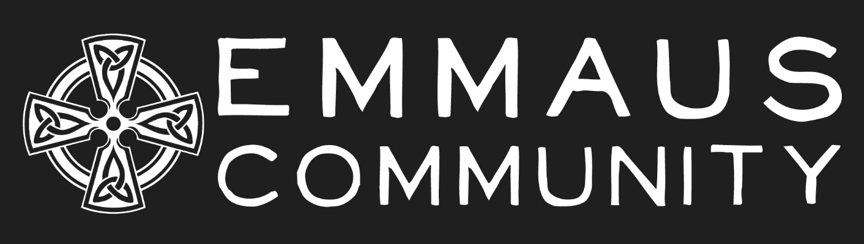
Annual Rhythm of Life Service
Welcome & Land Acknowledgment

Opening Prayer (Meagan)
We are gathered
in this place, at this time,
to celebrate, to act as witnesses,
to rejoice in our life together.

Gracious God,
source of our life and giver of our freedom,
be present with us now
opening our ears to hear your Word to us;
opening our eyes to see you in our companions on the journey;
opening our minds
that they might be nourished by your wisdom;
opening our hearts
that they might be emboldened by your love;
opening our lips that they might speak of your goodness.
Pour out your Spirit upon us
that we may be made more fully alive
for we come in the name of Jesus
who meets us on the road.
Amen

CONFESSION
Let us spend a moment reflecting on this past year in community, holding to the light those places we have turned away from the invitation to love God and each other in community.

Silence

For the times when we have not been present to God or to each other,
Lord have mercy

For the times when we have not practiced simplicity, forgetting to turn to you as our true source of nourishment.
Lord have mercy

For the times we have allowed our lives to become unbalanced, forgetting to prioritize times of prayer with you, for each other and for your world.
Lord have mercy

For the times we have not practiced reconciliation with you, in our relationships or with the land you have placed us on.
Lord have mercy

For the times when we have not extended hospitality and have not accepted the gift of hospitality from others,
Christ have mercy

O God, calm us into a quietness that heals and listens. Mould our longings and passions, our wounds and fears, that we might magnify your love. Forgive, renew and refresh us in your mercy. Amen

Absolution

Psalm

Receiving our Novices and Companions

Entering a Discernment Year
Formation Director: As Formation director to the Emmaus Community, I have affirmed that Vanessa Caruso, Melanie Ihmels and Jaqueline Cornelia Van Voorst have completed the Novice process and that Chapter has heard and affirmed their call to enter a year of Discernment towards Covenanted Membership in the Emmaus Community.

Prior: What is it you seek?

Novice: I seek the mercy of God and companionship in this community. I stand before God and before you my siblings in Christ, to joyfully commit my life to God and to explore the vows of prayer, simplicity and presence in the Emmaus Community in this next year of Discernment.

Prior: Members of the Emmaus Community, will you recieve Cornelia, Melanie and Vanessa into this year of intentional discernment? Will you pray for them and walk with them as they seek to have their hearts burn within them as they follow Christ in a life of prayer, simplicity and presence?

Chapter: We will, thanks be to God!

Rob: Let us pray...

Companion

Formation Director: As Formation director to the Emmaus Community, I affirm that Caroline has completed the Novice process and that Chapter has heard and affirmed her call to become a Companion of the Emmaus Community.

Prior: What is that you seek?

Novice: I seek the mercy of God and companionship in the Emmaus Community.

Prior: Will you join the Emmaus Community in their commitment to follow a Rule of life as a way of living out your baptismal vows?

Novice: I will.

Prior: Will you joyfully strive to live a life of prayer, simplicity and presence in the context that God has placed you?

Novice: I will.

Prior: Members of the Emmaus Community, will you recieve Caroline as a Companion of the community? Will you pray for all of our Companions and walk with them as they encounter Christ on the road?

EC: We will, thanks be to God

Matt: Let us pray...

Emmaus Community Reaffirmation and presentation of our Rhythm and Rule

Prior(s): as we enter a new year in community together, we offer our prayerful intentions to follow God, in community, in this next year. To that end we invite our Companions, Vowed members and Discerners to lift up our customary and rhythm of life as a sign of our common commitments to follow Christ.

Silent prayer

Members of the Emmaus Community, will you continue to journey together with God and each other, meeting together as a community; in prayer and worship, in joy and grief, in uncertainty and in hope, being a sign of God’s in-breaking reign of justice and peace in this place?

With God’s help, we will!

Will you be accountable to one another, growing together, listening to each other and the context God has placed you?

With God’s help, we will!

Will you willingly share a life of prayer, presence and simplicity and will you continue to walk together as disciples, seeking reconciliation and offering compassion and companionship?

With God’s help, we will!

Will you seek and know Christ in the breaking of bread, in the Word spoken and lived and in lives open to transformation?

With God’s help, we will!

[Will you, the Visitors to the Emmaus Community, support, encourage and challenge us to maintain our commitment to this spiritual way of life? Will you pray for us and uphold us as we seek to follow the way of Christ?

Community Visitors: With God’s help, we will!
We pray that God will strengthen you and fill you with the Holy Spirit as you journey together, encountering Christ on the way - And may God, who has begun this good work in us, bring it to fulfillment.

(if no visitors)

May God strengthen us and fill us with the Holy Spirit as we journey together. And may God, who has begun this good work in us, bring it to fulfillment.
All: Thanks be to God, Alleluia!

Sending

All that I am, oh God,
I place into your hands
All that I do,
I place into your hands
Everything I work for
I place into your hands
Everything I hope for
I place into your hands
The troubles that weary me
I place into your hands
The thoughts that disturb me
I place into your hands
My longings and fears
I place into your hands
My intentions to live faithfully as your body, through our rule of life
I place into your hands
Our ministries and visions
I place into your hands
Each that I pray for
I place into your hands
Each that I care for
I place into your hands

Into your hands oh God, we commend this community, our lives, our intentions, our whole being, this day and always. Amen.

Blessing (Community Visitor?)

Let us bless the Lord
Thanks be to God

