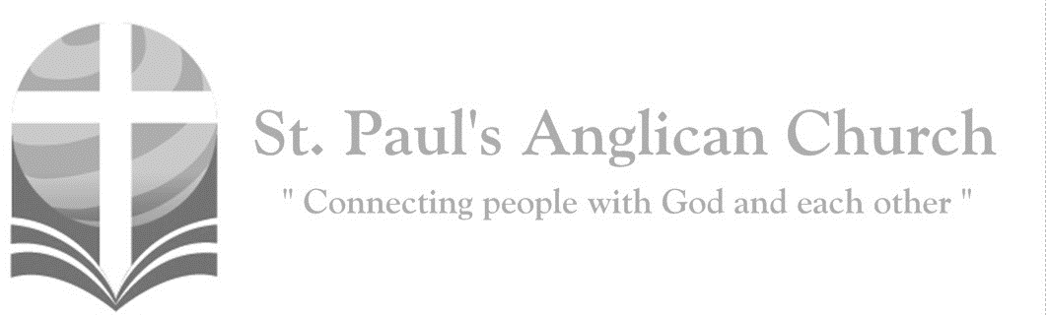
Sunday, May 24, 2020: Ascension of the Lord

Go and make disciples of all nations, says the Lord; I am with you always, to the close of the age. (Matthew 28:19-20)

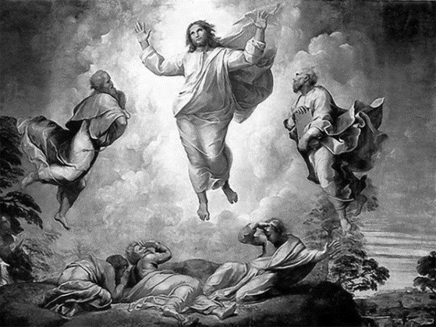

Opening Song: Hosanna
Praise is rising
Eyes are turning to You
We turn to You
Hope is stirring
Hearts are yearning for You
We long for You

(Pre-Chorus) 'Cause when we see You
We find strength to face the day
In Your presence
All our fears are washed away
Washed away
Hosanna, hosanna
You are the God who saves us
Worthy of all our praises
Hosanna, hosanna
Come have Your way among us
We welcome You here Lord Jesus

Hear the sound of
Hearts returning to You
We turn to You
In Your Kingdom
Broken lives are made new
You make us new (To Pre-Chorus)

Morning Prayer
Leader: Lord, open our lips,
All: And our mouth shall proclaim your praise.
Leader: O God, make speed to save us.
All: O Lord, make haste to help us. Glory to the Father, and to the Son, and to the Holy Spirit: as it was in the beginning, is now, and will be for ever. Amen. Alleluia!

Leader: Alleluia! The Lord is risen indeed: O come, let us worship.
All: Glory to God in the highest, and peace to his people on earth. Lord God, heavenly king, almighty God and Father, we worship you, we give you thanks, we praise you for your glory. Lord Jesus Christ, only Son of the Father, Lord God, Lamb of God, you take away the sin of the world: have mercy on us; you are seated at the right hand of the Father: receive our prayer. For you alone are the Holy One, you alone are the Lord, you alone are the Most High, Jesus Christ, with the Holy Spirit, in the glory of God the Father. Amen.

The Reading of Scripture
First Reading: Acts 1:1-11
In the first book, Theophilus, I wrote about all that Jesus did and taught from the beginning until the day when he was taken up to heaven, after giving instructions through the Holy Spirit to the apostles whom he had chosen. After his suffering he presented himself alive to them by many convincing proofs, appearing to them during forty days and speaking about the kingdom of God. While staying with them, he ordered them not to leave Jerusalem, but to wait there for the promise of the Father. "This," he said, "is what you have heard from me; for John baptized with water, but you will be baptized with the Holy Spirit not many days from now." So when they had come together, they asked him, "Lord, is this the time when you will restore the kingdom to Israel?" He replied, "It is not for you to know the times or periods that the Father has set by his own authority. But you will receive power when the Holy Spirit has come upon you; and you will be my witnesses in Jerusalem, in all Judea and Samaria, and to the ends of the earth." When he had said this, as they were watching, he was lifted up, and a cloud took him out of their sight. While he was going and they were gazing up toward heaven, suddenly two men in white robes stood by them. They said, "Men of Galilee, why do you stand looking up toward heaven? This Jesus, who has been taken up from you into heaven, will come in the same way as you saw him go into heaven."
Reader: The Word of the Lord.
People: Thanks be to God.

Canticle: Psalm 47

O clap your hands, you nations all,
and shout with joyful mirth!
How awesome is the Lord Most High,
great King o’er all the earth!
He brought down nations under us,
and peoples ’neath our feet.
He chose inheritance for us;
His love did Jacob meet.

God has ascended with a shout—the Lord with trumpet sound.
Sing praise to God, sing to our King; sing praises long and loud. (continued on next page)
For God is King of all the earth—sing with a psalm of praise.
God reigns o’er nations; He sits on His holy throne always.

The nobles of the nations come, they gather in the land,
Assembling as the people of the God of Abraham.
For all the kings of all the earth belong to God alone,
He is exalted greatly as He reigns upon His throne!

Second Reading: Ephesians 1:15-23
I have heard of your faith in the Lord Jesus and your love toward all the saints, and for this reason I do not cease to give thanks for you as I remember you in my prayers. I pray that the God of our Lord Jesus Christ, the Father of glory, may give you a spirit of wisdom and revelation as you come to know him, so that, with the eyes of your heart enlightened, you may know what is the hope to which he has called you, what are the riches of his glorious inheritance among the saints, and what is the immeasurable greatness of his power for us who believe, according to the working of his great power. God put this power to work in Christ when he raised him from the dead and seated him at his right hand in the heavenly places, far above all rule and authority and power and dominion, and above every name that is named, not only in this age but also in the age to come. And he has put all things under his feet and has made him the head over all things for the church, which is his body, the fullness of him who fills all in all.
Reader: The Word of the Lord.
People: Thanks be to God.

The Gospel Reading
Leader: The Lord be with you.
People: And also with you.
Leader: The Holy Gospel of our Lord Jesus Christ according to St. Luke.
People: Glory to you, Lord Jesus Christ.
Gospel Reading: Luke 24:44-53
Then he said to them, "These are my words that I spoke to you while I was still with you--that everything written about me in the law of Moses, the prophets, and the psalms must be fulfilled." Then he opened their minds to understand the scriptures, and he said to them, "Thus it is written, that the Messiah is to suffer and to rise from the dead on the third day, and that repentance and forgiveness of sins is to be proclaimed in his name to all nations, beginning from Jerusalem. You are witnesses of these things. And see, I am sending upon you what my Father promised; so stay here in the city until you have been clothed with power from on high." Then he led them out as far as Bethany, and, lifting up his hands, he blessed them. While he was blessing them, he withdrew from them and was carried up into heaven. And they worshiped him, and returned to Jerusalem with great joy; and they were continually in the temple blessing God.
Leader: The Gospel of Christ.
People: Praise to you, Lord Jesus Christ.

Message from the Rev. Dr. Myron Penner

Affirmation of Faith – The Apostle’s Creed
All: I believe in God, the Father almighty, Creator of heaven and earth. I believe in Jesus Christ, his only Son, our Lord. He was conceived by the power of the Holy Spirit and born of the Virgin Mary. He suffered under Pontius Pilate, was crucified, died and was buried. He descended to the dead. On the third day, he rose again. He ascended into heaven and is seated at the right hand of the Father. He will come again to judge the living and the dead. I believe in the Holy Spirit, the holy catholic Church, the communion of saints, the forgiveness of sins, the resurrection of the body, and the life everlasting. Amen.

Prayers of the People
Reader: Let us pray in faith to God our Father, to his Son Jesus Christ,
and to the Holy Spirit, saying, “Lord, hear and have mercy.” For the Church of the living God throughout the world, including those in the St. Paul’s Cycle of Prayer: David Heritage and Rosalie Freund and their children Susan and Anne; Rick and Barb Mickelson; Yohana Rihana; and Angela Sutton, as well as all of those in the Anglican Cycle of Prayer, let us ask the riches of his grace.
All: Lord, hear and have mercy.
Reader: For all who proclaim the word of truth, let us ask the infinite wisdom of Christ.
All: Lord, hear and have mercy.
Reader: For all who have consecrated their lives to the kingdom of God, and for all struggling to follow the way of Christ, let us ask the gifts of the Spirit.
All: Lord, hear and have mercy.
Reader: For Elizabeth our Queen, for Justin the Prime Minister of this country, and for all who govern the nations, that they may strive for justice and peace, let us ask the strength of God.
All: Lord, hear and have mercy.
Reader: For scholars and research-workers, that their studies may benefit humanity, let us ask the light of the Lord.
All: Lord, hear and have mercy.
Reader: For all who have passed from this life in faith and obedience, let us ask the peace of Christ.
All: Lord, hear and have mercy.

The Collect
Leader: Almighty God, your Son Jesus Christ ascended to the throne of heaven that he might rule over all things as Lord. Keep the Church in the unity of the Spirit and in the bond of his peace, and bring the whole of creation to worship at his feet, who is alive and reigns with you and the Holy Spirit, one God, now and for ever.
All: Amen.

The Lord’s Prayer
Leader: And now, as our Saviour Christ has taught us, we are bold to say,
All: Our Father, who art in heaven, hallowed be thy name, thy kingdom come, thy will be done, on earth as it is in heaven. Give us this day our daily bread. And forgive us our trespasses, as we forgive those who trespass against us. And lead us not into temptation, but deliver us from evil. For thine is the kingdom, the power, and the glory, for ever and ever. Amen.

Closing Song: Crown Him with Many Crowns

Crown Him with many crowns
The Lamb upon His throne
Hark how the heav'nly anthem drowns
All music but its own
Awake my soul and sing
Of Him who died for Thee
And hail Him as thy matchless King
Through all eternity

Crown Him the Lord of love
Behold His hands and side
Rich wounds yet visible above
In beauty glorified (cont. on next page)
All hail, Redeemer, hail
For Thou hast died for me
Thy praise and glory shall not fail
Through out eternity

Crown Him the Lord of life
Who triumphed o'er the grave
Who rose victorious in the strife
For those He came to save
His glories now we sing
Who died and rose on high
Who died eternal life to bring
And lives that death may die
Crown Him the Lord of heav'n
One with the Father known
One with the Spirit through Him giv'n
From yonder glorious throne
To Thee be endless praise
For Thou for us hast died
Be Thou, O Lord through endless days
Adored and magnified

The Dismissal
Leader: Let us bless the Lord.
All: Thanks be to God.
Leader: May the God of peace enable us to do his will in every kind of goodness, working in us what pleases him, through Jesus Christ, to whom be the glory for ever and ever.
All: Amen.

St. Paul's Facebook Group
Greetings parishioners! We have a private group for the St. Paul's congregation that will be used for special updates - mainly personal prayer requests, bulletin board information, etc. Please visit the following link and request to join:
https://www.facebook.com/groups/294520607296705/
You must be approved by an admin to join. Thank you!

St. Paul’s Cycle of Prayer:
David Heritage and Rosalie Freund
and Susan and Anne;
Rick and Barb Mickelson;
Yohana Rihana;
Angela Sutton
Anglican Cycle of Prayer:
Diocese of Huron; the Rt. Rev. Dr. Todd Townsend, Bishop. The staff of the Diocesan Synod Office: the Rt. Rev. Jane Alexander (s. Tim), Bishop; Alan Perry (s. Noel Yuen), Executive Archdeacon; John Gee, Diocesan Vocational Deacon and Treasurer; Jennifer Wirun, Bishop’s Assistant; Margaret Glidden (s. Roy), Director of Communications; Shelly King (s. Richard), Deacon and Administrative Assistant; Karen Simons (s. Joe), Centennial Writer-in-Residence. Buyé Diocese Youth Coordinator: Audace Kwizera. Montana First Nation.

St. Paul’s Anglican Church
10127 145 Street, Edmonton T5N 2X6
Phone: (780) 455-0771; Email: office@stpauls-anglican.ca
Website: www.stpauls-anglican.ca
Office Hours:
Monday-Thursday: 9:00AM-12:00PM
Closed: Fri/Sat/Sun and Stat Holidays
St. Paul’s Vestry:
Peter Jackson, Rector’s Warden
Margot Byer, People’s Warden
David Heritage, Treasurer
Barb Dixon, Vestry Member
John Green, Vestry Member
Deanna Kalles, Vestry Member
David Parker, Vestry Member
Carol Rudat, Vestry Member

facebook.com/stpachurchedmonton
@StEdmonton
For Care/Concern Team
or other prayer requests, email:
office@stpauls-anglican.ca
For urgent prayer requests call
the church office: (780) 455-0771
For pastoral emergencies call:
(587) 334-2130

St. Paul’s Staff:
Rector: The Rev. Myron B. Penner
Office Administrator: RJ Chambers
Youth Leader: Victoria Eeles

