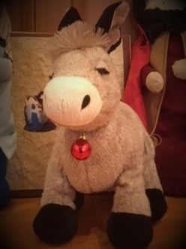 **WHERE’S PEDRO???**

**Pedro, the Las Posadas donkey, has**

**wandered away from Mary and Joseph.**

**Can you find him in his 8 various hiding spots?**

**#1 (easy)**

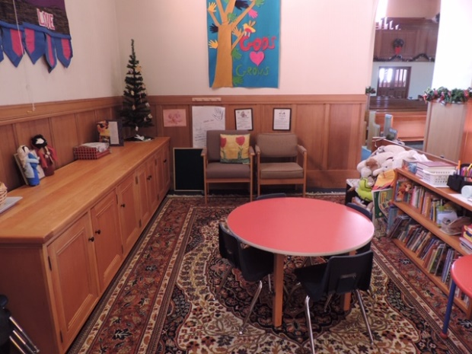

**#2 (easy)**

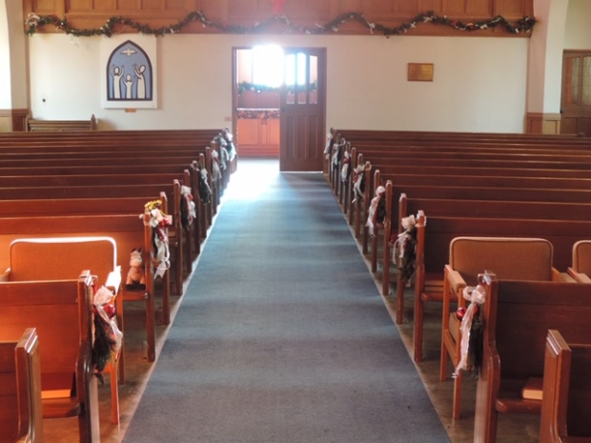

**#3 (moderately easy)**

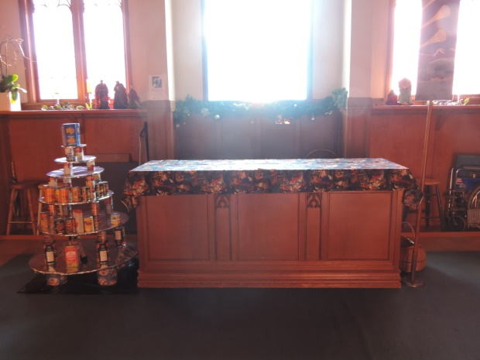

**#4 (moderate)**

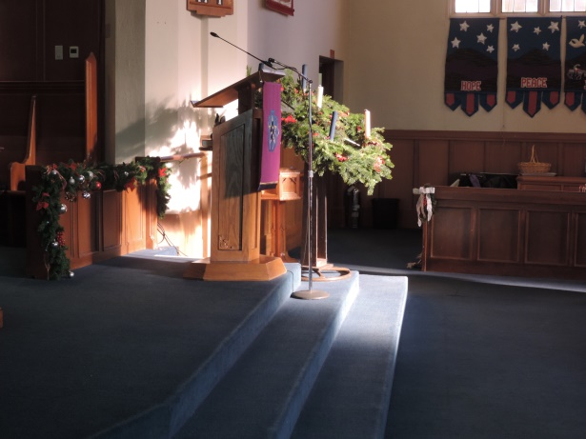

**#5 (moderate)**

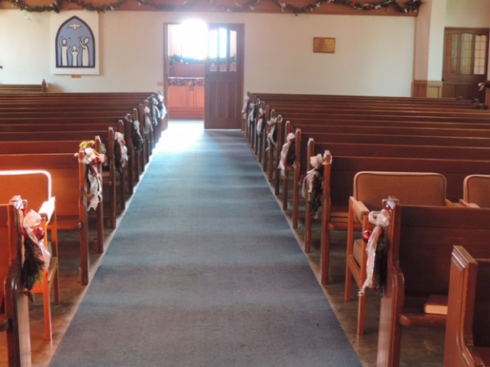

**#6 (may be a challenge)**

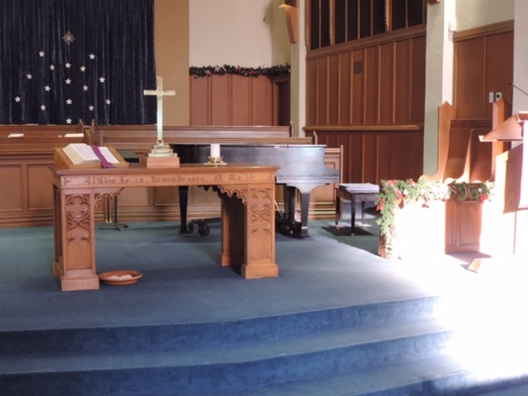

**#7 (a challenge)**



**#8 (a challenge!)**

