**The Territory of the People**

Anglican Church

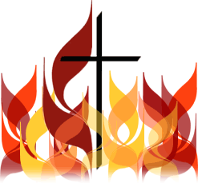

**Territory Bulletin**

**28 May 2020 – Season of Pentecost**

**BISHOP ELECT LINCOLN’S REFLECTION:**

Friends,

The Feast of Pentecost is upon us, and I like to share this story from “The Sayings of the Desert Fathers”:

Abba Lot went to Abba Joseph and said to him, “Abba, as far as I can I say my little office, I fast a little, I pray and meditate, I live in peace as far as I can, I purify my thoughts. What else can I do?” Then the old man stood up and stretched his hands toward heaven. His fingers became like ten lamps of fire and he said to him, “If you will, you can become all flame.”

While we work on re-opening our parishes and work on keeping everyone safe, our faith is more than our building. Yes, the full expression of our faith is in our worship of God together, but our faith is never limited to that hour we spend with each other. Our faith is our lives, lived out in our homes and communities. Our faith is our prayers and readings at home while we isolate. Our faith is our words and actions to our world.

We can all become like flame, burning with the love of God more strongly and burning with that love for all the world. It is how much we desire this which limits us. The Holy Spirit, which fills all of us can and does give us all the gifts we need to be greater and greater witnesses to that Love.

I encourage all of you to let the Spirit burn within you to fill your communities with the unconditional Love God shows to all creation. Let the Spirit purge away all that hinders God’s work in your lives. Let the Spirit transform you into what God desires you to be.

May the Holy Spirit transform all of us in these days and weeks to come.

Lincoln



We light a candle,  
and enjoy the flickering light ,  
the fragrance  
and warmth it creates.  
But without the spark that ignites,  
there will be no flame.  
Without the wax,  
the source of power,  
the wick will not burn.  
Without the flame,  
there will be no fragrance,  
no warmth, no light.

And so with us, Lord.  
You are the catalyst that ignites us,  
and the fuel that sustains us.  
You fill us with your fragrance  
as you enter our lives.  
You empower us  
to carry your flame in our hearts,  
to be the fragrance, warmth,  
and light of your love,  
in this dark world.

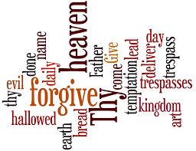**Prayers…**

* We pray for our parishes, and congregations during this time of uncertainty, change, and anxiety, in the midst of the COVID–19 pandemic and as we make plans to re-open our churches
* We pray for our Bishop Elect Lincoln Mckoen, and his wife Tanya, as Lincoln transitions from his parish ministry to Bishop of the Territory of the People
* We pray for Bruce Chalmers and family as he prepares to join us in ministry serving at North Thompson Shared Ministry.
* We pray for Len Fraser during his time of transition to retirement
* We pray for the Rev Canon Isabel Healy Morrow as she continues her journey of recovery through dialysis and chemo treatments, giving thanks for all who support her.
* We pray for the Lillooet Shared Ministry in their search for new leadership
* We pray for St Michael’s, Prince George, St. John the Divine, Quesnel, and Grace Church Prince George during their time of transition

**Territory News:**

**COVID-19**

**The Territory Office** remains closed at this time as staff continue to work from home. The office telephone has been forwarded to the cell phone of Margaret Mitchell, Office Coordinator, who is available to answer your calls during regular office hours – Tuesday to Thursday, 9:30am – 4:00pm.

The office email [office@territory.anglican.ca](mailto:office@territory.anglican.ca) is also monitored during regular office hours.

**Idle Buildings -** please click [here](https://www.territoryofthepeople.ca/news/covid-19-and-idle-buildings) for important information from our insurance company about buildings which are idle during the COVID-19 pandemic.

**Weddings -** Many things can be done by ZOOM, but in the Province of BC, weddings are not one of them! Click [here](https://static1.squarespace.com/static/5754e78407eaa05442bcbd33/t/5ea0b528936e9a386bd36130/1587590447663/Rel+Reg+Update+-+Legal+marriages+in+BC+April+2020.pdf) for a letter from BC Vital Statistics.

**Re-Opening Plans –** Bishop Elect Lincoln has shared the Territory plans for re-opening our churches. Click [here](https://www.territoryofthepeople.ca/news/re-opening-plans).

**Armatus: *Learn to Protect***

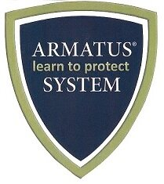With all this time on our hands as we self isolate at home and/or keep our social distance… we have an opportunity to complete the **Armatus: *Learn to Protect*** course modules online by using your personal computer or tablet. Each course takes approximately 15 minutes to complete. Although our churches are closed for the time being, they will re-open in due course and our ministry to others will continue. Click here to see if you are required to take the modules. Should you require further information, please contact Cathy Wozlowski, Safe Church Administrator at [wozcathy@gmail.com](mailto:wozcathy@gmail.com)

Please be aware the Lay Ministers of Word and Sacrament License is conditional on completing the Armatus Safe Church on-line training. Click [here](https://www.territoryofthepeople.ca/resources/pages/safe-church) for more information. When you have completed your on-line training, send a copy of your Certificate of Completion to the Territory Office.

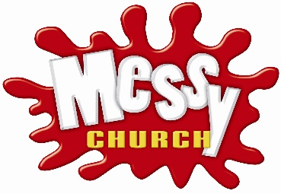**Other News:**

**Messy Church Canada** is holding a National “Messy Connections” Conference in Winnipeg from October 15 to 18, 2020. Information about the Conference and Registration can be found [here](https://www.eventbrite.ca/e/messy-connections-the-canadian-messy-church-conference-tickets-90378543657).

**BISHOP’S SCHEDULE AND IMPORTANT DATES AND DEADLINES**

|  |  |
| --- | --- |
| May 1 Bishop Elect Lincoln Mckoen began his ministry as the Territory Administrator  June 25 Administration Committee – 7pm Zoom meeting  September 1 Deadline Anglican Foundation Grants  September 24 Administration Committee – 7pm Zoom Meeting | October 2-4 Equip – Kamloops  October 15 Deadline Parish Grants  October 15 Deadline Rufus Gibbs Grants  October 15 Deadline Ministry Fund Grants  October 31 Administration Committee – 9am In Person budget meeting – Kamloops  Nov 20-21 Coordinating Council – the Shrine Cache Creek |

|  |  |
| --- | --- |
| **HANDY LINKS:**   * [Anglican Church of Canada](https://www.anglican.ca) * [Anglican Journal](https://www.anglicanjournal.com/) * [Anglican Foundation](https://www.anglicanfoundation.org) * [The Anglican Diocese of Montreal](https://www.montreal.anglican.ca/) * [Book of Alternative Services](https://c2892002f453b41e8581-48246336d122ce2b0bccb7a98e224e96.ssl.cf2.rackcdn.com/BAS.pdf) * Calendar of Intercessions Prayer Cycle – [**April to June**](https://www.territoryofthepeople.ca/pages/resources)**, 2020** * [Common Praise online](http://www.commonpraiseonline.ca/) | * [Employee Assistance Program - Lifeworks](https://www.lifeworks.com/) * [How to Pray – a meditation by St. Seraphim of Sarov](https://static1.squarespace.com/static/5754e78407eaa05442bcbd33/t/5d89253088af8a5b46e8e380/1569269043423/How+to+Pray.pdf) b.1754 * [Pilgrim Paths](http://www.pilgrimpaths.co.uk/page17.html): labyrinth prayer walks accompanying the church year of prayer, feasts and celebrations. Volumes On and Two in pdf format. * [PWRDF](https://pwrdf.org/) * [Territory of the People website](https://www.territoryofthepeople.ca/pages/territory-bulletins) |

**Courtesy of Lincoln:**

**How do Bishops self-distance?**

**By staying two mitres apart!**







Thank you to all the superheroes out there who continue to work, so we can continue to stay safe and healthy…