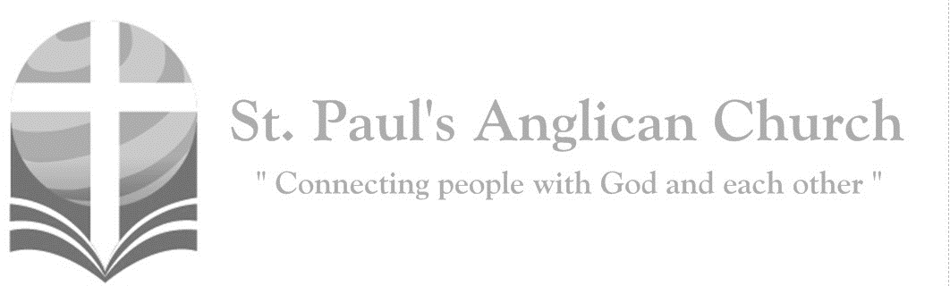
Sunday, May 31, 2020: The Day of Pentecost

Come, Holy Spirit, fill the hearts of your faithful;
and kindle in us the fire of your love.

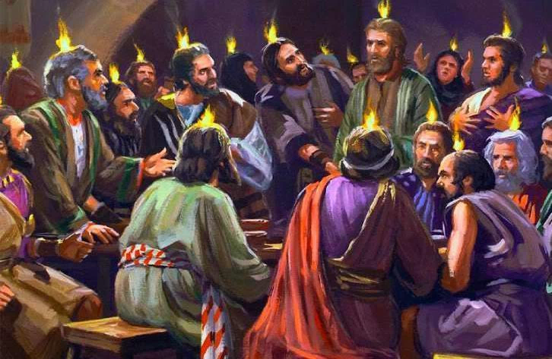

Opening Song: Holy Spirit, Come with Power
Holy Spirit, come with power
Breathe into our aching night
We expect you this glad hour
Waiting for your strength and light
We are fearful, we are ailing
We are weak and selfish too
Break upon your congregation
Give us vigour, life anew

Holy Spirit, come with fire
Burn us with your presence new
Let us as one mighty choir
Sing our hymn of praise to you
Burn away our wasted sadness
And enflame us with your love
Burst upon your congregation
Give us gladness from above

Holy Spirit, bring your message
Burn and breathe each word anew
Deep into our tired living
Till we strive your work to do
Teach us love and trusting kindness
Lend our hands to those who hurt
Breathe upon your congregation
And inspire us with your word

The Gathering of the Community
Celebrant: Alleluia! Christ is risen.
People: The Lord is risen indeed. Alleluia!
Celebrant: May his grace and peace be with you.
People: May he fill our hearts with joy.
Celebrant: Almighty God,
All: to you all hearts are open, all desires known, and from you no secrets are hidden. Cleanse the thoughts of our hearts by the inspiration of your Holy Spirit that we may perfectly love you, and worthily magnify your holy name; through Christ our Lord. Amen.
Celebrant: Almighty and everliving God, who fulfilled the promises of Easter by sending us your Holy Spirit and opening to every race and nation the way of life eternal, keep us in the unity of your Spirit, that every tongue may tell of your glory; through Jesus Christ our Lord, who lives and reigns with you and the Holy Spirit, one God, now and for ever.
People: Amen.

The Reading of Scripture
First Reading: Acts 2:1-21
When the day of Pentecost had come, they were all together in one place. And suddenly from heaven there came a sound like the rush of a violent wind, and it filled the entire house where they were sitting. Divided tongues, as of fire, appeared among them, and a tongue rested on each of them. All of them were filled with the Holy Spirit and began to speak in other languages, as the Spirit gave them ability. Now there were devout Jews from every nation under heaven living in Jerusalem. And at this sound the crowd gathered and was bewildered, because each one heard them speaking in the native language of each. Amazed and astonished, they asked, "Are not all these who are speaking Galileans? And how is it that we hear, each of us, in our own native language? Parthians, Medes, Elamites, and residents of Mesopotamia, Judea and Cappadocia, Pontus and Asia, Phrygia and Pamphylia, Egypt and the parts of Libya belonging to Cyrene, and visitors from Rome, both Jews and proselytes, Cretans and Arabs--in our own languages we hear them speaking about God's deeds of power." All were amazed and perplexed, saying to one another, "What does this mean?" But others sneered and said, "They are filled with new wine." But Peter, standing with the eleven, raised his voice and addressed them, "Men of Judea and all who live in Jerusalem, let this be known to you, and listen to what I say. Indeed, these are not drunk, as you suppose, for it is only nine o'clock in the morning. No, this is what was spoken through the prophet Joel: 'In the last days it will be, God declares, that I will pour out my Spirit upon all flesh, and your sons and your daughters shall prophesy, and your young men shall see visions, and your old men shall dream dreams. Even upon my slaves, both men and women, in those days I will pour out my Spirit; and they shall prophesy. And I will show portents in the heaven above and signs on the earth below, blood, and fire, and smoky mist. The sun shall be turned to darkness and the moon to blood, before the coming of the Lord's great and glorious day. Then everyone who calls on the name of the Lord shall be saved.'
Reader: The Word of the Lord.
People: Thanks be to God.

Canticle: Psalm 104:24-35
Refrain:

O Lord, how manifold are your works! In wisdom you have made them all; the earth is full of your creatures. Yonder is the great and wide sea with its living things too many to number, creatures both small and great. There move the ships, and there is that Leviathan, which you have made for the sport of it. All of them look to you to give them their food in due season. Refrain. (Continued on next page)
You give it to them; they gather it; you open your hand, and they are filled with good things. You hide your face, and they are terrified; you take away their breath, and they die and return to their dust. You send forth your Spirit, and they are created; and so you renew the face of the earth. May your glory, O Lord, endure for ever; may you rejoice in all your works. Refrain.

You look at the earth and it trembles; you touch the mountains and they smoke. I will sing to the Lord as long as I live; I will praise my God while I have my being. May these words of mine please you; I will rejoice in the Lord. Bless the Lord, O my soul. Hallelujah! Refrain.

Second Reading: 1 Corinthians 12:3b-13
No one can say "Jesus is Lord" except by the Holy Spirit. Now there are varieties of gifts, but the same Spirit; and there are varieties of services, but the same Lord; and there are varieties of activities, but it is the same God who activates all of them in everyone. To each is given the manifestation of the Spirit for the common good. To one is given through the Spirit the utterance of wisdom, and to another the utterance of knowledge according to the same Spirit, to another faith by the same Spirit, to another gifts of healing by the one Spirit, to another the working of miracles, to another prophecy, to another the discernment of spirits, to another various kinds of tongues, to another the interpretation of tongues. All these are activated by one and the same Spirit, who allots to each one individually just as the Spirit chooses. For just as the body is one and has many members, and all the members of the body, though many, are one body, so it is with Christ. For in the one Spirit we were all baptized into one body--Jews or Greeks, slaves or free--and we were all made to drink of one Spirit.
Reader: The Word of the Lord.
People: Thanks be to God.

The Gospel Reading
Leader: The Lord be with you.
People: And also with you.
Leader: The Holy Gospel of our Lord Jesus Christ according to St. John.
People: Glory to you, Lord Jesus Christ.
Gospel Reading: John 20:19-23
When it was evening on that day, the first day of the week, and the doors of the house where the disciples had met were locked for fear of the Jews, Jesus came and stood among them and said, "Peace be with you." After he said this, he showed them his hands and his side. Then the disciples rejoiced when they saw the Lord. Jesus said to them again, "Peace be with you. As the Father has sent me, so I send you." When he had said this, he breathed on them and said to them, "Receive the Holy Spirit. If you forgive the sins of any, they are forgiven them; if you retain the sins of any, they are retained."
Leader: The Gospel of Christ.
People: Praise to you, Lord Jesus Christ.

Message from the Rev. Dr. Myron Penner

Affirmation of Faith – Vine and Branches
All: We believe in God, the Root of all living, Creator of all things. We live in Christ Jesus, God’s Son, who loved all people and who makes us one in his love. He suffered and died, and was raised to new life. In his death and resurrection, we are also raised to new life. Christ is our Vine, and we are his branches; and without him we cannot live. We live by the Holy Spirit, flowing through us so that we may bear fruit for God, the fruit of love. In the Spirit we are one with Christ, one with each other, and one in ministry to all the world. We trust in the one holy church, the communing of saints, the forgiveness of sin, the mystery of resurrection, and the grace of eternal life. Amen.

Prayers of the People
Reader: Hear our cry, Almighty God. Listen to our prayer. How long will we have to hide in our homes from this invisible enemy? Where will it strike next? And whom? What will happen to the economy? How will we provide food and shelter for our loved ones if there is no work? We are filled with questions of “What if…?” Our screens relay a continuous escalation of suffering and death around the world. Panic and anxiety abounds. Our souls are weary from the strain of the life-altering unknowns we are forced to live with. Heavenly Father, from the depths of our pain and confusion, we cry out to You. From fear-filled hearts and anxious minds, we plead with You. Rescue us, Father of compassion and grace. We lift up our eyes to You, Lord God, the One who sits enthroned in heaven. Today, we lift up those in our St. Paul’s Cycle of Prayer: Chandra Singham and Hannah David and their daughter Tisha Raj; Nick Delaney and Angela Ziniewicz; Gay Gering; and David Lenzi; as well as all of those in the Anglican Cycle of Prayer, let us pray,
All: Lord, have mercy.
Reader: On all who have contracted the virus.
All: Lord, have mercy.
Reader: On all who have lost loved ones to this sickness and are in mourning and anguish.
All: Lord, have mercy.
Reader: On all who are unable to earn an income because their jobs have been suspended.
All: Lord, have mercy.
Reader: We cry out for healing and needed resources. We cry out for comfort and peace (silence).
Reader: On all medical professionals and caretakers attending to those infected with the virus.
All: Christ, have mercy.
Reader: On all scientists and technologists striving to find a vaccine and to make it available.
All: Christ, have mercy.
Reader: On all leaders of institutions and governments as they make decisions to try and contain the virus.
All: Christ, have mercy.
Reader: We pray for strength in the long and exhausting hours of labor. We pray for wisdom in the research and difficult decisions (silence).
Reader: On all who have not yet contracted the virus.
All: Lord, have mercy.
Reader: On the most vulnerable of our society who are unable to buy extra food or get proper medical attention.
All: Lord, have mercy.
Reader: On all disciples of Jesus Christ discerning how to reflect His love to others within this crisis.
All: Lord, have mercy.
Reader: We plead for protection of health. We plead for all to remain calm and kind (silence).
Reader: The Lord is the everlasting God, the Creator of the expanse of the universe. And yet this earth is no longer as You created it to be. Holy Father, our earth groans from the devastation caused by the curse of the Fall. My God, Your Word is true. One day You will liberate creation from its bondage to decay and death. Life is sacred and precious in your sight. You are the God Who sees us and sustains us. In Jesus you have shown us your love. Give us power together with all those who are Christ’s own to grasp how long and high and deep and wide your love of us is in Jesus Christ. And that we would know that love. Nothing can separate us this unfailing love and kindness, not even sickness or the fear of tomorrow. You are our Light as we walk in this darkness. We will remember to celebrate the beautiful gifts You have given us in this present moment. Almighty God, You are our Rock, our Refuge from the enemy, our hiding place. You calm our frantic thoughts and fill our despairing hearts with joy and strength. In Your Presence living water springs forth in the wilderness. You restore our souls.

Confession of Sin
Celebrant: Dear friends in Christ, God is steadfast in love and infinite in mercy; he welcomes sinners and invites them to his table. Let us confess our sins, confident in God’s forgiveness.
Silent Confession
Celebrant: Most merciful God,
All: we confess that we have sinned against you in thought, word, and deed, by what we have done and by what we have left undone. We have not loved you with our whole heart; we have not loved our neighbours as ourselves. We are truly sorry and we humbly repent. For the sake of your Son Jesus Christ, have mercy on us and forgive us, that we may delight in your will, and walk in your ways, to the glory of your name. Amen.
Celebrant: Almighty God have mercy upon you, pardon and deliver you from all your sins, confirm and strengthen you in all goodness and keep you in eternal life through Jesus Christ our Lord.
People: Amen.

The Peace
Celebrant: The peace of the Lord be always with you.
People: And also with you.

Prayer Over the Gifts
Celebrant: Giver of life,
All: receive all we offer you this day. Let the Spirit you bestow on your Church continue to work in the world through the hearts of all who believe. We ask this in the name of Jesus Christ the Lord. Amen.

Celebrant: The Lord be with you.
People: And also with you.
Celebrant: Lift up your hearts.
People: We lift them to the Lord.
Celebrant: Let us give thanks to the Lord our God.
People: It is right to give our thanks and praise.
Celebrant: Blessed are you, gracious God, creator of heaven and earth; we give you thanks and praise through Jesus Christ our Lord. In fulfillment of your promise you pour forth your Spirit upon us, filling us with gifts and leading us into all truth. You give us power to proclaim your gospel to all nations and to serve you as a royal priesthood. Therefore, we join our voices with angels and archangels, and with all those in whom the Spirit dwells, to proclaim the glory of your name.
All: (Said) Holy, holy, holy Lord, God of power and might, heaven and earth are full of your glory. Hosanna in the highest. Blessed is he who comes in the name of the Lord. Hosanna in the highest.
Celebrant: Holy and gracious God, accept our praise, through your Son our Saviour Jesus Christ; who on the night he was handed over to suffering and death, took bread and gave you thanks, saying, “Take, and eat: this is my body which is broken for you.” In the same way he took the cup, saying, “This is my blood which is shed for you. When you do this, you do it in memory of me.” Remembering, therefore, his death and resurrection, we offer you this bread and this cup, giving thanks that you have made us worthy to stand in your presence and serve you. We ask you to send your Holy Spirit upon the offering of your holy Church. Gather into one all who share in these sacred mysteries, filling them with the Holy Spirit and confirming their faith in the truth, that together we may praise you and give you glory through your Servant, Jesus Christ. All glory and honour are yours, Father and Son, with the Holy Spirit in the holy Church, now and for ever.
All: Amen.

Celebrant: As our Saviour taught us, let us pray,
All: (Said) Our Father in heaven, hallowed be your name. Your kingdom come, your will be done, on earth as in heaven. Give us today our daily bread. Forgive us our sins as we forgive those who sin against us. Save us from the time of trial, and deliver us from evil. For the kingdom, the power, and the glory are yours, now and for ever. Amen.

Celebrant: We break this bread to share in the body of Christ.
All: We, being many, are one body, for we all share in the one bread.

Celebrant: The gifts of God for the People of God.
People: Thanks be to God.

The Communion
Please share the gifts of the bread and the wine with those who are gathered with you.

Lamb of God
(Sung) O, Lamb of God, you take away the sin of the world: have mercy on us.
O, Lamb of God, you take away the sin of the world: have mercy on us.
O, Lamb of God, you take away the sin of the world: grant us peace.

Communion Song: The River
To the river I am going
Bringing sins I cannot bear
Come and cleanse me, come forgive me
Lord I need to meet You there

In these waters healing mercy
Flows with freedom from despair
I am going to that river
Lord, I need to meet You there

(Chorus) Precious Jesus I am ready
To surrender every care
Take my hand now, lead me closer
Lord I need to meet You there

Come and join us in the river
Come find life beyond compare
He is calling, He is waiting
Jesus longs to meet you there

Prayer After Communion
Celebrant: (pg. 346) Father,
All: may we who have received this eucharist live in the unity of your Holy Spirit, that we may show forth his gifts to all the world. We ask this in the name of Jesus Christ our Lord. Amen.

Celebrant: (pg. 214) Glory to God,
All: whose power, working in us, can do infinitely more than we can ask or imagine. Glory to God from generation to generation, in the Church and in Christ Jesus, for ever and ever. Amen.

Blessing

Closing Song: Shout to the North

Men of faith rise up and sing
Of the great and glorious King
You are strong when you feel weak
In your brokenness complete

(Chorus)
Shout to the north and the south
Sing to the east and the west
Jesus is Savior to all
Lord of heaven and earth

Rise up women of the truth
Stand and sing to broken hearts
Who can know the healing power
Of our awesome King of love
(To Chorus)

Rise up church with broken wings
Fill this place with songs again
Of our God who reigns on high
By His grace again we'll fly
(To Chorus)

We've been through fire
We've been through rain
We've been refined
By the power of His name
We've fallen deeper
In love with You
You've burned
The truth on our lips (To Chorus)

The Dismissal
Leader: Go forth into the world, rejoicing in the power of the Spirit.
All: Thanks be to God. Amen.

Thank You From Lauren Rudat
I (Lauren) want to say a very heartfelt thank you to everyone who came out/joined on zoom/contributed to my bridal shower on Saturday! From beautiful driveway decorations by Macreena, Jae, and Luka, to a live song performance, to delicious cake and all of the beautiful gifts and cards I received, the entire day is a memory that I will treasure for many years! I was blown away by the generosity, time, and care you showed, and my heart is very full. What an incredible community to begin our marriage in. We cherish you! Special thank you to Stephanie Armstrong and Michelle Schurek for your planning, you two are a dream team!

Guys Table Top Zoom Hang Out – Thursdays 7-9PM on Zoom
Come join Dave Parker and other guys of all ages for a Zoom meeting Hang Out every Thursday 7:00-9:00PM. We will be working on our own projects at home, while chatting and sharing what we are doing with each other. For example, Dave will be painting miniatures for games, but anything works (as long as power tools are not involved). You are also welcome to invite non-parishioners that you think might be interested. To join us, please visit the Event page on the website, select the Guys Table Top Event and click on the Zoom link.

St. Paul’s Cycle of Prayer:
Chandra Singham and Hannah David and Tisha Raj;
Nick Delaney and Angela Ziniewicz;
Gay Gering;
David Lenzi
Anglican Cycle of Prayer:
Diocese of Kootenay; the Rt. Rev. Dr. Lynne McNaughton. Diocese of Edmonton outreach ministries: Bleeding Heart Art Space; PrayerWorks Hall; Diocesan Outreach Youth Coordinator, Clark Hardy; the intentional Christian community of Ascension House. The Archdeacons of the Diocese of Buyé: Amos Mutezimana, Evariste Nsabimana, Casmir Ndereyimana, Frederic Miburo, Simeon Ntirandekura, and Leonidas Nizigiyimana. Paul First Nation.

St. Paul’s Anglican Church
10127 145 Street, Edmonton T5N 2X6
Phone: (780) 455-0771; Email: office@stpauls-anglican.ca
Website: www.stpauls-anglican.ca
Office Hours:
Monday-Thursday: 9:00AM-12:00PM
Closed: Fri/Sat/Sun and Stat Holidays
St. Paul’s Vestry:
Peter Jackson, Rector’s Warden
Margot Byer, People’s Warden
David Heritage, Treasurer
Barb Dixon, Vestry Member
John Green, Vestry Member
Deanna Kalles, Vestry Member
David Parker, Vestry Member
Carol Rudat, Vestry Member

facebook.com/stpachurchedmonton
@StEdmonton
For Care/Concern Team
or other prayer requests, email:
office@stpauls-anglican.ca
For urgent prayer requests call
the church office: (780) 455-0771
For pastoral emergencies call:
(587) 334-2130

St. Paul’s Staff:
Rector: The Rev. Myron B. Penner
Office Administrator: RJ Chambers
Youth Leader: Victoria Eeles

