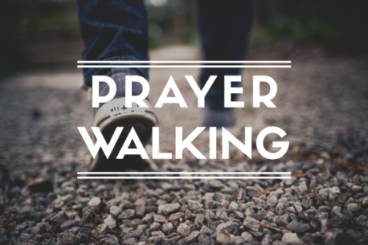

Prayer is a strategic way to seek God on behalf of our community. Remember, in Matthew 5:14-16 Jesus declared that His followers “are the light of the world.” This is an amazing privilege and an awesome responsibility.

This summer, please take time to go for a walk in your neighbourhood. As you do, please ask God to B.L.E.S.S. your neighbours, according to acrostic prayer guide below.

Whatever time you can give to this will be a blessing! There will be no “Zoom & Prayer” this summer. Instead, please join us at 6 pm, July 12 and August 9 for Park & Pray at Webster’s Corners Park!

Body pray for safety and health, especially in light of COVID-19
Labor pray for good employment, provision and productivity
Emotion pray for joy, inner strength, contentment, and peace
Social pray for good relationships with family and friends
Spiritual pray for response to the Gospel and growth in grace

living and sharing the life of Jesus

