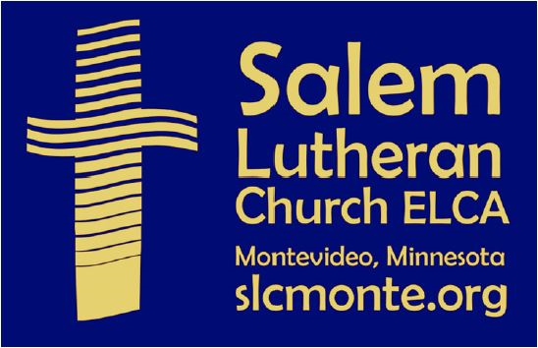
SALEM LUTHERAN CHURCH – ELCA
631 N 7TH ST.
MONTEVIDEO MN 56265
320-269-7624
slcelca@msn.com
May 2020 SLC News

During the COVID19 outbreak, Salem’s worship services are online. As a way to include those who do not use the internet, we are testing the option of you calling in to listen to the worship service on your phone. There is no charge to you for this service, and we are happy to provide it if people use it.

These are the dates and times for when the instructions below will work.
Sunday May 3, 2020 10:00 AM Wednesday May 6, 2020 6:00 PM
Sunday May 10, 2020 10:00 AM Wednesday May 13, 2020 6:00 PM
Sunday May 17, 2020 10:00 AM Wednesday May 20, 2020 6:00 PM
Sunday May 24, 2020 10:00 AM Wednesday May 27, 2020 6:00 PM
Sunday May 31, 2020 10:00 AM

INSTRUCTIONS TO LISTEN TOLL FREE:
Before the service begins call either of the toll free numbers listed below:
· 877 853 5257
· 888 475 4499
You will be asked to enter the following using your phone keys:
· Meeting ID (Wednesdays at 6PM): 698 391 543 then press #
Participant ID: just enter # (If you are asked for this)
Password: just enter # (If you are asked for this)

· Meeting ID (Sundays at 10AM): 973 082 238 then press #
Participant ID: just enter # (If you are asked for this)
Password: just enter # (If you are asked for this)

· Remain on the line and you will be connected. You may not hear anything except music and silence before the service begins.
· If you need to call after the service has started, that is okay. You’ll simply begin listening at the current point in the service.
· You may hang up at the end of the service or at any point.

Blessings to you, and I hope that you will use this toll free call in service to join us for worship.

Thank you!
Pr. Matt Philaya

Great Turnout for Strombeck Cemetery Cleanup Saturday, April 25
Social Distancing By Household Successfully Maintained
It was a beautiful day when a number of Salem members gathered at Strombeck Cemetery for spring cleanup. Those who attended were mindful of practicing social distancing with others not from the same household.
Much work was completed. Leaves and sticks were picked up and hauled away. The encroaching brush was cleared back on the east end of the cemetery. It was a great service project at the perfect location to spend outdoors with others.
Service projects are a great way to work together during this time when we cannot get together in other ways. Thank you to those who have volunteered their time. MP

Salem Embraces God's Mission + Equips God's People
Learn about the ministry we support through the SWMN Synod
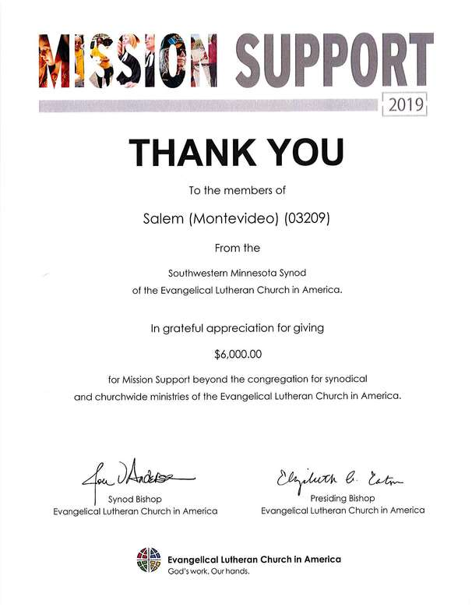
Over the course of 2019, Salem sent $6000 to the SWMN Synod to help support their partnership with us. The PDF attachment included in this post is a letter from Pr. Dee Pederson (who joined us in January for a special visioning meeting) thanking us for this support and describing the impact it has.
As pastor, I would like to also say a big THANK YOU for your giving to Salem that makes this possible. This is OUR offering together as a congregation to the work of the church beyond ourselves.
Note that the statement mentioned in the letter was not scanned to PDF, which simply lists the regular gifts made to the SWMN Synod by Salem throughout 2019.

40 DAYS OF GIVING
If you have been setting aside money for the 40 Days of Giving to ELCA World Hunger, we are ready to collect it and send it in after Saturday, May 4! Our initial goal had been $1000, and we will send in all that we receive to ELCA World Hunger, even if it exceeds that goal.
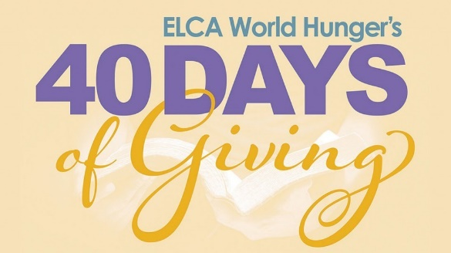
At the April Salem Council meeting it was decided that the most practical way to collect these funds is through Tithe.ly. Jackie Lindvall has created a specific giving category in Tithe.ly just for 40 Days of Giving. This is the preferred method so as to reduce the amount of direct handling of loose change and cash, which requires additional volunteers to come in. If you need to bring in your money directly to the church, please contact Pr. Matt or the Salem Office to make those arrangements. Checks made out to Salem with 40 Days of Giving in the memo line are also acceptable. Again, the deadline for doing this is Saturday, May 4 so that the check can be sent in the following week once the total is calculated.

Finance Committee Report
Prepared by Joe Helgeson on behalf of the Finance Committee
Year to Date Income $29,897.23
Year to Date Budgeted Income $35,543.00
Year to Date Expenses $35,125.23
Year to Date Budgeted Expense $43,141.00
A full financial report is available in the Church Office

April-May-June Christ In Our Home Available
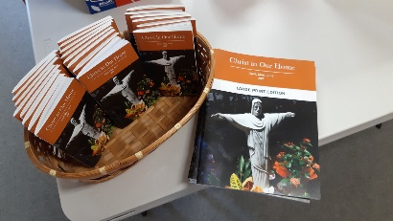
There are a number of copies of Christ In Our Home at the church. If you would like a copy, please email me at matt.philaya@slcmonte.org with your address and whether you would like large print or regular. I will be happy to deliver it when I get a chance.
You can also pick up a copy if you like on Wednesdays and Fridays OR if you happen to see my vehicle at the church.

CALENDAR

Sundays
9:00-10:00am Sunday Worship ONLINE
10:00-11:00am Sunday Worship ONLINE
11:00am Fellowship ONLINE

Wednesdays
9:00-10:00am Worship Service - Channel 180 Recorded the previous Sunday
6:00-7:00pm Wednesday Evening Worship ONLINE
6:30-7:30pm Worship Service - Channel 180 Recorded the previous Sunday

Fridays
9:00-10:00am Worship Service - Channel 180 Recorded the previous Sunday
10:00-11:00am Friday Morning Coffee ONLINE

Salem Lutheran Church
631 North Seventh Street
Montevideo, MN 56265

SLC Newsletter
www.slcmonte.org

