St Stephen the Martyr Anglican Church, Burnaby
Morning Prayer Together and Apart
July 5, 2020
5th Sunday after Pentecost

Opening Words

HYMN CP-354 Come Thou Fount – See pages 6

A Penitential Rite & Territorial Acknowledgment
The freedom in which we live is bounded by promises we are called to keep.

As children of Noah, we inherit his Covenant: to honour all life.

Grafted on to the root of Abraham, we inherit his Covenant: we are blessed, so that we might be a blessing to all nations.

Having received, through Moses, the Ten Commandments, we inherit his covenant: to worship no other gods; to rest from ceaseless work; to honour the wisdom of our elders; to keep our promises; to disavow idolatry, blasphemy, murder, theft, dishonesty, and greed.

As Canadians we are party to the treaties which formed us as a nation. This land where we now live is the ancestral lands of the Squamish, Musqueam, Tsleil-Watuth, and Kwiketlem nations.

In our baptism, we vow to seek, and find, and honour God in scripture and sacrament, in each other, in the stranger, the outsider, and the marginalized. We vow to seek justice, safeguard the integrity of creation, to resist evil and whenever we fall into sin, to repent and return to the Lord.

In the death, resurrection, and ascension of Jesus we are embraced into a new covenant, of eternal hope, and the forgiveness of sins.

According to our baptismal covenant, we confess that we have failed to live within the bounds of these promises. We confess our sins- individual, institutional, and systemic, and repent of the harm that is caused by our collective failure to honour all life.

Trusting that God keeps God’s promises, that light shines in the darkness and is not overcome, that love has power to make all things new; that God’s will can and one day shall be done on earth as it is in heaven: we ask for strength and courage to live each day as people of covenant, vow, and treaty.

Lord, have mercy. Christ, have mercy. Lord, have mercy.

Opening Responses
The kingdom of God is at hand;
O Come, Let us worship.
Lord, open our lips
And our mouth shall proclaim your praise.
O God, make speed to save us.
O Lord, make haste to help us.
Glory to the Father, and to the Son, and to the Holy Spirit:
as it was in the beginning, is now, and will be for ever. Amen.
The kingdom of God is at hand;
O Come, Let us worship.

The Jubilate – Psalm 100
Make a joyful noise to God, all the earth.
We will worship the Holy One with gladness;
Come into the Divine’s presence with singing.
We sing, for God made us, and we are God’s people.
Enter the gates of holiness with thanksgiving and praise.
We give thanks to God, for God is good.
Know that the Creator remains steadfast for all generations.
We rejoice, for God’s steadfast love endures forever.
(adapted from an inclusive language version by Ana Gobledale, UK)

Proclamation of the Word

Zechariah 9:9-12
Rejoice greatly, O daughter Zion! Shout aloud, O daughter Jerusalem! Lo, your king comes to you; triumphant and victorious is he, humble and riding on a donkey, on a colt, the foal of a donkey. He will cut off the chariot from Ephraim and the war horse from Jerusalem; and the battle bow shall be cut off, and he shall command peace to the nations; his dominion shall be from sea to sea, and from the River to the ends of the earth. As for you also, because of the blood of my covenant with you, I will set your prisoners free from the waterless pit. Return to your stronghold, O prisoners of hope; today I declare that I will restore to you double.

Hear what the Spirit is saying to God’s People.
All: Thanks be to God!

Psalm 145: 8-14
❖ The LORD is gracious and merciful, slow to anger and abounding in steadfast love.
❖ The LORD is good to all, and his compassion is over all that he has made.
❖ All your works shall give thanks to you, O LORD, and all your faithful shall bless you.
❖ They shall speak of the glory of your kingdom, and tell of your power,
❖ to make known to all people your mighty deeds, and the glorious splendor of your kingdom.
❖ Your kingdom is an everlasting kingdom, and your dominion endures throughout all generations.
❖ The LORD is faithful in all his words, and gracious in all his deeds.
❖ The LORD upholds all who are falling, and raises up all who are bowed down.

Romans 7: 15-25a
I do not understand my own actions. For I do not do what I want, but I do the very thing I hate. Now if I do what I do not want, I agree that the law is good. But in fact it is no longer I that do it, but sin that dwells within me. For I know that nothing good dwells within me, that is, in my flesh. I can will what is right, but I cannot do it. For I do not do the good I want, but the evil I do not want is what I do. Now if I do what I do not want, it is no longer I that do it, but sin that dwells within me. So I find it to be a law that when I want to do what is good, evil lies close at hand. For I delight in the law of God in my inmost self, but I see in my members another law at war with the law of my mind, making me captive to the law of sin that dwells in my members. Wretched man that I am! Who will rescue me from this body of death? Thanks be to God through Jesus Christ our Lord!

Hear what the Spirit is saying to God’s People.
All: Thanks be to God!

Matthew 11: 16-19, 25-30
"But to what will I compare this generation? It is like children sitting in the marketplaces and calling to one another, ‘We played the flute for you, and you did not dance; we wailed, and you did not mourn.' For John came neither eating nor drinking, and they say, 'He has a demon'; the Son of Man came eating and drinking, and they say, 'Look, a glutton and a drunkard, a friend of tax collectors and sinners!' Yet wisdom is vindicated by her deeds."

At that time Jesus said, "I thank you, Father, Lord of heaven and earth, because you have hidden these things from the wise and the intelligent and have revealed them to infants; yes, Father, for such was your gracious will. All things have been handed over to me by my Father; and no one knows the Son except the Father, and no one knows the Father except the Son and anyone to whom the Son chooses to reveal him. "Come to me, all you that are weary and are carrying heavy burdens, and I will give you rest. Take my yoke upon you, and learn from me; for I am gentle and humble in heart, and you will find rest for your souls. For my yoke is easy, and my burden is light."

The Gospel of Christ
All: Praise to You, Lord Jesus Christ.

Reflection: Video “The Gospel of the Kingdom”

Musical Reflection – Ugo Onwujiobi
Affirmation of Faith
Hear, O Israel,
the Lord our God, the Lord is one.
Love the Lord your God with all your heart,
with all your soul, with all your mind,
and with all your strength.
This is the first and the great commandment.
The second is like it: Love your neighbour as yourself.
There is no commandment greater than these.

Intercessions and Thanksgivings
In peace, we pray to you, Lord God.

Silence

For all people in their daily life and work;
For our families, friends, and neighbours, and for all those who are alone.

For our parish family, remembering this week: Greg & Shelly Rusch and family; Bob Rusch, Anita Sandiford, Betty Schellenberg and family.
For those who normally would use our facilities: the AA groups, choirs, exercise groups, daycares, and faith groups.
For this community, our country, and the world;
For all who work for justice, freedom, and peace.

For the just and proper use of your creation;
For the victims of hunger, fear, injustice, and oppression.
For all who are in danger, sorrow, or any kind of trouble;
For those who minister to the sick, the friendless, and the needy.

For the peace and unity of the Church of God;
For all who proclaim the gospel, and all who seek the truth.

For +Melissa our archbishop, Ruth our rector, and for all bishops and other ministers;
For the ministries within the Diocese of New Westminster, remembering especially the Legal Officers of the Diocese.

For all who serve God in the world, remembering our companion Diocese, the Episcopal Diocese of Northern Philippines
and our companion parish, St Stephen Mission in Bunga.
Hear us, Lord;
For your mercy is great.

For those who have asked for our prayers: Victor Baird, Dawn Noske, Lydia Holmlund, Moira Small, Gail Babiuk, Hank Kassteen, Mike Koombes, Marianne Sweet, Audrey Watson, Lenora Morse, Barb Hunter, Ken Fraser, and Linda Uno.
For our own needs and those of others.
Silence. People may add their own petitions.

Hear us, Lord;
For your mercy is great.

We pray for all those who have died in the peace of Christ, and for those whose faith is known to you alone, that they may have a place in your eternal kingdom.
Silence. People may name their remembered dead

Rest eternal grant to them, O Lord,
And let light perpetual shine upon them.

Lord, let your loving kindness be upon them;
Who put their trust in you.

We thank you, Lord, for all the blessings of this life.
Silence. People may add their own thanksgivings

We will exalt you, O God;
And praise your name for ever and ever.

Collect of the Day
Lord of heaven and earth, whose Son came eating and drinking, exposing the rivalry that tears the world apart: may we share his feast and friendship and lay our burdens in his liberating arms; through Jesus Christ, Wisdom’s child. Amen.
Prayers for an Inclusive Church (2009) alt.

The Lord’s Prayer
Gathering our prayers and praises into one, let us pray as our Saviour taught us,
Our Father in heaven, hallowed be your name,
your kingdom come, your will be done,
on earth as in heaven.
Give us today our daily bread.
Forgive us our sins as we forgive those who sin against us.
Save us from the time of trial, and deliver us from evil.
For the kingdom, the power, and the glory are yours,
now and for ever. Amen.

Let us bless the Lord.
Thanks be to God. Alleluia!

May the God of hope fill us with all joy and peace in believing through the power of the Holy Spirit.
Amen.

HYMN CP467 Forth in Thy Name, O Lord, I Go -- See Page 7

Closing Announcements

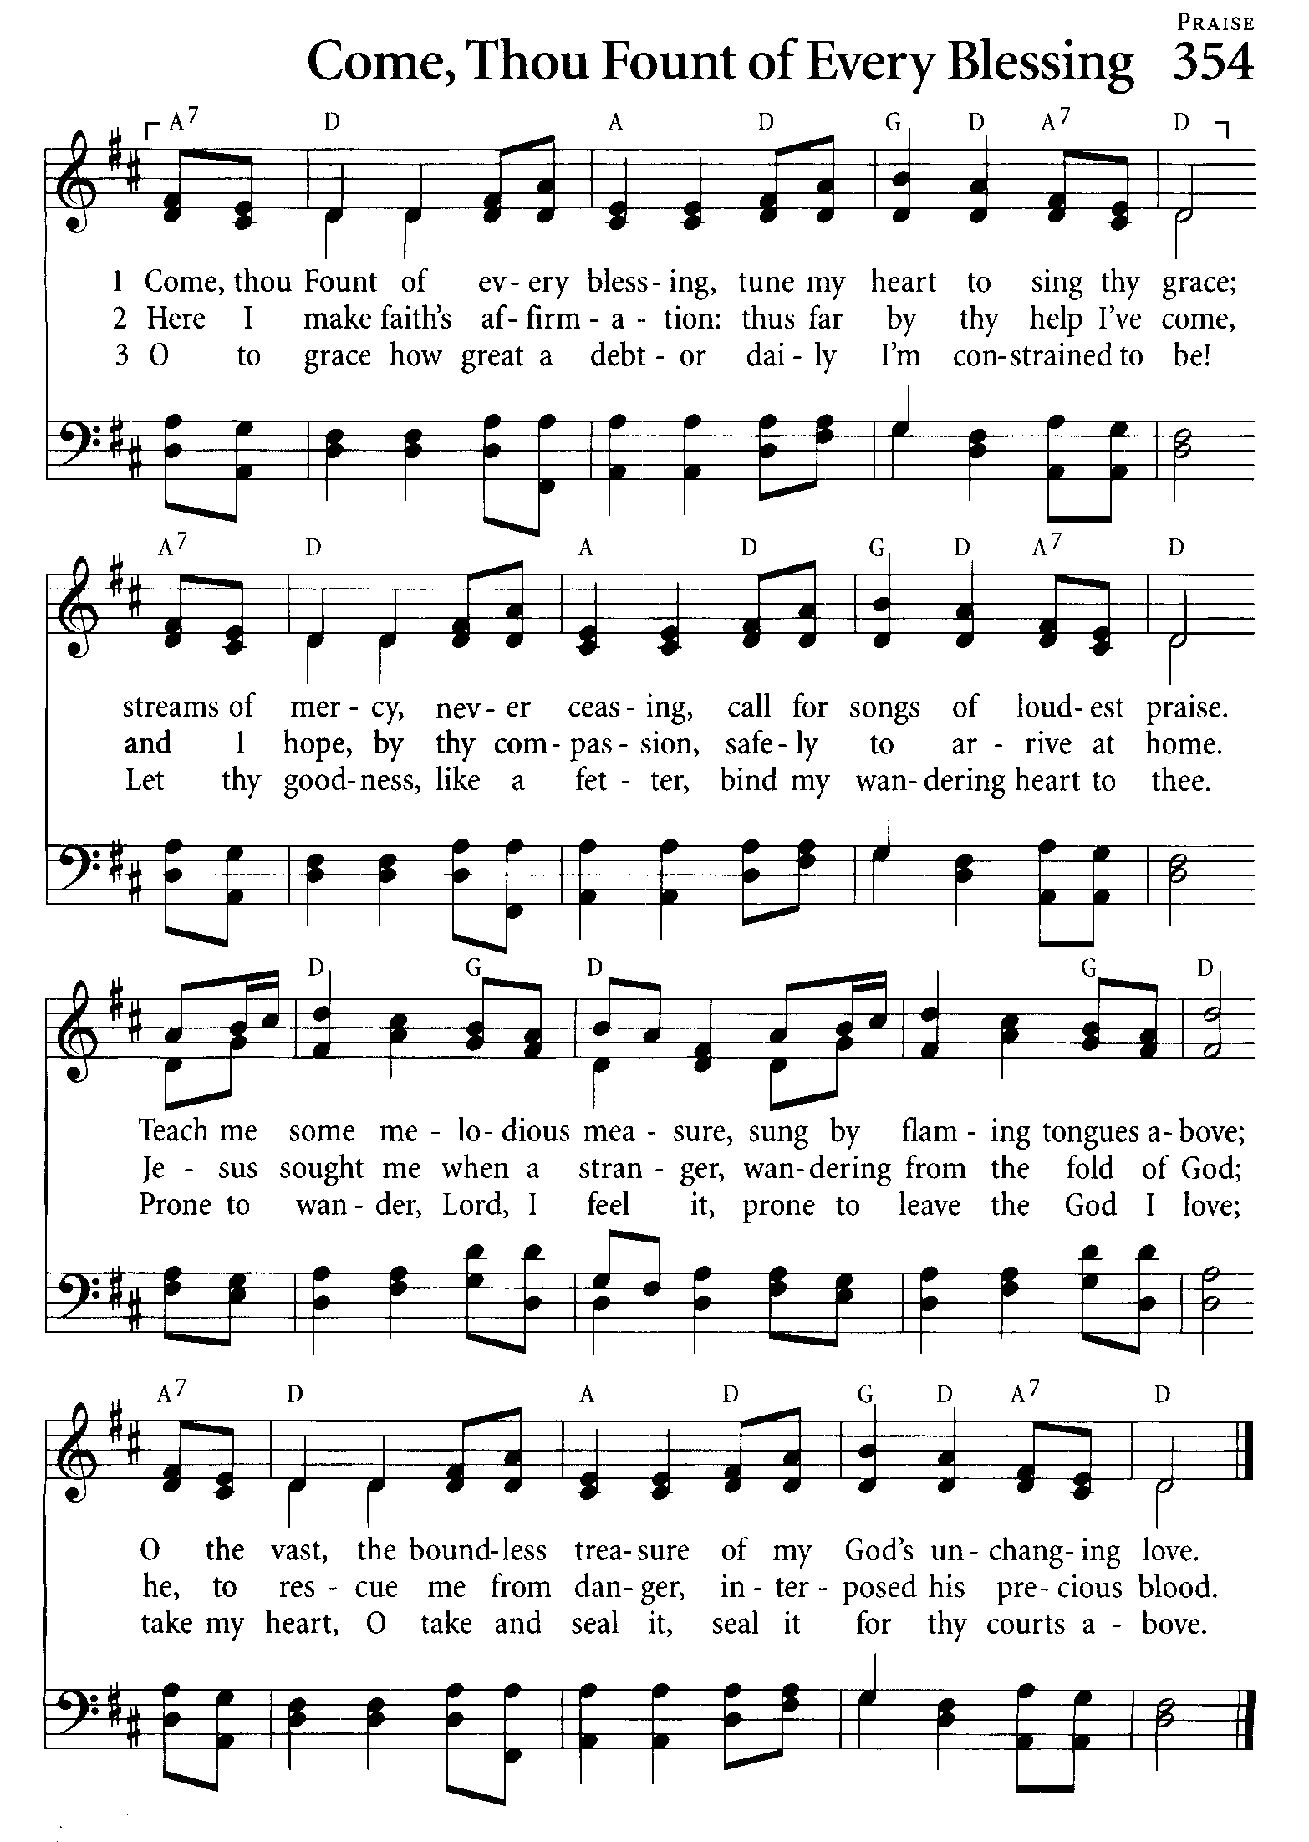

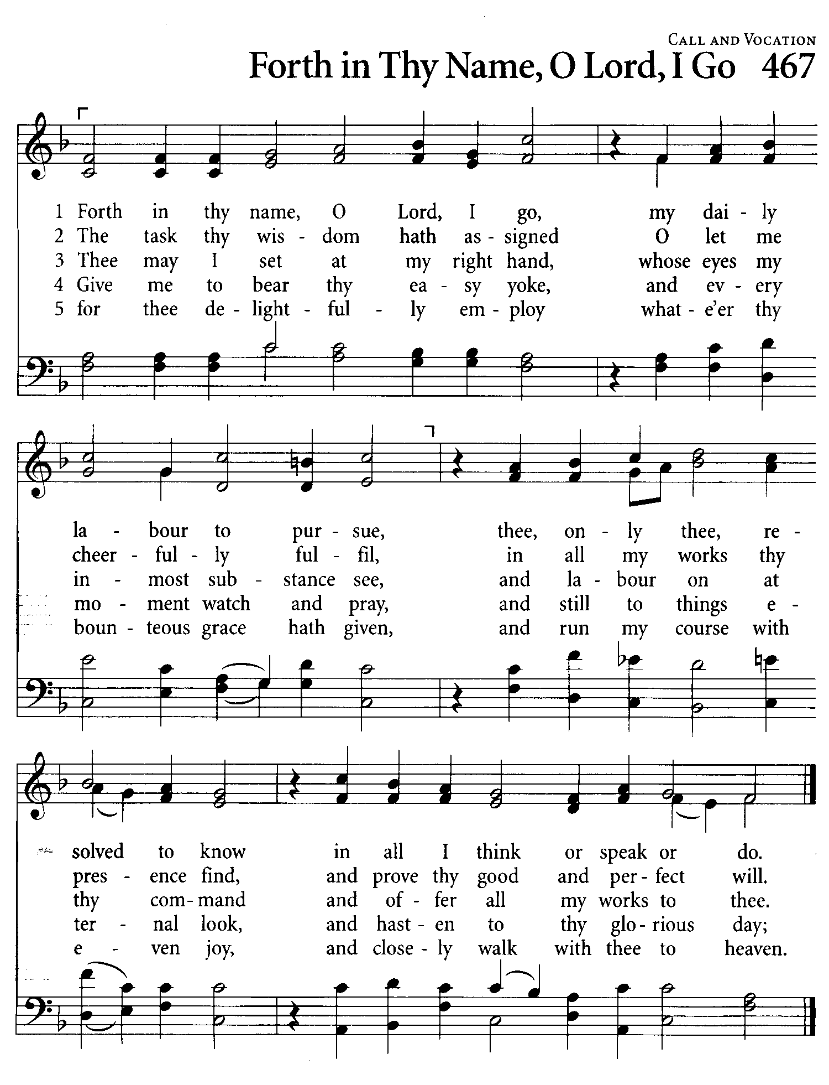

Here is the Morning Prayer bulletin
for this coming Sunday – July 5, 2020

This Morning Prayer order of service will be used for our on-line Zoom attendees, for those who are able to join us in-Person, and also those at home during this time who are unable to join us by Zoom or in-Person.

People are invited to use it alone or with members of their households. If you are praying with others, you are encouraged to take turns acting as "leader" and divide the words between you.

When praying this service alone, you are encouraged to set aside a space and time for prayer. Some people find it helpful to light a candle or use the same chair each time.

You may find it meaningful to read through this worship at 10am on Sundays when others from St Stephen's will be praying too, but whenever you pray know that you are united with Christians praying in a similar way through the world.

Would you like to join us
on Sunday Morning?
You can do this on your telephone!

If you have a telephone or cellphone, you can join us on Sunday mornings at 10:00 AM for our Zoom service! Just follow along with your bulletin and hear the music, the scriptures, the prayers, and Pastor Ruth’s message for us.

- Using your phone, dial the Zoom phoneline: 778-907-2071.
(It is best to call in around 9:55 AM so we can get everyone settled in before we start.)
- At the prompt, enter the meeting ID: 820 4853 6733
(you might be asked to enter the # sign afterwards)
- When prompted, enter the Password: 034102
- Wait a moment while you are connected.
- During the call, if you want to mute your phone so that no one can hear you, press *6. To unmute the call so you can talk, press *6 again.
- To leave the meeting, just hang up.

Coffee Time Codes

If you would like to join us for coffee time shortly after the service, use these codes.

Time: 11:30 am-12:30 PM
Meeting ID: 878 3715 7338
Password: 235281

