SUMMARY OF THE COLLECTED DATA
Congregation and Leadership Team responses are compared side by side.

The following graph shows the mean responses to the question, "Overall, how effective are we at living out [this characteristic] in our church?" which was asked at the end of each characteristic section.

The 10 Characteristics  - GEP-God's Empowering Presence  - GEW-God-Exalting Worship  - SD-Spiritual Disciplines  - LGC-Learning & Growing in the Community  - LCR-Loving & Caring Relationships  - SLD-Servant-Leadership Development  - OF-An Outward Focus  - WAA-Wise Administration & Accountability  - NBC-Networking with the Body of Christ  - SG-Stewardship & Generosity | 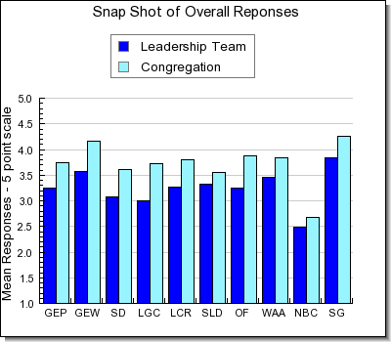

Dear Friends,

Greetings to you in the wonderful Name of Jesus!

Sincere thanks and appreciation to you for completing the CHAT survey back in late March/early April. We are very pleased that 65 people from our congregation participated. This gives us a good overview of Evangel Temple, specifically in the 10 characteristic areas listed in the above graph. You will notice that the dark blue bar reflects the Leadership Team’s responses and the lighter shade reflects that of the congregation.

The information gathered is very valuable to us as we continue our pastoral search. The leadership of Evangel has studied this at a recent Church Health Assessment Tool (CHAT) Retreat on July 17 – 18, 2020. Such an evaluation is very significant as we analyze who we are as a congregation.

The survey reports will be shared with the incoming Lead Pastor and it will be a very helpful tool. The information will serve us as we go forward together and do our very best to accomplish the will of God. Let’s purpose daily to grow in the faith, being the best we can and introduce people to “the Lamb of God who takes away the sins of the world.” (John 1:29) Thank you again for your investment in Evangel Temple.

