**PACIFIC’S COVID 19 GUIDELINES**

**PACIFIC’S COVID-19 SAFETY PROTOCOLS ARE AS FOLLOWS**

**MEETINGS ARE CURRENTLY ONLY TAKING PLACE OUTSIDE,   
UNDER THE CANOPY AT THE BACK OF THE PARKING LOT.**



Although we are excited to welcome Jon ImBeau to these gatherings,

please remember that there will be **no hand shaking**.



**Maximum of 50** people at any one time.



**Hand sanitizing stations** are set up as you enter the canopy. Please sanitize your hands before entering.



**Masks will be provided.** We strongly recommend that you wear one when attending an event. **Masks are mandatory** when you are in transit (ie. entering the building to use the washroom).



**Chairs will be spaced apart** to remain socially distanced**.** Some chairs will be placed together for those in a family cluster.

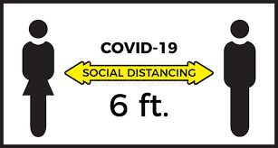

**Thank you for following the 6 feet social distancing guidelines!**



**Our Promise to You!** Your safety is very important to us, so we have made every effort to sanitize the door handles, chairs, washrooms and other surfaces prior to the event taking place.



**Washrooms are available for use.** When entering the building, please sanitize your hands as you enter and wear a mask. Follow the directional signs. Once inside the washrooms, bottles of sanitizer and paper towel will be provided to disinfect the toilet seat and flush handle before and after use.