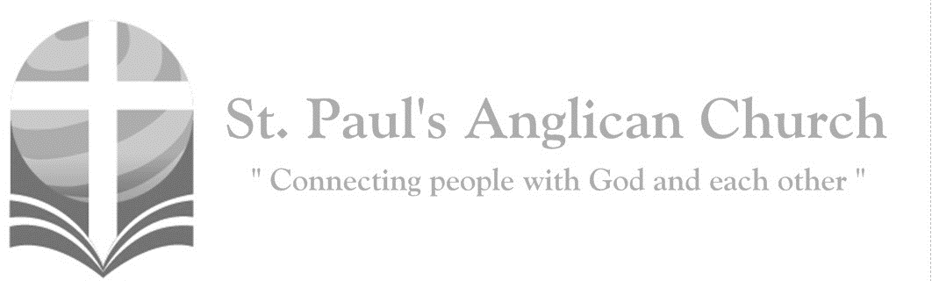
Sunday, August 23, 2020: 12th Sunday After Pentecost

Jesus is the Christ, the Son of the living God. (Matthew 16:16)
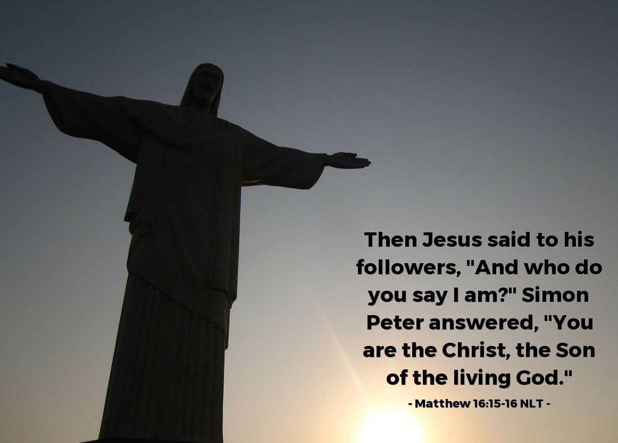
ST. PAUL’S COVID-19 RESPONSE

Welcome!! During this unique time in history, services will look a bit different than normal and will likely be different for quite a while. We want to care for the whole parish during this time and one way to care for one another is keeping each other safe. As such, we ask you to follow these guidelines while worshiping with us:
- Experiencing Cough, Fever, or Other Symptom/s? Go home immediately and please stay home for fourteen days following the end of your symptoms.
- Wear a Mask. All parishioners must wear a mask to all services (as per City of Edmonton bylaw 19408). Exceptions to this include children under the age of two and those with a medical condition where wearing a mask is not possible. Masks may be removed when taking communion but must be replaced immediately following. If you do not have a mask, we have cloth masks available in the foyer.
- Maintain Physical Distance. At all times, please remain a minimum of six feet (three seat spaces) from all other individuals not part of your family unit. You will find tape on the floor six feet apart in multiple locations to help you maintain this distance. Please also maintain physical distance outside.
- Listen to the Ushers. There will be ushers inside and outside to help direct these new procedures. Please heed their direction as they are trying to keep everyone safe and healthy.
- Sign-In Upon Arrival. Please sign-in with the designated usher when you arrive onsite. This will help us track who is in attendance just in case we do have to notify the parish if someone tests Covid positive following a service.
- Sanitize Hands Frequently. Please sanitize your hands upon entry and before taking communion. You may also sanitize as often as you would like during the service. Please also try to refrain from touching surfaces and your face.
- Refrain from Singing. At this time, congregational singing is not allowed by the government of Alberta. Please listen to the lyrics being sung by the leader/s and meditate upon them. You may also hum along to the music as long as your mouth remains closed.
- Recycle Bulletins. Please do not leave bulletins in the pews. A recycle bin is available at the exit door. You may also take the bulletin home.
- Use of Washroom. The only washroom available at this time is located at the back of the Sanctuary (just North of the Main Entry doors). Please wipe down all surfaces (including toilet and handle, counter, and faucet) following use.
- Parts of Building Closed. At this time, the only accessible parts of the building are the Sanctuary, Sanctuary washroom, and alley foyer. All other rooms are closed for use including the main washrooms, hall, basement, and chapel. Please do not access any closed section of the building without permission.

Opening Song: My Soul Follows Hard After Thee
My soul follows hard after you
Early in the morning
Will I rise up and seek You
And because you have been my help
Under the shadow of your wings
I will rejoice

The Gathering of the Community
Celebrant: The grace of our Lord Jesus Christ, and the love of God, and the fellowship of the Holy Spirit, be with you all.
People: And also with you.
Celebrant: Almighty God,
All: to you all hearts are open, all desires known, and from you no secrets are hidden. Cleanse the thoughts of our hearts by the inspiration of your Holy Spirit that we may perfectly love you, and worthily magnify your holy name; through Christ our Lord. Amen.
Celebrant: Almighty God, we are taught by your word that all our doings without love are worth nothing. Send your Holy Spirit and pour into our hearts that most excellent gift of love, the true bond of peace and of all virtue; through Jesus Christ our Lord, who lives and reigns with you and the Holy Spirit, one God, now and for ever.
People: Amen.

The Reading of Scripture
First Reading: Exodus 1:8-2:10
Now a new king arose over Egypt, who did not know Joseph. He said to his people, "Look, the Israelite people are more numerous and more powerful than we. Come, let us deal shrewdly with them, or they will increase and, in the event of war, join our enemies and fight against us and escape from the land." Therefore, they set taskmasters over them to oppress them with forced labor. They built supply cities, Pithom and Rameses, for Pharaoh. But the more they were oppressed, the more they multiplied and spread, so that the Egyptians came to dread the Israelites. The Egyptians became ruthless in imposing tasks on the Israelites, and made their lives bitter with hard service in mortar and brick and in every kind of field labor. They were ruthless in all the tasks that they imposed on them. The king of Egypt said to the Hebrew midwives, one of whom was named Shiphrah and the other Puah, "When you act as midwives to the Hebrew women, and see them on the birthstool, if it is a boy, kill him; but if it is a girl, she shall live." But the midwives feared God; they did not do as the king of Egypt commanded them, but they let the boys live. So the king of Egypt summoned the midwives and said to them, "Why have you done this, and allowed the boys to live?" The midwives said to Pharaoh, "Because the Hebrew women are not like the Egyptian women; for they are vigorous and give birth before the midwife comes to them." So God dealt well with the midwives; and the people multiplied and became very strong. And because the midwives feared God, he gave them families. Then Pharaoh commanded all his people, "Every boy that is born to the Hebrews you shall throw into the Nile, but you shall let every girl live." Now a man from the house of Levi went and married a Levite woman. The woman conceived and bore a son; and when she saw that he was a fine baby, she hid him three months. When she could hide him no longer she got a papyrus basket for him, and plastered it with bitumen and pitch; she put the child in it and placed it among the reeds on the bank of the river. His sister stood at a distance, to see what would happen to him. The daughter of Pharaoh came down to bathe at the river, while her attendants walked beside the river. She saw the basket among the reeds and sent her maid to bring it. When she opened it, she saw the child. He was crying, and she took pity on him, "This must be one of the Hebrews' children," she said. Then his sister said to Pharaoh's daughter, "Shall I go and get you a nurse from the Hebrew women to nurse the child for you?" Pharaoh's daughter said to her, "Yes." So the girl went and called the child's mother. Pharaoh's daughter said to her, "Take this child and nurse it for me, and I will give you your wages." So the woman took the child and nursed it. When the child grew up, she brought him to Pharaoh's daughter, and she took him as her son. She named him Moses, "because," she said, "I drew him out of the water."

Reader: The Word of the Lord.
People: Thanks be to God.
Canticle: Psalm 124

“If the Lord had not been with us,”
O let Is-ra-el now say:
“If the Lord had not been with us,
when we were amidst the fray;
When attackers in their anger
would have put us in the grave;
Torrents would have there engulfed
us, raging floods swept us away.”
Blessed be the Lord who has not let us be torn from His care.
Like a bird, we have escaped from out of the cruel fowler’s snare.
For the snare has now been broken; we’ve escaped as in new birth;
Our help’s ever in the Lord’s name, who made heaven and the earth.

Second Reading: Romans 12:1-8
I appeal to you therefore, brothers and sisters, by the mercies of God, to present your bodies as a living sacrifice, holy and acceptable to God, which is your spiritual worship. Do not be conformed to this world, but be transformed by the renewing of your minds, so that you may discern what is the will of God--what is good and acceptable and perfect. For by the grace given to me I say to everyone among you not to think of yourself more highly than you ought to think, but to think with sober judgment, each according to the measure of faith that God has assigned. For as in one body we have many members, and not all the members have the same function, so we, who are many, are one body in Christ, and individually we are members one of another. We have gifts that differ according to the grace given to us: prophecy, in proportion to faith; ministry, in ministering; the teacher, in teaching; the exhorter, in exhortation; the giver, in generosity; the leader, in diligence; the compassionate, in cheerfulness.
Reader: The Word of the Lord.
People: Thanks be to God.

Processional Chorus – How Firm a Foundation

How firm a foundation
You saints of the Lord
Is laid for your faith
In His excellent word
What more can He say
Than to you He has said
To you who for refuge
To Jesus have fled
The Gospel Reading
Reader: The Lord be with you.
People: And also with you.
Reader: The Holy Gospel of our Lord Jesus Christ according to St. Matthew.
People: Glory to you, Lord Jesus Christ.
Gospel Reading: Matthew 16:13-20
Now when Jesus came into the district of Caesarea Philippi, he asked his disciples, "Who do people say that the Son of Man is?" And they said, "Some say John the Baptist, but others Elijah, and still others Jeremiah or one of the prophets." He said to them, "But who do you say that I am?" Simon Peter answered, "You are the Messiah, the Son of the living God." And Jesus answered him, "Blessed are you, Simon son of Jonah! For flesh and blood has not revealed this to you, but my Father in heaven. And I tell you, you are Peter, and on this rock I will build my church, and the gates of Hades will not prevail against it. I will give you the keys of the kingdom of heaven, and whatever you bind on earth will be bound in heaven, and whatever you loose on earth will be loosed in heaven." Then he sternly ordered the disciples not to tell anyone that he was the Messiah.
Reader: The Gospel of Christ.
People: Praise to you, Lord Jesus Christ.

Worship Through Song

How Firm a Foundation
When through fiery trials
Your pathway shall lie
My grace all-sufficient
Shall be your supply
The flame shall not hurt you
I only design
Your dross to consume
And your gold to refine

Be Glad in the Lord
(Chorus)
Be glad in the Lord and rejoice
You righteous ones
How blessed is he
Whose heart is set free
In the faithful forgiveness of God

Silence hiding my sin
Yet groaning and burning within
I wasted away like a stream
In the heat of the day (To Chorus)

If I will walk in the light
Just as he is in the light
I know he is faithful and just
And he cleanses my sin by his blood
(To Chorus)

How blessed is he
Whose heart is set free
In the faithful forgiveness of all our sins
In the faithful forgiveness of God

Ponder
Whatever is good and lovely
Whatever is pure and true
Ponder these things
Ponder these things
Be troubled in heart for nothing
Be grateful and pray it through
His peace will come, His peace will come
Rejoice in the Lord in all things
Your gentleness known to all
He is at hand, He is at hand
(Repeat first verse)

Listening Time

Sermon by the Rev. Dr. Myron B. Penner – Sermon Notes:
________________________________________________________________________________________________________________________________________________________________________________________________________________________________________________________________________________________________________________________________________________________________________________________________________________________________________________________________________________________________________________________
________________________________________________________________________________________________________________________________________________
________________________________________________________________________________________________________________________________________________________________________________________________________________________
________________________________________________________________________________________________________________________________________________________________________________________________________________________________________________________________________________________________________________________________________________________________________

Affirmation of Faith – Modern Affirmation
Celebrant: Let us confess our faith, as we say,
All: We believe in God the Father, infinite in wisdom, power, and love,
whose mercy is over all creation, and whose will is ever directed to the good of
God’s children: who creates, loves and redeems us. We believe in Jesus Christ,
Son of God and Son of man, the gift of the Father’s unfailing grace, the ground
of our hope, and the promise of our deliverance from sin and death, who will
come again in glory. We believe in the Holy Spirit who brings God’s presence in
our lives, whereby we are kept in perpetual remembrance of the truth of
Christ, and through whom we find strength and help in time of need. We
believe in one God: Father, Son, and Holy Spirit. We believe that this faith
should manifest itself in the service of love as set forth in the example of our
blessed Lord, to the end that the kingdom of God may come upon the earth.
Amen.

Prayers of the People
Leader: As we stand in God’s presence, let us pray to the Lord, saying, “Lord, have mercy.” Remembering today from the St. Paul’s Cycle of prayer: Jeff, Michelle, Aiden, Nathaniel, and Macreena Schurek; Chuck and Kjeryn Allard; Cheryl Critchell; and Carol McKinney; as well as all of those in the Anglican Cycle of Prayer. For the whole People of God, that each one may be a true and faithful servant of Christ, let us pray to the Lord.
All: Lord, have mercy.
Leader: For those drawing near to the light of faith, that the Lord will bring them to true knowledge of himself, let us pray to the Lord.
All: Lord, have mercy.
Leader: For our families and friends, that the Lord will give them joy and satisfaction in all that they do, let us pray to the Lord.
All: Lord, have mercy.
Leader: For those who are lonely, sick, hungry, persecuted, or ignored, that the Lord will comfort and sustain them, let us pray to the Lord.
All: Lord, have mercy.
Leader: For our country, that the Lord will help us to contribute to its true growth and well-being, let us pray to the Lord.
All: Lord, have mercy.
Leader: For the whole human family, that we may live together in justice and peace, let us pray to the Lord.
All: Lord, have mercy. Amen.

Confession of Sin
Celebrant: (pg. 191) Dear friends in Christ, God is steadfast in love and infinite in mercy; he welcomes sinners and invites them to his table. Let us confess our sins, confident in God’s forgiveness.
Silent Confession
Celebrant: Almighty God,
All: Father of our Lord Jesus Christ, you made all things, and you call everyone to account. With shame we admit that we have sinned against you, in what we have thought, said, and done, and we deserve your judgment. We turn from our sins and are truly sorry for them. Have mercy on us, most merciful Father. For the sake of your Son, our Lord Jesus Christ, forgive us all that is past. Enable us to serve and please you in new life, to your honour and glory, through Jesus Christ our Lord. Amen.
Celebrant: Almighty God have mercy upon you, pardon and deliver you from all your sins, confirm and strengthen you in all goodness and keep you in eternal life through Jesus Christ our Lord.
People: Amen.

The Peace
Celebrant: The peace of the Lord be always with you.
People: And also with you.

Prayer Over the Gifts
Celebrant: God of glory,
All: receive all we offer this day as a symbol of our love, and increase in us that true and perfect gift. We ask this in the name of Jesus Christ our Lord. Amen.

Celebrant: The Lord be with you.
People: And also with you.
Celebrant: Lift up your hearts.
People: We lift them to the Lord.
Celebrant: Let us give thanks to the Lord our God.
People: It is right to give our thanks and praise.

Celebrant: It is right to give you thanks and praise, O Lord, our God, sustainer of the universe, you are worthy of glory and praise.
People: Glory to you for ever and ever.
Celebrant: At your command all things came to be: the vast expanse of interstellar space, galaxies, suns, the planets in their courses, and this fragile earth, our island home; by your will they were created and have their being.
People: Glory to you for ever and ever.
Celebrant: From the primal elements you brought forth the human race, and blessed us with memory, reason, and skill; you made us the stewards of creation.
People: Glory to you for ever and ever.
Celebrant: But we turn against you, and betray your trust; and we turn against one another. Again and again you call us to return. Through the prophets and sages, you reveal your righteous law. In the fullness of time you sent your Son, born of a woman, to be our Saviour. He was wounded for our transgressions, and bruised for our iniquities. By his death he opened to us the way of freedom and peace.
People: Glory to you for ever and ever.
Celebrant: Therefore we praise you, joining with the heavenly chorus, with prophets, apostles, and martyrs, and with those in every generation who have looked to you in hope, to proclaim with them your glory, in their unending hymn:
All: (Said) Holy, holy, holy Lord, God of power and might,
heaven and earth are full of your glory. Hosanna in the highest.
Blessed is he who comes in the name of the Lord.
Hosanna in the highest.

Celebrant: Blessed are you, Lord our God, for sending us Jesus, the Christ, who on the night he was handed over to suffering and death, took bread, said the blessing, broke the bread, gave it to his friends, and said, “Take this, and eat it: this is my body which is given for you. Do this for the remembrance of me.” In the same way, after supper, he took the cup of wine; he gave you thanks, and said, “Drink this, all of you: this is my blood of the new covenant, which is shed for you and for many for the forgiveness of sins. Whenever you drink it, do this for the remembrance of me.”
People: Glory to you for ever and ever.
Celebrant: Gracious God, we recall the death of your Son Jesus Christ, we proclaim his resurrection and ascension, and we look with expectation for his coming as Lord of all the nations. We who have been redeemed by him, and made a new people by water and the Spirit, now bring you these gifts. Send your Holy Spirit upon us and upon this offering of your Church, that we who eat and drink at this holy table may share the divine life of Christ our Lord.
People: Glory to you for ever and ever.
Celebrant: Pour out your Spirit upon the whole earth and make it your new creation. Gather your Church together from the ends of the earth into your kingdom, where peace and justice are revealed, that we, with all your people, of every language, race, and nation, may share the banquet you have promised; through Christ, with Christ, and in Christ, all honour and glory are yours, creator of all.
People: Glory to you for ever and ever. Amen.

Celebrant: As our Saviour taught us, let us pray,
All: (Said) Our Father in heaven, hallowed be your name. Your kingdom come, your will be done, on earth as in heaven. Give us today our daily bread. Forgive us our sins as we forgive those who sin against us. Save us from the time of trial, and deliver us from evil. For the kingdom, the power, and the glory are yours, now and for ever. Amen.

Celebrant: We break this bread to share in the body of Christ.
All: We, being many, are one body, for we all share in the one bread.

Celebrant: The gifts of God for the People of God.
People: Thanks be to God.

The Communion
Please listen carefully to the verbal instructions given. You are welcome to receive communion or come forward for a blessing. Gluten-free wafers are also available. Please sanitize your hands as you approach the front of the church. If you prefer to receive a blessing, please fold your arms over your chest. If you would like to make an offering, please do so after you take the bread.

Lamb of God
(Said by congregation) Lamb of God, you take away the sins of the world. Lamb of God, you take away the sins of the world. Lord have mercy, Christ have mercy, Lord have mercy on us.

Communion Music – Special Music

Prayer After Communion
Celebrant: Living God,
All: increase in us the healing power of your love. Guide and direct us that we may please you in all things, for the sake of Jesus Christ our Lord. Amen.
Celebrant: Glory to God,
All: whose power, working in us, can do infinitely more than we can ask or imagine. Glory to God from generation to generation, in the Church and in Christ Jesus, for ever and ever. Amen.

Blessing

Congregational Announcements (Rev. Myron)

Closing Song: Blessed Be Your Name

The Lord bless you and keep you
Make his face shine upon you
And be gracious to you
The Lord turn his face toward you
And give you peace

May his favor be upon you
And a thousand generations
And your family and your children
And their children and their children

May his presence go before you
And behind you and beside you
All around you and within you
He is with you, He is with you

In the morning, in the evening
In your coming and your going
In your weeping and rejoicing
He is for you, He is for you

The Dismissal
Celebrant: Go forth into the world, rejoicing in the power of the Spirit.
All: Thanks be to God. Amen.

Job Opportunity: Director of Community Outreach
This new position will be a part-time leadership position and will report directly to the Rector. The Director of Community Outreach will be responsible for providing Christ-centred programming that is consistent with the values, vision, and mission of St. Paul’s (as expressed in our Narrative Statement of Identity) in order to maximize parish engagement with and inspire response to the needs of the Grovenor Community, its surrounding communities, and the wider City of Edmonton.
Job Title: Director of Community Outreach
Closing date: September 1, 2020
Location: St. Paul’s Anglican Church - Edmonton
Hours: A maximum of 20 hours per week
Date Available: September 15, 2020. Probationary period of three months.
Salary: $28 per hour (dependent on experience and qualifications) with an increase
of $1 per hour following probationary period.

To learn more about this position (including a full job description and the process for application), please visit www.stpauls-anglican.ca/pages/job-opportunity

Anglican Cycle of Prayer:
Diocese of Saskatchewan; the Rt. Rev. Michael Hawkins, Bishop; the Rt. Rev. Adam Halkett, Bishop of Missinipi; the Rt. Rev. Isaiah Larry Beardy, Assisting Bishop of Missinipi. Holy Trinity, Riverbend: Rebecca Harris (s. Ian), Priest-in-Charge. Buyé Diocese, Bigombo Parish: Simeon Ntirandekura, Rector. Kehewin Cree Nation.

Next Week’s Ministry Teams:
Music: Adele and Team
Service Team: Green and Tilburn Teams
Reader/Prayers: Carol R.

This Week’s Ministry Teams:
Music: Jodi and Team
Service Team: B and Jackson Teams
Reader/Prayers: Renée J.

St. Paul’s Cycle of Prayer:
Jeff, Michelle, Aiden, Nathaniel, and Macreena Schurek;
Chuck and Kjeryn Allard;
Cheryl Critchell;
Carol McKinney
St. Paul’s Staff:
Rector: The Rev. Myron B. Penner
Office Administrator: RJ Chambers
Youth Leader: Victoria Eeles

For Care/Concern Team
or other prayer requests, email:
office@stpauls-anglican.ca
For urgent prayer requests call
the church office: (780) 455-0771
For pastoral emergencies call:
(587) 334-2130

@StEdmonton
facebook.com/stpachurchedmonton
St. Paul’s Vestry:
Peter Jackson, Rector’s Warden
Margot Byer, People’s Warden
David Heritage, Treasurer
Barb Dixon, Vestry Member
John Green, Vestry Member
Deanna Kalles, Vestry Member
David Parker, Vestry Member
Carol Rudat, Vestry Member

Office Hours:
Monday-Thursday: 9:00AM-12:00PM
Closed: Fri/Sat/Sun and Stat Holidays
St. Paul’s Anglican Church
10127 145 Street, Edmonton T5N 2X6
Phone: (780) 455-0771; Email: office@stpauls-anglican.ca
Website: www.stpauls-anglican.ca

