WON’T YOU BE MY NEIGHBOUR
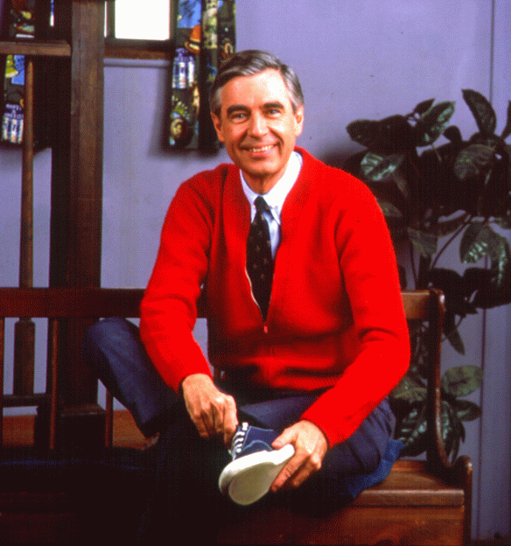

CC Image courtesy of Dreambird on Flickr

“Listening is where love begins: listening to ourselves and then to our neighbour.”
—Mr.Rogers

“…you shall love your neighbour as yourself.”
—Jesus

Who are the neighbours of Lynn Valley United? How are they making a difference in God’s world? How can we be a good neighbour?

Beginning Sept. 7 until Oct. 18 activities and worship at LVUC are going to be centered around these questions. Please join in and be part of wondering how, along with our neighbours, we can make a difference in God’s world.

Sunday Mornings 10:30

Sept 13 Reset Sunday with Lynn Valley Ministry Team. This Sunday begins Pandemic 2.0: From Reaction to Resilience. Worship will be taped in advance and we will welcome a safe number of people into the sanctuary to watch together and for some conversation afterwards. All COVID protocols will be in place. Please check with the office if you would like to attend in person. Worship will continue to also be streamed online.

Sept. 20 Rev. Jenny Carter’s congregation has been transformed through their relationships with neighbouring groups committed to serving the community and the world. She will tell us about what they did to get there.

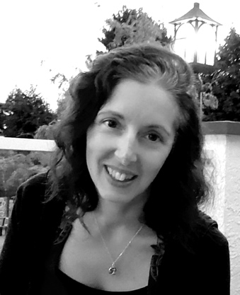
Sept. 27 Michelle Dodds is Executive Director of the North Shore Women’s Centre, which is a community-based resource and a catalyst for change from a feminist perspective.

Oct. 4 Dr. John Thatamanil is Associate Professor of Theology and World Religions at Union Theological Seminary in New York. His driving question is ‘…how can Christian communities come to see religious diversity as a promise rather than a problem?’

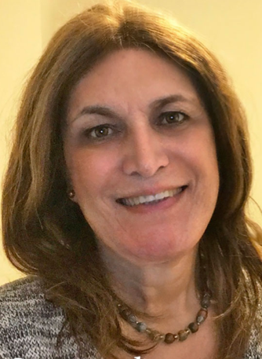
Oct. 11 Lisa Salazar MA (PPL), SCP (she/her) Lisa is the first openly trans Certified Spiritual Care Practitioner at Vancouver Coastal Health. She holds an MA in Public and Pastoral Leadership from Vancouver School of Theology. She is a published author, researched, speaker and workshop facilitator.

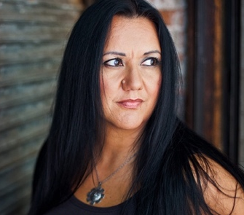
Oct. 18 Dr. Cheryl Bear is the incoming Director of Community Ministry at First United Church in the DTES. She is Nadleh Whut’en from the Dakelh Nation, Associate Professor at Regent College, and moving towards ordination in the United Church of Canada.

“The connections we make in the course of a life – maybe that is what heaven is.”
—Mr. Rogers

