**The Parish of St. Matthew, Abbotsford**

**Anglican Church of Canada**

**The Fifteenth Sunday After Pentecost**

**September 13th, 2020**

**Service of Holy Eucharist**

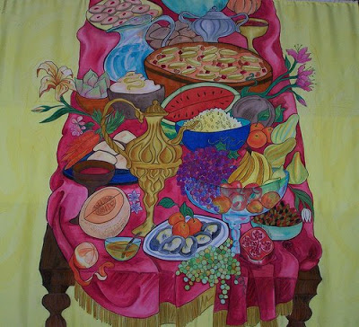

**11:00 AM**

**The Book of Alternative Services**

***Helping each other explore God's Beauty, Truth and Goodness***

Greeter

Sides-person

Server

Musician Lloyd Bates

Counters

**The Gathering of the Community**

Announcements

**Greeting**

***Celebrant:*** The grace of our Lord Jesus Christ, and the love of God, and the fellowship of the Holy Spirit be with you all.

***People:* And also with you.**

Processional Hymn………………*From All the Wind’s Wide Quarters* 43 CP

From all the wind's wide quarters

come, see the feast is spread,

of soul-sustaining waters,

of true and living bread;

of sorrows long-departed,

and joys beyond compare –

come, poor and humble-hearted,

the feast of life to share!

With mercy all-prevailing

God bids the wanderer come;

in grace and peace unfailing

invites the children home.

With loving-kindness tender,

God frees us from our sins –

in glory and in splendour

the feast of life begins!

Come, claim the promise spoken!

God's purpose stands secure.

The fruitful word unbroken

shall evermore endure.

All ancient bondage ended

to sin's corrupting powers –

forgiven, freed, befriended,

the feast of life is ours!

**Collect for Purity**

***Celebrant:*** Almighty God,

***All:* to you all hearts are open, all desires known,**

**and from you no secrets are hidden.**

**Cleanse the thoughts of our hearts**

**by the inspiration of your Holy Spirit,**

**that we may perfectly love you,**

**and worthily magnify your holy name;**

**through Christ our Lord. Amen.**

Song of Praise……………………*Womb of Life and Source of Being* 390 CP

Womb of life, and source of being, .

home of ev'ry restless heart,

in your arms the worlds awakened;

you have loves us from the start.

We, your children, gather 'round you,

at the table you prepare.

Sharing stories tears and laughter,

we are nurtured by your care.

Word in flesh, our brother Jesus,

born to bring us second birth,

you have come to stand beside us,

knowing weakness, knowing earth.

Priest who shares our human struggles,

Life of Life, and Death of Death,

risen Christ, come stand among us,

send the Spirit by your breath.

Brooding Spirit, move among us;

be our partner, be our friend.

When our mem'ry fails, remind us whose we are,

what we intend. Labor with us,

aid the birthing of the new world made new,

ever singing, ever praising, one with all,

and one with you.

Mother, Brother, holy Partner;

Father, Spirit, Only Son:

we would praise your name forever,

one-in-three, and three-in-one.

We would share your life, your passion,

share your word of world made new,

ever singing, ever praising,

one with all, and one with you.

**Collect of the Day**

***Celebrant:*** Almighty God,

***All:* you call your Church to witness**

**that in Christ we are reconciled to you.**

**Help us so to proclaim the good news of your love,**

**that all who hear it may turn to you;**

**through Jesus Christ our Lord,**

**who lives and rigns with you and the Holy Spirit,**

**one God, now and for ever. Amen.**

**The Proclamation of the Word**

First Reading……………………..*Exodus 14:19-31*

***Reader:*** *Hear what the Spirit is saying to the Church.*

***All: With your help, O Lord, we will listen and live.***

Psalm 114

Hallelujah!

When Israel came out of Egypt, *

**the house of Jacob from a people of strange speech,**

Judah became the sanctuary of the Lord *

**and Israel the dominion of God.**

The sea beheld it and fled; *

**Jordan turned and went back.**

The mountains skipped like rams, *

**and the little hills like young sheep.**

What ailed you, O sea, that you fled? *

**O Jordan, that you turned back?**

You mountains, that you skipped like rams? *

**You little hills like young sheep?**

Tremble, O earth, at the presence of the Lord, *

**at the presence of the God of Jacob,**

who turned the hard rock into a pool of water *

**and flint-stone into a flowing spring. Hallelujah!**

**Glory Be to the Father and to the Son and to the Holy Spirit, as it was in the beginning is now and ever shall be, world without end, Amen.**

Second Reading…………………………*Romans 14:1-12*

***Reader:*** *Hear what the Spirit is saying to the Church.*

***All: With your help, O Lord, we will listen and live.***

Gradual Hymn…………………………….*Alleluia* 710 CP

3x before the Gospel; 2x after the Gospel

**(*All stand for the Gospel and turn to face the reader*)**

***Reader:***The Lord be with you.

***People*: And also with you.**

***Reader:***The Holy Gospel of our Lord Jesus Christ according to Matthew

***People:***  **Glory to you, Lord Jesus Christ**

Gospel……………………………*Matthew 18:21-35*

***Reader:***The Gospel of Christ

***People:* Praise to you, Lord Jesus Christ**

Sermon Fr. Allen

*A time of reflection*

**Affirmation of Faith - Common Worship England**

**We believe and trust in God the Creator,**

**source of all being and life,**

**the one for whom we exist.**

**We believe and trust in God the Word,**

**who took our human nature,**

**died for us and rose again.**

**We believe and trust in God the Holy Spirit,**

**who gives life to the people of God**

**and makes Christ known in the world.**

**This is the faith we affirm.**

**We believe and trust in one God,**

**the holy and undivided Trinity.**

Prayers of the People

**Confession and Absolution**

***Celebrant:*** Come my sisters and brothers in Christ; enter the door of grace, where more forgiveness awaits us than this world could ever contain. Let us pray.

***Celebrant:*** God, your grace reaches through races and nations, neither favouring the righteous nor despising the uncouth; Lord have mercy.

*All:* **Lord have mercy on me.**

***Celebrant:*** God of love, your hopes for us are not deterred by human rebelliousness. indifference or ignorance; Christ have mercy.

*All:* **Christ have mercy on me.**

***Celebrant:*** Holy God, you find us in our wandering and save us from all that would cut us off from the light of God; Lord have mercy.

***All:*** **Lord have mercy on me.**

***All:* God of countless mercies, we confess our sins to you, knowing that you see our need much better than we do. Please forgive not only the sins we recognise, but also the many to which the culture in which we live may have blinded us. Uncover any private subterfuge, reprove our compliance with community evil, and bring us again into the blessed condition of grace. Through Christ Jesus our Redeemer. Amen.**

***Celebrant:*** Family of God, it is not your fate to carry burdens of guilt, or to be obsessed with painstaking yet vain self-justifications. There is no one who pardons more completely than our God, and no Saviour whose peace is sweeter than that of our Christ. Receive into your heart and mind the rejuvenating life of the Holy Spirit. Now receive pardon, deliverance, strength and life eternal, through Jesus Christ our Lord.

***All:* Amen**

**The Peace**

***Celebrant:*** The peace of the Lord be always with you.

***People:* And also with you.**

**The Celebration of the Eucharist**

Offertory Hymn…………………….*With the Body That Was Broken* 75 CP

**Prayer over the Gifts**

***Celebrant:*** Holy God

accept all we offer you this day.

May we who are reconciled at this table

bring wholeness to our broken world.

We ask this in the name of Jesus Christ the Lord. **Amen.**

**Eucharistic Prayer #1**

***Celebrant:*** The Lord be with you.

***People:*** **And also with you.**

***Celebrant:*** Lift up your hearts.

***People:* We lift them to the Lord.**

***Celebrant:*** Let us give thanks to the Lord our God.

***People:* It is right to give our thanks and praise.**

***Celebrant:*** It is indeed right that we should praise you, gracious God,

for you created all things....

….Therefore, with them, and with all your saints who have served you in every age, we give thanks and raise our voices to proclaim the glory of your name.

***All:* Holy, holy, holy Lord,**

**God of power and might,**

**heaven and earth are full of your glory.**

**Hosanna in the highest.**

**Blessed is he who comes in the name of the Lord.**

**Hosanna in the highest.**

***Celebrant:*** Holy God, source of life and goodness,all creation rightly gives you praise….

….Gracious God, his perfect sacrifice destroys the power of sin and death; by raising him to life you give us life for evermore. Therefore we proclaim our hope.

***All:* Dying you destroyed our death,**

**rising you restored our life,**

**Lord Jesus, come in glory.**

***Celebrant:*** Recalling his death, proclaiming his resurrection,….

….Through Christ, with Christ, and in Christ, in the unity of the Holy Spirit,

all glory is yours, almighty Father,

now and for ever.

***People:* Amen.**

**The Lord’s Prayer**

Celebrant: As our Saviour taught us let us pray

All: **Our Father who is in Heaven,**

**Hallowed be your Name.   
Your Kingdom come,**

**Your Will be done, on earth as in Heaven.   
Give us today our daily bread   
And forgive us our sins as we forgive those who sin against us.   
Save us from the time of trial and deliver from evil;   
For Yours is the Kingdom, The Power and the Glory,**

**Forever and ever, Amen.**

**Breaking of the Bread**

***Celebrant*:** Creator of all, you gave us golden fields of wheat

whose many grains we have gathered and made into this one bread.

***All:*** **So may your Church be gathered**

**from the ends of the earth into your kingdom.**

**The Communion**

***Celebrant:*** The Gifts of God for the People of God

***All:* Thanks be to God**

Eucharist Assistant Linda Burton

Hymns during Communion

**Prayer after Communion**

***Celebrant:*** Father

your word and sacrament give us food and life

May we who have shared in holy things bear fruit to your honour and glory,

in the name of Jesus Christ the Lord. **Amen.**

***Celebrant:*** Glory to God,

***All:* whose power, working in us,**

**can do infinitely more**

**than we can ask or imagine.**

**Glory to God from generation to generation,**

**in the Church and in Christ Jesus,**

**for ever and ever. Amen.**

Recessional hymn…………*Singing Songs of Expectation* 536 CP

Singing songs of expectation,  
Onward goes the pilgrim band,  
Through the night of doubt and sorrow,  
Marching to the promised land.  
Clear before us through the darkness  
Gleams and burns the guiding light:  
Trusting God we march together  
Stepping fearless through the night.

One the light of God's own presence,  
O'er his ransomed people shed,  
Chasing far the gloom and terror,  
Bright'ning all the path we tread:  
One the object of our journey,  
One the faith which never tires,  
One the earnest looking forward,  
One the hope our God inspires.

One the strain the lips of thousands  
Lift as from the heart of one;  
One the conflict, one the peril,  
One the march in God begun:  
One the gladness of rejoicing  
On the far eternal shore,  
Where the one almighty Father  
Reigns in love for evermore.

**Dismissal (Commiting to be a blessing as we’ve been blessed)**

***Celebrant:*** Go in Peace to Love and Serve the Lord.

***People:* Thanks be to God.**

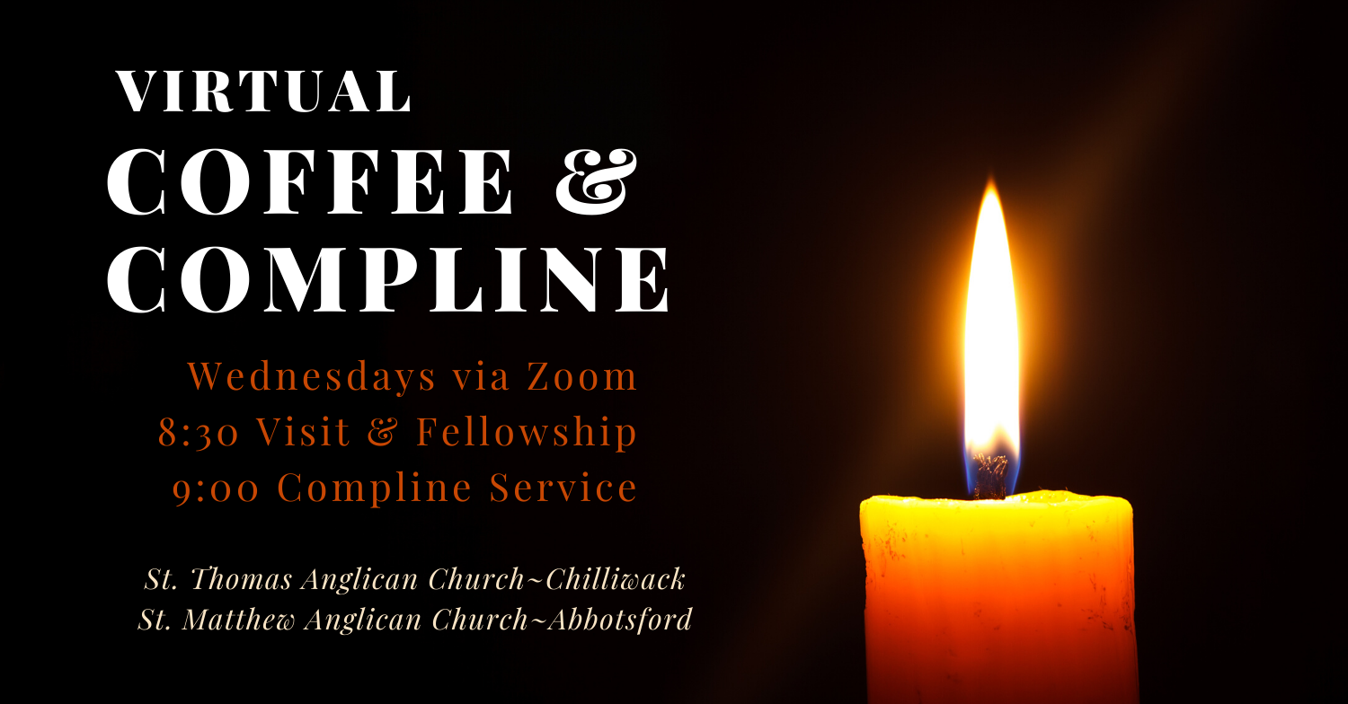

**Click here to register:**[**https://tinyurl.com/wedcompline**](http://www.tinyurl.com/wedcompline)**(You only need to register once to attend all of the services.)**

**Join us at 8:30 with a cup of tea or coffee to visit, or join at 8:55 to end the evening with the ancient office of Compline.  Compline is a quiet, meditative service of prayers and music, meant as preparation for sleep and a peaceful night. It derives its name from a Latin word meaning  ‘completion’.**

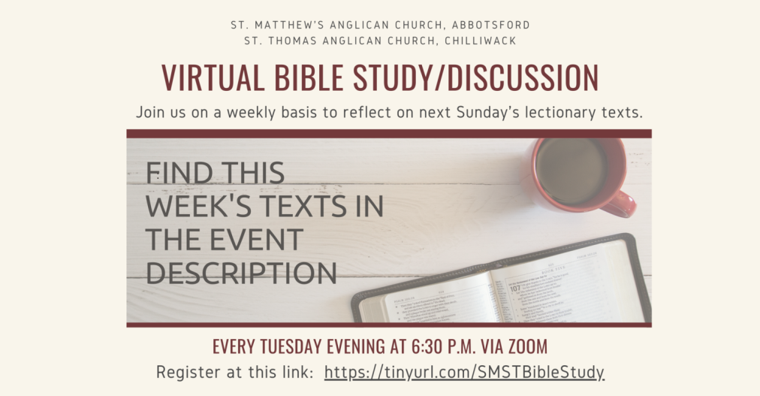

**The Parish of St. Matthew**

**Anglican Church of Canada**

**Diocese of New Westminster**

2010 Guilford Drive

Abbotsford, BC V2S 5R2

Office Phone: 604-853-2416

Email: [church@abbotsfordanglican.ca](mailto:church@abbotsfordanglican.ca)

Website: [www.abbotsfordanglican.ca](http://www.abbotsfordanglican.ca)

**Follow us on social media**

facebook.com/abbotsfordanglican

@abbyanglican

**Archbishop:** The Very Rt.Rev. Melissa M. Skelton

**Priest:** Father Allen Doerksen

[allen@abbotsfordanglican.ca](mailto:allen@abbotsfordanglican.ca)

Fr. Allen’s Cell (text and phone) 604-302-1082

**Parish Council:**

Father Allen Doerksen

Virginia Hooper – Rector’s Warden, Synod Delegate

Tyler Evans – People’s Warden, Alternate Synod Delegate

Kerri Onken – Treasurer

Ike Ezema – Member at Large

Trevor Smale – Member at Large

Melody Redekop – Member at Large

**Envelope Secretary:** Paul and Pat Thiessen

**Church Office Hours:**

Tuesday 9:30 am – 1:30 pm

Wednesday 9 am – 12 pm

Friday 9 am – 12 pm