St Stephen the Martyr Anglican Church, Burnaby
Holy Eucharist with Zoom Option
Sunday, September 20, 2020
The16th Sunday After Pentecost

The Gathering of the Community

Words of Welcome, Orientation, & A Territorial Acknowledgment

During our first hymn, children and their Sunday School teachers may move to the Parish Hall for a short class. Children and their teachers will return at Holy Eucharist.

HYMN CP 435 Take My Life and Let It Be See page 10

Celebrant The grace of our Lord Jesus Christ,
and the love of God,
and the fellowship of the Holy Spirit,
be with you all.
People And also with you.

The Collect of the Day
Celebrant Let us pray.
People O God, from your providing hand
even the dissatisfied and grumbling
receive what they need for their lives.
Teach us your ways of justice
and lead us to practise your generosity,
so that we may live a life worthy of the gospel
made known through your Son
Jesus Christ, our Saviour. Amen.
Revised Common Lectionary Prayers (2002) alt.

Proclamation of the Word

A Reading from the Letter to the Philippians
(Chapter 1, verses 21-30)
Read by Bob Rusch
For to me, living is Christ and dying is gain. If I am to live in the flesh, that means fruitful labor for me; and I do not know which I prefer. I am hard pressed between the two: my desire is to depart and be with Christ, for that is far better, but to remain in the flesh is more necessary for you. Since I am convinced of this, I know that I will remain and continue with all of you for your progress and joy in faith, so that I may share abundantly in your boasting in Christ Jesus when I come to you again. Only, live your life in a manner worthy of the gospel of Christ, so that, whether I come and see you or am absent and hear about you, I will know that you are standing firm in one spirit, striving side by side with one mind for the faith of the gospel, and are in no way intimidated by your opponents. For them this is evidence of their destruction, but of your salvation. And this is God's doing. For he has graciously granted you the privilege not only of believing in Christ, but of suffering for him as well--since you are having the same struggle that you saw I had and now hear that I still have.

Hear what the Spirit is saying to God’s People.
All: Thanks be to God!

Psalm 105:1-6, 37-45
Read by Edward Kind and Pat Numata
❖O give thanks to the LORD, call on his name, make known his deeds among the peoples.
❖Sing to him, sing praises to him; tell of all his wonderful works. Glory in his holy name; let the hearts of those who seek the LORD rejoice.
❖Seek the LORD and his strength; seek his presence continually.
❖Remember the wonderful works he has done, his miracles, and the judgments he uttered,
❖O offspring of his servant Abraham, children of Jacob, his chosen ones.
❖Then he brought Israel out with silver and gold, and there was no one among their tribes who stumbled.
❖Egypt was glad when they departed, for dread of them had fallen upon it.
❖He spread a cloud for a covering, and fire to give light by night. They asked, and he brought quails, and gave them food from heaven in abundance.
❖He opened the rock, and water gushed out; it flowed through the desert like a river.
❖For he remembered his holy promise, and Abraham, his servant.
❖So he brought his people out with joy, his chosen ones with singing.
❖He gave them the lands of the nations, and they took possession of the wealth of the peoples,
❖that they might keep his statutes and observe his laws. Praise the LORD!
A Reading from the Gospel of Matthew
(Chapter 20, verses 1-16)
Read by Val Krause

Reader: The Lord be with you.
All: And also with you.
Reader: The Holy Gospel of our Lord Jesus Christ according to Matthew.
All: Glory to you Lord Jesus Christ
"For the kingdom of heaven is like a landowner who went out early in the morning to hire laborers for his vineyard. After agreeing with the laborers for the usual daily wage, he sent them into his vineyard. When he went out about nine o'clock, he saw others standing idle in the marketplace; and he said to them, 'You also go into the vineyard, and I will pay you whatever is right.' So they went. When he went out again about noon and about three o'clock, he did the same. And about five o'clock he went out and found others standing around; and he said to them, 'Why are you standing here idle all day?' They said to him, 'Because no one has hired us.' He said to them, 'You also go into the vineyard.'

When evening came, the owner of the vineyard said to his manager, 'Call the laborers and give them their pay, beginning with the last and then going to the first.' When those hired about five o'clock came, each of them received the usual daily wage. Now when the first came, they thought they would receive more; but each of them also received the usual daily wage. And when they received it, they grumbled against the landowner, saying, 'These last worked only one hour, and you have made them equal to us who have borne the burden of the day and the scorching heat.' But he replied to one of them, 'Friend, I am doing you no wrong; did you not agree with me for the usual daily wage? Take what belongs to you and go; I choose to give to this last the same as I give to you. Am I not allowed to do what I choose with what belongs to me? Or are you envious because I am generous?' So the last will be first, and the first will be last.”

The Gospel of Christ
All: Praise to You, Lord Jesus Christ.

Reflection: The Rev. Ruth Monette

Musical Reflection – Ugo Onwujiobi

Apostles’ Creed
Celebrant Let us confess the faith of our baptism, as we say,
All I believe in God, the Father almighty,
creator of heaven and earth.
I believe in Jesus Christ, his only Son, our Lord.
He was conceived by the power of the Holy Spirit
and born of the Virgin Mary.
He suffered under Pontius Pilate,
was crucified, died, and was buried.
He descended to the dead.
On the third day he rose again.
He ascended into heaven,
and is seated at the right hand of the Father.
He will come again to judge the living and the dead.
I believe in the Holy Spirit, the holy catholic Church,
the communion of saints, the forgiveness of sins,
the resurrection of the body, and the life everlasting. Amen.

Prayers of the People
Led by Sara Shaw and Douglas Dow
In peace, we pray to you, Lord God.

~ Silence ~

For all people in their daily life and work;
For our families, friends, and neighbours, and
for all those who are alone.

For our parish family, remembering this week: Barb & Al Hunter, Salar Jafari, Muriel Johnson, and Belle Johnston.
For those who use our facilities: the AA groups, exercise groups, children’s programs, daycare, and faith groups.

For this community, our country, and the world;
For all who work for justice, freedom, and peace.

For the just and proper use of your creation;
For the victims of hunger, fear, injustice, and oppression.

For all who are in danger, sorrow, or any kind of trouble;
For those who minister to the sick, the friendless, and the needy.

For the peace and unity of the Church of God;
For all who proclaim the gospel, and all who seek the truth.

For +Melissa our archbishop, Ruth our rector, and for all bishops and other ministers;
For the ministries within the Diocese of New Westminster, remembering especially the Mission to Seafarers; St Jude Anglican Home; Vancouver General Hospital; College and University Campus Ministries; and Chaplains to the Retired Clergy.

For all who serve God in the world, remembering our companion Diocese, the Episcopal Diocese of Northern Philippines
and our companion parish, St Stephen Mission in Bunga.

Hear us, Lord;
For your mercy is great.

For those who have asked for our prayers: Vivian Kroeker, Victor Baird, Lydia Holmlund, Moira Small, Ron Holding, Dale Floyd, Hank Kassteen, Mike Koombes, Audrey Watson, Lenora Morse, Barb Hunter, Ken Fraser, Linda Uno, Dawn Noske, Ray Werking, and Margaret Krause.
For our own needs and those of others.

~ Silence. People may add their own petitions. ~

Hear us, Lord;
For your mercy is great.

We pray for all those who have died in the peace of Christ, and for those whose faith is known to you alone, that they may have a place in your eternal kingdom.

~ Silence. People may name their remembered dead. ~

Rest eternal grant to them, O Lord,
And let light perpetual shine upon them.

Lord, let your loving kindness be upon them;
Who put their trust in you.

We thank you, Lord, for all the blessings of this life.

~ Silence. People may add their own thanksgivings. ~

We will exalt you, O God;
And praise your name for ever and ever.

We pray to you also for the forgiveness of our sins.

~ Silence may be kept. ~

People Have mercy upon us, most merciful One;
in your compassion forgive us our sins,
known and unknown, things done and left undone;
and so uphold us by your Spirit
that we may live and serve you in newness of life,
to the honour and glory of your name;
through Jesus Christ our Lord. Amen.

Celebrant Almighty God, have mercy upon you, forgive you all your sins through our Lord Jesus Christ, strengthen you in all goodness, and by the power of the Holy Spirit keep you in eternal life. Amen.

The peace of the Lord be always with you.
People And also with you.

~ We will not be “passing the peace” among the congregation at this time. Please remain in your seats. ~

The Celebration of the Eucharist

The Great Thanksgiving
Celebrant May God be with you.
People And also with you.
Celebrant Lift up your hearts.
People We lift them to the Holy One.

Celebrant Let us give thanks to the Lord our God.
People It is right to give our thanks and praise.

Celebrant We give you thanks and praise, almighty God,
for the gift of a world full of wonder,
and for our life which comes from you.
By your power you sustain the universe.

You created us to love you with all our heart,
and to love each other as ourselves,
but we rebel against you by the evil that we do.
In Jesus, your Son, you bring healing to our world
and gather us into one great family.
Therefore, with all who serve you on earth and in heaven,
we praise your wonderful name, as we say,

All Holy, holy, holy Lord, God of power and might,
heaven and earth are full of your glory.
Hosanna in the highest.
Blessed is he who comes in the name of the Lord.
Hosanna in the highest.

Celebrant We give you thanks and praise, loving God,
because in sending Jesus, your Christ, to us
you showed us how much you love us.
Jesus cares for the poor and the hungry.
He suffers with the sick and the rejected.
Betrayed and forsaken, he did not strike back
but overcame hatred with love.
On the cross he defeated the power of sin and death.
By raising him from the dead you show us the power of your love to bring new life to all your people.

On the night before he gave up his life for us,
Jesus, at supper with his friends,
took bread, gave thanks to you,
broke it, and gave it to them,
saying, “Take this, all of you, and eat it:
this is my body which is given for you.”
After supper, Jesus took the cup of wine,
said the blessing, gave it to his friends,
and said, “Drink this, all of you:
this is the cup of my blood,
the blood of the new and eternal covenant,
which is shed for you and for many,
so that sins may be forgiven.
Do this in memory of me.”

Gracious God, with this bread and wine
we celebrate the death and resurrection of Jesus,
and we offer ourselves to you in him.
Send your Holy Spirit on us and on these gifts,
that we may know the presence of Jesus
in the breaking of bread,
and share in the life of the family of your children.

Creator, you call us to be your servants;
fill us with the courage and love of Jesus,
that all the world may gather in joy
at the table of your kingdom.
We sing your praise, almighty God,
through Jesus, the Christ,
in the power of the Holy Spirit,
now and for ever.
People Glory to you for ever and ever. Amen.
The Lord’s Prayer
Gathering our prayers and praises into one, let us pray as our Saviour taught us,
Our Father in heaven, hallowed be your name,
your kingdom come, your will be done,
on earth as in heaven.
Give us today our daily bread.
Forgive us our sins as we forgive those who sin against us.
Save us from the time of trial, and deliver us from evil.
For the kingdom, the power, and the glory are yours,
now and for ever. Amen.

The Breaking of the Bread
Celebrant “I am the bread which has come down from heaven,” says the Lord.
All Give us this bread for ever.
Celebrant “I am the vine, you are the branches.”
All May we dwell in him, as he lives in us.

The Communion
Celebrant The gifts of God for the People of God.
People Thanks be to God.

~ At this time, Holy Communion is offered in one kind only. To reduce the movement of people in a space where maintaining the 2-metre physical distancing will be challenging, Pastor Ruth will be bringing Communion to your seats. Please stay in your seat (you may kneel or stand to receive) and do not remove your mask until after you have the wafer in your hand. To receive please extend both hands, one on top of the other, for Pastor Ruth to place the wafer on your palm. If you would prefer a blessing instead, please ask for one. ~

Musical Reflection – Ugo Onwujiobi

Prayer after Communion
Celebrant Let us pray.

We give you thanks, almighty God, that you have refreshed us through the healing power of this gift of life. In your mercy, strengthen us through this gift,
in faith toward you and in fervent love toward one another; for the sake of Jesus Christ our Lord. Amen.
Evangelical Lutheran Worship (2006)
Celebrant Glory to God,
All whose power, working in us, can do infinitely more than we can ask or imagine. Glory to God from generation to generation, in the Church and in Christ Jesus, for ever and ever. Amen.

Dismissal
Celebrant The peace of God, which passes all understanding, keep your hearts and minds in the knowledge and love of God, and of his Son Jesus Christ our Lord: And the blessing of God almighty, the Father, the Son, and the Holy Spirit be among you and remain with you always. Amen

Celebrant Go in peace to love and serve the Lord.
People Thanks be to God.

HYMN CP 02 When Morning Gilds the Skies See Page 11

~ Please stay seated for a few announcements. ~

~ Coffee and tea will be available in the Parish Hall following the service. You are encouraged to consider socializing outside and to remember your physical distancing. ~

We thank all those who have participated in worship and social time today, especially
Greeters: Betty Schellenberg and Vici McParlan
Altar Guild: Delphine Gin and Pat Hargreaves
Zoom Hosts: Val Krause and Lois Holmlund

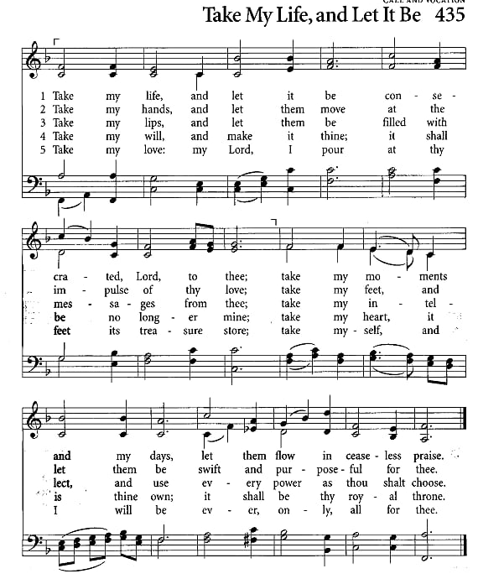

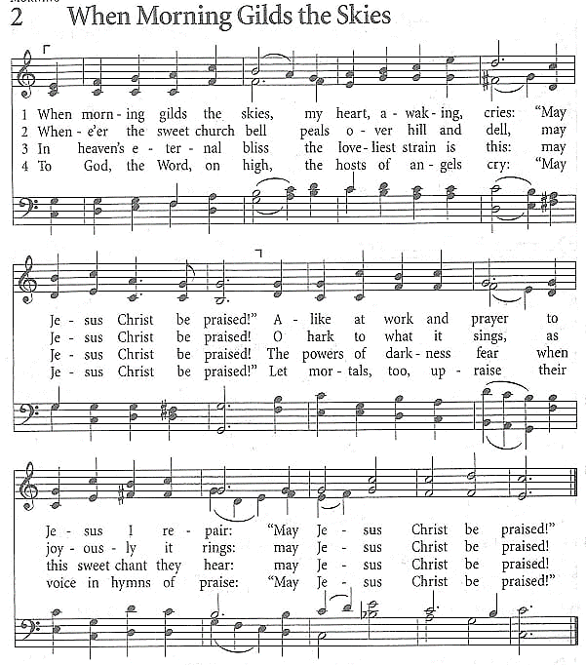

Notes

St Stephen the Martyr Anglican Church
9887 Cameron St, Burnaby BC V3J 1M3
Web: www.StStephenburnaby.ca
Email: info@ststephenburnaby.ca
Telephone: 604-421-0472
Rector: The Rev. Ruth Monette
Office Administrator: Lois Holmlund
Wardens: Esther Hizsa, Val Krause, & Elaine Renforth

