Notes for message- The End week 2

The End… Jesus is Coming Back!

Rev 1:1-3 The revelation of Jesus Christ, which God gave him to show his servants what must soon take place. He made it known by sending his angel to his servant John, who testifies to everything he saw-that is, the word of God and the testimony of Jesus Christ. Blessed is the one who reads the words of this prophecy, and blessed are those who hear it and take to heart what is written in it, because the time is near. NIV

OUTLINE: Rev 1:19 Write, therefore, what you have seen, what is now and what will take place later. NIV

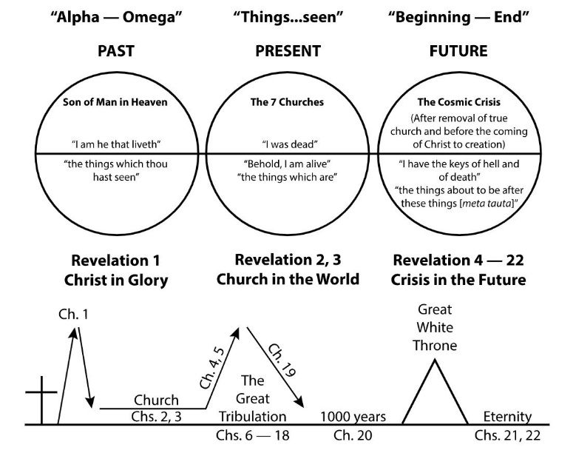

Jesus is qualified to be worshipped continually and forever-

- Jesus is more than just a buddy.

Rev 4:8-11 Each of the four living creatures had six wings and was covered with eyes all around, even under his wings. Day and night they never stop saying: "Holy, holy, holy is the Lord God Almighty, who was, and is, and is to come." Whenever the living creatures give glory, honor and thanks to him who sits on the throne and who lives for ever and ever, the twenty-four elders fall down before him who sits on the throne, and worship him who lives for ever and ever. They lay their crowns before the throne and say: "You are worthy, our Lord and God, to receive glory and honor and power, for you created all things, and by your will they were created and have their being.” NIV

- Our human tendency is to think of ourselves as God.

Rom 12:1 ...offer your bodies as living sacrifices, holy and pleasing to God-this is your spiritual act of worship.

Jesus is qualified to bring judgment and perfect justice upon the earth-

Rev 5:2-5 And I saw a mighty angel proclaiming in a loud voice, "Who is worthy to break the seals and open the scroll?" But no one in heaven or on earth or under the earth could open the scroll or even look inside it. I wept and wept because no one was found who was worthy to open the scroll or look inside. Then one of the elders said to me, "Do not weep! See, the Lion of the tribe of Judah, the Root of David, has triumphed. He is able to open the scroll and its seven seals." NIV

Rev 6:16-17 "Fall on us and hide us from the face of him who sits on the throne and from the wrath of the Lamb! For the great day of their wrath has come, and who can stand?" NIV

- John pictured this judgment as a series of twenty one events. (Rev. chapters 6-18)
- To escape the wrath of the Lamb, you need to trust in the blood of the lamb.

Rom 5:9 Since we have now been justified by his blood, how much more shall we be saved from God's wrath through him. NIV
- Will our escape happen before, during, or after the tribulation?

1 Thess 5:9-11 For God did not appoint us to suffer wrath but to receive salvation through our Lord Jesus Christ. He died for us so that, whether we are awake or asleep, we may live together with him. Therefore encourage one another and build each other up, just as in fact you are doing. NIV

Jesus is qualified to triumph over the forces of evil and will recreate the world-

- Here comes the white horse!

Rev 19:11-13 I saw heaven standing open and there before me was a white horse, whose rider is called Faithful and True. With justice he judges and makes war. His eyes are like blazing fire, and on his head are many crowns. He has a name written on him that no one knows but he himself. He is dressed in a robe dipped in blood, and his name is the Word of God. NIV

Rev 19:16 On his robe and on his thigh he has this name written: KING OF KINGS AND LORD OF LORDS. NIV

- Satan himself is then bound and rendered powerless for 1000 years.

Rev 20:1-2 And I saw an angel coming down out of heaven, having the key to the Abyss and holding in his hand a great chain. He seized the dragon, that ancient serpent, who is the devil, or Satan, and bound him for a thousand years. NIV

- Those who refuse God’s offer of salvation will face the “Great White Throne” judgment.

Rev 20:12 The dead were judged according to what they had done as recorded in the books. NIV

- After this, Jesus will make all things new!

Rev 21:1-5 Then I saw a new heaven and a new earth, for the first heaven and the first earth had passed away, and there was no longer any sea. I saw the Holy City, the new Jerusalem, coming down out of heaven from God, prepared as a bride beautifully dressed for her husband. And I heard a loud voice from the throne saying, "Now the dwelling of God is with men, and he will live with them. They will be his people, and God himself will be with them and be their God. He will wipe every tear from their eyes. There will be no more death or mourning or crying or pain, for the old order of things has passed away." He who was seated on the throne said, "I am making everything new!" Then he said, "Write this down, for these words are trustworthy and true." NIV

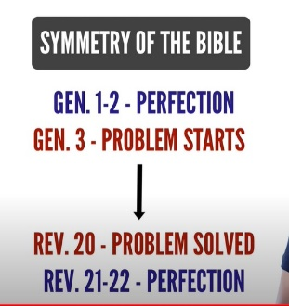

Rev 22:17 The Spirit and the bride say, "Come!" And let him who hears say, "Come!" Whoever is thirsty, let him come; and whoever wishes, let him take the free gift of the water of life. NIV

