****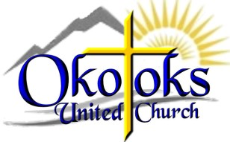

**Tuesdays: Oct. 20, Oct. 27, Nov. 3**

**6:00 to 8:30 p.m.**

**Saturdays: Oct. 24,**

**Oct 31, Nov 7,**

**10 a.m. to 12:30 p.m.**

**43 Riverside Drive**

New COVID-19 PROTOCOLS IN EFFECT

**Jacket Racket**

***FREE winter clothing exchange, everyone welcome!***

**Donations can be dropped at:**

* **Sobeys**
* **Okotoks Public Library**
* **Foothills Cleaners**
* **Better Than Home Laundry**
* **Pason Centennial Gold Arena**
* **Okotoks United Church**
* **Main Street Market & More**
* **Okotoks Fire Hall on Milligan**

**Please note: In light of COVID-19 we have to establish clear guidelines to be successful**

* Only **one person per household** to come and select the items.
* **Two customers** will be allowed in at one time. Wait in your car until you are waved in.
* Upon entry: Wear a **mask**. **Hand sanitizer with greater than 60% alcohol** will be provided. First names and phone numbers will be collected and retained in a confidential manner for 14 days.
* **Know the sizes** of the items that you want
* If items are tried on and not taken, they will be placed in a designated bin and left for 72 hours
* If you take items home and decide they are not for you or the person you selected them for, place them in the donation bins around town and they will be returned to the church.
* **No children** may attend

**We thank you in advance for your understanding of our need to keep everyone as safe as possible.**