Community Hub Guide for Participants
mosaicHouse will be using Zoom, a communications platform to facilitate community in a safe and fun way.
Zoom is available for your desktop computer, tablet or through your mobile device as an app (for both Apple and Android). It is possible to run the Zoom platform through your web browser, however there are limited features and functions.

Installing Zoom
The best way, is to install the client when prompted to download and install Zoom when you click a join link. Otherwise you can download the client from https://zoom.us/download
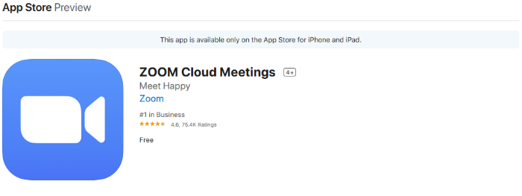
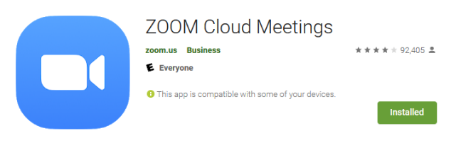
For Mac users, please view this guide as it may require an extra step:
https://support.zoom.us/hc/en-us/articles/203020795-How-To-Install-on-Mac
For Mobile users, download the “Zoom Cloud Meetings” app from the Apple App Store or Google Play Store.

Joining a Meeting
- Open the Zoom desktop client.
- Join a meeting using one of these methods:
  - Click Join a Meeting if you want to join without signing in.

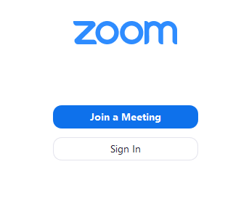

  - Or you may log in by clicking Sign In.

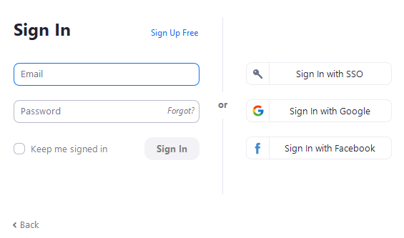
- To sign in, use your existing Google or Facebook account. If you don’t have an account, click Sign Up Free.

- Then, click Join

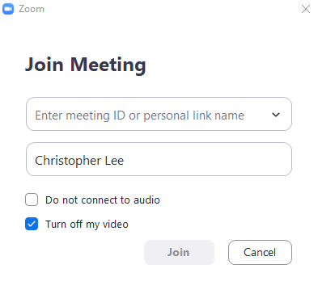
- Enter the meeting ID number (9 digit number associated with the meeting) and your name.

- Click on Join.
- Lastly, you will be prompted on how to connect your audio to the meeting. Click on Join with Computer Audio.

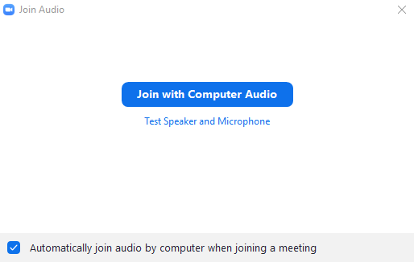

You may also join a ‘test meeting’ to familiarize yourself with Zoom: https://zoom.us/test

Microphone and Camera
If you are experiencing difficulty with seeing or hearing, make sure your computer’s volume and camera are ON.
You should also check to see whether or not your camera or microphone is muted. Your video will be off by default to allow you some time to orient yourself in front of the camera and computer screen.
Look to the bottom left of your Zoom screen. When there is a red strike through the microphone or the video icon, this means you are muted or your video is turned off to others:

Simply click on the icon to toggle it ON or OFF.
***Tip: It is recommended to keep your microphone muted. When your microphone is muted, press and hold your spacebar while you speak. Once you release the spacebar your microphone will be muted once again. This helps to reduce background noise and interference for the other participants.***

Interaction
To facilitate an enjoyable experience, click on the Chat icon at the bottom of the screen. A Zoom group chat panel should appear on the right side. Here, you have the opportunity to chat with everyone or a specific individual. The host may also provide important and useful information.

Here’s a video tutorial for scheduling and joining a Zoom meeting:
https://youtu.be/sJq_OM5VcDY
To review how to join a Zoom meeting, start the video from the 5 minute mark.
If you have any questions, ask your Community Hub Host, or you may contact the Pastor of houseChurches: christopher@mosaichouse.ca

