St Stephen the Martyr Anglican Church, Burnaby
Holy Eucharist with Zoom Option

Sunday, October 25, 2020
The 21st Sunday after Pentecost

Our Money Story Week 2: Release

gathering of the community
Words of Welcome, Orientation, and Territorial Acknowledgment

During our first hymn, children and their Sunday School teachers may move to the Parish Hall for a short class. Children and their teachers will return at Holy Eucharist.

~ You may stand for the opening hymn & prayers.~

HYMN CP 397 Praise the One Who Breaks the Darkness See pages 14-15

Celebrant: Through Moses, God said,

All: “Let my People go.”
Celebrant: In Scripture, the law declares:

All: “In the seventh year, you must cancel all debts.”
Celebrant: With grace, Jesus said:

All: “Give one coat away.”

Celebrant: With honesty, Jesus taught:
All: “Sell what you have, give that money to the poor.”

Celebrant: Faith has always involved letting go, releasing, setting free,
Dropping our nets, giving to others, and following.
All: So in this hour of worship, may we release that which binds us.
May we worship with open, untamed, and porous hearts,
so that we can walk freely with God.

Celebrant: Let it be so.
All: Amen.

prayer of confession
Celebrant: Let us pray.
All: Gracious God,
We admit to holding tight to that which we know and understand.
We put you in a box to avoid the shades of gray that come with faith.
We put worship in a box to avoid the discomfort of change.
We put ourselves in boxes labeled with gender expectations and societal norms.
We put others in boxes labeled “worthy” and “unworthy.”
We put all that we have in a box and pray we won’t run out.
So in this moment, we confess to holding tight to fear, greed, and worldly structures.
Forgive us for missing the point.
Open our eyes to a new way—
to a holiness found in open boxes, unclenched fists,
shades of gray, and holy release.
Gratefully we pray, Amen.
proclamation of the word
~ You may sit for the readings. ~

A Reading from Deuteronomy (Chapter 15, verses 1-11) Read by Vici

Every seventh year you shall grant a remission of debts. And this is the manner of the remission: every creditor shall remit the claim that is held against a neighbor, not exacting it of a neighbor who is a member of the community, because the Lord’s remission has been proclaimed. Of a foreigner you may exact it, but you must remit your claim on whatever any member of your community owes you. There will, however, be no one in need among you, because the Lord is sure to bless you in the land that the Lord your God is giving you as a possession to occupy, if only you will obey the Lord your God by diligently observing this entire commandment that I command you today. When the Lord your God has blessed you, as he promised you, you will lend to many nations, but you will not borrow; you will rule over many nations, but they will not rule over you.

If there is among you anyone in need, a member of your community in any of your towns within the land that the Lord your God is giving you, do not be hard-hearted or tight-fisted toward your needy neighbor. You should rather open your hand, willingly lending enough to meet the need, whatever it may be. Be careful that you do not entertain a mean thought, thinking, “The seventh year, the year of remission, is near,” and therefore view your needy neighbor with hostility and give nothing; your neighbor might cry to the Lord against you, and you would incur guilt. ¹Give liberally and be ungrudging when you do so, for on this account the Lord your God will bless you in all your work and in all that you undertake. Since there will never cease to be some in need on the earth, I therefore command you, “Open your hand to the poor and needy neighbor in your land.”

Reader: Hear what the Spirit is saying to God’s People.
All: Thanks be to God!

Psalms 90 (Verses 1-6, and 13-17) Read by Barb and Al
❖ Lord, you have been our refuge
❖ from one generation to another.

❖ Before the mountains were brought forth, or the land and the earth were born,
❖ from age to age you are God.

❖ You turn us back to the dust and say,
“❖ Go back, O child of earth.”

❖ For a thousand years in your sight are like yesterday when it is past
❖ and like a watch in the night.

❖ You sweep us away like a dream;
❖ we fade away suddenly like the grass.
❖ In the morning it is green and flourishes;
❖ in the evening it is dried up and withered.

❖ Return, O Lord; how long will you tarry?
❖ be gracious to your servants.

❖ Satisfy us by your loving-kindness in the morning;
❖ so shall we rejoice and be glad all the days of our life.

❖ Make us glad by the measure of the days that you afflicted us
❖ and the years in which we suffered adversity.

❖ Show your servants your works
❖ and your splendour to their children.

❖ May the graciousness of the Lord our God be upon us;
❖ prosper the work of our hands; prosper our handiwork.

A Reading from the Gospel of Matthew (Chapter 19, verses 16-22) Read by Douglas

Reader: The Lord be with you.
All: And also with you.
Reader: The Holy Gospel of our Lord Jesus Christ according to Matthew.
All: Glory to you Lord Jesus Christ

Then someone came to him and said, “Teacher, what good deed must I do to have eternal life?”
And he said to him, “Why do you ask me about what is good? There is only one who is good. If you wish to enter into life, keep the commandments.”
He said to him, “Which ones?”
And Jesus said, “You shall not murder; You shall not commit adultery; You shall not steal; You shall not bear false witness; Honor your father and mother; also, You shall love your neighbor as yourself.”
The young man said to him, “I have kept all these; what do I still lack?”
Jesus said to him, “If you wish to be perfect, go, sell your possessions, and give the money to the poor, and you will have treasure in heaven; then come, follow me.”
When the young man heard this word, he went away grieving, for he had many possessions.

Reader: The Gospel of Christ
All: Praise to You, Lord Jesus Christ.

reflection The Rev. Ruth Monette

prayer for illumination
Gracious God, we release our hearts to you.
First, we remove the pressure,
For release requires the freedom to be moved.
Then we allow our hearts to return to their original resting position—
In sync with you, with the rhythm of rain pounding the earth,
and this whole wild creation.
Then, we pray that you will find our hearts available—
Not just physically, but emotionally and spiritually.
So like the mockingbird releases her song,
We release our hearts to you.
Move in them. Stir us awake. Speak to us now.
We are waiting. Amen.

musical reflection Played by Ugo Onwujiobi

affirmation of faith
~ You may stand for the Affirmation of Faith.~

We believe that on the first day,
God released love and creativity over a void;
and that void became mountains and rivers, sunsets, and starry nights.
We believe God released
God’s people from the grips of slavery,
liberating us day in and day out.
We believe God laid down with death
and was released from its grip,
knowing suffering and freeing us from this fragile life.
And we believe God invites us —day in and day out—
to release our fears,
let go of assumptions, tear down walls,
throw open the doors, and walk closer to love.
May it be so.
Amen.

prayers of the people
Led by Edward and Pam

~ For the Prayers of the People, you may sit, stand, or kneel.~

Voice 1: Let us pray with confidence to God, saying, “Holy One, hear our prayer.”

Voice 2: We pray for God’s people throughout the world, for this gathering, for Melissa, our archbishop; Ruth, our rector; for all ministers and people. For the ministries within the Diocese of New Westminster, remembering especially All Saints, Ladner; All Saints, Agassi; All Saints, Burnaby;
All Saints, Mission; and St Stephen Mission in Bunga, the Episcopal Diocese of Northern Philippines, our companion parish and Diocese.

Voice 1: O God, guard and direct your Church in the way of unity, service, and praise.

All: Holy One, hear our prayer.

Voice 2: We pray for peace, for goodwill among nations, and for the well-being of all people. We remember especially those whose lives are linked with ours. In our parish, we pray for Colin & Brenda MacDuff, Margaret McKinnon, and Vici McParlan; we pray for those who use our facilities including the AA groups, exercise groups, children’s program, daycare, and faith groups. This week we pray also for Elections BC that all polling stations, including ours, may be safe, healthy, and effective locations for the exercise of democracy.

Voice 1: Give to all peoples an awareness of the unity of the human family.

All: Holy One, hear our prayer.

Voice 2: We pray for the coming of Your kingdom. May we proclaim of the good news of salvation to all of creation and be signs and symbols of your unconditional love to all whom we meet.

Voice 1: Cleanse our hearts of prejudice and selfishness, and inspire us to hunger and thirst for what is right. Teach us to use your creation for your greater praise, that all may share the good things you provide.

All: Holy One, hear our prayer.

Voice 2: We pray for those who have sought our prayers: Victor Baird, Joy Borthwick, Dale Floyd, Ken Fraser, Ron Holding, Lydia Holmlund, Barb Hunter, Hank Kassteen, Mike and Gail Koombes, Vivian Kroeker, Lenora Morse, Dawn Noske, Moira Small, Linda Uno, Audrey Watson, and Ray Werking.

Voice 1: Strengthen all who give their energy or skill for the healing of those who are sick in body or in mind. Set free all who are bound by fear and despair.

All: Holy One, hear our prayer.

Voice 2: We pray for those who have died, Huda Alsedawe and others you may hold in your hearts, and those who grieve, remembering particularly at this time the Alsedawe family.

Voice 1: Grant a peaceful end and eternal rest to all who are dying, and
your comfort to those who mourn.

All: Holy One, hear our prayer.

Voice 2: We hold space now for the prayers and thanksgivings on your heart.

~After a significant pause~

Voice 1: Gracious God, you have heard the prayers of your faithful people; you know our needs before we ask, and our ignorance in asking. Grant our requests as may be best for us. This we ask in the name of your Son Jesus Christ our Lord. Amen.

All: Holy One, hear our prayer.

Celebrant: The peace of the Lord be always with you.
All: And also with you.

~ We will not be “passing the peace” among the congregation at this time. Please remain in your seats. ~

invitation to the table
Celebrant: The dinner table is always a place where we tell stories.
We tell stories of growing up and falling in love, of making mistakes and figuring it out.
We tell stories that make us laugh, stories that make us cry, and stories that help us remember.
This table is no different.
For at this table we tell stories about a God who loves us unconditionally.
We tell stories about a man who fed the hungry, washed the feet of his disciples, and said, “This is my body—for you.”

So friends, as you come to this table today, bring your stories— Stories about who you are and who you want to be.
Stories of shame and disappointment, stories of fear and faith.
Bring your money stories, your faith stories, your love and heartbreak stories—bring them all.
For no matter the narrative, God welcomes us at this table.
You belong here.
There is a seat saved for you.

HYMN CP 545 We Will Lay our Burdens Down See page 12
~ You may stand for the Eucharistic prayer.~

the great thanksgiving

Celebrant: May God be with you.
All: And also with you.
Celebrant: Lift up your hearts.
All: We lift them to the Holy One.
Celebrant: Let us give thanks to the Lord our God.
All: It is right to give our thanks and praise.
Celebrant: Creator God, prayer has not always been easy for us.
Our mind flutters with news updates and questions of faith—
our thoughts like a river that won’t stop.

So today we take a deep breath—
Inhaling your name into the cobwebs of our lungs,
Willing your presence to wipe away the dust of self-doubt and fear.
And with that breath,
We ask you that you would tell us again:
Tell us again how you moved over the waters.
Tell us again how you led them with a pillar of fire.
Tell us again of that still, small voice,
And then tell us of the prophets.
Tell us of Mary and Joseph and that angel chorus.
Tell us of the blind man, and the leper, and the crowds that you healed. Tell us what it was like to walk on water.
Tell us of the little children that ran to you.
Tell us of the justice you preached.
Tell us of the hosannas and the palm branches. Tell us again of the love that changed the world.

Tell us again, because we are forgetful people.
It is part of our human nature;
That is why we long for this space week after week,
So that we might be reminded of who we are and whose we are.
So tell us again.
For our anxiety is loud. Our scarcity is loud.
Our fear is loud.
Our anger is loud.
Our shame is loud.
Our loneliness and self-doubt are loud. Mental illness is loud.
Doubt is loud, so tell us again.
Tell us again how it all began.
Tell us of manna in the wilderness and the disciples around the table.
Tell us again of your love for this world.
Tell us again how it changed everything.
Tell us again, so that we have the strength to tell others.
And give us the strength to remember your story anew.

And remembering your story, let us proclaim it, saying together with all of creation:

All: Holy, holy, holy Lord, God of power and might,
Heaven and earth are full of your glory.
Hosanna in the highest.
Blessed is he who comes in the name of the Lord.
Hosanna in the highest.

Celebrant: Holy and gracious God, accept our praise,
through your Son our Saviour Jesus Christ;
who on the night he was handed over to suffering and death,
took bread and gave you thanks, saying, “Take, and eat:
this is my body which is broken for you.”

In the same way he took the cup, saying,
“This is my blood which is shed for you.
When you do this, you do it in memory of me.”

Remembering, therefore, his death and resurrection,
we offer you this bread and this cup,
giving thanks that you have made us worthy
to stand in your presence and serve you.

We ask you to pour out your Spirit on this table.
Tether your Spirit to our fragile bones.
Be with us in these ordinary symbols of extraordinary love,

Gather into one all who share in these sacred mysteries,
filling them with the Holy Spirit and confirming their faith in the truth,
that together we may praise you and give you glory
through your Servant, Jesus Christ.
All glory and honour are yours, Father and Son,
All: Amen.

the lord’s prayer
~ We say this prayer in unison. Participants on the Zoom call are invited to unmute. ~

Celebrant: As we prepare to eat together as your disciples did,
We remember and speak Your truth out loud, praying together,

All: Our Father in heaven, hallowed be your name,
your kingdom come, your will be done,
on earth as in heaven.
Give us today our daily bread.
Forgive us our sins as we forgive those who sin against us.
Save us from the time of trial, and deliver us from evil.
For the kingdom, the power, and the glory are yours,
now and for ever. Amen.
the breaking of the bread
Celebrant: “I am the bread of life,” says the Lord.
“Whoever comes to me will never be hungry;
“whoever believes in me will never thirst.”
All: Taste and see that the Lord is good;
happy are they who trust in him!

the communion
Celebrant: The gifts of God for the People of God.
All: Thanks be to God.

~ At this time, Holy Communion is offered in one kind only (just a wafer).
So that the majority of people may maintain the physical distancing protocols,
Pastor Ruth will bring Communion to your seat.
You may sit, stand, or kneel to receive your wafer. Please extend both hands, one on top of the other and Pastor Ruth will place the wafer on your palm.
Remove your mask to consume the wafer, after Pastor Ruth moves on to the next person.
If you need a gluten-free wafer or would prefer a blessing instead, please ask for one. ~

musical reflection during eucharist Ugo Onwujiobi

~ You may stand for the concluding prayers.~

prayer after communion

Celebrant: Holy God,
It is not always easy to give what we have.
We count pennies.
We weigh the pros and cons.
We calculate what we have given before,
And we remind ourselves what we are giving to now.
We all have our money stories.
And yet,
Even though it can take work for us to practice release,
We trust that you can take these gifts—
However freely or reluctantly given—
And use them to build a more beautiful world.

Having received the gifts you give us in Communion,
Release us to be gifts to others.
Gratefully we pray,
All: Amen.

Celebrant: Glory to God,
All: whose power, working in us, can do infinitely more than we can ask or imagine. Glory to God from generation to generation,
in the Church and in Christ Jesus, for ever and ever. Amen.
~ You may sit for a few announcements. ~

HYMN CP 577 God of Grace and God of Glory See Page 13

dismissal

Celebrant: As you leave this place, remember who you are and whose you are and may the grace, peace, and blessing of the One God: Creator, Redeemer, Sustainer be upon you now and always. Amen

Celebrant: Go in peace to love and serve the Lord.
All: Thanks be to God.

~ Coffee and tea will be available in the Parish Hall following the service. You are encouraged to consider socializing outside and to remember your physical distancing. ~

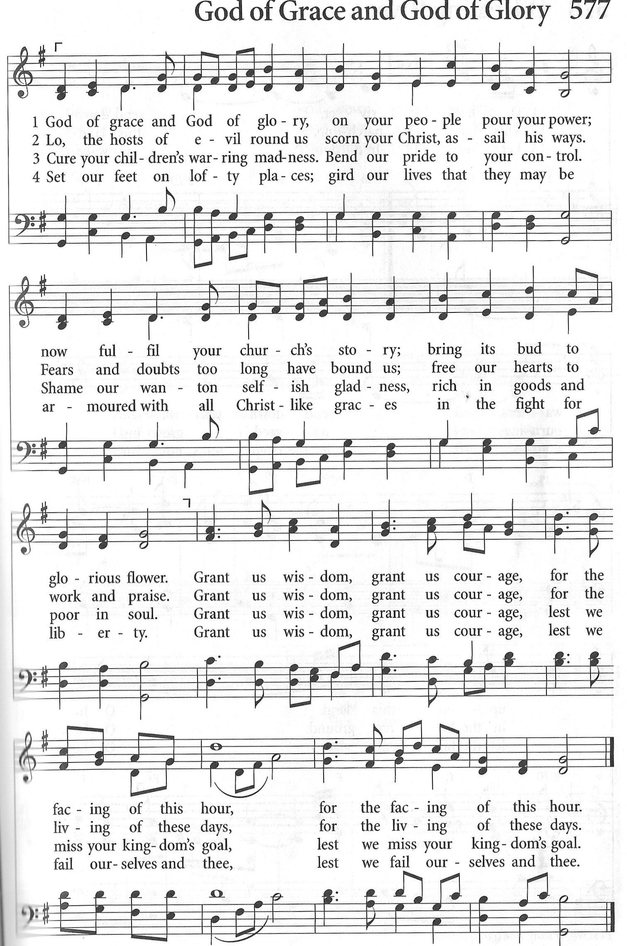
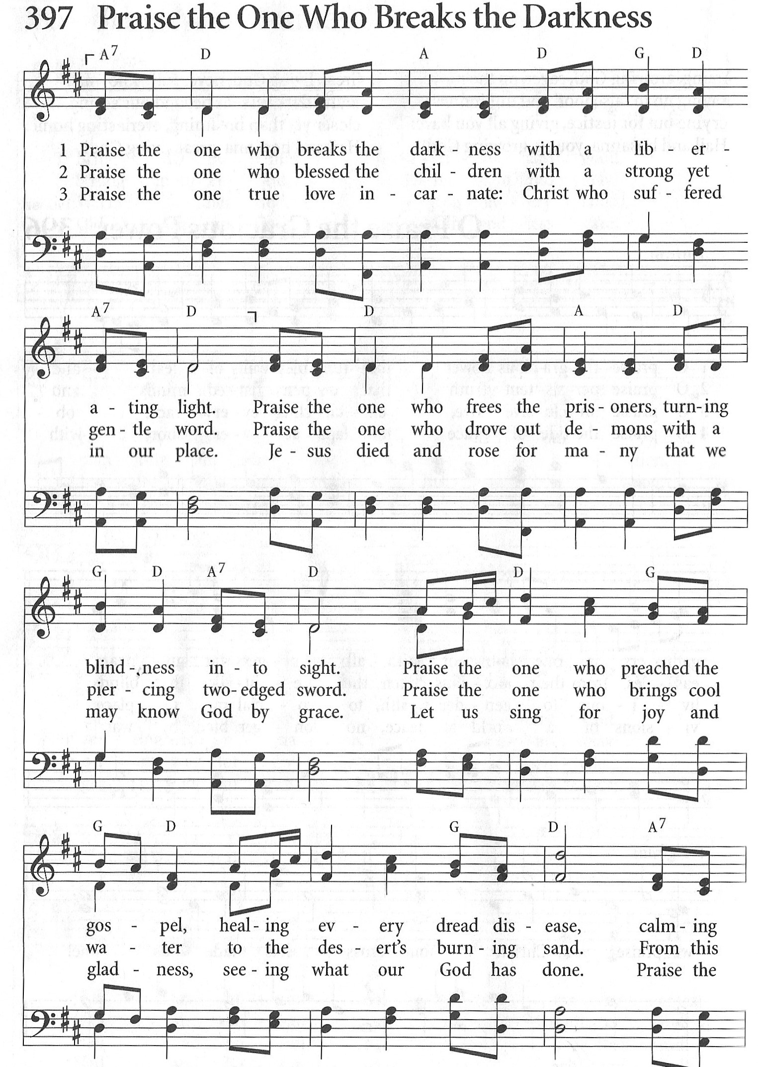

Continued on next page

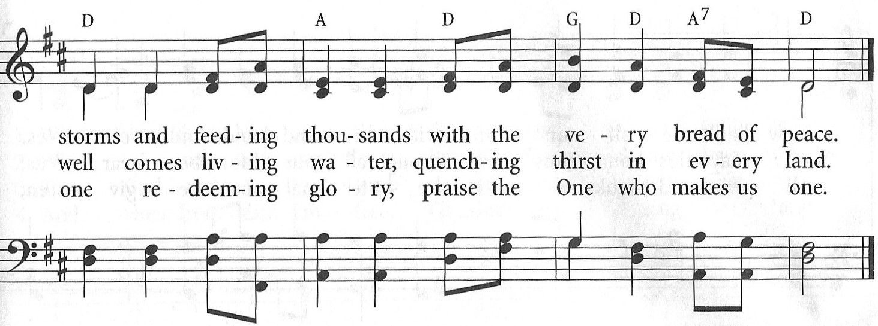

We thank all those who have participated in the worship and social time today: the Greeters, Altar Guild, Zoom hosts, Coffee hosts, and all others who have volunteered their time.

Sources for Today’s Liturgy
Written by Sarah Are | A Sanctified Art LLC | sanctifiedart.org
Eucharistic Prayer 2 | Book of Alternative Services | Anglican Church of Canada
Prayers of the People | Book of Alternative Services | modified by Ruth Monette

St Stephen the Martyr Anglican Church

9887 Cameron St, Burnaby BC V3J 1M3
Web: www.StStephenBurnaby.ca
Email: info@ststephenburnaby.ca
Telephone: 604-421-0472

Rector: The Rev. Ruth Monette
Music Director: Ugo Onwujiobi
Office Administrator: Lois Holmlund
Wardens: Esther Hizsa, Val Krause, & Elaine Renforth

