PAR AUTHORIZATION FORM
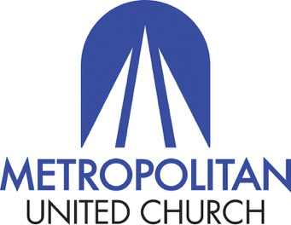

Yes, I wish to give to Metropolitan United Church through
Pre-Authorized Remittance (PAR).

Your Name: ______________________________________________________

I request and authorize The United Church of Canada to debit my account on the 20th of every month in the total amount of $ _____________________.

The contribution is to benefit the church as follows:

Local Church $ __________________

Mission and Service $ __________________

Other $ __________________

Signed _________________________________________ Date _______________________

Your PAR contact person is: Financial Manager Elena Pejcinovska in the Metropolitan United Church office at 416-363-0331, ext. 229; elenap@metunited.ca

Thank you for returning this form via email and thank you for your financial gifts to the ministry and mission of Metropolitan United Church, Toronto.

____________________________________________________________________________

For reference, your current level of giving to Metropolitan is:

Total Amount $ __________________ divided as follows:

Local Church $ ___________________

Mission and Service $ ___________________

Other $ ___________________

