SEASON OF CREATION ZOOM SESSIONS 2020
Originating from St. Paul’s Anglican Cathedral, Kamloops BC, Canada
All sessions will occur on Wednesday evenings at 7 p.m. by Zoom conference call. Each week an invitation and teaser with questions and quotes will be distributed two days prior to the sessions.

Please pre-register using Eventbrite at https://www.eventbrite.ca/x/season-of-creation-tickets-118358777289 Click View Event Details and select any or all sessions you plan to attend. For more information please contact the Very Rev. Ken Gray deanspc@shaw.ca 778 220 2631

Sept 2 Climate Emergency – or Not? Alecia Greenfield

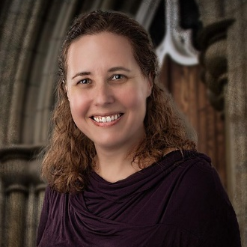
A priest of the Anglican Diocese of New Westminster, Alecia’s first degree was in philosophy and religious studies (UBC, 1996), after which she moved to Prince George, BC, working in fundraising and organisational development for museums and cultural institutions. She was Manager of the Prince George Railway and Forestry Museum in 2005.

Following an MBA in 2013 she attended the Vancouver School of Theology. She is presently assistant priest at St. Francis in the Wood in Vancouver. She currently chairs the Diocesan Climate Emergency Working Group which calls for ongoing dialogue within the church around the climate crisis. The group believes that such dialogue will lead to increased action by all persons of faith.

There is a lively debate around the value, or danger, of declaring a climate emergency. While many people think it an accurate characterization of what is happening globally and locally, some suggest that such emotive language is causing harm to the spirits of children and youth.

What do you think? Come and join the conversation. Climate emergency? Or not!
Sept 9 Creation and my Community Chief Patrick Michell

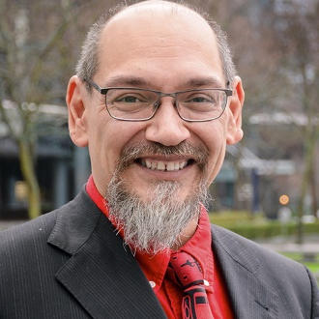
Unless our world tries to do something about climate change, I’m concerned that big change is coming. I don’t think that I can solve climate change alone. It’s bigger than all of us and it’s going to require all of us working together to solve this problem.

At Kanaka Bar, preparing for climate change is seen as an important milestone towards the achievement of community’s vision of self-sufficiency. It is being incorporated in everything that is being done by the community on a day to day basis.

Over recent years, many changes have been observed throughout the Traditional Territory. Community members have noticed that wildlife is moving away from the community and travelling further up-mountain, salmon numbers are decreasing and are swimming deeper in the Fraser River in search of cooler temperatures and vegetation growth is changing. As well, consistent rainfall has been replaced by long periods of dry weather and unpredictable storms.

Understanding the ways in which Kanaka Bar is vulnerable to climate change has allowed the community to take meaningful steps towards reducing their risks and becoming more resilient by developing an adaptation strategy. Actions range from installing weather monitoring stations in the community, to expanding food production initiatives, to hosting annual workshops on climate change. Together they represent a “Made at Kanaka, by Kanaka for Kanaka” adaption plan that will benefit the community in a holistic way that goes far beyond coping with climate change.

Chief Patrick is a passionate and articulate speaker on how we engage with creation and how we all, indigenous and settler folks can respond creatively to the climate crisis.

Come and discover what one community can do, and has already accomplished. Come and be encouraged and inspired.

Sept 16 St. Francis: An Appreciation Canon Len Fraser

The Rev. Canon Len Fraser recently retired from priestly ministry at Grace Church, Prince George. Originally a steel fabricator, working for a time here in Kamloops in the 1980s (he built the roof trusses for the Sandman Centre here in Kamloops) and as an occasional member of St. Pauls, Len felt a call to ordained ministry leading him to study at the Vancouver School of Theology. Ordained ministry followed in Lillooet and Prince George.

As a lover of creation, and an astute observer of people and nature, Len has for many years been interested in the work and teaching of St. Francis. In 1979, Pope John Paul II declared St. Francis the Patron Saint of Ecologists. In some ways, St. Francis of Assisi could be viewed as the original Earth Day advocate. Not only did he care for the poor and sick, but he preached multiple sermons on animals, and wanted all creatures on Earth, including humans, to be treated as equals under God. Some of his sermons included stories about birds, fish, and rabbits. It is no surprise that Pope Francis claimed his name for his pontifical ministry, especially noteworthy given the recent 5th anniversary of the publication of the encyclical Laudato si’.

Come and discover a historic Saint of the Church, whose image adorns one of our chapel windows. Come and see how Francis continues to inspire people like us in the 21st Century.

Sept 23 Nature, Climate, People Elise Buckle

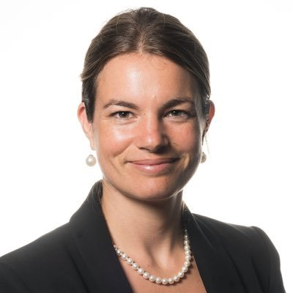
As President and Director of Climate & Sustainability, Advisor to the UN, Elise is highly committed to making this world a better place for people and nature. She has been working in the field of sustainable development for fifteen years.

She graduated from Sciences Po Paris and the London School of Economics and started her career in the field of humanitarian aid and development. She worked overseas on disaster reduction for the United Nations in Latin America and ACTED, an NGO based in Central Asia.

In 2012, she joined UNI Global Union, an international network of 900 members representing 20 million employees, focusing on sustainable finance. She led several Corporate Social Responsibility campaigns and managed to get Société Générale to sign a global agreement on human rights. In 2016, she worked for the United Nations Development Programme Climate Vulnerable Forum team focusing on climate and labour and for the World Business Council for Sustainable Development as climate policy manager.

Elise was in the room when the Paris Agreement was negotiated and signed. She has a unique insider perspective and will share how the UN climate negotiation process can and will shape public policy globally and nationally.

Coincidentally Elise is married to Matthew Buckle, son of our own Jon Buckle. Elise and Matthew live near Geneva, Switzerland.

Come and learn about how international conversations around climate connect with local experiences, right here in the Thompson Rivers Valley.

Sept 30 The Politics of Climate Dan Hines

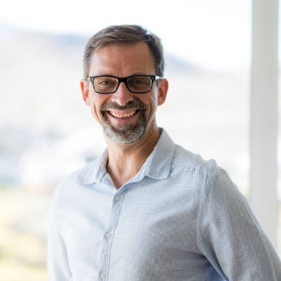
Mentored by the community activist, intellectual, and writer Parker J. Palmer, Dan serves as an international freelance speaker, workshop facilitator and leadership consultant in various contexts and communities. In recent years, his workshops and programs have taken him to China, Central America , throughout Canada and the U.S, and on sailboats and hiking trails.

Dan is an Anglican priest, has run for public office, and managed a zoo! He was born, raised and lives in the unceded and traditional territory of the Secwépemc people (Kamloops, BC); his ancestors have been ranchers, loggers, and government employees in the valley for three generations.

Dan writes: I strive to create a more just, compassionate and healthy world. One of my callings is to help nurture personal and professional integrity and the courage to act on it. I've found that when leaders bring integrity and humanity to the places where they live and work, it is life giving. It helps to overcome the destructive results of so much of what I witness everyday: moral failure, distrust, stress, isolation, fatigue and burnout.

A courageous spirit has led Dan through many life situations including a time of ministry here at St. Paul’s. He is politically astute and well equipped to help us explore strategic options and political possibilities around climate and the environment.

Come and hear one person’s story and consider not only the art of the possible, but what may be necessary for our world and society to change direction in the months and years ahead. There is no Planet B!

These presentations originate from the ancestral and unceded lands of the Tk'emlúps te Secwépemc people, the original keepers and inhabitants of this land.

