Reviews of 1917 and Ehud the Left-Handed Guy
A Sermon Preached at LPCC, Feb 2, 2020
An Oscar Review and Judges 3:12-30
Rev. John Suk, PhD

Before we read today’s scripture, I invited the children to leave for Sunday School. You see, our scripture for today was a war story, a particularly violent war story. I didn’t want to have to explain it to the children or apologize to the parents.

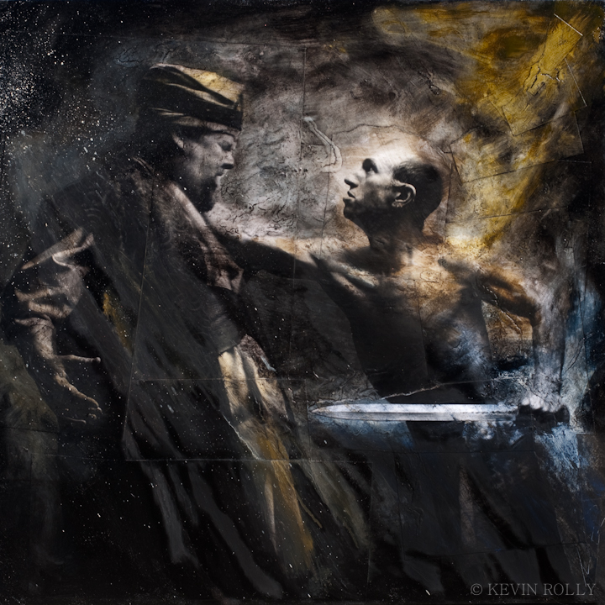

And the movie that I’m going to review today, 1917, was rated “R.” That means anyone under the age of 17 who wants to see the movie has to be accompanied by an adult. 1917 is very violent.

Why do we like these stories? Why are we such suckers for violence, murder and mayhem?

So, first, the story of Ehud and Eglon. Not only is it violent, but ironically, this story is also supposed to be a divine comedy.
Unfortunately, most of the humor gets lost in translation. I'll try to give you a taste of it, though.

Ehud is a Benjaminite, which means, in Hebrew, "son of my right hand." But we are also told that Ehud is a left-handed “son of my right hand.” Right off, the audience wants to know how the left-handed son of a right-handed people will take advantage of this confusion.

What is more, the obese King Eglon's name sounds like the Hebrew word for "fatted calf." So, now Hebrews are asking themselves how a left-handed son of my right hand is going to slaughter the fatted calf.

As it happens, after Ehud delivers Israel’s war tax, or tribute, to King Eglon, Ehud manages to trick the King’s retainers into leaving, so that Ehud is alone with the King. Then Ehud grabs his sword, successfully hidden on the wrong-right side of his body and buries it in Eglon’s belly.

Ehud then dumps the dead King in a bathroom, shuts the door, and runs. In Hebrew what follows literally reads: "The servants came and saw, look, the doors of the upper room are locked, and they said he must be relieving himself. They waited a long time and look, he's not opening the doors of his room, and they took the keys and opened them, and look, their lord is sprawled on the floor, dead.”

Next, the Israelites take on the Moabite army. The Moabite soldiers are said to be “vigourous and strong,” though the word used can also mean "fat." So, in a neat little parallel to the fate of their master, all the "fat" Moabite soldiers are struck down too.

This story, whenever it was read, had Israelites rolling on the floor with mirth and laughter. When they finally quieted down, one of them would only have to say, "he was relieving himself," or "they were all vigorously fat soldiers" or “look,” and everyone would break out in laughter all over again.

The Oscar nominated 1917, on the other hand, isn’t funny. Not at all.

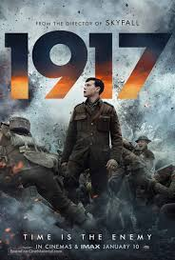

In brief, two British soldiers, Schofield and Blake, have to cross no-man’s land to warn 1600 isolated British troops to call off a doomed attack.

It’s a death trip, underlined by images of burial, bottomless pits, and a hellish inferno.

At one point, a German airplane crashes, lucifer like, out of the sky. After rescuing the German pilot, the pilot plugs a knife deep into Blake’s belly and kills him—an echo of Ehud and Eglon. Only Schofield is left. So, we all pray, with Jean Valjean, “Bring him home. Bring him peace. He is only a boy.”

And that morning, after navigating Hades and bullets, Schofield gets to the 1600 isolated troops. And some of them survive.

So why do we throng to see 1917? Why are we such suckers for this violence, murder and mayhem?

You are probably thinking, “well, we like these stories because they have deeper meaning, a moral.” Maybe. But just because a story has a meaning, is it the right one? Consider Ehud and Eglon again. It is quite clear that this story is told—as are all the stories in Judges—to convince the Israelites to worship Yahweh, and Yahweh alone. If they do so, God will give them health, wealth, and peace. If they do not worship Yahweh, however, God will abandon them, and they will be conquered.

The problem, of course, is that this isn’t true. Whether or not the Jewish people have been faithful over the past twenty-five-hundred years, their history has almost always been, regardless of their piety, one of suffering, persecution, exiles, pogroms and holocausts. Even now, anti-Semitism is on the rise, and most of the nations surrounding Israel want the Jewish state quashed. It is ugly.

Meanwhile, sadly, the State of Israel has responded with military occupation and illegal settlement and confiscation of conquered Palestinian territory, a universally recognized war crime and not peace at all.

So, it isn’t true that when Israel walks with the Lord, in the light of his word, what a glory he sheds on their way; it isn’t true that while Israel does his good will, he abides with them still, and with all who will trust and obey.” We used to sing such meaning for ourselves too, but that is not how the world turns. Sometimes, often even, evil nations, like evil people, prosper. And nations trying to do the right thing, fail.

And what is the moral or meaning of 1917? That heroes triumph over adversity? That something as hellish as war cannot stop brave men? That to do one’s duty is the main thing? That today is a good day to die? I don’t know. For all of its macabre beauty 1917 left me feeling depressed about the human prospect.

So why do we throng to see it? Why are we suckers for violence, murder and mayhem? Well, maybe such stories excite our basest, most ancient fight or flight instincts, without actually putting us in danger. Plus, there must be 101 reasons philosophers could give for the appeal of violence as an artistic subject.

But here’s the thing. If nothing else, both of these stories reinforce something that we all know but all too rarely focus on. War is hell.

I do not mean to say that when we are up against some final wall, and it is a matter of war or death camps, or basic freedoms—I do not mean to suggest we should never fight back. I am, at best, a half-baked pacifist.

But I am saying that those who live by war, countries that make war a habit, that find provocations easily, who cannot refrain from using violence to further what they think of as being in their national interest—those who live by the sword will die by the sword. This is another Biblical meaning than the one in Eglon and Ehud’s story, a very different one, and it is, I think, much closer to the truth.

I sometimes fear that here in Canada, as a neighbour of the USA and a partner with NATO, we are at risk of forgetting that war is hell, that it is not the answer, and we have begun to buy into the myth that might makes right, and anyways the West will never lose.

We live in an era where, for meaning, we are inundated with half-truths and excuses and propaganda and fake news. I invite you to remember that even the Bible—as in the story of Eglon and Ehud—even the Bible gets meaning wrong sometimes. Think critically. Especially about military affairs and war.

We live in an era where our neighbour to the South, the United States—a country of which I am a citizen—has intervened militarily in the affairs of its neighbours to its South, in Central and South America, over 80 times in 100 years, mostly in the name of democracy. Well, then, Central and South America should be among the most democratic places the world.

We live in an era where our neighbour to the South, the United States, has been at war in the middle East continually since 2003—a good part of that time with our Canadian help. For all such violent interventions, this is still one of the most dangerous places in the world.

I don’t know how to fix these geopolitical matters. You don’t either. But, at the very least, when it comes to our prayers, we need to be with Maya Angelou, who prays, “Father, Mother, God, you, the borderless sea of substance, we ask you to give all the world that which we need the most: peace.”

Except that we must pray this prayer having learned from Ehud and the Israelites that ultimately God chooses to answer our prayers for peace only by making us humans responsible to make it so. It’s our job and ours alone. There is no “trust and obey God” path that guarantees peace, no “but we’re a Christian nation,” narrative that secures our superiority. We should try to learn, instead, how, by our voting and investing, in our politics and locker-room conversations, in our schools and churches—we could learn how, not merely to pray for peace, but to wage peace, ourselves.

You know. What Jesus wanted.

