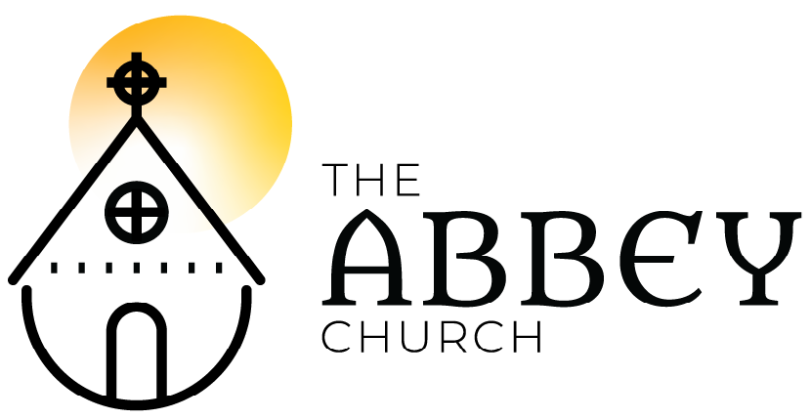
Easter 5A – May 10, 2020

Please submit your prayer requests in the YouTube chat or email to admin@emmauscommunity.ca – this week we are doing contemplative prayer and Roxy will be offering prayers during the worship.

Tolling of the Bells

Welcome - Rob Crosby-Shearer, EC

Land Acknowledgment -Jesse Robertson

Bell x 3

Opening Words
For the love of all those who mother;
Thanks be to God.
For their patience and vulnerability when tested;
Thanks be to God.
For their strength when tired;
Thanks be to God.
For their fierce hope when despairing;
Thanks be to God.

For Jesus, born of a woman and nurtured in her love, and for Mary, a reminder of your patient, waiting, revolutionary love.
Thanks be to God. Amen

Opening Song: Joyous Light
(Hail Gladdening Light)
Hail Gladdening Light, sun so bright
Jesus Christ, end of night, alleluia, alleluia
Hail Gladdening Light, Eternal Bright
at evening time, 'round us shine, alleluia, alleluia

We hymn the Father, we hymn the Son
We hymn the Spirit, wholly Divine
No one more worthy of songs to be sung
To the Giver of Life, all glory is Thine.

Hail Gladdening Light, such joyous Light
O Brilliant Star, forever shine, alleluia x2
Based on an ancient hymn - Giglio / Tomlin / Crowder / Gower / 2004 sixsteps / worshiptogether.com songs / CCLI

Poem: “The Way” Steve Garnaas-Holmes; read by Melanie Ihmels

Collect

Song: Gospel Acclamation
Alleluia! Alleluia! Alleluia! (x4)

Reading: John 10:10. – Catherine Pate
Alleluia! Alleluia! Alleluia! (x2)
Mass of Restoration / Josh Blakesley / OCP / OneLicense

Sermon: Brendon Neilson

Silence

The Creed
I believe in God the Maker almighty,
Creator of heaven and earth;
I believe in Jesus Christ, God’s only Son, our Lord. He was conceived by the power of the Holy Spirit and born of the Virgin Mary.

He suffered under Pontius Pilate, was crucified, died and was buried. He descended to the dead on the third day he rose again.
He ascended into heav’n and is seated at the right hand of the Maker.
He will come again to judge the living and the dead.

I believe in the Holy Spirit, the holy catholic Church, the communion of saints, the forgiveness of sins, +the resurrection of the body, and the life everlasting. Amen.
Ryan Flanigan, alt., © 2017, Common Hymnal, CCLI

Contemplative Prayers of the People
Nothing can trouble, nothing can frighten.
Those who seek God shall never go wanting.
Nothing can trouble, nothing can frighten.
God alone fills us.
Based on the word of St. Theresa of Avila.
Ateliers et Presses de Taize / Onelicense (with streaming)

Offertory: Christ is the Light of the World
In Christ we offer all that he has offered
the perfect offering.

Christ is the life of the world. X2

So we remember all that he remembered
the whole of Love returned.

Christ is the life of the world. X2

Let us lift up, lift our hearts.
Let us lift up, lift our hearts.
It is good to lift our hearts to the Lord.

Sent forth in beauty, reconciling all things
radiant in holiness.
Christ is the life of the world. X3
Sandra McCracken / Drink Your Tea Music / CCLI

Prayer Over the Gifts

The Holy Eucharist:
The Lord be with you! And also with you
Lift up your hearts! We lift them to the Lord
Let us give thanks to the Lord our God.
It is right to give God thanks and praise…

(occasionally: Glory to You forever and ever!)

The Sanctus:
Holy, holy, holy Lord
God of power and might!
Heaven and Earth are full of your glory. Hosanna in the highest. +Blessed is the one who comes in the name of the Lord. Hosanna in the highest.

…

The Memorial Acclamation:
Christ has died! Christ is risen!
Christ will come again!
Eucharistic Prayer adapted - St. Lydia’s Table, Brooklyn, NY

…

The Lord’s Prayer:
As beloved children of our loving Parent,
we pray as Jesus taught us: Our Father who art in heaven, hallowed be Thy name, Thy kingdom come, Thy will be done, on earth as in it is heaven. Give us this day our daily bread. And forgive us our trespasses as we forgive those who trespass against us. And lead us not into temptation but deliver us from evil. For thine is the kingdom, the power, and the glory. Forever and ever. Amen.

These are the gifts of God for the people of God, feed on Christ in your hearts through faith with thanksgiving. Amen.

Silence

Song: Come My Way, My Truth My Life
Come, my Way, my Truth, my Life:
such a way as gives us breath,
such a truth as ends all strife,
such a life as killeth death.

Come, my Light,
my Feast, my Strength:
such a light as shows a feast,
such a feast as mends in length,
such a strength as makes his guest.

Come, my Joy, my Love, my Heart:
such a joy as none can move,
such a love as none can part,
such a heart as joys in love.

George Herbert / R.V. Williams – adapted by a version by the Blackfriars – New York City / OneLicense.

Prayer After Communion

Closing Song: Be Thou My Vision
Be thou my vision o Lord of my heart
Naught be all else to me, save that thou art
Thou my best thought, by day or by night
Waking or sleeping thy presence my light.

Riches I heed not, nor world’s empty praise
Thou mine inheritance now and always
Thou and thou only first in my heart
High King of heaven my treasure thou art.

High King of heaven, when victory is won,
May I reach heaven’s joys bright heaven’s Sun!
Heart of my own heart, whatever befall
Still be my vision o Ruler of all.
(8th Century; tr. Mary Elizabeth Byrne (1880-1931); vers. Eleanor Hull (1860-1935) Music traditional © Oxford U. Pres.

Blessing
May God, who gave birth to all creation, bless you:
may God, who became incarnate by an earthly mother, bless you:
may God, who broods as a mother over her children, bless you.
The blessing of God, +Source of all being eternal word and Holy Spirit, dwell within you, now and for ever.
Amen.

Sending:
Go in the peace and joy of the risen Lord!
Thanks be to God. Alleluia! Alleluia!

