Wednesday Morning Prayer - Lent

A Saint may be recalled

Bell x 3

Opening Responses:
Lord, open *our lips
*and our mouth shall proclaim *your praise.

Glory to You Source of all Being, Eternal Word and Ho*ly *Spirit /

*as it was in the beginning,
is now and ev*er *shall be. /

*World without *end, A*men.
asterisk indicates change of note.

Penitence
Let us confess our sins against God and neighbor:
(together) Before God, with the people of God, We confess our sin; the ways we wound our life, the lives of others and the life of God’s world.

Bell / Silence is kept.

Trisagion
Holy God - Holy and mighty
Holy immortal One
Have mercy - Have mercy
On us (repeat x 3)
Fernando Ortega /Cerdo Verde Music / CCLI

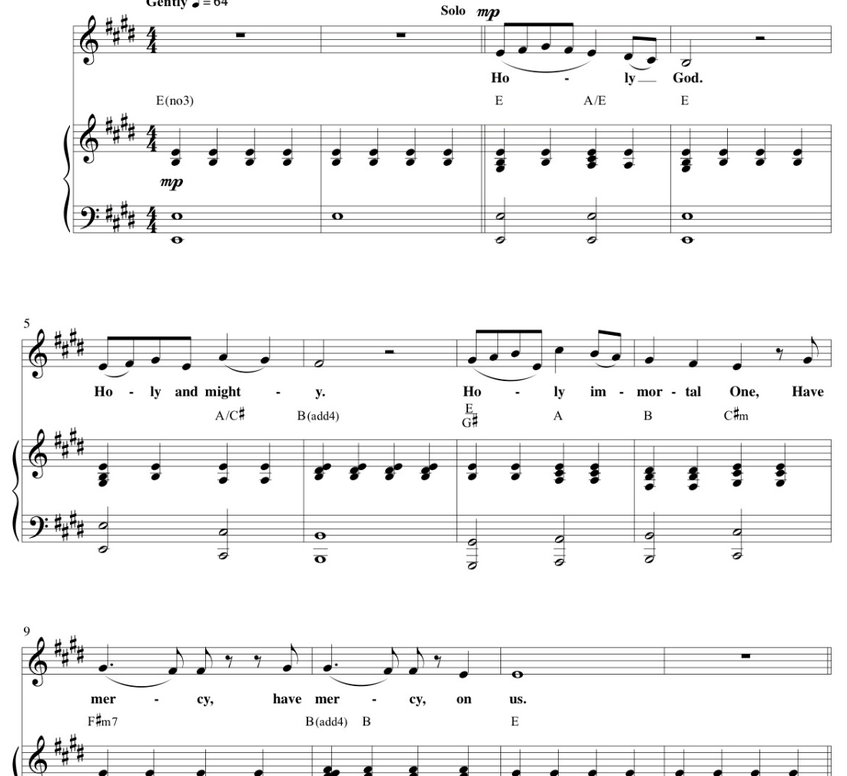

Absolution or Assurance of Grace

Opening Prayer
The night has passed,
and the day lies open before us;
let us pray with one heart and mind.

Bell. Silence is kept.

As we rejoice in the gift of this new day,
so may the light of your presence, O God,
set our hearts on fire with love for you;
now and for ever. Amen.
or, the sung version of this prayer

Poetry or Song

Gratitude
Let us give thanks to God our Creator always and for everything, saying, “We thank you, God.”

For the beauty and wonder of creation,
We thank you, God.
For all that is gracious in the lives of all people, revealing the image of Christ,
We thank you, God.
For our daily food, for our homes and families, community and friends,
We thank you, God.
For minds to think and hearts to love,
We thank you, God.
For health, strength, and skill to work, and for leisure to rest and play,
We thank you, God.
For those who are brave and courageous, patient in suffering and faithful in adversity,
We thank you, God.
For all who pursue peace, justice, and truth,
We thank you, God.
I invite your spoken or silent prayers of gratitude…
[together we say] We thank you, God.
For (. . . and) all the saints whose lives have reflected the light of Christ,
We thank you, God.

The Psalm
The appointed psalm of the day is chanted
… at the end of the Psalm:
Glory to you Source of All Be-ing *
Eternal Word and Ho-ly Spirit *
As it was in the beginning, is now and ever shall be * world without end, Amen.

The Gospel (and/or other Scripture Reading)
Acclamation Sung before and after the Gospel:

Please stand in body or spirit…
Gospel Acclamation:
Lord to whom shall we go?
Lord to whom shall we go?
You are gracious and merciful
Lord to whom shall we go?
Slow to anger and abounding in love
Lord to whom shall we go?
Lord to whom shall we go?
Let us trust in your Word.
Kent Gustafsen / Light For the World. Used With Personal Permission.

Bell / Silence / Bell

Following the silence, a time of sharing around how we are called by God’s Spirit through the ancient words of scripture.

Our Intercessions
Our spoken or silent intercessions are offered to God and before each other. A simple litany may also be used.

Collect the collect of the day, or another collect such as this (St. John Chrysostom):

ALMIGHTY God, who hast given us grace at this time with one accord to make our common supplications unto thee; and dost promise that when two or three are gathered together in thy Name thou wilt grant their requests: Fulfil now, O Lord, the desires and petitions of thy servants, as may be most expedient for them; granting us in this world knowledge of thy truth, and in the world to come life everlasting. Amen.

The Lord’s Prayer (Traditional)
As beloved children of a loving Parent
– we are bold to pray:
Our Father, who art in heaven, hallowed be thy name, thy kingdom come, thy will be done, on earth as it is in heaven. Give us this day our daily bread. And forgive us our trespasses, as we forgive those who trespass against us. And lead us not into temptation, but deliver us from evil. For thine is the kingdom, the power, and the glory, forever and ever, Amen.

Sending
[sung or spoken] Let us bless the Lord.
Thanks be to God.

Bell x 3

