***Engage! Support! Participate!***

**Strengthening our Relations:**

***Vancouver Celebrates Canada 150+***

***with our Indigenous Neighbours***

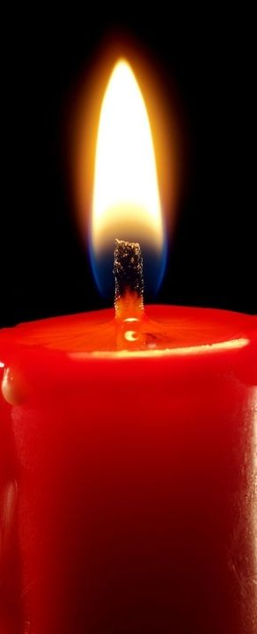

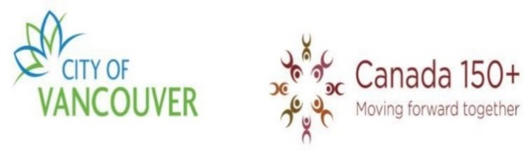



**April to December, 2017**

**Information, Activities & Dates**

for members and friends of West Point Grey United Church

4595 West 8th Avenue, Vancouver, B.C. tel: 604-224-4388

### Matthew, Chapter 5: Verses 23 and 24

***“Therefore, if you are offering your gift at the altar and there remember that your brother or sister has something against you, leave your gift there in front of the altar. First go and be reconciled to them; then come and offer your gift.”***

**<<<<<<<<<<<<<<<<<< In this booklet >>>>>>>>>>>>>>>>>>>**

* What is **Canada 150?** Why is “Plus” added (**Canada 150+**)?
* The **United Church’s** early involvement in Indian Residential Schools***,*** our

church’s Apology & the Truth and Reconciliation Commission Report

* In what ways can we continue to participate in healing with our Indigenous

neighbours? How are **Canada 150+** activities related to healing?

* Drawings by Valeria Lees
* Books available for adults and children
* Activities for all ages in the Vancouver region

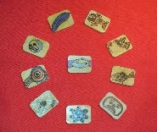 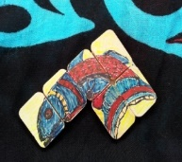

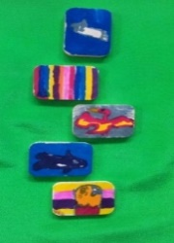 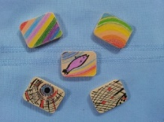

***On the front cover, and on pages 2 and 4***

**On the front cover** is the **red candle** we light at the beginning of Sunday services at West Point Grey United Church. It is followed by lighting the Christ candle. **In lighting a reconciliation candle**, we acknowledge the lands upon which we worship are the ancestral, cultural, traditional, and unceded territories of the Musqueam, Squamish, and Tseil-Waututh people from time immemorial. Our red candle is lit as a prayer for the ongoing work of reconciliation with our First Nations sisters and brothers.

**On pages 2 and 4** are sets of **wooden tiles** decorated by members of West Point Grey United Church congregation prior to the 2013 Truth and Reconciliation Commission (TRC) as an indicator of our community’s respect and good will towards the Indigenous peoples of Canada, and as a remembrance of our common endeavours in the days, weeks, and years ahead as we work towards justice and fairness.

**West Point Grey United Church invites feedback on the content of this collection and encourages other congregations to share with us their ideas for Reconciliation activities in their own congregations and with local communities.**

**City of Vancouver 150+ Plans**

**for everyone including our Indigenous Neighbours**

<http://vancouver.ca/people-programs/vancouver-commemorates-canada-150.aspx>

Logo for the City of Vancouver and The City of Reconciliation

Vancouver, the “City of Reconciliation,” has named the birthday celebration of Canadian Confederation (July 1, 1867) as **CANADA 150+**.  The history of our country predates Confederation—our country is really more than 150 years old--thus the “plus” (+). Canadians live on lands which have been occupied by Indigenous people for *thousands* of years. However, the relationships between Aboriginal and Non-Aboriginal Canadians present us with some challenges. The logo for CANADA 150+ includes the hopeful words, *"Moving Forward Together."*  During the coming year, we will engage in activities which acknowledge the sesquicentennial and also a *much longer history* marked by both suffering and joy. <http://vancouver.ca/news-calendar/moving-forward-together-canada-150.aspx>

[The City of Reconciliation framework](http://council.vancouver.ca/20141028/documents/rr1.pdf) http://vancouver.ca/images/cov/icons/pdf.png has 3 foundational components whose aim is to strengthen the City’s services and relationships with the Musqueam, Squamish, and Tsleil-Waututh First Nations, and the urban Aboriginal community: **Cultural Competency, Strengthening Relations, and Effective Decision-making**

**Long-term goals:**

* Strengthen local First Nations and urban aboriginal relations
* Promote Aboriginal peoples’ arts, culture, awareness, and understanding
* Incorporate First Nations and urban Aboriginal perspectives for effective services

Aligning the Truth and Reconciliation ***Calls to Action*** with the City’s work, our activities can be summarized under three themes: (1) **Healthy communities and wellness**, (2) **Achieving Indigenous human rights/recognition**, and (3) **Advancing awareness, knowledge, and capacity**.

***As a City of Reconciliation, residents of Vancouver will endeavour to:***

* Form sustaining relationships of mutual respect and understanding with local First Nations and the urban Aboriginal community;
* Incorporate First Nations and urban Aboriginal perspectives into work and decisions;
* Provide services that benefit members of the First Nations and the urban Aboriginal community.

***Events our congregation can attend during Canada 150+ celebrations in Vancouver***:

* The Drum is Calling Festival in Larwill Park, July 22-30.
* The Gathering of Canoes on Jericho Beach in July.
* Art and Museum displays – ongoing.
* Walk for Reconciliation – September 2017 – route to be announced shortly.
* Community centre and faith group events. As we receive notices, we’ll let you know.
* **Canada 150+** events organized by the Federal, Provincial and Municipal governments: *[food, dancing, guest entertainers, speakers, parades, costumes, and fireworks]*

**The Truth and Reconciliation Commission (TRC)**

**What was the Truth and Reconciliation Commission?**

The Truth and Reconciliation Commission was part of the Indian Residential Schools Settlement Agreement coming out of the largest class-action lawsuit in Canadian history.  The TRC travelled across Canada hearing and documenting stories of the survivors who had attended those schools as well as accounts of personal experiences from families, communities, churches and former school employees.  The TRC visited Vancouver, one of seven sites, for a week in September, 2013.  Following detailed, intensive work, a final report was made public in May, 2015. The report included 94 Calls to Action from the TRC to Governments and for all of us: <http://www.trc.ca/websites/trcinstitution/File/2015/Findings/Calls_to_Action_English2.pdf>

**What were the purposes and goals of the TRC?**

The TRC was designed to expose and document the truth about what happened in   
residential schools. Truth is an essential foundation for reconciliation between Indigenous Peoples (First Nations, Inuit and Metis) and others. Opportunities to tell stories of forceful removal from home, denial of contact with family and the suppression of language and culture were provided. Details of sexual and physical abuse, food shortage, and contagion were documented. The stories enabled recognition of the grave harm done through the policies of the Canadian Government and churches engaged to operate the schools. Establishing a basis for renewed relationships based upon respect and mutual understanding was an over-arching goal.

**Why was the TRC important to Canadians?**

The operation of residential schools is an important part of our shared Canadian history  
from the perspectives of both Indigenous Peoples and other Canadians.  It is a history which is not well known or understood.  Some have problems accepting the truth. Without truth, reconciliation--requiring prayer, patience, understanding, courage and perseverance--may not be possible.  Reconciliation is expected to take continued effort over years to come.

**What is West Point Grey United Church doing to continue healing?**

The WPGUC congregation has undertaken a number of reconciliation events since 2013.  We will continue to host more. Over the coming weeks and months these events will often coincide with City of Vancouver Canada 150+ activities as Canada marks the 150th anniversary of Confederation.

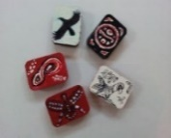 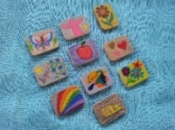 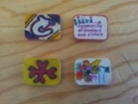

“**Let us find a way to belong to this time and place together. Our future, and the well-being of all our children,**

**rests with the kind of relationships we build today.”**

**-Chief Dr. Robert Joseph**

**A History of United Church Involvement in Residential Schools**

* During the 19th and early 20th century, the Canadian Government thought that First Peoples needed to be assimilated into Western European culture. Residential schools played an important role in this policy, which removed children from their families and communities and often discouraged the language and practices of First Nations cultures.
* During the 19th century, both the Methodist and Presbyterian churches were highly committed to universal public education. At the same time, there was little corporate understanding of the importance of cultural sensitivity in both education and in telling the gospel. There was little respect for the existing culture and spirituality of First Nations communities.
* An uncritical approach to mission enabled the church to become an agent of government in promoting and operating residential schools. In 1925, the United Church assumed responsibility for 12 schools until the last one closed in 1969. The Anglicans and Roman Catholics and many Presbyterians operated 120 Indian Residential Schools.
* In 1931, there were 80 residential schools in Canada. In 1948, there were 72 residential schools with 9,368 students, about half the Indian student population. However, in some regions—the North, B.C., and the Prairies, —the proportion was higher. There were communities where all the children were forcibly removed. The Government set the standards and provided the funding (often inadequate) for the schools, and legally required children to attend. The church was involved in helping to select school principals, and provided Christian Education workers.
* Aside from a few voices rarely heard by those in power, the United Church assented to the policy of assimilation that informed this system of residential schools.
* Thinking began to change in the 1940's and 1950's about the harm to children in separating them from their families and the failure of assimilation in practice and as a policy goal. [The Apology to First Nations Peoples](http://www.united-church.ca/beliefs/policies/1986/a651) was delivered by General Council of the United Church in 1986, and again in 1998. In 1990 the churches and Canadian society began to hear the stories of former residential school students and their families; these included descriptions of cultural, physical, psychological, sexual, and other abuses. In 1994, the General Council of the United Church established The Healing Fund, a $1 million fund-raising and education campaign to support healing initiatives of the First Nations.
* The United Church was involved in the following Indian Residential Schools: Ahousaht, Alberni, Port Simpson, Coqualeetza, Edmonton, Morley, Round Lake, Cote, File Hills, Norway House, Brandon, Portage la Prairie, and Mount Elgin (Muncey), as well as residences in Kitimat, B.C. and Teulon, Manitoba. Of approximately 80,000 students alive today, about 6.7 % attended United Church-run residential schools.
* The United Church supported the Truth and Reconciliation Commission’s work from 2012-2015. Members actively engaged in the work in several different ways—sharing documents, engaging in circle discussions, study and prayer groups. Our church was represented at the meeting in Ottawa at which the TRC presented its Final Report, with its 94 recommendations (Action Items) to the Government and to Canadians. Since then, United Churches across Canada have continued to hold reconciliation events, seeking to understand, seek justice, draw closer, and live in harmony with our Indigenous neighbours.

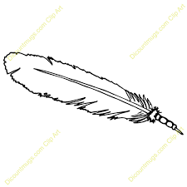

**Drawings by Valeria Lees**

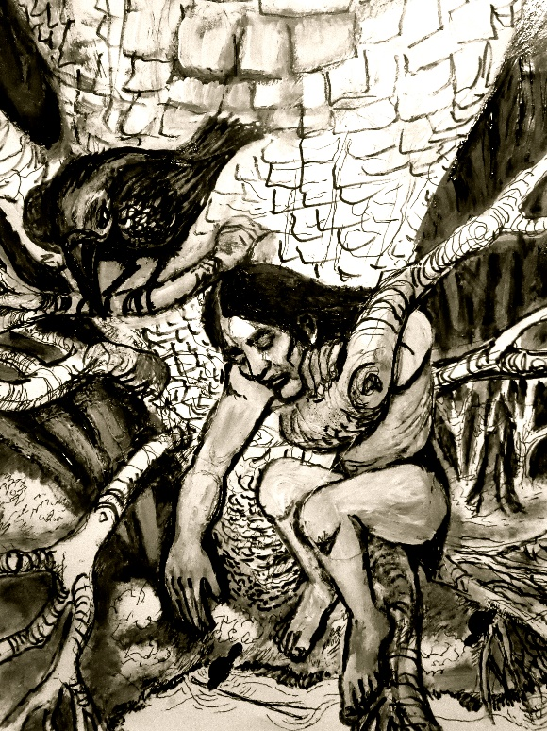

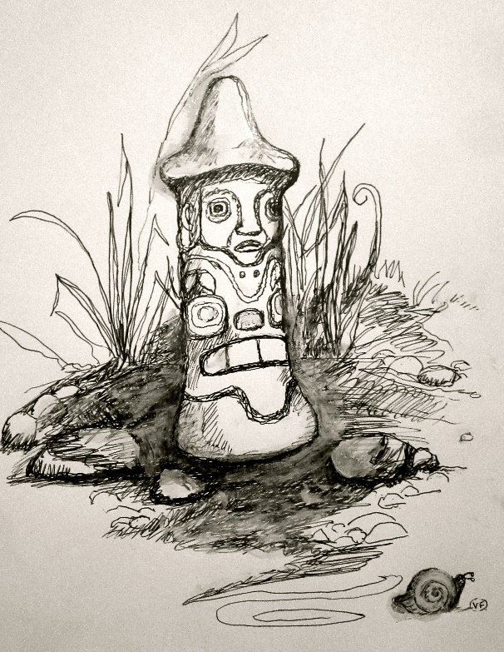

**“Raven is depicted stealing Beaver’s house-building ideas and giving them to Human Beings…..the other is an ancient hand maul, an attractive carved tool used for plank-splitting….“** *(Valeria Lees, West Point Grey U.C.)*

**Books for Adults and Children**

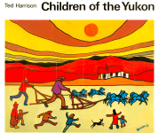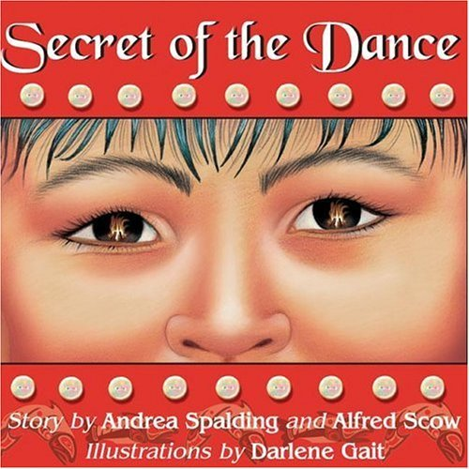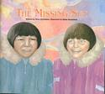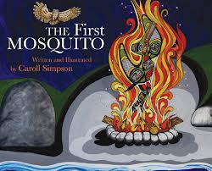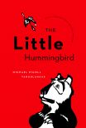

*For children:*

**Ted Harrison**, *Children of the Yukon*. Tundra Books. *(Art & story about the north)*. Tundra, 1984.

**Andrea Spalding and Alfred Scow**, *Secret of the Dance*. Orca Book Publishers, 2009.

**Peter Eyvindson**, *The Missing Sun* (about Inuit children). Pemmican Publishing, 2003.

**Caroll Simpson,** *The First Mosquito*. Heritage House Publishers, 2010.

**Michael Nicoll Yahgulanaas**, *The Little Hummingbird*. Greystone Books. 2010.

**Dave Bouchard and Roy Henry Vickers**, *The Elders are Watching*. Pgw, 2004.

***Recent additions to our Reconciliation Collection >>***

**Learn the Alphabet** (with Northwest Coast Native art. A beautifully illustrated “board book” for toddlers)

**Goodnight World; Animals of the Native Northwest.** 26 First Nations and Native artists share their art and culture helping children learn that animals are highly respected in their culture and are featured in traditions of stories, dances and songs.

**Northern Lights the Soccer Trails,** by Michael Arvaarluk Kusugak (Highlights the Inuit belief that the Northern Lights are ancestors attending a lively game of soccer.)

*For adults:*

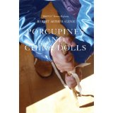 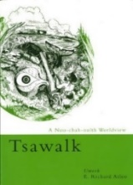 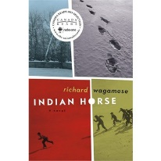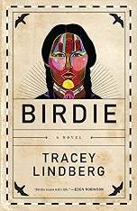 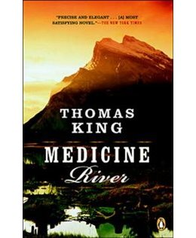

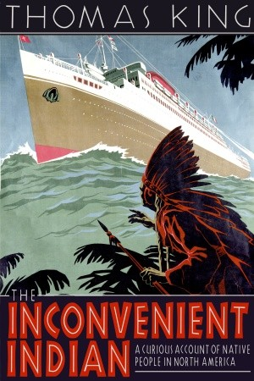

*\*****The following books are available from our church on two-week loans.***

**Robert Alexie (2009). Porcupines and China Dolls.** Theytus Books**.** (302 pp.)*

**Richard Atleo (2005). Tsawalk: A Nuu-chah-nulth Worldview**. UBC Press. (168 pp.)

**Thomas King (1989). Medicine River.** Penguin Canada.(320 pp.)”

**Thomas King* (2012). The Inconvenient Indian.** Doubleday Canada(304 pp.)*

**Tracy Lindberg (2015). Birdie.** Harper Collins Publishing. (288 pp.)*

**Bev Sellars (2012). They Called Me Number One: Secrets and Survival at an Indian Residential School.** Talonbooks. (256 pp,)

**Roy Henry Vickers & Robert Budd (2013). Raven Brings the Light.** Harbour Publishing.

**Richard Wagamese (2012).**  **Indian Horse**. D&M Publishers. (232 pp)*

**Learning, Exploring, Appreciating, Experiencing**

***Activities for All Ages as Canada Celebrates its 150th Birthday!***



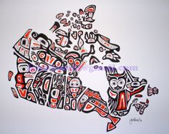

* ***Visit the Musqueam First Nations Reserve*** in southwest Vancouver. [www.musqueam.bc.ca](http://www.musqueam.bc.ca) *and* www.musqueam.bc.ca/educational-tours. Book a tour with friends and relatives. Be sure to visit the Art Gallery! The Musqueam community centre also offers pre-booked catering for lunches and suppers.
* ***Visit the Squamish Nation*** [www.squamish.net/](http://www.squamish.net/). The annual Squamish NationPowwow takes place in July.
* ***Visit the Tsleil-Waututh Nation*** [www.twnation.ca/](http://www.twnation.ca/) The Cultural Festival takes place in August.
* ***Visit the*** ***UBC Museum of Anthropology:*** exhibits and demonstrations [www.moa.ubc.ca](http://www.moa.ubc.ca)
* ***Visit Art Galleries and Museums****:*
* Bill Reid Gallery, 639 Hornby Street
* Spirit Wrestler Gallery, 47 Water Street
* Hills Native Art Gallery, 165 Water Street
* Eagle Spirit Gallery, 1803 Maritime Mews, Granville Island
* Squamish Lil’wat Cultural Centre, 4584 Blackcomb Way, Whistler, BC
* ***Visit other websites***:

[www.trc.ca](http://www.trc.ca) Truth and Reconciliation Commission, Canada

[www.unitedchurchofcanada/ca](http://www.unitedchurchofcanada/ca) (See the section on the Truth and Reconciliation Commission)*.*

[www.reconcilationcanada.ca](http://www.reconcilationcanada.ca) (Reconciliation Canada)

[www.irsss.ca](http://www.irsss.ca) (Indian Residential School Survivors Society)

[www.thechildrenremembered.ca](http://www.thechildrenremembered.ca) (The Children Remembered)

