48th Annual St. Mark’s Fair
Registration Package

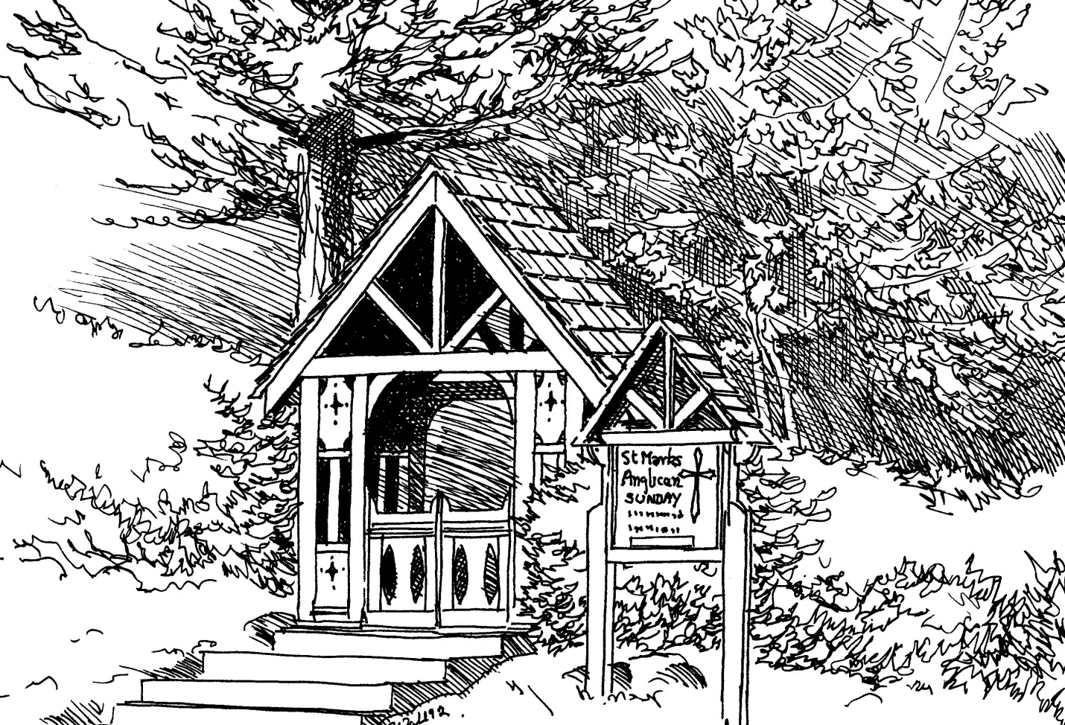
Qualicum Beach, Vancouver Island, BC

July 25th, 2019
(8:30 – 3:00)

Over 140 Vendors
Thousands of Visitors
Antiques & Collectibles…
Quality Crafts & Jewellery…
Furniture, Books, Clothing & Kids’ Stuff…
Unique Gifts, Specialty Foods...

Refreshments & Entertainment.

Come out and join us!

For further information:
St. Mark’s Anglican Church
138 Hoylake Rd West
Qualicum Beach, BC, V9K 1K3

https://www.stmarkqualicum.ca/
qbstmarksfair@gmail.com
250-752-5414

