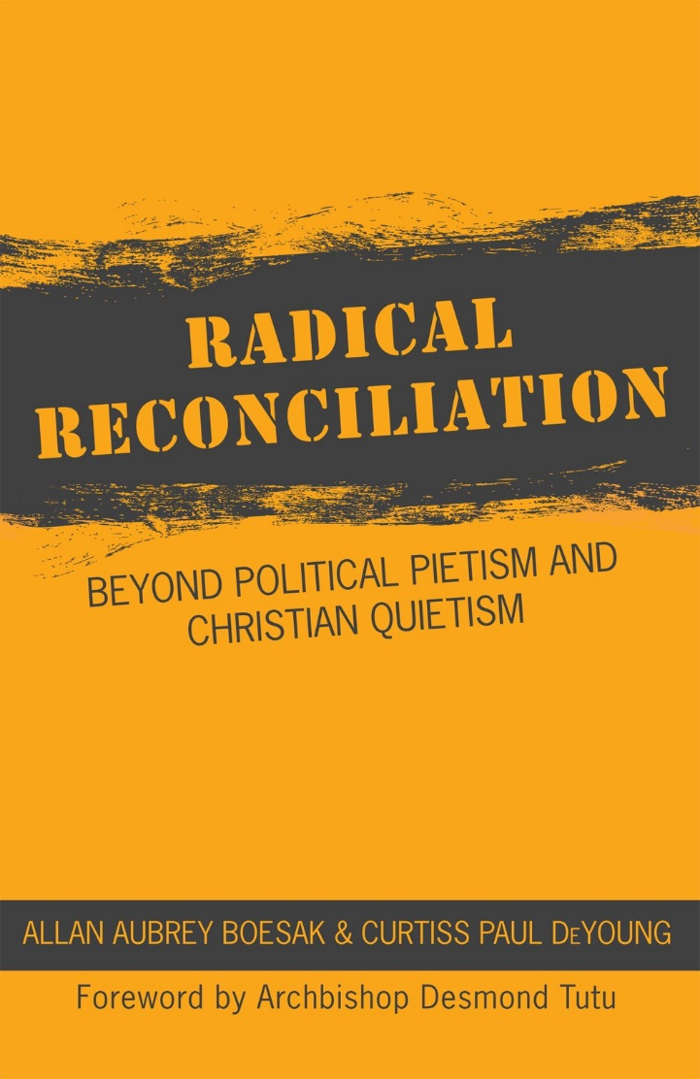

Radical Reconciliation
A book study for Lent

Week One – Reconciliation Redefined
Time for conversation/Coffee/meal
Prayer to start
Gracious and loving God,
Who in Christ reconciles the world to yourself.
May we be those who, reconciled within ourselves and our communities,
Reach out in love and justice to bring transformation to your world.
In the name of Christ, the reconciler,
Who with you and the Spirit of Life
Exist in loving relationship,
Now and in all eternity. Amen.

Bible Reflections
Ephesians 2.15-16
¹⁵He has abolished the law with its commandments and ordinances, so that he might create in himself one new humanity in place of the two, thus making peace, ¹⁶and might reconcile both groups to God in one body through the cross, thus putting to death that hostility through it.
Read the passage twice, with a minute of silence between the readings. Then speak aloud any words or phrases which stand out for you and, if you wish, why they do so. If time allows talk about these questions.
- What does this writer seem to be saying about reconciliation.?
- Who do you think the author is addressing?
- Have I learned something new from this passage?

“…efforts at reconciliation often do not go deep enough or far enough.” P11

Discussion
How would you define ‘Reconciliation?’ Do you have any difficulties with the word? How does it make you feel?
What about these words?
- Decolonisation
- Transformation
- Patriarchy
- Justice
- Post-colonial
- Healing
In the first chapters the authors use the word ‘postcolonial’ – there is debate among Social and Political Scientists as to whether anywhere is actually ‘post-colonial’. Do you think Canada is a postcolonial nation (or, more accurately, group of nations)?
The authors talk of a new level of reconciliation based upon a critique of the process in South Africa during and after the fall of Apartheid. They say “Mr. De Klerk (Prime Minister) did not intend to allow reconciliation to confront the country with the demands of the gospel, to to blunt the process of radical change and transformation”. They talk of the Gospel as radical and transformative – but that it is so often used to ‘tame’ and ‘domesticate’.
Is this the Church in the service of empire? In what ways has our own tradition been complicit in these activities?
New Testament Reconciliation Defined
Katallasso - to change places/to exchange.
“As John de Gruchy draws out the implication, when we are ‘reconciled’ we exchange places “with ‘the other’ and (are) in solidarity with rather than against ‘the other’”
- Who is/are the other/s in our own context?
- How might we engage in that exchange and stand in solidarity with them?
A Critique of Empire
At heart reconciliation presents a challenge to empire, to quote Mary:
⁵¹ He has shown strength with his arm;
he has scattered the proud in the thoughts of their hearts.
⁵² He has brought down the powerful from their thrones,
and lifted up the lowly;
⁵³ he has filled the hungry with good things,
and sent the rich away empty. (Gospel of Luke Chapter 1)
We, like Paul, and we will see later, Jesus are ‘colonised citizens of empire’. We have internalised the structures of empire and have been ‘internally colonised’. How might we make ourselves more aware of the structures, privilege, or powerlessness which we perpetuate in being such citizens?
The author maintains that Christian faith cannot be depoliticised – and that the heart of the Gospel story, the crucifixion and resurrection of Jesus Christ, is in itself an act of political resistance to empire and a stand against unjust structures.
Reconciliation is real. Reconciliation is radical. Reconciliation is revolutionary.
- Which of these phrases most surprises you? Or disturbs you? Or inspires you?
Part of the process of radical reconciliation is to recognise our own privilege (those of us in dominant ethnic groups or who benefit from being (for instance) male, cisgendered, and/or ‘straight’) in our everyday life.
- Is there a situation where you feel you might have – unwittingly or deliberately – benefitted from your race, gender identity, or sexuality?
The author ends the first chapter by saying “The first century church was established as new revolutionary venture for colonized and colonizers to rediscover their true identity in Christ and to experience a reconciliation that was personally and socially real, radical, and revolutionary. These faith communities created space and place for people to live into the full realization of what it meant to be one new humanity.”
- How might we be able to create those spaces and places in our own Christian communities? Do we want to?
Rizpah and Prophetic Action
The story of Rizpah is a little known story from 2 Samuel Chapters 21-24. The author describes this story as an intrusion into the David stories where David the king is challenged by the prophetic actions of king Saul’s widow. It is a ‘resistance to the official narrative favoured by the king’.
- Who’s stories do we, as a church, and as a society, need to hear? Who are the voiceless in and around our communities?
- How could we hear those stories?
- Where could we hear those stories?
- What might that mean that we have to do?
- Are we too busy listening to those at the centre of power rather than the voices of the margins?
The story of Rizpah talks of ‘expiation’ – of making good that which has been wrong. Restitution is offered as a better way of thinking of that in our current situation. As Boesak writes, the questions should include “How can I turn evil into good. What is it that I can do that can set the relationship right between us, that would make you feel that justice has been done to you?” (p.29) In the case of David, the author contends, he doesn’t really wish to meet these needs, but to find a politically expedient solution that makes life easier for him.
- Are we willing to ask these questions of ourselves, our society, our Church?
- What might be the cost of asking these questions?
- To whom will we give the right to define the path of reconciliation? Are we trying to ‘do’ reconciliation in our own lands in the same way that the dominant settler culture ‘did’ colonisation?
The author points out that “those in positions of power and privilege cannot define reconciliation nor affect it on behalf of others over whom they have power.” (p.37)
Summing up
Take some time to discuss what this session has brought to you, and what you have brought to it. Are there questions to take with you? New things to think about? Concerns you have? Hopes you have?
What are you going to do next? What are we going to do with these things?
Prayer to close
For all that we have learned,
for those things which have challenged, disturbed, excited, surprised us
we give you thanks.
We pray for open hearts and open minds,
That we may build our faith not on empire
But on Jesus Christ, our reconciler. Amen

