Get on the Right Bus
A Sermon Preached at Lawrence Park Community Church, Oct 20, 2019
Rev. John Suk, PhD

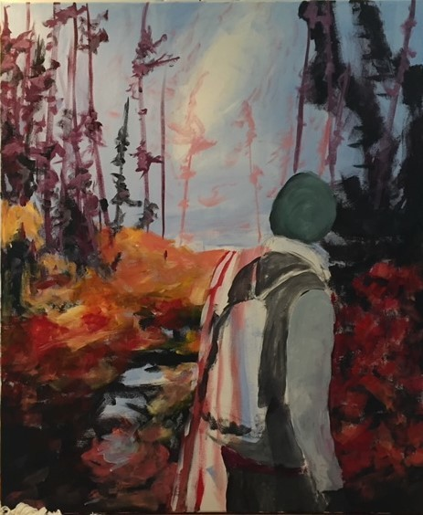

Sometimes, we choose the wrong bus.

Rev. Harry Emerson Fosdick tells of a man who boarded a bus in New York City intending to go to Detroit. At the end of his very long road trip he got off of the bus and asked a porter for directions to Woodward Avenue.

The porter told him there was no Woodward Avenue in town. So, the traveler became angry, and said, "I know Detroit. I know there is a Woodward Avenue in Detroit. Tell me how to get there."

To which the porter responded, “well, I suppose there must be a Woodward Avenue in Detroit, if you say so. But right now, you are in Kansas City.” In spite of the traveler’s best intentions, he had made the wrong choice and landed in the wrong city.

The choices we make—whether intentionally or out of ignorance—are fraught. Our choices have consequences. Are you on the right bus?

Jim Lawson’s painting, here, is—at least in part—about choice.

When I look at it, I see a hiker whose body language suggests that she is heading off the canvas, towards her right. I suppose the trail goes that way. Usually, most of us stick to the well-trod path. We don’t have to think so much, that way. First comes love, then comes marriage—or maybe a partner—then comes Madeline and Henry in a—two—baby carriages. Meanwhile, like everyone else, we then prioritize careers, a bigger house, Hockey Night in Canada, job promotions, travel, cruises, and eventually, downsizing. It’s easy. It’s how it is done.

But if you look at Jim’s painting closely, there might be another option.

You see, there is this mysterious and evocative light, not off to the right, where she is headed, but at the center of the painting. The hiker is looking at it, sideways. In that direction, if not a path, there is a way forward there, perhaps off trail, through shallow water, a path not often taken, to the light. And so, she must choose. Will she stick to the path everyone else does, or will she go on an adventure?

Of course, most decisions are six of one, half-a-dozen of another. Soy latte or a skim milk latte? Play a three iron or a four iron?

Some decisions, on the other hand, matter a great deal. Who do you choose as friends? What will you live for? How will you manage the earth’s climate file? How will you use your influence at work: just to build shareholder value or will you also use your influence to build a better world? Are you on the right bus?

Today we witnessed a baptism. Madeline and Henry are really, really cute. Best friends for life, probably. They have great parents and grandparents and even godparents. Like many of us, they have been born into privilege: they will grow up in a safe and loving home, they will have health care, they will have good educations, they will have opportunities that most world citizens can only dream of.

Their parents have decided for Madeline and Henry, by having them baptized into the universal church. That’s what baptism has always stood for, thousands of years now. And, in line with that choice, William and Lindsay have promised to make sure their children know all about Jesus. Good choice, I’d say.

But eventually Madeline and Henry will reach a certain age, and they’ll have to choose a bus all on their own.

Now, as much as I like to see a church full of young adults, and as much as I think church communities are good places for raising families, finding meaning, and enriching your lives, I am not primarily talking here about my hope that Madeline and Henry will eventually choose for church themselves, rather than for a temple or mosque or nothing at all, as if one way to spiritual clarity is the only way.

But I am talking about something Jesus once said, something that I wish every adult would carefully weigh and decide on. Jesus said that the first great command was to love God, and the second, which is like the first, is to love your neighbor as yourself. Jesus meant that the best way to love God is by loving your neighbor. Intentionally. As your life plan. Like you love yourself.

It’s easy, in a life lacking introspection, where we might stumble from one seemingly important choice to another, without ever really thinking about it, to get on the wrong bus, and not notice that our truest self has chosen something other than our neighbor to live for. Don’t do it.

Instead, take a moment to look at Jim’s painting. Something in me wants that hiker to choose for the light instead of the well-worn path everyone else takes. And you know, life is really too short to be going somewhere just because it’s easy, without thinking.

So, choose. The right bus.

