Size Matters
A Sermon Preached at Lawrence Park Community Church, Jan 7, 2018
Psalm 19, 1 Corinthians 13:13
Rev. John D. Suk, PhD

Psalm 29

1. Ascribe to the LORD, O mighty ones,
Ascribe to the LORD glory and strength
2. Ascribe to the LORD the glory due his name;
worship the LORD in the splender of his holiness.

3. The voice of the LORD is over the waters;
the God of glory thunders
the Lord thunders over the mighty waters.
4. The voice of the LORD is powerful;
the voice of the Lord is majestic.
5. The voice of the LORD breaks the cedars;
the LORD breaks in pieces
the cedars of Lebanon.

6. He makes Lebanon skip like a calf,
Sirion like a young wild ox.

7. The voice of the LORD strikes
with flashes of lightening.
8. The voice of the LORD shakes the desert;
the LORD shakes the Desert of Kadesh.
9. The voice of the LORD twists the oaks and
strips the forests bare.
And in his temple all cry “Glory!”

10. The LORD sits enthroned over the flood;
The LORD is enthroned as King forever.
11. The LORD gives strength to his people;
The LORD blesses his people with peace.

Friends:

Size matters. Our fascination with size is on display as soon as babies are born. “How much did she weigh?”

“My baby weighed seven pounds eight ounces.”

“Wow! That’s good. But my son weighed nine pounds two ounces!”

Size matters. Next thing you know, those little babies grow bigger and bigger and find themselves in a playground. And they can soon be heard making claims about their fathers. “My father is bigger than your father.” Says the first.

“Oh Yah? Well, my father has a bigger truck than your dad.”

“Oh yah? Well my dad can beat up your dad.” And so on. Next thing you know, those kids are moving on from the playground to bigger salaries, bigger houses, negotiating bigger retaliatory tariffs and voting for bigger tax cuts.

Size matters. This week Kim Jong Un made a speech in which he said:

. . . the U.S. is within the range of our nuclear strike and a nuclear button is always on the desk of my office, and this is just a reality, not a threat.

So, Kim baits President Trump—the man with little hands, according to Marco Rubio—but also the man with the world’s biggest army, biggest air force, and biggest navy. Of course, Trump takes the bait, and tweets:

North Korean Leader Kim Jong Un just stated that the “Nuclear Button is on his desk at all times.” Will someone from his depleted and food starved regime please inform him that I too have a Nuclear Button, but it is a much bigger & more powerful one than his, and my Button works!

Size matters. Size is a long-standing human obsession. From Stonehenge to the Great Pyramid, from the Titanic to Jumbo Jets, from Mount Everest’s heights to the Grand Canyon’s depths—we celebrate big, take refuge in the ginormous, and brag about might.

Which is why some people care about God’s size too. They usually want to say their God is big. Even today, people brag that their God is omnipotent, omniscient, omnipresent— “Omni-” in such phrases, pretty much meaning “big,” or “biggest.” And Psalm 29? Well, Psalm 29 is ancient Israel’s “God” version of Trump’s “my button is bigger than your button.” The little buttons, on the other hand, are all of the Canaanite’s little gods.

The Psalm works this way—as you can see from the handout in your bulletins. The first two and last two verses, in a sort of envelope structure, simply make the claim that God is great: greater in glory and strength, greater in holiness, and greater in kingly power than any other god, greater even than verse one’s “mighty ones,” that is, we learn from the rest of the Psalm, bigger than the gods of the Canaanites.

What follows in verses three to nine, inside the envelope, are seven “voice” lines, centered on the core of the Psalm, verse six. Seven the number of fullness or completion. The seven voice lines are a poetic demonstration of just how big Israel’s God is. In these verses, God’s voice is described as one whose power annihilates the Canaanite gods.
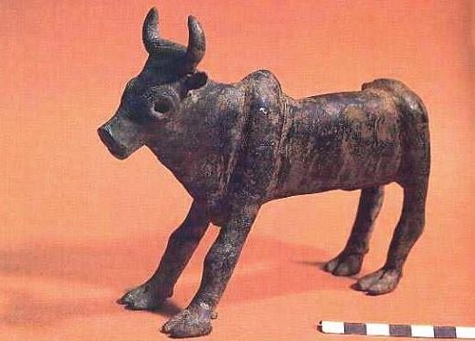
(Slide One: The Father God) There were basically four of these Gods. El was the father god, often pictured as a calf or cow, as in this slide. The Israelites worshipped El at Mount Sinai where the built a golden statue to him while Moses was up the mountain. El had several children.

(Slide Two: Yam) El’s first child was Yam, the sea—the same sea mentioned in verse three. The Mediterranean Ocean, to Israel’s East, was obviously Yam’s abode. Yam was the God
of chaos, and often portrayed as a sea monster.

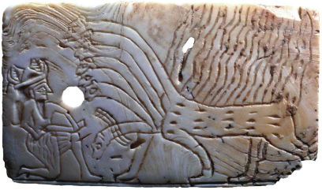

(Slide Three: Mot) El’s second child was Mot, the God of death, who lived in the desert, to Israel’s North East. This slide pictures a bone with Mot’s Sumerian name inscribed on it, that is now marketed on the internet for modern pagans.

(Slide Four: Baal) The third child was Baal, the favourite Canaanite God. the god of storm and lightning who lived in the clouds, or in his palace in Sirion—modern day Mount Herman, to Israel’s North. Baal is always pictured as holding a club (made of Lebanon’s Oak trees) or a bolt of lightning, as here. In Canaanite myth, Baal eventually defeated both Yam and Mot to become the high God of the Canaanites.

Now, according to the Psalm, these gods all lived outside of Israel’s borders. They were described here as “foreigners” in a most prejudicial way. We know from the Bible, however, that Israel’s people often worshipped these gods anyway. The Psalmist’s ideal of religious monotheism was a long, hard sell. So, these Canaanite gods competed with Israel’s God for the trembling affection of the people of Israel. Though according to Psalm 29, the battle between Israel’s Yahweh, and Canaan’s so-called mighty ones is no contest, so the decision about whom to worship should be easy.
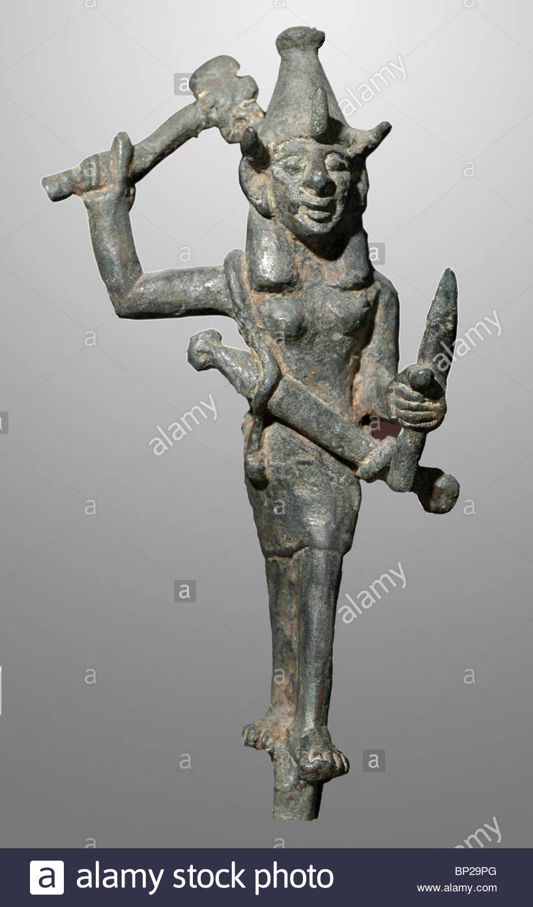

You see, in verse three, (see your handouts) Israel’s God thunders over the mighty sea, Yam. In doing so, Yahweh not only deflates Yam, but also usurps the storm power of Baal, the God of thunder.

In verse five, God breaks the cedars of Lebanon where altars to Baal were erected, laying bare Baal’s puny power.

In verse six, at the center of the Psalm, Israel’s God makes Lebanon skip like a calf—a poke at El, the highest of the Gods, who was, remember, idealized, and so idolized, as a calf; and Sirion like a young wild ox, another poke at Baal, who lived on Mount Sirion. At the heart of this Psalm, the Canaanite gods are mocked.

In verse seven, God minimizes Baal again, by taking control of the flashes of lightning, normally Baal’s weapon of choice, and in verse eight God beats up on Mot, the God of death in the Desert of Kadesh.

Finally, in verse nine the voice of the Lord sounds a seventh time and the oaks are twisted and the forests stripped bare. Groves of oak trees, or other forests and mountainsides were the places of choice for the worship of Baal. Notice, for example, how in Hosea 4.13, Hosea condemns Israelites for their unfaithfulness to the LORD, by saying: "They sacrifice on the mountaintops and burn offerings on the hills, under oak, poplar and terebinth where the shade is pleasant." By making Baal's mountain skip in verse six, and by twisting and stripping the forests bare in verse nine, Yahweh mocks Baal's authority. True worshippers of Yahweh gather not in the forests, but as verse nine has it, "in his [Jerusalem] temple" where all cry, "glory!"

So, how do you like this Trump-like picture of God—where God is bigger, badder, better—much, much more powerful and mighty with bigger buttons than any other God?

Today is the first Sunday of epiphany. Epiphany is an ancient Christian holy day that celebrates a very different understanding of God. On epiphany, we turn the page on the God of bigger buttons, and turn to Jesus as a much clearer picture of what God is all about. And, when we look for God in Jesus, rather than in Psalm 29, what we will find is actually an evolutionary sea-change in how God is understood today.

That is, if we really want to understand what God is like, we are to listen to his voice—not in thunder or carnage or bigness, but we are now to listen for the voice of God in the teachings of the unlikely person of Jesus.

Unlikely. Born in a stable to an unwed mother. A refugee for the first few years of his life, as his parents escaped political repression by fleeing to Egypt—which is actually the story most often preached on Epiphany. Jesus was not a mover and shaker, but a carpenter—at least for a few years, before he gave it up. Jesus was a preacher who never had the advantage of going to seminary, a person who devoted his life to comforting the grieving, healing the sick, and speaking the truth, quietly, even to deadly power.

Jesus was someone who refused to use the law or its upholders to beat down other people, but who insisted, instead, that laws were meant to make the lives of regular folks better, and if they didn’t, they were no good. Jesus was someone who was willing to suffer for his convictions, who was willing to upend social conventions by eating, drinking and partying with those who had no friends. Jesus was a teacher whose voice suggested we turn the other cheek, that a little was enough, that the poor were precious, and that our neighbors were what it is all about.

There is, within the Bible, evolutionary development in thinking about God—just as there has been in modern Judaism. Instead of emphasizing power and might and destructive power, Epiphany encourages us to listen for a still, quiet voice of God in the weak and condemned Jesus instead. This means, in a word, the Bible is not so much about the bigness of our God, but about pursuing shalom and love as our goals, defining justice and mercy as our benchmarks, even if we suffer for doing so along the way.

I don’t mean, by saying so, to pretend that power—at least human power—doesn’t have its place, or that human power is something we ought to ignore and not seek. Christians are not called to be naïve. But the message of Epiphany—the message engraved in the ministry of Jesus—is that among all the things we can strive for, the greatest of these is always love, no matter what size it comes in.

Several members of the church asked for a copy of Neil Gaiman’s benediction for a New Year. It is below. Note that I made one change to Gaiman’s wording, as noted during the service.

May your coming year be filled with magic and dreams and [“surprising kindnesses” instead of “good madness”]. I hope you read some fine books and kiss someone who thinks you’re wonderful, and don’t forget to make some art – write or draw or build or sing or live as only you can. May your coming year be a wonderful thing in which you dream both dangerously and outrageously. I hope you’ll make something that didn’t exist before you made it, that you will be loved and you will be liked and you will have people to love and to like in return. And most importantly, because I think there should be more kindness and more wisdom in the world right now – I hope that you will, when you need to be, be wise and that you will always be kind. And I hope that somewhere in the next year you surprise yourself.

https://www.improvisedlife.com/2011/01/04/neil-gaimans-benediction-for-new-years-or-any-other-time/

