Essential
Practices
Let God Touch Your Heart
[Grab your reader’s attention with a great quote from the document or use this space to emphasize a key point. To place this text box anywhere on the page, just drag it.]

Practice of Submission
Philippians 2:1-11

Erin Julihn
Coast Hills Community Church
February 7, 2016

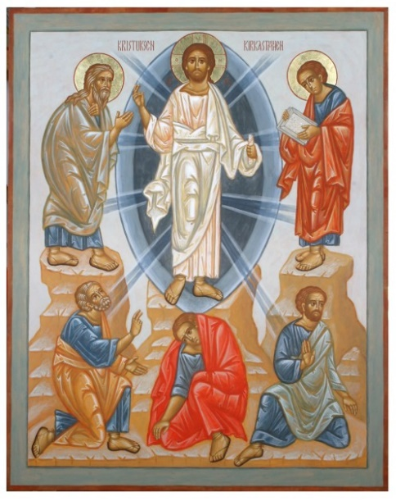
Slide 1.)
Image of the Transfiguration: http://dailyoffice.org/2012/08/05/evening-prayer-8-5-12-eve-of-the-transfiguration/transfiguration-jyrki-pouta-497/

Slide 2.)
Luke 9:28-36 (NIV)
About eight days after Jesus said this, he took Peter, John and James with him and went up onto a mountain to pray. 29 As he was praying, the appearance of his face changed, and his clothes became as bright as a flash of lightning. 30 Two men, Moses and Elijah, appeared in glorious splendor, talking with Jesus. 31 They spoke about his departure, which he was about to bring to fulfillment at Jerusalem. 32 Peter and his companions were very sleepy, but when they became fully awake, they saw his glory and the two men standing with him. 33 As the men were leaving Jesus, Peter said to him, “Master, it is good for us to be here. Let us put up three shelters—one for you, one for Moses and one for Elijah.” (He did not know what he was saying.)
34 While he was speaking, a cloud appeared and covered them, and they were afraid as they entered the cloud. 35 A voice came from the cloud, saying, “This is my Son, whom I have chosen; listen to him.” 36 When the voice had spoken, they found that Jesus was alone. The disciples kept this to themselves and did not tell anyone at that time what they had seen.

Slide 3.)
Repeat Transfiguration Image from #1

Slide 4.)
Philippians 2: 5-8 (NIV)
“Your attitude should be the same as that of Christ Jesus: Who, being in very nature God, did not consider equality with God something to be grasped, but made himself nothing, taking the very nature of a servant, being made in human likeness. And being found in appearance as a man, he humbled himself and became obedient to death- even death on a cross.”

Slide 5.)
A practise of Submission that reflects Jesus stems from a deep and growing understanding of:
a.) Jesus' IDENTITY as God
b.) our own IDENTITY as his Loved Children.

Slide 6.)
A practise of Submission that reflects Jesus is one that makes the Choice of Self Sacrifice:
a.) The character of God is one of Kingly Radiance AND Sacrifice and Servitude
b.) Personal Choice
John 10:18
“No one takes it (my life) from me, but I lay it down of my own accord. I have the authority to lay it down and the authority to take it up again...”
c.) Not acting blindly but actively Listening and Following Jesus as King...Submitting to Jesus First above all else.

Slide 7.)
We have a King who fully understands how hard this is:
“Father, if you are willing, take this cup (this task of suffering and dying to rescue us) from me: yet not my will, but yours be done.” And Luke tells us that...An angel from heaven appeared to him and strengthened him.” (Lk 22:42-43)

Slide 8.)
He couldn't do it alone.
Only Jesus can do the real work of changing us to be like him in this way, he is the only one who can empower us to follow him in this downward trajectory.

Slide 9.)
A practise of Submission that reflects Jesus comes from a position of knowing Jesus' True Identity and Our own, makes the Choice of Self Sacrifice and produces real Life.

Slide 10.)
In breaking the hold that death had on him, Jesus ended the hold that death can have on us, in all its suffering, brokenness and pain.
“I have come that they may have life and have it to the full” (John 10:10)

Slide 11.)
We will know it's really life when it looks and tastes like the good fruit of Jesus' Spirit- Love, Joy, Peace, Patience, Gentleness, Kindness, Goodness, Faithfulness and Self Control. (Galatians 5:22?)

Slide 12.)
Phil 2:1-11
...if you have any encouragement from being united with Christ, if any comfort from his love, if any common sharing in the Spirit, if any tenderness and compassion, 2 then make my joy complete by being like-minded, having the same love, being one in spirit and of one mind. 3 Do nothing out of selfish ambition or vain conceit. Rather, in humility value others above yourselves, 4 not looking to your own interests but each of you to the interests of the others.
5 Your attitude should be the same as that of Christ Jesus:
6 Who, being in very nature God,
did not consider equality with God something to be grasped or used to his own advantage;
7 rather, he made himself nothing
by taking the very nature of a servant, being made in human likeness.
8 And being found in appearance as a man,
he humbled himself by becoming obedient to death—even death on a cross!
9 Therefore God exalted him to the highest place
and gave him the name that is above every name,
10 that at the name of Jesus every knee should bow,
in heaven and on earth and under the earth,
11 and every tongue acknowledge that Jesus Christ is Lord,
to the glory of God the Father.

