NEWSLETTER FOR ALL WOMEN

DIOCESE OF CALGARY
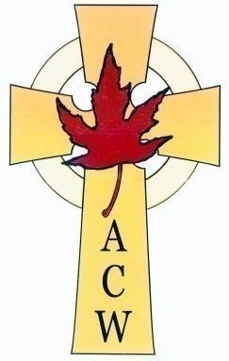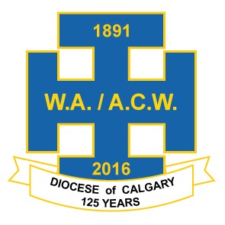
Anglican Church Women Prayer
Almighty God, our heavenly Father, who sent your blessed Son into the world to be the Saviour of all; Grant us a deep sense of gratitude for your grace and mercy towards us. Enable us by your Spirit to reveal your love in prayer and work and stewardship, so that your salvation may become known to all people, and your Name glorified throughout the earth: through Jesus Christ our Lord.
Amen

Calgary Diocesan Anglican Church Women

President, Margaret Newton, Message

Dear Friends in Christ – I started this message several months ago at a time when we were just starting Lent and putting the final arrangements in place for our Annual Conference. Today, we all live in a different world – some are still in self-isolation, church is via Zoom and YouTube, we all have masks at the ready when we venture out of our homes. For those with family in care facilities it is just now that “socially distanced” visits are happening. Provincial and federal borders are closed – all these changes are driven by the very real need to keep us all safe. I know many of you have been joining others around the world in praying and thanking God for all our health care workers, front line workers, and those essential workers that allow so many of us to live safely in our homes.

Sadly we had to cancel our Annual Conference which was to have been held at St. Peter’s Anglican Church in Okotoks. We wish to express our thanks to Rev. Dr. Norbert Haukenfrers and his key parish members including our own Newsletter board member Cisley Robinson who welcomed us with open hearts and were working full on for our conference. Father Norbert kindly has agreed to our coming to St. Peter’s in 2021 for our conference and our guest speaker Julie Moser also agreed to reschedule. We are blessed! And looking forward to Spring 2021!

The National Presidents Conference was also cancelled – it was to be held in Cornerbrook, Newfoundland the end of September. Plans are underway to reschedule if possible for September 2021.

The Silver Cross Service and Luncheon that was to have taken place in September sadly has also been cancelled.

I thank you all for your understanding and pray that it will not be long before we can all be together safely again.

Bless you all - stay safe - pray for each other.

I have shared a few prayers that I hope you will find helpful in this newsletter.

We remember all our Priests and Deacons, our Chaplain Betty, the Priests and staff at our Diocesan Offices, our Commissary and Archbishop Gregory – all have led with Grace and Compassion in difficult and anxious times.

This issue’s theme is Forgiveness and I have a story to share from our Second Vice-President Pearl Franz this will really touch your heart. Our Chaplain Rev. Betty Piwowar has also shared another thoughtful message on forgiveness. Our First Vice-President Linda Holt has shared a terrific book on forgiveness with us in the book reviews. And Most Excitingly we are going to host a Fall Retreat on Zoom! You will find the details in this newsletter. Please share the information as we have the capacity for a large attendance.

I believe we are almost finished finding out about me – the only thing to talk about is my career – it is all about the books. I started working as a “Page” in the Barrie Public Library [Barrie, Ontario] when I was 14, the summer before grade nine, and I continued to work in libraries until I retired at age 68 from the Marigold Library System [Strathmore, AB]. I attended Seneca College [North York, Metropolitan Toronto, Ontario] and obtained a Library Technicians Diploma. I spent a lifetime taking further education just as all of you would have done to keep up with the changes in your chosen fields. I just love public libraries – I loved working for our patrons – and had the blessings of the perfect job at the end of my library career. I was Bibliographic Services Manager for Marigold – which meant that I got to work with library staff from across the region. My passion for cataloguing materials started off with typing up headings and all that lovely information on 3” x 5” cards and ended up doing everything on a computer live. What has been interesting to me is all the new systems for cataloguing that have come along – all to make it easier for people to find the answers to their questions.

And, finally, Pearl Franz, our Second Vice-President shared this inspiring story of forgiveness and agreed that I could include it in our newsletter. Thanks Pearl – it is a wonderful story.

Here’s an anecdote about my parents.

In 1978, my parents had a very painful separation. Lots of tears, anger, feeling lost and unworthy...

In 2010, my mother was visiting us. We had moved my father here because of his failing health. They, both, had remarried and were single again.

Because of my father’s 2nd divorce and my mother becoming a widow, they both wanted to see each other. So, I brought my mother to his care home. It was such a beautiful sight to behold. Their tears, asking for forgiveness, and then forgiving each other, was truly a blessing for them and the rest of us.

God is a forgiving God. His work was on display that day. It had been 32 years since they had seen each other. Truly a miracle.
************
In the days ahead please know that my prayers are with each of you. Until the next time we are together …

“The grace of our Lord Jesus Christ, and the love of God, and the fellowship of the Holy Ghost, be with us all evermore.” AMEN [2nd Corinthians 13: 14 BCP]

Margaret Newton,
President,
Diocese of Calgary Anglican Church Women.

Psalm 91
You who live in the shelter of the Most High, who abide in the shadow of the Almighty, will say to the LORD, “My refuge and my fortress; my God, in whom I trust.”

For he will deliver you from the snare of the fowler and from the deadly pestilence; he will cover you with his pinions, and under his wings you will find refuge; his faithfulness is a shield and buckler. You will not fear the terror of the night, or the arrow that flies by day, or the pestilence that stalks in darkness, or the destruction that wastes at noonday.

A thousand may fall at your side, ten thousand at your right hand, but it will not come near you.
You will only look with your eyes and see the punishment of the wicked.

Because you have made the LORD your refuge, the Most High your dwelling place, no evil shall befall you, no scourge come near your tent.

For he will command his angels concerning you to guard you in all your ways.
On their hands they will bear you up, so that you will not dash your foot against a stone.
You will tread on the lion and the adder, the young lion and the serpent you will trample under foot.

Those who love me, I will deliver; I will protect those who know my name.
When they call to me, I will answer them; I will be with them in trouble, I will rescue them and honor them.

With long life I will satisfy them, and show them my salvation

Susan Torris
St Peter’s Okotoks

From the Corrymeela Community in Northern Ireland
[Prayers for community in a time of Pandemic]

God of the home and God of the pilgrim,
we begin to dig in for an uncertain season,
and embark on a journey together. May each day on the road bring us closer together
This is a path we haven’t been on. closer to a land of grateful reunion
Yet we know in each step closer to the place you call home.
you are there alongside us:
a guide, a protector, a friend. AMEN
The Church of England [Prayers about the Breakout] [Covid 19]

Keep us, good Lord,
under the shadow of your mercy
in this time of uncertainty and distress.
Sustain and support the anxious and fearful,
and lift up all who are brought low;
that we may rejoice in your comfort
knowing that nothing can separate us from your love
in Christ Jesus our Lord.
Amen.

Some COVID thoughts from your Executive and Board –
On Wednesday July 15, 2020 members of the Executive and Board met for the first time since January. We were blessed to use the Diocese Zoom hosted by the Ven. Pilar Gateman. Pilar got us in and left us to it. We discussed a lot of business but it was also an opportunity to talk about how we each were coping with the fall out of COVID. Here are some observations :

Rev. Betty Piwowar – Betty found herself searching for where she was at and appreciating nature and seeing God’s hand in creation. She found opportunities she hadn’t found before.
1st Vice President Linda Holt – Linda found that she had time to step back. She feels blessed to be outside. Linda also mentioned that there has been incredible sadness over the past few months – funerals or postponement of them has been difficult as well as having a Mom in a care facility where Linda was only able to visit through the window for many months.
2nd Vice President Pearl Franz – Pearl connected better with a neighbour. Pearl mentioned that her ACW has met on the church law a few weeks ago for a social time keeping distant and that Laura Mae Doan has been keeping in touch with all the ladies through a weekly letter.
Past President Susan Redpath – Susan found this an opportunity to spend more time in Biblical study and prayer.
Secretary Eileen Williams – Eileen shared that her granddaughter was a joy and brought laughter to her home. Eileen has been connecting with her church family by phone.
Member at Large Barb Hamblin – Barb shared that her church had had a lawn get together two weeks ago with about 30 people in a attendance. The lawn was covered in circles and folk were delighted to have the opportunity to chat and get caught up.
And … what have I been doing … enjoying our back porch, reading, and every Wednesday evening sharing evening prayer with a friend over the phone. It has been a time of much thought and prayer.
Margaret

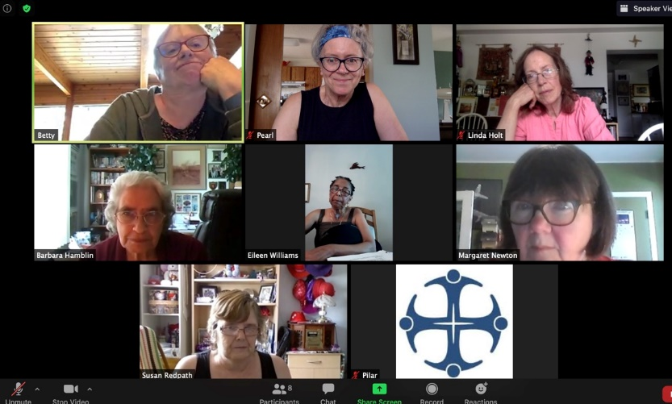
From the Chaplain’s Desk

The theme of this newsletter is “forgiveness”. We all have had people or things that we have found hard to forgive. However we are called to forgive. In the Jesus Prayer we ask God to forgive us our sins as we forgive those who sin against us.

Let me share some myths about forgiveness:

“To forgive is to forget”. This may not be possible. Our wariness may have caused us to learn from the bad experience, it may compromise our trust in the other, but never the less we forgive even if we do not forget.

“Forgiveness only benefits the one who caused the hurt”. When we cannot forgive someone then our animosity eats at us. We become bitter. When we forgive hopefully we can let go and move on with our lives. Holding on to hurts only serves to weigh us down and diminish the light we share.

So how do we move forward?

Forgiving is a process. We have to work our way through things like hurt and anger. We have forgiven when we let go of ill will. Healing and restoration of broken relationships take time, in some cases months or even years. We need to separate the person from the wrongful deed.

We have to decide to forgive. Let’s face it sometimes we like to hold on to our grudges and hurts. We need to ask for God’s help as we seek reconciliation. It is hard to grow in Christ if we refuse to forgive.

Why is it sometimes hard to forgive? It may be we enjoy being seen as victim. We can get sympathy as we share our hurt with others. Sometimes we bring others alongside to support us in our hurt and solicit their solidarity against the one seen to have wronged us. Pride may also have a role. We need to be in the right.

I also wonder if our refusal to forgive stems from our wishing to punish the one who has hurt us. This is not our Lord’s way, nor is it healthy for us. It continues to hurt the one we need to forgive. Now we are inflicting the pain. This is not building Christian community or Christian love.

We also may need to ask others to forgive us. If we realize we have caused hurt, intentionally or unintentionally we need to ask the other for forgiveness.

Sometimes we will find we just need to forgive ourselves. We have regrets. That’s what confession is for, to bring these before God, and to ask the Holy Spirit to show us the way forward.

It is the Spirit which is our guide in forgiveness. The Spirit shows us where we need to forgive and where we need to ask for forgiveness. As God forgives all of us, so we forgive.

Prayer

We were asked to write something about prayer for the fall issue. For me there is no right way to pray. I think just as we are all different there can be ways that fit our ways of being, our personality. Some of us need a prayer book or need a composed prayer. Others pray extemporaneously. Some find prayer beads helpful as in the Anglican Rosary.

Think of prayer as a relationship with a friend. That friend is our Lord. We need a friend when we experience a crisis. That is the prayer we turn to in desperation, the “help me Jesus” or “no atheists in the trenches” ‘kind of prayer. We cry out and God hears.

Then there are the times we tell our friend about the needs of others. This is intercessory Prayer, private prayer, or like the Prayers of the People on a Sunday. We ask God to intercede for the needs of others.

Then most commonly we petition God for something we need. We have our want list. Our friend is probably okay with that if we also raise up the needs of others and if it isn’t our only kind of prayer’s

And what do we do when a friend helps us or those we ask the friend to help with? We say Thank you. This is the kind of prayer we most often neglect, the one that says thank you, the prayers of Thanksgiving. How would our relationship with a friend carry on if we never said thank you?

Each of us pray probably in all these ways. Some of us use the daily offices (Morning or Evening Prayer from the BAS or BCP). There is the beautiful office of Compline or Night prayer. A little used service for family Prayer is also found in both books.

For me, I like a kind of prayer that just brings me into God’s presence, sitting in peace and listening. I also like praying with my Anglican Rosary praying the ancient prayers like St. Patrick’s Breastplate, or my intercessory prayers. When I think of the presence kind of prayer I think of visiting my late dad.

My daughter wondered how the two of us could just sit together and not need to say anything. We were two introverts being together. I think this is why I just enjoy being in the presence of our God, not having to utter words: God knows my heart.

It doesn’t matter how we pray, but pray we must!

"Be strong and courageous. Do not be
terrified: do not be discouraged, for the Lord your God will be with you wherever you go.” Joshua 1:9
To all our women and their families:

Sorry I have taken so long to reach out to you in this stressful time. I guess in the first week
I did mostly what women do, saw we had food supply of what we needed.

We saw this coming and had gathered our stock before the rush. Made plans to reach out to others who might need support.

Shopped on line for each grandchild to have books games and puzzles as they hunker down and parents work from home. Evened baked, which for me is a Christmas activity.

Put in a plan for myself for my days, and as an old teacher, helped my grandkids plan theirs which we shared even from the little boys in Australia on line.

For my family I think I have tried to be mentoring the adult grands and the families. Try to be
Ms. Positive hope.

Have a group lighting a candle and praying for the world and those in need at 9:00 each night. Now includes friends across the country. If you are not part of another group please join me. I just feel so together with my communities at this time. I stand in my bedroom window and pray for my neighbors many of whom are not people of prayer. I can see their lights and name them.
This week’s OT reading is from Ezekiel 37:1-14. I encourage you to read it and read to the end of the chapter. Through Ezekiel God is telling and preparing the people of the hope to return to their land. God gives Ezekiel a vision of a valley of dry bones. God asks can these bones live. They are the house of Israel. Ezekiel says only you know Lord God.
In the vision the bones come together as he obeys the Lord and gives God’s words to the bones. I call you all to come together in any virtual way you can. For our older members write those letters owed to others or mail cards to shut-ins if like me you have a stock pile from years before. Reach out. Come together. Be a part of the body, be it a knee bone or a finger bone.

This reminds me of 1 COR 12. The next part is the crux of the story. There is no life in the bones until God instructs Ezekiel to call upon the Breath, the Spirit of God, and the Holy Spirit. So must we call upon the Spirit to sustain us and others as we go through this Valley.

Remember from Psalm 23, God walks beside us supporting us with his rod and staff, as he cates for us as our Shepherd.
Why did I include the whole chapter? I was awakened by the next part that called the divided kingdoms of Judah and Israel to re: unite as God’s people. That is what I think God is calling us to do as God’s people. We are enriched by being different parts as the body but it is the Holy Spirit of God that unites us. May we faithfully be God’s people and God’s hands, feet and voice in this time of trial
In Christ,
Betty Piwowar
Diocesan Chaplain
Anglican Women

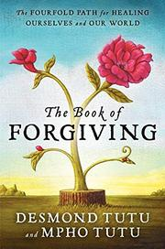

THE BOOK OF FORGIVING

The Fourfold Path for Healing Ourselves and Our World

By Desmond Tutu and Mpho Tutu

This deceptively simple book by Nobel Peace Prize winner Archbishop Desmond Tutu and his Anglican Priest daughter Mpho, is well worth the read. It contains excruciatingly vivid stories of times in South Africa, balanced with very direct instructions on starting the process of forgiveness.

People hurt other people because they have been hurt is the underlying message. Written as a self-help book, the book progresses through the stages of Forgiveness, the “Fourfold Path”: telling the story, naming the hurt, granting forgiveness, and renewing or releasing the relationship. It also includes information for those who need another’s forgiveness or for those who need to forgive themselves.

The Tutus state that you need to come to terms with issues of anger, grief and loss and you can do this through the meditation, ritual and journal exercises, which are included at the end of each chapter. For example, in the Chapter on “Naming the Hurt”, there is a Meditation on Validation, a Stone Ritual and a Grief Journal exercise. Both Desmond and Mpho share personal stories and write about how they too are working through the process of forgiveness. “There is nothing that cannot be forgiven, and there is no one undeserving of forgiveness,” they write.

This is not easy though, and may take a lifetime of hard work. Their message is that there is really no other way, so the effort is necessary. In the book, you are given examples from people who have forgiven horrible crimes. Included in the text are websites to spur action: for example, Forgiveness story websites, and anonymous apology websites.
Every chapter is very detailed but simple enough to encourage you to try it. I would recommend “The Book of Forgiving” to anyone interested in exploring the cycle of forgiveness, or to anyone interested in forgiving or being forgiven.

In God’s Hands – Desmond Tutu
[The Archbishop of Canterbury’s Lent Book 2015]

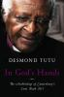

When I was lucky enough to read Linda Holt’s review of Desmond Tutu’s book on Forgiveness I was reminded of a book that our Parish used as a Lenten Study a few years ago. I was interested to learn that

Archbishops of Canterbury have commissioned an 'Archbishop of Canterbury's Lent Book' for decades. The books concentrate on theological or devotional Christian themes relevant to Lent, in preparation for the celebration of the passion and resurrection of Jesus Christ in Holy Week and Easter. Usually the books are presented in six to eight chapters with discussion questions included in each chapter. These books are a treasure at any time of the year!

In this little gem of a book, Archbishop Tutu distills the wisdom forged through a childhood of poverty and apartheid, an adulthood lived in the glare of the world’s media, and the long and agonizing struggle for truth and reconciliation in South Africa, into the simplicity which Jesus tells us characterizes the Kingdom of God.

Archbishop Tutu’s meditation speaks to the infinite love of God and the infinite value of the human individual. Not only are we in God’s hands, he says, our names are engraved on His palms. Throughout an often-turbulent life, Archbishop Tutu has fought for justice and against oppression and prejudice. What has driven him forward is an unshakable belief that human beings are created in the image of God and are infinitely valuable. God loves us not because we are lovable but because He first loved us. God loved us even before we were created. Archbishop Tutu is a gifted writer and this study is inspirational and well worth the read.

ACW DIOCESAN QUILT
Please contact Jennifer to book the quilt for your church event 403-948-6463 or jennjmingram@gmail.com

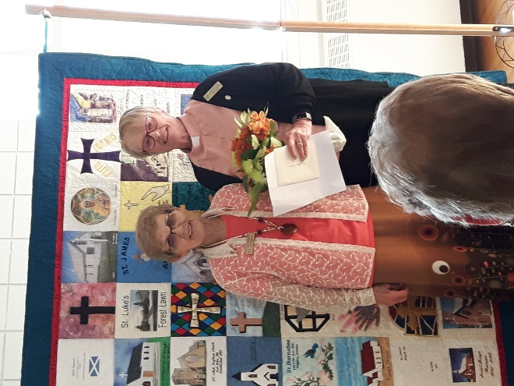
Rev. Betty Piwowar and Betty Nadurak at the 2019 Silver Cross Luncheon

Anglican Church Women Website

The Anglican Church Women of the Diocese of Calgary have a website at www.acwcalgarydiocese.com where you can view the latest newsletters as well as get information on upcoming conferences, retreats and events. We also post pictures and articles from past diocesan events. Feel free to submit stories, articles or pictures to the website at email@acwcalgarydiocese.com. You can also find application forms on the website for Silver Cross, Book of Remembrance, and conference registrations.

Welcome to the ANGLICAN WOMEN, DIOCESE OF CALGARY Facebook Page.

I am excited to invite you to join our Facebook Page. Please send me any information, pictures, news articles or inspirational memos that you would like to share across Facebook. I am always looking for items of interest to post. Please contact Margaret Newton at margmoore49@gmail.com .You can search in Facebook for Anglican Women, Diocese of Calgary and follow our page -OR- if viewing this newsletter on line click here and then click to follow our page. By liking our page it boosts our visibility in Facebook. PLEASE LIKE US

At our January 2020 Executive Meeting we were delighted when Linda Holt our 1st Vice-President agreed to prepare short vignettes of Women of Faith in our Diocese to be posted on our Facebook page. Linda has taken a hiatus over the summer but be on the lookout for more in the fall. All the vignettes have been shared many times and there has been great interest in the ladies that have been presented so far – with many lovely messages of support and love. Thanks Linda for these wonderful tributes.
Here are the first four that were published.

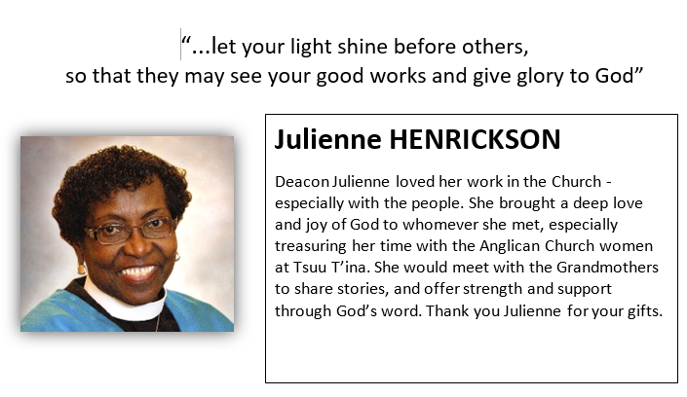
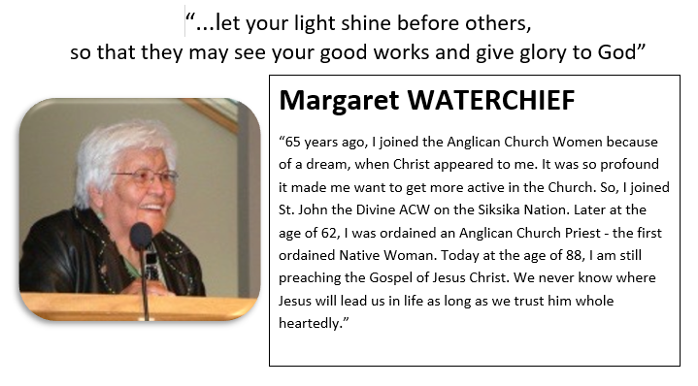
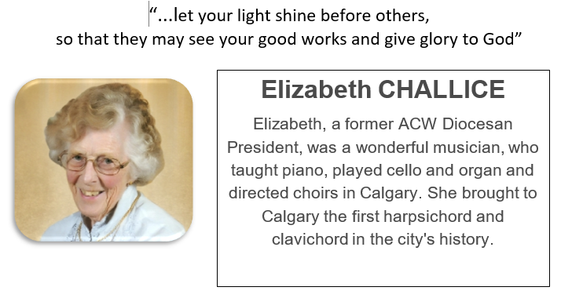
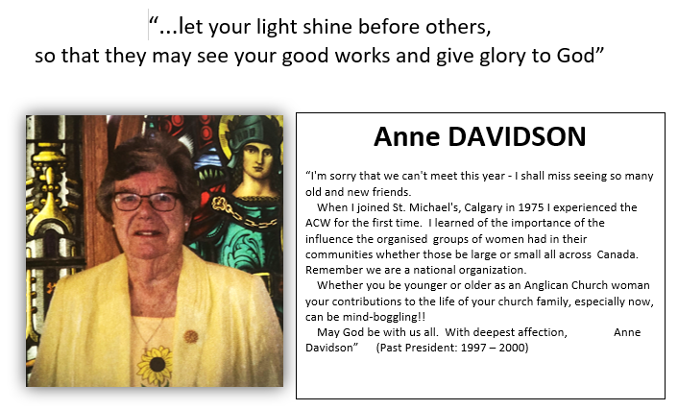

SAVE THE DATE

Saturday September 26th, 2020
Join us for a ZOOM FALL RETREAT

Guest Speaker – Rev. Dr. Kyle Norman

Theme : INTRODUCTION TO SPIRITUAL PRACTICES

More information to come shortly with registration details.

NEWSLETTER SUBSCRIPTIONS

Just a reminder that it is time to renew your Newsletter. Due to the increasing costs of printing and postage, we are urging you to subscribe via E-mail if you are able. If this method does not work for you, we are more than happy to mail it to you. The cost to print and distribute the Newsletter is approximately two-thirds more than the funds received for subscriptions.

The cost is $10.00 per year for mail or e-mail subscriptions. Please fill in the form below.
Please make your cheque payable to ACW – Diocese of Calgary and mail it along with your form to Mary Dymond, 212 Lake Moraine Place S.E., Calgary, Alberta, T2J 2Y9.

NAME_______________________________________________

ADDRESS_____________________________________________

OR SEND MY NEWSLETTER TO THE FOLLOWING E-MAIL ADDRESS
___________________________________________________

The Book of Remembrance

The Book of Remembrance is a bound book in which the names of the WA and ACW deceased members are recorded in beautiful hand calligraphy. The book was started and dedicated by Bishop Calvert in 1953, and is kept in a special case in the Cathedral Church of the Redeemer in Calgary. There are over three hundred names entered, and the Book is taken to the Annual Conference each year so that members may have the opportunity to remember past friends.

ANGLICAN CHURCH WOMEN
Diocese of CALGARY
Application for Diocesan Book of Remembrance

PLEASE PRINT CLEARLY Date of application ___________________________
DD/MM/YR
FROM (group) _____________________Town or City ________________________________

Name to be inscribed (including Christian Names)

Date of birth (if wished) _____________________ Date of death _______________________
DD/MM/YR DD/MM/YR INSCRIPTION: ____________________________________________________________________________

Please confine inscription to two lines if possible.

Address & telephone number _______________________________________________

Signed________________________________________________________________
Please return application and cheque for $15 payable to ACW, Diocese of Calgary no later than Feb. 1st. To: Vera Apletree. 58 Malibou Rd. S.W. Calgary AB. T2V 1W8 Phone: 403-255-2406

A.C.W. BOARD OF THE DIOCESE 2020
www.acwcalgarydiocese.com
email: nfo@acwcalgarydiocese.com
Patrons: The Archbishop Rt. Rev. Greg Kerr-Wilson & Mrs. Vicki Kerr-Wilson
Position | Names | Phone #
President | Margaret Newton  Box 177 Gleichen, AB. T0J 1N0 | (403) 734-0031  margmoore49@gmail.com
Past President | Susan Redpath  3923 Whitehorn Dr. NE  Calgary, AB. T1Y 4T3 | (403) 993-2006  sredpath@telus.net
First Vice President | Linda Holt  Box 474 Gleichen, AB. T0J 1N0 | ( 403) 734-2130  lin-sid@telus.net
Second Vice President | Pearl Franz  3 Sherwood Crescent  Red Deer, AB T4N 0A9 | (403) 302-9351  pearlfranz@gmail.com
Treasurer | Mary Dymond  212 Lake Moraine Pl. SE  Calgary, AB. T2J 2Y9 | (403) 278-0317  mkdymond@gmail.com
Secretary: | Eileen Williams  15 Cedargrove Pl. SW.  Calgary, AB. T2W 4T8 | (403) 251-4610  orethacal@gmail.com
Appointments
Chaplain | Rev. Betty Piwowar | (403) 678-4502  (403) 678-1136 (c)  Bpiwowar@telusplanet.net
Member at Large | Susan Redpath  3923 Whitehorn Dr. NE  Calgary, AB. T1Y 4T3 | (403) 993-2006  sredpath@telus.net
Member at Large | Carol Kyle  1035-78 Ave. S.W.  Calgary, AB. T2V 0T9 | (403) 255-7932  dougalugadonut@shaw.ca
Newsletter | Cisley Robinson  24 – 105 Elm Pl  Okotoks. AB T1S1Y9 | (403) 995-0999  csrobins@telusplanet.net
Calendars | Mary Anne Armstrong  455 Lake Topaz Cres SE  Calgary, AB. T2J 2H7 | (403) 271-2285  cmaa@telus.net
Archivist/Historian | Ann Bright  6012 Lloyd Cres. S.W.  Calgary, AB. T3E 5V7 | (403)249-4075  acbright@telus.net
Silver Cross/ Names of the Departed | Betty Nadurak  #213 - 7239 Sierra Morena Blvd. S.W  Calgary, AB. T3H 3L7 | (403)686-1110  bettynadurak@gmail.com
Publicity/ Quilt Keeper | Jennifer Ingram  95 Elk Hill  Airdrie, AB. T4B 1Y6 | (403) 948-6463  (587) 434-0405 (c)  jennjmingram@gmail.com
Book of Remembrance | Vera Apletree  8332 - 33rd Ave NW  Calgary, AB. T2V 1W8 | (403)255-2406  no email
Regional
Web Master  Calgary | Linda Anderson  8332 - 33rd Ave NW  Calgary, AB. T3B 1L9 | (403) 615-0651  linda@rasltd.ca
Medicine Hat/Brooks | Barbara Hamblin  2 Greenwood Ct. SW.  Medicine Hat, AB. T1Z 7X7 | (403) 528-3571  mhamblin@telusplanet.net
Red Deer/Drumheller |  | Vacant
Lethbridge |  | Vacant
High River |  | Vacant

