Sermon Questions for PCC Small Groups
Title: DEAR EVE: Finding Hope in the Tragedy and Triumph of our First Mother

Text: Excerpts from Genesis and Hebrews 11:4
Series: Hebrews
Date Preached: May 8, 2017
Introductory Comments: Pray for the Spirit’s guidance and illumination (that he turns on the light). Look at the painting of Jesus resurrecting Adam and Eve from the dead. What questions or emotions does this image generate?
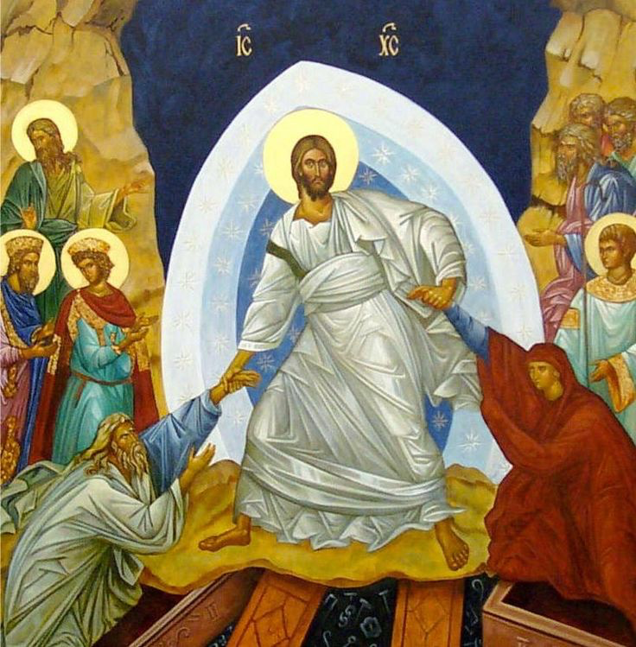

Questions:
- See Genesis 3:16-19. How does the curse affect Adam and Eve differently? What does this tell us about human suffering and how women “feel” the affects of the curse compared to men?
- Read Genesis 4:1-13. From reading the Genesis account alone, is there any clue as to why Abel was accepted and not Cain? Had God revealed to the first family something about the kind of offering he requires in order to have a relationship with him? If so, what was that revelation? (Check the earlier context)
- Read Hebrews 11:4. How does this text explain why God accepted Abel and his offering and not Cain’s.
- Eve’s heartbreak:
How do we see God’s mercy and grace imbedded into the curse against Eve? (See Gen. 3:14, 15) Why do many say that this text is the first Messianic prophecy in the bible?
- Did Eve require faith in order to receive God’s promise? (See 4:25, 26)
- How do you respond to the “call to respond” in Sunday’s message?
How are we to respond to the biography of Eve, and her boys?

- We have a real enemy to fight:
- A lie to renounce: We must decisively renounce the lie that there are many ways to come to God. There are not. There is but one way and that way is through Jesus Christ and his sacrificial death of the cross and triumphant resurrection. As you know, we live in a pluralistic society that is intolerant of singular truth claims. Will we opt out for the populist way of Cain?
- A sin to identify: We must acknowledge the particular sin that crouches at our door. “No temptation has seized you but such as is…” As God graciously draws nears, he invites confession.
- We have a Savior to trust:
The curse that resulted from sin has affected us all. But Jesus came to be the curse for us. In Jesus, the curse of perpetual despair has been broken. He has risen from the dead as the victor over sin’s harsh realities. Evil will not have the last word on you or your family!

