Campbell River United Church
An Inclusive Community Centered in Christ

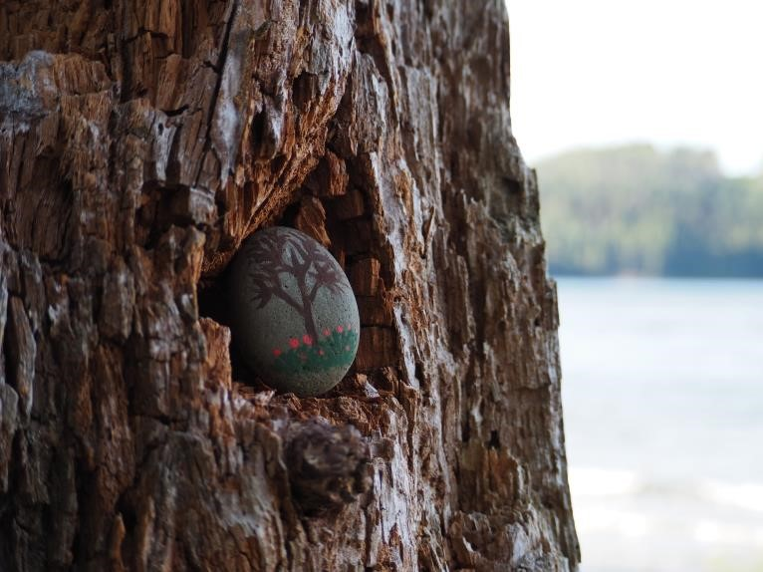

“In Communion”

Home Church - World Communion Sunday
18th Sunday after Pentecost October 4, 2020

Rev. Sally Bullas

Preparing the Space
As we gather on the unceded traditional territory of the Wei Wai Kum First Nation and lay open our welcome to all, I invite you to lean into the ritual of preparing yourself to be at one and in communion with the Holy and Sacred. Take a moment to pause and allow the Spirit of God to find its way into this time, space, and the place where you are. Sit for a moment within your surroundings and allow them to embrace you with intention and peace. Place before you bread and juice signifying your participation in the shared community around the table of Christ. Light a candle if you wish. Open yourself to the One who is with us and within us. Breathe in place.

Gathering Words
“The heavens herald your glory, O God, and the skies display your handiwork. Day after day they tell their story, and night after night they reveal the depth of their understanding. Without speech, without words, without even an audible voice, their cry echoes through all the world, and their message reaches the ends of the earth.” (Psalm 19:1-4a, The
Inclusive Bible)

One: Come, let us find ourselves in communion with one another and all the world.
All: We come…with open hearts, open hands, open minds, and open to the invitation to be in communion with one another and all the world.

Opening Prayer and lighting of the Christ Candle:
Julian of Norwich
And all shall be well and all shall be well
and all manner of things shall be well. (Christ candle is lit)

Hymn: “God We Praise You for the Morning” VU#415

- God, we praise you for the morning; hope springs forth with each new day, new beginning, prayer, and promise, joy in work and in play.

- God, we praise you for creation, mountains, seas, and prairie land. Waking souls find joy and healing in your bountiful hand.

- God, we praise you for compassion, all the loving that you show; human touching, tears, and laughter, help your children to grow.

- God, we praise you for your Spirit, Comforter and daily friend, restless searcher, gentle teacher, strength and courage you send.

- God, we praise you for the Saviour, come that we may know your ways.
In his loving, dying, rising, Christ is Lord of our days.

Prayer of Confession: (Based on Psalm 19)
One: | Your law, O God, is perfect;
All: | it refreshes the soul.
One: | Your rule is to be trusted;
All: | it gives wisdom to the naïve.
One: | Your purposes, O God, are right;
All: | they gladden the heart.
One: | Your command is clear;
All: | it gives light to the eyes.
One: | But who can detect one’s own failings?
All: | Forgive the misdeeds we don’t even know about?
One: | May our faults never control us.
All: | May the words of our mouths and the thoughts of our hearts
 | be pleasing in your sight, O God, our rock and our redeemer.

Pause for Reflection

Words of Assurance: (Judy Chicago)
And then all that has divided us will merge
And then compassion will be wedded to power
And then softness will come to a world that is harsh and unkind
And then both men and women will be gentle
And then both women and men will be strong
And then no person will be subject to another’s will
And then all will be rich and free and varied
And then the greed of some will give way to the needs of many
And then all will share equally in the earth’s abundance
And then all will care for the sick and the weak and the old
And then all will cherish life’s creatures
And then all will live in harmony with each other and the earth.
And then everywhere will be called Eden once again.

Peace of Christ: Christ is with and within each of us – let us share with one another the peace of Christ!

One: The Peace of Christ be with you!
All: And also with you!

First Reading (From “The Inclusive Bible”)
Exodus 20:1-4, 7-9, 12-20
Then God spoke all these words, and said, “I am YHWH who brought you out of the land of Egypt, out of the house of bondage. Do not worship any gods except me! Do not make for yourselves any carved image or likeness of anything in heaven above or on the earth beneath or in the waters under the earth. Do not utter the Name of YHWH to misuse it, for YHWH will not acquit anyone who utters God’s Name to misuse it! Remember the Sabbath day and keep it holy! For six days you will labour and do all your work. Honour your mother and your father, so that you may have a long life in the land that YHWH has given to you! No murdering! No adultery! No stealing! No giving false testimony against your neighbour! No desiring your neighbour’s house!
No desiring your neighbour’s spouse, or worker—female or male—or ox, or donkey, or anything that belongs to your neighbour!” When the people witnessed the thunder and lightening, and heart the sound like blaring trumpets, and saw the smoking mountain, they shook in fear. Keeping their distance, they said to Moses, “Speak to us and we will listen, but do not let God speak to us, or it will surely be our death.” But Moses said, “Don’t be afraid. God’s coming this way was simply a test for you, to give you a sense of awe and reverence, and to keep you from sinning.

Gospel (From “The Inclusive Bible”)
Matthew 21:33-46
“Listen to another parable. There was a property owner who planted a vineyard, put a hedge around it, installed a winepress and erected a tower. Then the owner leased it out to tenant farmers and went on a journey. When vintage time arrived, the owner sent aides to the tenants to divide the shares of the grapes. The tenants responded by seizing the aides. They beat one, killed another and stoned a third. A second time the owner sent even more aides than before, but they treated them in the same way. Finally, the owner sent the family heir to them, thinking, ‘they will respect my heir.’ When the growers saw the heir, they said to one another, ‘Here’s the one who stands in the way of our having everything. With a single act of murder we could seize the inheritance.’ With that, they grabbed and killed the heir outside the vineyard. What do you suppose the owner of the vineyard will do to those tenants?” They replied, “The owner will bring that wicked crowd to a horrible death and lease the vineyard out to others, who will see to it that there are grapes for the proprietor at vintage time.” Jesus said to them, “Did you ever read in the scriptures, ‘The stone which the builders rejected has become the chief cornerstone; it was our God’s doing, and we find it marvelous to behold’? That’s why I tell you that the kin-dom of God will be taken from you and given to the people who will bear its fruit. Those who fall on this stone will be dashed to pieces, and those on whom it falls will be smashed.” When the chief priests and the Pharisees heard these parables, they realized that Jesus was speaking about them. Although they sought to arrest him, they feared the crowds, who regarded Jesus as a prophet.

One: Holy Wisdom, Holy Word.
All: Thanks be to God.

Reflection: “In Communion”

Pause for Reflection

A New Creed: Let us affirm our faith . . . We are not alone, we live in God’s world.
We believe in God: who has created and is creating, who has come in Jesus, the Word made flesh, to reconcile and make new, who works in us and others by the Spirit. We trust in God. We are called to be the Church: to celebrate God’s presence, to live with respect in Creation, to love and serve others, to seek justice and resist evil, to proclaim Jesus, crucified and risen, our judge and our hope. In life, in death, in life beyond death, God is with us.
We are not alone.
Thanks be to God.

We Gather at the Table:
(UCofC World Wide Communion Sunday Liturgy by Alydia Smith)

One: | God be with you all.
All: | And also with you.
One: | Lift up your hearts;
All: | We lift them up to God.
One: | Let us give thanks to God!
All: | It is right to give God our thanks and praise!

One: | Though creation sometimes weeps,
All: | we wait lovingly for you, God.
One: | For you created the heavens, earth, and all that is in them:
 | you cast sunbeams, open flowers, and feed insects. You are
 | beyond the galaxies, under the oceans, and inside each grain of
 | wheat. You could sustain all of your creation, but you will not,
 | without us.
All: | Thank you for the wonders of creation and for your great
 | trust in us.
One: | Though humanity sometimes weeps,
All: | we wait lovingly for you, God.
One: | For you smiled on an outcasted Hagar, blessing her descendants,
 | you guided the doubtful Israelites, leading them to freedom,
 | you spoke through the Judges and the Prophets, providing words
 | of wisdom, you lived among us as a teacher, healer, and friend,
 | giving us a sacred path to follow. You could have made us self-
 | sustaining, but you did not, your love sustains us.
All: | Thank you for the worldwide fellowship of disciples, who
 | faithfully attempt to share your love with all of creation.

All: | O Holy, holy, holy God, O God of time and space.
 | All earth and sea and sky bear witness to your grace
 | Hosanna in the highest heav’n, creation sings your praise.
 | And blessed is the One who comes and bears your name
 | always.
One: | In Jesus, love incarnate, you provide us all we need for each day:
All: | his words comfort the weary;
 | his actions challenge the contented;
 | his touch heals the sick;
 | his presence feeds the deepest hunger in our souls.
Sanctus:

All: | Christ has died! Christ is risen! Christ will come again!
One: | In Jesus and in his feast you provide for us the sustenance we
 | need to respond to the cries of creation.
All: | The bread of life, nourishes our deprived bodies.
 | The cup of blessings, revives our thirsty souls.
One: | The gathered community, strengthens our growing faith.
Memorial Acclamation:

The Prayer of Jesus: “A Translation” VU#916 Our Father-Mother, who is in the heavens, may your name be made holy, may your dominion come, may your will be done, on earth as it is in heaven. Give us today the bread we need; and forgive us our debts, as we have forgiven our debtors; and do not put us to the test, but rescue us from evil.
For yours is the dominion, and the power,
 | and the glory forever. Amen.
One: | Though the church sometimes weeps,
All: | we wait lovingly for you, God.
One: | And so we join with our siblings around the world by
 | remembering that on the night in which Jesus was betrayed, he
 | took bread, blessed it, broke it, and shared it with his disciples,
 | saying:
All: | “Take eat; this is my body, given for you. Do this for the
 | remembrance of me.”
One: | After supper, Jesus took the cup, gave thanks, and gave it for all
 | to drink, saying:
All: | “This cup is the new covenant in my blood, shed for you and
 | for all people. Do this for the remembrance of me.”
One: | God, we remember and give thanks for your Son,
 | and we ask that you bless and pour your spirit on these simple
 | things, bread and wine:
All: | Make this broken bread whole in our taking.
 | Make this full cup overflow in our sharing.
One: | With these elements nourish and sustain us, our way, our truth,
 | our life; our Creator, our Redemer, our Sustainer. Praise be to
 | you, now, tomorrow, and forever.
(We partake of the bread and the juice)

Offering: Thank you for continuing to be the people of Christ as best you might in the midst of strife, strange times, and challenging circumstances. Church and its ministries look very different in the midst of a pandemic, but there are still opportunities to reach out to one another safely, with kindness and acts of compassion. The life and work of the Community of Faith that is Campbell River United Church is noticed in many ways: through respect and care for the other, social distancing and protective measures, kindness and compassion, the responsible re-emergence of outreach programs with safety protocols in place, and in the gathering to pray and praise God in ways that honour our need to protect ourselves, each other, and the most vulnerable amongst us. Thank you all for your commitment to being church in a new way.

Let us pray:
Father/Mother God, Holy Spirit…
Help us to stay connected to our hearts and each other.
Help us to see the good in ourselves and each other.
Help us to serve the spirit of goodness in all we meet.
Help us to restore love upon this earth.
May all be fed.
May all be healed. May all be loved.
Amen. John Robbins (adapted)

Prayers of the People

Hymn: “Would You Bless Our Homes and Families” VU#556

- Would you bless our homes and families, Source of life who calls us here; in our world of stress and tension teach us love that conquers fear. Help us learn to love each other with a love that constant stays; teach us when we face our troubles, love's expressed in many ways.

- When our way is undemanding, let us use the time that's ours to delight in simple pleasures, sharing joys in gentle hours. When our way is anxious walking and a heavy path we plod,
teach us trust in one another and in you, our gracious God.

- From the homes in which we're nurtured, with the love that shapes us there, teach us, God, to claim as family every one whose life we share.
And through all that life may offer,
may we in your love remain;
may the love we share in families be alive to praise your name.

- Let us reach beyond the boundaries of our daily thought and care till the family you have chosen spills its love out everywhere. Help us learn to love each other with a love that constant stays; teach us when we face our troubles love's expressed in many ways.

Blessing:
One: The Creator’s blessing be yours on your road, on your journey, guiding you, cherishing you. First Name A-M:
The Son’s blessing be yours, wine and water, bread and stories, feeding you, challenging you.
First name N-Z:
The Spirit’s blessing be yours, wind and fire, joy and wisdom, comforting you, disturbing you.
All: The Angel’s blessing be yours, on your house, on your living, guarding you, encouraging you. Let us walk together, a community on a journey, sustained in God’s blessing.
Amen!
One: Let us go now in peace to love and serve God.
All: Thanks be to God.

