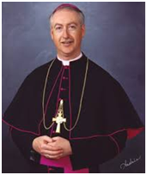
Pastoral Scene 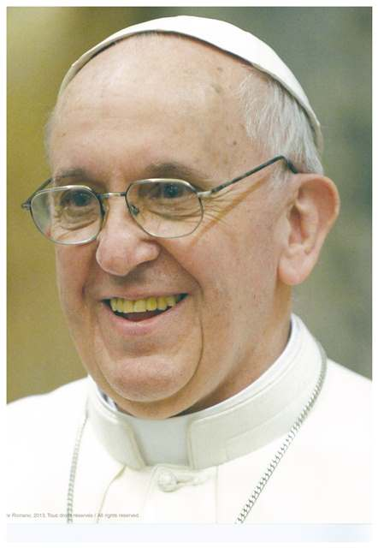

Euthanasia on agenda for Bishops' meeting with Francis
Posted in Archdiocesan News By Andrew Ehrkamp, News Editor
Archbishop Richard Smith plans to raise the issue of euthanasia and the increasing secularization of Canadian society as part of a delegation of bishops visiting the Vatican later this month.
“I think a lot of people are allowing their minds to be shaped by the emotional messages, and indeed by the Supreme Court judgment, that it is acceptable for us to kill the innocent in order to alleviate suffering,” said Smith, the point person on cultural issues for the bishops from Western and Northern Canada.
Euthanasia became legal in Canada as of last year.
“It used to be that even if you weren’t people of faith, one bedrock principle of maintaining the common good was that you do not kill the innocent,” Smith said. “Now we have institutions, which all along we had entrusted to hold that principle up medicine and law now allowing that principle to be weakened.”
Pope Francis will meet with bishops from Western and Northern Canada on March 27, the beginning of their weeklong ad limina visit to the Vatican. He will meet separately with bishops from Ontario, Quebec and Atlantic Canada.
The Latin words ad limina apostolorum mean "to the threshold of the Apostles." The visits derive from the ancient tradition of each bishop regularly visiting the tombs of St. Peter and St. Paul in Rome to seek guidance. The pilgrimage is a chance for bishops to talk about issues in their region and to ask Pope Francis and his closest advisers for insight.
Smith is Western and Northern Canada’s lead bishop for the Congregation for the Doctrine of the Faith and he plans raise cultural issues in Canada, including gender identity, during the ad limina visit.
He noted a change in mindset, away from the Gospel, has intensified since the Canadian bishops’ last ad limina in 2006. At the time, same-sex marriage had just been legalized in Canada.
“When we separate from the reality of what it means to be a human being, made in the image and likeness of God, then all of sudden the idea arises that ‘I can decide whatever I want to be, however I want to be human,'” Smith said.
“At the heart of it all is overcoming the separation from reality and living in reconciled communion with truth, reconciled communion with the person of Jesus.”
Smith said Pope Francis will also want a sense of the issues facing the poor or marginalized in Canada and what the Church can do to help.
“How can we show mercy to them? How can bring the light of the Gospel to them? How can we give them a real reason for hope? He will want to hear from us, our heart, not just the head.”
The ad limina visits are normally every five years, but the last one for Canadian bishops was in 2006 due to Pope Benedict’s frail health.

You can follow Archbishop Smith's trip to Rome on his Blog at the Archdiocese's website: http://www.caedm.ca/

