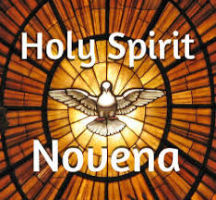

The novena in honor of the Holy Spirit is the oldest of all novenas since it was first made at the direction of Our Lord Himself when He sent His apostles back to Jerusalem to await the coming of the Holy Spirit on the first Pentecost. It is still the only novena officially prescribed by the Church. Addressed to the Third Person of the Blessed Trinity, it is a powerful plea for the light and strength and love so sorely needed by every Christian.

**Novena Prayer to the Holy Spirit in preparation for Pentecost Sunday**

O Lord Jesus Christ Who, before ascending into heaven did promise to send the Holy Spirit to finish Your work in the souls of Your Apostles and Disciples of whom we emulate. Grant the same Holy Spirit to us that He may perfect in our souls, the work of Your grace and Your love. Grant us the Spirit of wisdom that we may despise the perishable things of this world and aspire only after the things that are eternal, the Spirit of Understanding to enlighten our minds with the light of your divine truth, the Spirit of Counsel that we may ever choose the surest way of pleasing God and gaining heaven, the Spirit of Fortitude that we may bear our crosses with You and that we may overcome with courage all the obstacles that oppose our salvation, the Spirit of Knowledge that we may know God and the know ourselves and grow perfect in the science of the Saints, the Spirit of Piety that we may find the service of God sweet and amiable, and the Spirit of Awe and Wonder that we may be filled with a loving reverence towards God and may dread in any way to displease Him. Mark us, dear Lord with the sign of true discipleship, and animate in us all things with Your Holy Spirit. Amen

