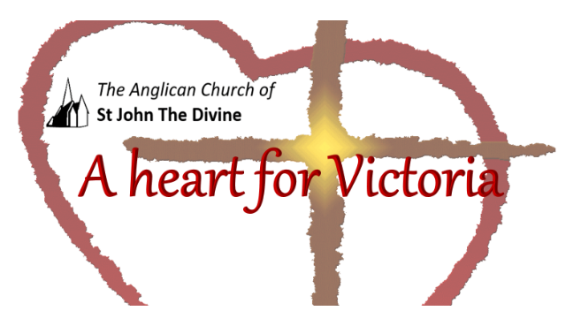

Wednesday, November 11th
Lunchtime Worship

St. John’s acknowledges that the Church buildings , and all living in Victoria, are on the ancestral lands of the Lekwungen speaking people .

On this day of memory we gather to sing and to pray,
we remember the past and look to the future.
On this day when the guns once fell silent,
we come before you God, seeking Your peace.
On this day of hope in the face of terror,
we come before you God, praying with all our hearts:
God our help in ages past, our hope for years to come.
Open our eyes and the eyes of the nations
to find a different path through the disagreements of life in this world.
In this time of story, song, and prayer,
may we be re-committed to being people of Peace, true peace.
May we catch a vision of how the world could live together.
And so we echo the old prayers,
Make us channels of your peace.
Let there be Peace on Earth and let it begin with us!
Amen.
Gorde Waldie

We will now take two minutes in silence to remember our fallen heroes and their families.

In Flanders Fields
In Flanders fields the poppies blow
Between the crosses, row on row,
That mark our place; and in the sky
The larks, still bravely singing, fly
Scarce heard amid the guns below.
We are the Dead. Short days ago
We lived, felt dawn, saw sunset glow,
Loved and were loved, and now we lie
In Flanders fields.
Take up our quarrel with the foe:
To you from failing hands we throw
The torch; be yours to hold it high.
If ye break faith with us who die
We shall not sleep, though poppies grow
In Flanders fields.

John McCrae

Psalm 3,1-6

O Lord, how many are my foes!
Many are rising against me;
² many are saying of my soul,
“There is no salvation for him in God.]
³ But you, O Lord, are a shield about me,
my glory, and the lifter of my head.
⁴ I cried aloud to the Lord,
and he answered me from his holy hill.
⁵ I lay down and slept;
I woke again, for the Lord sustained me.
⁶ I will not be afraid of many thousands of people
who have set themselves against me all around.

Let us pray
Loving God,
Grant that we may walk in your presence:
your love in our hearts,
your truth in our minds,
your strength in our wills;
until, at the end of our daily journey,
we know the joy of our homecoming
and the welcome of our family’s embrace,
through Jesus Christ our Lord.
All: Amen. New Zealand Prayer book

Prayer for Remembrance Day Let us pray for all who suffer as a result of conflict, and ask that God may give us peace: for the service men and women who have died in the violence of war, each one remembered by and known to God; may God give peace.
God give peace.

For those who love them in death as in life, offering the distress of our grief and the sadness of our loss; may God give peace.
God give peace.

For all members of the armed forces who are in danger this day, remembering family, friends and all who pray for their safe return; may God give peace.
God give peace.

For civilian women, children and men whose lives are disfigured by war or terror, calling to mind in penitence the anger and hatreds of humanity; may God give peace.
God give peace.

For peacemakers and peacekeepers, who seek to keep this world secure and free; may God give peace.
God give peace.

For all who bear the burden and privilege of leadership, political, military and religious; asking for gifts of wisdom and resolve in the search for reconciliation and peace; may God give peace.
God give peace.

O God of truth and justice, we hold before you those whose memory we cherish, and those whose names we will never know. Help us to lift our eyes above the torment of this broken world, and grant us the grace to pray for those who wish us harm. As we honour the past, may we put our faith in your future; for you are the source of life and hope, now and for ever. Amen.

Catholic Principals Council

The Disciples’ Prayer
All
Our mother, who is in heaven and within us,
We call upon your names.
Your wisdom come. Your will be done
In all the spaces in which you dwell.
Give us each day sustenance and perseverance.
Remind us of our limits as we give grace to the limits of others.
Separate us from the temptation of empire,
But deliver us into community.
For you are the dwelling place within us
The empowerment around us
And the celebration among us
Now and for ever.
Broadview United Church

Thank you for sharing this time with us to remember. Go in peace to love and serve. Thanks be to God.

Copyright acknowledgment
Order of service based on New Patterns for Worship © 2003
Some material included in this service is copyright: © The Archbishops' Council 2000
Some material included in this service is copyright: © The Archbishops' Council 2002

