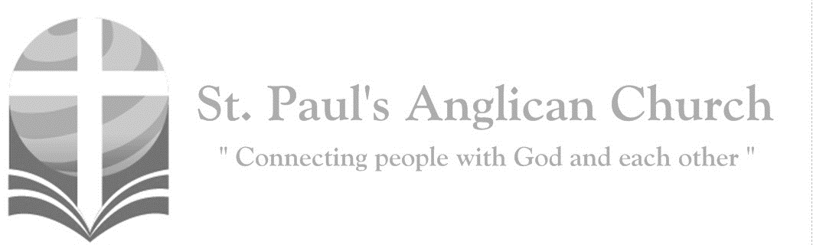
Sunday, November 15, 2020: 24th Sunday After Pentecost
I am the vine, you are the branches, says the Lord. Those who abide in me, and I in them, bear much fruit. (John 15:5)
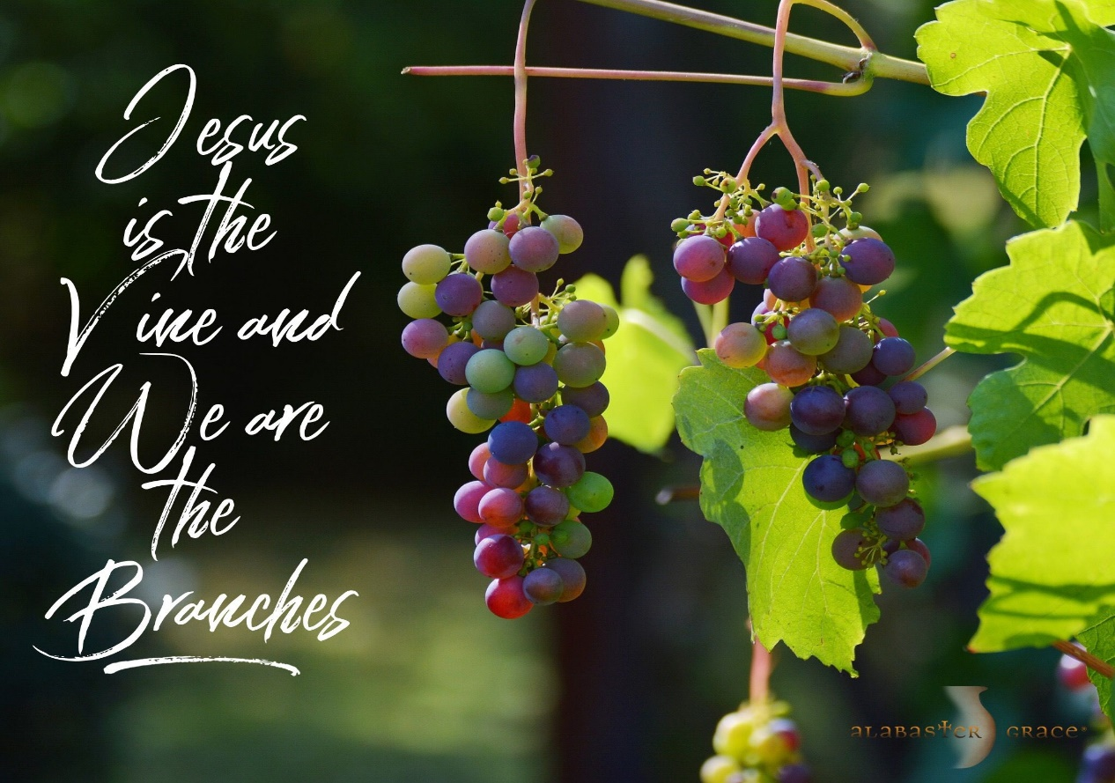
Welcome!! During this unique time in history, services will look a bit different than normal and will likely be different for quite a while. We want to care for the whole parish during this time and one way to care for one another is keeping each other safe. As such, we ask you to follow these guidelines while worshiping with us:
- Experiencing Cough, Fever, or Other Symptom/s? Go home immediately and please stay home for fourteen days following the end of your symptoms.
- Wear a Mask. All parishioners must wear a mask to all services (as per City of Edmonton bylaw 19408). Exceptions to this include children under the age of two and those with a medical condition where wearing a mask is not possible. Masks may be removed when taking communion but must be replaced immediately following. If you do not have a mask, we have cloth masks available in the foyer.
- Maintain Physical Distance. At all times, please remain a minimum of six feet (three seat spaces) from all other individuals not part of your family unit. You will find tape on the floor six feet apart in multiple locations to help you maintain this distance. Please also maintain physical distance outside.
- Listen to the Ushers. There will be ushers inside and outside to help direct these new procedures. Please heed their direction as they are trying to keep everyone safe and healthy.
- Sign-In Upon Arrival. Please sign-in with the designated usher when you arrive onsite. This will help us track who is in attendance just in case we do have to notify the parish if someone tests Covid positive following a service.
- Sanitize Hands Frequently. Please sanitize your hands upon entry and before taking communion. You may also sanitize as often as you would like during the service. Please also try to refrain from touching surfaces and your face.
- Refrain from Singing. At this time, congregational singing is not allowed by the government of Alberta. Please listen to the lyrics being sung by the leader/s and meditate upon them. You may also hum along to the music as long as your mouth remains closed.
- Recycle Bulletins. Please do not leave bulletins in the pews. A recycle bin is available at the exit door. You may also take the bulletin home.
- Use of Washroom. The only washroom available at this time is located at the back of the Sanctuary (just North of the Main Entry doors). Please wipe down all surfaces (including toilet and handle, counter, and faucet) following use.
- Parts of Building Closed. At this time, the only accessible parts of the building are the Sanctuary, Sanctuary washroom, and alley foyer. All other rooms are closed for use including the main washrooms, hall, basement, and chapel. Please do not access any closed section of the building without permission.

ST. PAUL’S COVID-19 RESPONSE
Opening Song: Be Thou My Vision
Be Thou my Vision, O Lord of my heart
Naught be all else to me
Save that Thou art
Thou my best thought by day or by night
Waking or sleeping
Thy presence my light

Be Thou my Wisdom
And Thou my true Word
I ever with Thee and Thou with me Lord
Thou my great Father, I Thy true son
Thou in me dwelling and I with Thee one

High King of heaven, my victory won
May I reach heaven's joys
Bright heaven's Sun
Heart of my own heart whatever befall
Still be my Vision O Ruler of all

Penitential Rite
Leader: Dear friends in Christ, as we prepare to worship almighty God, let us with penitent and obedient hearts confess our sins, that we may obtain forgiveness by his infinite goodness and mercy.
Silence is Kept
All: Most merciful God, we confess that we have sinned against you in thought, word, and deed, by what we have done and by what we have left undone. We have not loved you with our whole heart; we have not loved our neighbours as ourselves. We are truly sorry and we humbly repent. For the sake of your Son Jesus Christ, have mercy on us and forgive us, that we may delight in your will, and walk in your ways, to the glory of your name. Amen.
Leader: Almighty God have mercy upon you, pardon and deliver you from all your sins, confirm and strengthen you in all goodness, and keep you in eternal life; through Jesus Christ our Lord.
All: Amen.

Morning Prayer
Leader: Lord, open our lips,
All: And our mouth shall proclaim your praise.
Leader: O God, make speed to save us.
All: O Lord, make haste to help us. Glory to the Father, and to the Son, and to the Holy Spirit: as it was in the beginning, is now, and will be for ever. Amen. Alleluia!

Leader: The Lord is our refuge and strength: O come, let us worship.
All: Be joyful in the Lord, all you lands; serve the Lord with gladness and come before his presence with a song. Know this: The Lord himself is God; he himself has made us, and we are his; we are his people and the sheep of his pasture. Enter his gates with thanksgiving; go into his courts with praise; give thanks to him and call upon his name. For the Lord is good; his mercy is everlasting; and his faithfulness endures from age to age.

The Reading of Scripture
First Reading: Judges 4:1-7
The Israelites again did what was evil in the sight of the LORD, after Ehud died. So the LORD sold them into the hand of King Jabin of Canaan, who reigned in Hazor; the commander of his army was Sisera, who lived in Harosheth-ha-goiim. Then the Israelites cried out to the LORD for help; for he had nine hundred chariots of iron, and had oppressed the Israelites cruelly twenty years. At that time Deborah, a prophetess, wife of Lappidoth, was judging Israel. She used to sit under the palm of Deborah between Ramah and Bethel in the hill country of Ephraim; and the Israelites came up to her for judgment. She sent and summoned Barak son of Abinoam from Kedesh in Naphtali, and said to him, "The LORD, the God of Israel, commands you, 'Go, take position at Mount Tabor, bringing ten thousand from the tribe of Naphtali and the tribe of Zebulun. I will draw out Sisera, the general of Jabin's army, to meet you by the Wadi Kishon with his chariots and his troops; and I will give him into your hand.'"
Reader: The Word of the Lord.
People: Thanks be to God.

Canticle: Psalm 123
1 To you I lift up my eyes, *
to you enthroned in the heavens.
2 As the eyes of servants look to the hand of their masters, *
and the eyes of a maid to the hand of her mistress,
So our eyes look to the Lord our God, *
until he shows us his mercy.
3 Have mercy upon us, O Lord, have mercy, *
for we have had more than enough of contempt,
4 Too much of the scorn of the indolent rich, *
and of the derision of the proud.
Prayer: King of love, rule in the hearts of all people on earth through your Son Jesus Christ, that we may become one family and one kingdom serving you by serving each other. We ask this in his name.

Second Reading: 1 Thessalonians 5:1-11
Now concerning the times and the seasons, brothers and sisters, you do not need to have anything written to you. For you yourselves know very well that the day of the Lord will come like a thief in the night. When they say, "There is peace and security," then sudden destruction will come upon them, as labor pains come upon a pregnant woman, and there will be no escape! But you, beloved, are not in darkness, for that day to surprise you like a thief; for you are all children of light and children of the day; we are not of the night or of darkness. So then let us not fall asleep as others do, but let us keep awake and be sober; for those who sleep sleep at night, and those who are drunk get drunk at night. But since we belong to the day, let us be sober, and put on the breastplate of faith and love, and for a helmet the hope of salvation. For God has destined us not for wrath but for obtaining salvation through our Lord Jesus Christ, who died for us, so that whether we are awake or asleep we may live with him. Therefore encourage one another and build up each other, as indeed you are doing.
Reader: The Word of the Lord.
People: Thanks be to God.

Processional Chorus – Soli Deo Gloria

Soli Deo Gloria, all glory to God alone
Oh, Gloria

The Gospel Reading
Leader: The Lord be with you.
People: And also with you.
Leader: The Holy Gospel of our Lord Jesus Christ according to St. Matthew.
People: Glory to you, Lord Jesus Christ.
Gospel Reading: Matthew 25:14-30
"For it is as if a man, going on a journey, summoned his slaves and entrusted his property to them; to one he gave five talents, to another two, to another one, to each according to his ability. Then he went away. The one who had received the five talents went off at once and traded with them, and made five more talents. In the same way, the one who had the two talents made two more talents. But the one who had received the one talent went off and dug a hole in the ground and hid his master's money. After a long time the master of those slaves came and settled accounts with them. Then the one who had received the five talents came forward, bringing five more talents, saying, 'Master, you handed over to me five talents; see, I have made five more talents.' His master said to him, 'Well done, good and trustworthy slave; you have been trustworthy in a few things, I will put you in charge of many things; enter into the joy of your master.' And the one with the two talents also came forward, saying, 'Master, you handed over to me two talents; see, I have made two more talents.' His master said to him, 'Well done, good and trustworthy slave; you have been trustworthy in a few things, I will put you in charge of many things; enter into the joy of your master.' Then the one who had received the one talent also came forward, saying, 'Master, I knew that you were a harsh man, reaping where you did not sow, and gathering where you did not scatter seed; so I was afraid, and I went and hid your talent in the ground. Here you have what is yours.' But his master replied, 'You wicked and lazy slave! You knew, did you, that I reap where I did not sow, and gather where I did not scatter? Then you ought to have invested my money with the bankers, and on my return I would have received what was my own with interest. So take the talent from him, and give it to the one with the ten talents. For to all those who have, more will be given, and they will have an abundance; but from those who have nothing, even what they have will be taken away. As for this worthless slave, throw him into the outer darkness, where there will be weeping and gnashing of teeth.'"
Leader: The Gospel of Christ.
People: Praise to you, Lord Jesus Christ.

Worship Through Song

Soli Deo Gloria
We come before Your throne
To worship and adore
Worthy is the Lamb, amen

Robed in majesty
Our Servant and our King
Behold the Great I Am, amen

(Chorus) Soli Deo Gloria
All glory to God alone, oh, gloria

The hope of every heart
Love is here with us
Desire of the nations, amen, amen
(To Chorus)

All that is, bows down
All that breathes cries out
At the mention of Your Name
Earth and Heaven shout praise
That shakes the ground
For the glory of Your Name (To Chorus)

I Will Sing
With my mouth
I will tell of Your faithfulness
I'll declare Lord
Your covenant with my life

(Chorus)
I will sing of the Lord's great love forever
I will sing of the Lord's great love
I will sing of the Lord's great love forever
I will sing, oh, I will sing

Lord You are the glory of all our strength
Your presence along the way
For all our days (To Chorus)

Oh Lord God Almighty, who is like You
Oh Lord God Almighty, none beside You
Oh Lord God Almighty
All the earth and sky belong to You
(To Chorus)

I Will Offer Up My Life
I will offer up my life
In spirit and truth
Pouring out the oil of love
As my worship to You
In surrender I must give my every part
Lord receive the sacrifice
Of a broken heart

(Chorus) Jesus what can I give
What can I bring
To so faithful a friend, to so loving a King
Saviour what can be said
What can be sung
As a praise of Your name
For the things You have done
Oh my words could not tell
Not even in part
Of the debt of love that is owed
By this thankful heart

You deserve my every breath
For You've paid the great cost
Giving up Your life to death
Even death on a cross
You took all my shame away
There defeated my sin
Opened up the gates of heaven
And have beckoned me in
(To Chorus)

Listening Time

Sermon by Stephen Martin – Sermon Notes:
________________________________________________________________________________________________________________________________________________________________________________________________________________________________________________________________________________________________________________________________________________________________________________________________________________________________________________________________________________________________________________________
________________________________________________________________________________________________________________________________________________
________________________________________________________________________________________________________________________________________________
________________________________________________________________________________________________________________________________________________

Affirmation of Faith – The Apostle’s Creed
All: I believe in God, the Father almighty, Creator of heaven and earth. I believe in Jesus Christ, his only Son, our Lord. He was conceived by the power of the Holy Spirit and born of the Virgin Mary. He suffered under Pontius Pilate, was crucified, died and was buried. He descended to the dead. On the third day, he rose again. He ascended into heaven and is seated at the right hand of the Father. He will come again to judge the living and the dead. I believe in the Holy Spirit, the holy catholic Church, the communion of saints, the forgiveness of sins, the resurrection of the body, and the life everlasting. Amen.

Prayers of the People
Leader: In peace let us pray to the Lord, saying, “Lord, have mercy.” For peace from on high and for our salvation, let us pray to the Lord.
All: Lord, have mercy.
Leader: For the peace of the whole world, for the welfare of the holy Church of God, including those in the St. Paul’s Cycle of Prayer: David, Christine, and Eric Parker; Asher and Lauren Hébert; Jason and Jennifer Spoor; and George Jakeway; as well as all of those in the Anglican Cycle of Prayer; and for the unity of all, let us pray to the Lord.
All: Lord, have mercy.
Leader: For our bishops, and for all the clergy and people, let us pray to the Lord.
All: Lord, have mercy.
Leader: For Elizabeth our Queen, for the leaders of the nations, and for all in authority, let us pray to the Lord.
All: Lord, have mercy.
Leader: For this the city of Edmonton and for every city and community, including our community of Grovenor, and for those who live in them in faith, let us pray to the Lord.
All: Lord, have mercy.
Leader: For good weather, and for abundant harvests for all to share, let us pray to the Lord.
All: Lord, have mercy.
Leader: For those who travel by land, water, or air, for the sick and the suffering, for prisoners and captives, and for their safety, health, and salvation, let us pray to the Lord.
All: Lord, have mercy.
Leader: For our deliverance from all affliction, strife, and need, let us pray to the Lord.
All: Lord, have mercy.
Leader: For the absolution and remission of our sins and offences, let us pray to the Lord.
All: Lord, have mercy.
Leader: For all who have died, let us pray to the Lord.
All: Lord, have mercy.
Leader: Remembering all the saints, we commit ourselves, one another, and our whole life to Christ our God.
All: To you, O Lord.
Leader: Almighty God, you have given us grace at this time with one accord to make our common supplications to you, and you have promised through your well-beloved Son that when two or three are gathered together you will hear their requests. Fulfil now our desires and petitions, as may be best for us, granting us in this world knowledge of your truth, and in the age to come eternal life; for you, Father, are good and loving, and we glorify you through your Son Jesus Christ our Lord, in the Holy Spirit, now and for ever.
All: Amen.
The Collect
Leader: Almighty God, you sent your Son Jesus Christ to be the light of the world. Free us from all that darkens and ensnares us, and bring us to eternal light and joy; through the power of him who is alive and reigns with you and the Holy Spirit, one God, now and for ever.
All: Amen.

The Lord’s Prayer
Leader: And now, as our Saviour Christ has taught us, we are bold to say,
All: Our Father, who art in heaven, hallowed be thy name, thy kingdom come, thy will be done, on earth as it is in heaven. Give us this day our daily bread. And forgive us our trespasses, as we forgive those who trespass against us. And lead us not into temptation, but deliver us from evil. For thine is the kingdom, the power, and the glory, for ever and ever. Amen.

Closing Song: Shout to the North

Men of faith rise up and sing
Of the great and glorious King
You are strong when you feel weak
In your brokenness complete

(Chorus)
Shout to the north and the south
Sing to the east and the west
Jesus is Savior to all
Lord of heaven and earth

Rise up women of the truth
Stand and sing to broken hearts
Who can know the healing power
Of our awesome King of love
(To Chorus)

Rise up church with broken wings
Fill this place with songs again
Of our God who reigns on high
By His grace again we'll fly (To Chorus)

We've been through fire
We've been through rain
We've been refined
By the power of His name
We've fallen deeper in love with You
You've burned the truth on our lips
(To Chorus)

The Dismissal
Celebrant: Go forth into the world, rejoicing in the power of the Spirit.
All: Thanks be to God. Amen.
Community Corner for November 15

CityGate Leadership Forum is hosting the online seminar “The Church and Affordable Housing” on November 28 from 11:00-1:45pm MST. If you are interested in attending this course, please let Michelle know as we will register as a group. More about this seminar:
We know that housing unaffordability has become a growing issue that drives people away from our neighbourhoods. Yet we also know the importance of having a place to call home. We believe the church has a role in fostering a sense of home and belonging. In this context, how can followers of Christ creatively foster affordable housing options?

Food security in Edmonton is being addressed in many ways and through many initiatives! Food 4 Good is the food programming division of the Jasper Place Wellness Centre and seeks to ensure food justice, moving beyond food charity through social inclusion toward community wellness. Please visit https://food4good.ca/ to learn more about their collaborative vision, mission and work, and to see how you might be involved.

Netflix Coffee Talk – COVID SOCIAL TIME. Please join us online for a coffee/tea/cocoa time to discuss the newest shows! This new group will meet on Wednesday evenings from 7-8:30 pm. Our first meet up will be on November 18, and we will talk about "The Queen's Gambit." This is a series, and you only have to watch the first episode to join the discussion. If you've watched more, that's ok too! Please register with Michelle so she can send you the Zoom link.

Hands to Heart Ministry – Do you know of a teacher or service worker who could use a note of encouragement? Please let Michelle know and we will send that person a card! A big thank you to everyone who helped us encourage the staff at Grovenor Elementary School this past week.

Online Children’s Ministry – 11:30 AM on Sunday Mornings
Children’s Ministry has started back up through Zoom. Parents and Children can sign on to a Zoom session at 11:30AM on Sunday mornings. Link can be found on the website on the Events Page (Event called “Children’s Ministry Zoom”).

Virtual Gingerbread House Making – November 27, 6-8PM
Gingerbread houses via ZOOM on November 27, 6-8 pm! Do you have a family you are cohorting with? Plan to spend this evening together. Sign up November 1-22, cost is $10/house. Pick up your house at the church November 15-26 during office hours, or before or after the service. Not able to pick up your kit? Let us know and we will arrange a drop off the week of November 23. Zoom links will be sent out that week as well. Photos of finished works will be posted on the church website for everyone to enjoy. Contact Michelle or RJ to register.

Anglican Cycle of Prayer:
Diocese of Brandon: the Rt. Rev. William Cliff, Bishop; the Rt. Rev. Isaiah Larry Beardy, Assisting Bishop. St. Patrick, Edmonton: Kevin Kraglund (s. Brenda), Rector; Mark Vigrass (s. Manny Penera), Vocational Deacon; John Agwiking, Joanne Chambers (s. Don), Susan Storey, Honorary Assistants. Buyé Diocese, Buringanire Parish: Oscar Murengerantwari, Rector. Enoch Cree Nation.

Next Week’s Ministry Teams:
Music: Asher and Team
Service Team: Green and Tilburn Teams
Reader/Prayers: Andrew and Nancy

This Week’s Ministry Teams:
Music: Adele and Team
Service Team: B and Jackson Teams
Reader/Prayers: Renée J.

St. Paul’s Cycle of Prayer:
David, Christine, and Eric Parker;
Asher and Lauren Hébert;
Jason and Jennifer Spoor;
George Jakeway

For Care/Concern Team
or other prayer requests, email:
office@stpauls-anglican.ca
For urgent prayer requests call
the church office: (780) 455-0771
For pastoral emergencies call:
(587) 334-2130

@StEdmonton
facebook.com/stpachurchedmonton
St. Paul’s Vestry:
Paul Dowie, Rector’s Warden
Margot Byer, People’s Warden
David Heritage, Treasurer
Barb Dixon, Vestry Member
John Green, Vestry Member
Deanna Kalles, Vestry Member
David Parker, Vestry Member
Carol Rudat, Vestry Member

Office Hours:
Monday-Thursday: 9:00AM-12:00PM
Closed: Fri/Sat/Sun and Stat Holidays
St. Paul’s Anglican Church
10127 145 Street, Edmonton T5N 2X6
Phone: (780) 455-0771; Email: office@stpauls-anglican.ca
Website: www.stpauls-anglican.ca

St. Paul’s Staff:
Rector: The Rev. Myron B. Penner
Community Outreach: Michelle Schurek
Youth Leader: Abigail Harding
Office Administrator: RJ Chambers

