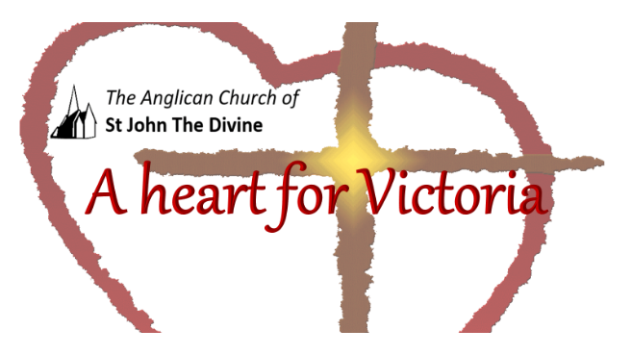

Wednesday, October 7th
Lunchtime Worship

St. John’s acknowledges that the Church buildings , and all living in Victoria, are on the ancestral lands of the Lekwungen speaking people .

Gathering to worship
Let us worship the Divine : Creator, Word and Spirit
All Amen

God is with you
All And also with you.

This is the day that the Divine has made
All We will rejoice and be glad in it.

Opening Prayer

All Lord, direct our thoughts, and teach us to pray.
Lift up our hearts to worship you in spirit and in truth
Amen
Blessed is the Creator
All for God has heard the voice of our prayer;

Psalm 121,1-8

1. I will lift up mine eyes unto the hills, from whence cometh my help.
2. My help cometh from the Lord, which made heaven and earth.
3. He will not suffer thy foot to be moved: he that keepeth thee will not slumber.
4. Behold, he that keepeth Israel shall neither slumber nor sleep.
5. The Lord is thy keeper: the Lord is thy shade upon thy right hand.
6. The sun shall not smite thee by day, nor the moon by night.
7. The Lord shall preserve thee from all evil: he shall preserve thy soul.
8. The Lord shall preserve thy going out and thy coming in from this time forth, and even for evermore.

A poem
The trees are in their autumn beauty,
The woodland paths are dry,
Under the October twilight the water
Mirrors a still sky;
Upon the brimming water among the stones
Are nine-and-fifty swans.
The nineteenth autumn has come upon me
Since I first made my count;
I saw, before I had well finished,
All suddenly mount
And scatter wheeling in great broken rings
Upon their clamorous wings...
But now they drift on the still water,
Mysterious, beautiful;
Among what rushes will they build,
By what lake's edge or pool
Delight men's eyes when I awake some day
To find they have flown away?"
William Butler Yates

With the whole church
All We affirm that we are made in the image of the Divine ,
Befriended by Christ,
Empowered by the Spirit

With people everywhere
All We affirm God’s goodness at the heart of humanity
Planted more deeply than all that is wrong

With all creation
All We celebrate the miracle and wonder of life;
The unfolding purposes of God, forever at work
In ourselves and the world
Iona Abbey Worship Book

Let us pray
Loving God,
Grant that we may walk in your presence:
your love in our hearts,
your truth in our minds,
your strength in our wills;
until, at the end of our daily journey,
we know the joy of our homecoming
and the welcome of our family’s embrace,
through Jesus Christ our Lord.
All: Amen. New Zeeland Prayer book

Let us keep in our hearts all those affected by Covid19 and let us pray for a time when, together, we can live without fear and anxiety. Wrap those that are suffering physically and mentally in our prayers. With our love, give them the strength to recover and find peace.

Gracious God,
All accept these prayers
In the name of our brother, Jesus Christ.

All Amen.

The Disciples’ Prayer
All
Our mother, who is in heaven and within us,
We call upon your names.
Your wisdom come. Your will be done
In all the spaces in which you dwell.
Give us each day sustenance and perseverance.
Remind us of our limits as we give grace to the limits of others.
Separate us from the temptation of empire,
But deliver us into community.
For you are the dwelling place within us
The empowerment around us
And the celebration among us
Now and for ever.
Broadview United Church

Going out to serve God

Let us bless our Loving God
All thanks be to God.
Blessing, honour and glory be yours,
here and everywhere,
now and for ever.
Amen.
Go in peace to love and serve .
All Thanks be to God. Amen.

Copyright acknowledgment
Order of service based on New Patterns for Worship © 2003
Some material included in this service is copyright: © The Archbishops' Council 2000
Some material included in this service is copyright: © The Archbishops' Council 2002

