Sermon Notes for November 15, 2020
Westview Baptist Church
Poverty

“Woe to those who lie on beds of ivory
and stretch themselves out on their couches,
and eat lambs from the flock
and calves from the midst of the stall,
who sing idle songs to the sound of the harp
and like David invent for themselves instruments of music,
who drink wine in bowls
and anoint themselves with the finest oils,
but are not grieved over the ruin of Joseph!
Therefore they shall now be the first of those who go into exile,
and the revelry of those who stretch themselves out shall pass away.”

Rich and Poor

And when he had spent everything, a severe famine arose in that country, and he began to be in need. So he went and hired himself out to one of the citizens of that country, who sent him into his fields to feed pigs. And he was longing to be fed with the pods that the pigs ate, and no one gave him anything. Luke 15:14-16 ESV

Web of Causality

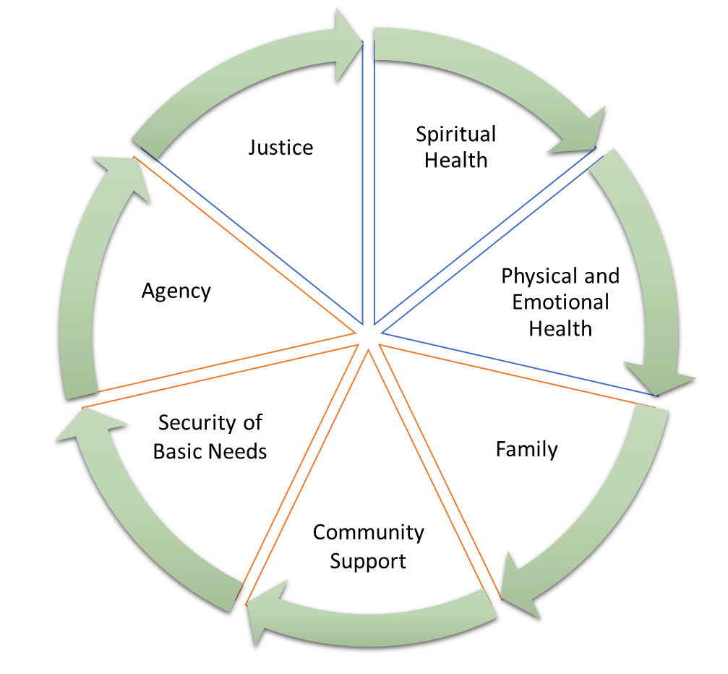

Then
- The Leper

- The Widow

Now
- Newcomers to Canada

- Seniors

- The Poor

The Point

- Wealth is not wrong in itself

- Concern for Shalom

