The Right Reverend Michael W. Hawkins Bishop of Saskatchewan
The Right Reverend Adam S. Halkett Bishop of Missinipi
Diocese of Saskatchewan PO Box 23125 Prince Albert SK S6V 8A7 (306) 763-2455

March 17, 2020

Dear Sister and Brothers,

In the time of my trouble I will call upon thee; for thou hearest me. Psalm 86.7

After much prayer and deliberation and consolation with our episcopal colleagues in the Ecclesiastical Province of Rupert’s Land and the clergy of the Diocese, we are suspending all public worship and gatherings of the Diocese of Saskatchewan effective immediately. This includes all our churches, chapels and buildings.

We have made this decision as a precaution and out of deep concern for our congregations and communities and for our vulnerable neighbours. We recognize how difficult and shocking this will be.

We call everyone in the Diocese to daily prayer, especially in this season of Lent and of this pandemic.

We will be providing means to assist us to gather in weekly worship, though not together in the same church building, including online services and we commend to your use the Family Prayers in the Book of Common Prayer pp.728ff. and the Home Prayers in the Book of Alternative Services pp. 687ff.

We want to affirm our commitment to the pastoral care of all. If you need a pastoral visit or Holy Communion, please do not hesitate to contact your parish priest. Your priests are here for you and with you through this crisis. Much of their work will be done by ‘phone and online in the next few weeks but please do call on them in case of a crisis, severe illness or someone dying.

We are prepared for our Churches to be open for private prayer at set and limited hours provided there is no public prayer and that the total number of people never exceeds ¼ of the number of pews in the congregation/nave.

We need to care for each other in the body and we encourage every congregation to work hard to stay in touch with each other, especially those who live alone, and to care for each other through the stress and fear of this time. If you know of anyone who needs urgent pastoral care, please let your priest know.

We need to be exemplary and extraordinary neighbours. How can you help and support those in your neighbourhood? What support can we offer to working parents who are struggling to keep children home with school cancelled, those who are in self isolation for two weeks and may need assistance with errands, and the elderly who need a chat or encouragement to take recommended precautions.

We are currently working on two difficult issues: Funerals and Building Use. The recommendations of Public Health authorities must be heeded for the good of all. Changes to our funeral customs and traditions will be necessary in this crisis. Effective immediately no public wake or funeral will be allowed in any of our Churches or Halls without prior consent from one of the bishops. Families should be considering smaller, family only funerals, graveside services and cremation. Many of our facilities are also used for social service and support groups and we do not want to cut these off. Please inform all groups who share or rent your facility of this decision, remind them of our concern for the safety of our communities, and ask them what plans they have in place in the face of Covid19. If you have groups or individuals that you want to continue to use our buildings past March 21st, you must first convince us that this continued use is worth the risk, that extra precautions are in place and that this use would not undermine our decision as a diocese.

The Synod Office will be closed to the public effective March 18th but we will still be here to answer your calls and emails and to book meetings by ‘phone and zoom. While the decision to suspend public worship is difficult, it calls us all to recommit ourselves to worship at all times and in all places. While the decision to close our churches is painful, it calls us to be the Church in prayer and in service.

In the time of my trouble I will call upon thee; for thou hearest me. Psalm 86.7

In Christ,
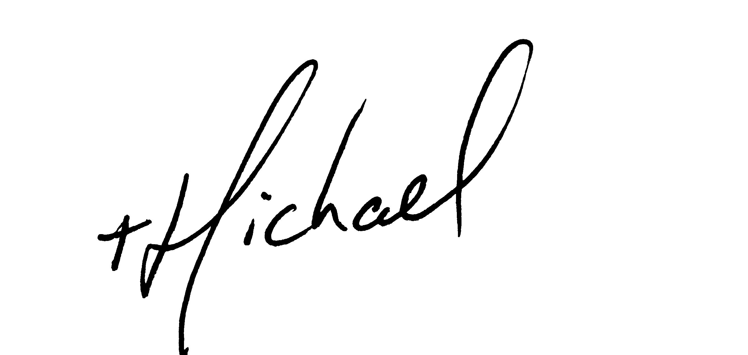

Adam S. Halkett Michael W. Hawkins

